AUTOMATION AND ROBOTIC TUTORIAL EXTRAS 6

1)
Calculate the position of the end effector of the linear arm below from the joint angles given.

y₃
Θ₅
0.6m
y₂
x₃
0.8m
1m
Θ₃
x₂
Θ₂
y₁
Θ₄
Θ₁
x₁
(0,0)

Θ₁=45º, Θ₂=140º, Θ₃=230º,

Divide problem up into right angle triangles.

x₁=1 cos 45=0.707m, y₁=1 sin 45=0.707m

so θ₄=140-90-45=5 (the 45 comes from 180-90-ϴ₁ in the first triangle)

x₂=0.8 cos 5=0.797m, y₂=0.8 sin 5=0.07m

θ₅=230-90-85=55 (the 85 comes from 180-90-ϴ₄ in the second triangle)

x₃=0.6 cos 55=0.344m, y₃=0.6 sin 55=0.491m

add up x’s and y’s for final co-ordinate

(1.848, 1.268)

2)
A robot arm is required to move to 3 different co-ordinates above a sheet of metal to perform a drilling operation. Produce an inverse kinematic solution to calculate the angular positions (θ₁ & θ₂ ) of joints 1 & 2 required to position the arm at the three Cartesian coordinates shown.

1m
1.5m
(1.6,1)
(1.2,0.8)
(1,0.5)
(0,0)
Θ₁
Θ₂
First construct simple kinamatic equations by trigometiric construction

1.5m (L₁)
1m(L₂)
(0,0)
(X,Y)
Θ₁
Θ₂
B
K₂
K₁

First us the X and Y final coordinate of the tool to construct a right angled triangle where the hypotenuse is B. From this we can get:

B² = X²+Y²

K₁=tan⁻¹(Y/X)

Now we need to find K₂. To do this we will need the cosine rule to derive a formula that relates the angle K₂ to the lengths of the sides. The cosine rule is:

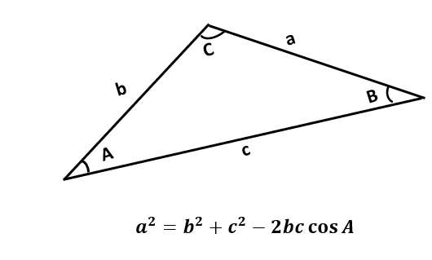

So if K₂ is the angle we are looking for we can map the triangle fromed by sides L₁, L₂ and B to the triangle above so :
A=K2, b=L1, a = L2, c = B
Giving
L₂² = L₁² + B²+ - 2.L₁.B.cos K₂.
Rearranging
2. L₁.B.cos K₂ = L₁²+ B²- L₂²
cos K₂ = (L₁²+ B²- L₂²)/ 2.B.L₁
K₂=cos⁻¹((L₁²+ B²-L₂²)/2BL₁)

Θ₁= K₁+ K₂

Now Θ₂ is the angle we are looking for we can map the triangle fromed by sides L₁, L₂ and B to the triangle above again but this time :
A= Θ₂, b=L₁, c=L₂ and a=B

Doing the same rearrangement process

Θ ₂=cos⁻¹((L₁²+L₂²-B²)/2L₁ L₂)

For (1.6,1)
These formula allow us to calculate B=1.89, K₁=32deg, K₂=31.79deg
Hence Θ₁=63.79deg, Θ₂=96.16deg

For (1.2,0.8)
These allow us to calculate B=1.44, K₁=26.56deg, K₂=41.8deg
Hence Θ₁=73.39deg, Θ₂=66.91deg
For (1,0.5)
These allow us to calculate B=1.11, K₁=19.65deg, K₂=56.2deg
Hence Θ₁=68.37deg, Θ₂=47.72deg

