AUTOMATION AND ROBOTIC TUTORIAL SOLUTION 6

1)
Calculate the position of the end effector of the linear arm below from the joint angles given.

y₃
Θ₅
0.5m
y₂
x₃
0.9m
Θ₃
x₂
Θ₂
1.2m
y₁
Θ₄
Θ₁

x₁
(0,0)

Θ₁=50º, Θ₂=150º, Θ₃=220º,

Divide problem up into right angle triangles.

x₁=1.2 cos 50=0.771m, y₁=1.2 sin 50=0.919m

θ₄=150-90-40=20

x₂=0.9 cos 20=0.845m, y₂=0.9 sin 20=0.308m

θ₅=220-90-70=60

x₃=0.5 cos 60=0.25m, y₃=0.5 sin 60=0.433m

add up x’s and y’s for final co-ordinate

(1.866, 1.66)

2)
A robot arm is required to move to 3 different co-ordinates above a sheet of metal to perform a drilling operation. Produce an inverse kinematic solution to calculate the angular positions (θ₁ & θ₂ ) of joints 1 & 2 required to position the arm at the three Cartesian coordinates shown.

1.25m
1m
(1.975,0.95)
(1.7,0.62)
(1.4,0.5)
(0,0)
Θ₁
Θ₂
First construct simple kinamatic equations by trigometiric construction

1m (L₁)
1.25m(L₂)
(0,0)
(1.975,0.95) (X,Y)
Θ₁
Θ₂
B
K₂
K₁

From this

B² = X²+Y²

K₁=tan⁻¹(Y/X)

K₂=cos⁻¹((L₁²-L₂²+B²)/2L₁B)

Θ₁= K₁+ K₂

Θ ₂=cos⁻¹((L₁²+L₂²-B²)/2L₁ L₂)

You will need the cosine rule to drive two of the above formula. The cosine rule is:

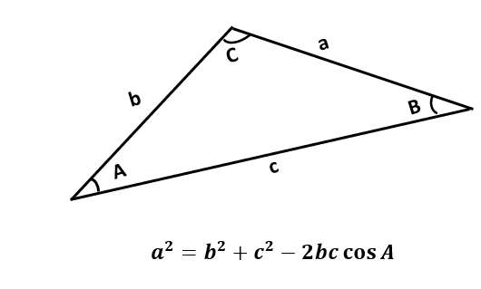

For (1.975,0.95)
These allow us to calculate B=2.19, K₁=25.69deg, K₂=14.54deg
Hence Θ₁=40.13deg, Θ₂=153.87deg

For (1.7,0.62)
These allow us to calculate B=1.81, K₁=20.03deg, K₂=41.44deg
Hence Θ₁=61.47deg, Θ₂=106.58deg
For (1.4,0.5)
These allow us to calculate B=1.49, K₁=19.65deg, K₂=56.2deg
Hence Θ₁=75.85deg, Θ₂=82.12deg

