AUTOMATION AND ROBOTIC TUTORIAL 1 SOLUTION

- Look at the following control functions. Are they linear/non-linear, time invariant/time variant?

$$y\left(t\right)+2u^{2}\left(t\right)+7u\left(t\right)+4t$$

Non-linear and time variant. Has power functions and a direct relationship to time.

$$y\left(t\right)+4u\left(t\right)+7c+4$$

Linear and time invariant. Has no power functions and no direct relationship to time.

$$y\left(t\right)+2tu^{3}\left(t\right)+3u\left(t\right)$$

Non-linear and time variant. Has power functions and a direct relationship to time.

- Feedback Calculation

Using the standard feedback arrangement from the lecture:

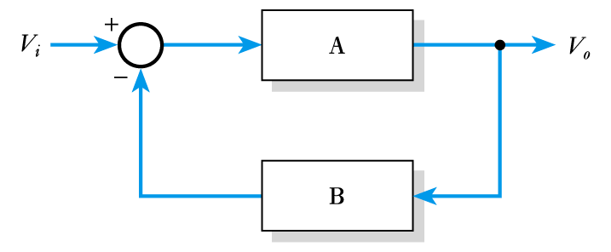

Calculate the required values to produce a stable voltage gain of 100 using a high-gain active amplifier with a gain of 100,000.

Determine the effect on the overall gain of the circuit if the gain of the active amplifier varies from 100,000 to 200,000.

SOLUTION

Since we require an overall gain of 100 we will can use the estimate use G=1/B. Hence B = 1/100 or 0.01

or for a more precise calculation.

Hence B=0.00999 pretty close to 0.01!

If A=100000 actual gain is:

If A=200000 actual gain is:

A 0.05% change. So feedback is very effective against large variances in gain

