Group Members: Michael, Andres, Seth

Date: 3/21/2023

CS 4390

Project 1 Task 3

Google Cloud Gmail API Setup

First, we started by making a brand new email called [cs4390bg@gmail.com](mailto:cs4390bg@gmail.com). Then we connected our email to the Google Cloud service by creating a new project which we called CS-Gmail as seen above.

Then we enable Gmail API into our project so we can “login” with our credentials because the Google Cloud creates one for you. Then you will be able to login to the app.

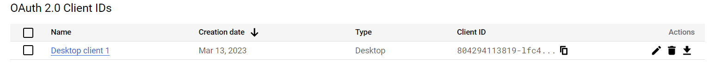

This is were the credtials are creates, and we just need to download them and paste them into our folder to be able to login.

After the credinatals and the API are set up for our project, we have to set up the consent screen for other users when they try using the app as well. This is because they have to consent on using the app because it might be “unsafe”. After this we switch the “Publishing status” to Production from Testing so the TA and others can access it without having to add every single individual email for those you can access it. After this we are ready to be able to login to our API from our python code.

These are the commands to run it from the command prompt. Then below is the emails that were sent.

