Task 2 Doc:

**Task Set 1:**

**1.1A(task2_1_1.py):**

Running the program without privilege, we get an error: Operation not permitted.

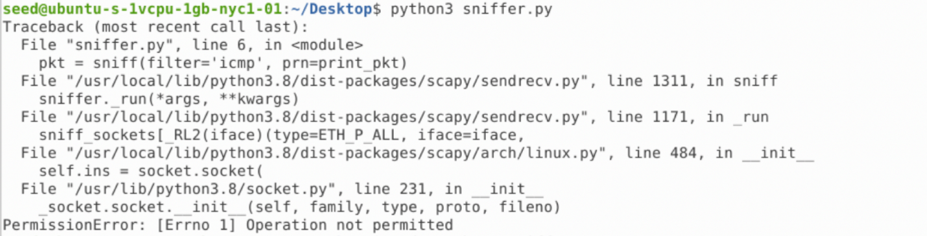

Running the program with root privilege, we are able to sniff packets.

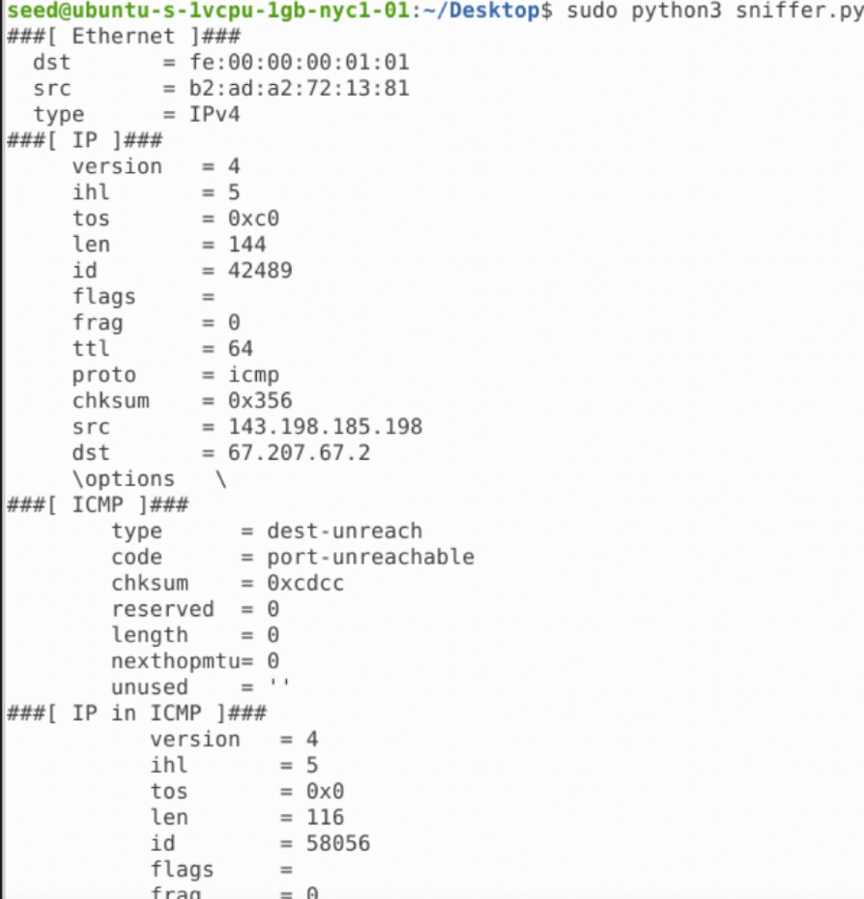

**1.1B(task2_1_1_b.py):**

The result

Capture any TCP packet that comes from a particular IP and with a destination port number 23.

Capture packets comes from or to go to a particular subnet. You can pick any subnet, such as 128.230.0.0/16; you should not pick the subnet that your VM is attached to.

**1.3(spoofer.py):**

Spoofing packets to a.dst:

**1.4(your_code_name_here.py):**

We ping 1.2.3.4, 10.9.0.99, and 8.8.8.8. Both 1.2.3.4 and 10.9.0.99 return alive even though 1.2.3.4 is a non-existing host. This proves that sniffer can now spoof an echo packet back to the sender properly. Due to Address Resolution Protocol(ARP) and MAC addresses, 10.9.0.99 return Destination Host Unreachable even though sniffer is working correctly.

