Contents

Agile 2

Tools 3

Team work 4

# 

# Agile

Project is a temporary activities undertaken to create a unique product or service, so the project has a specific goal to reach. For example, if we see a factory to make chocolate so all the company is a project, and producing chocolate is “Operation” why we call them that because there are always changes in the operation because we would be not sure that called uncertainty.

Project management always talk about the steps in any models used or methodologies we use to manage a project depending on a group from several steps and the simplest one is divided into four steps.

First step is INITIATION that is the idea of the project and then PLANINNG that we plan for the project the EXECUTION when we work on the project and last thing is CLOSING and that is where we check and make sure everything is working as we except and they used to say all of that has to be under control.

In software they have added 2 more steps and they call that SLDC so some book they say it is six steps and some say it is seven steps but anyway it does not matter if it six or seven while we know that the step should follow each other so we go for first step we finish that then we go to the next one and so on. And that was hard to change something if we need to and it costs more and sometimes cannot change anything or it is impossible to change something this was in the traditional model.

In software agile methodology depending on different concept that we are able do the project in a way that let us change and upgrade the depends on the client without difficulties, an information system development process that emphasize flexibility to anticipate new requirements during development.

That idea is to divide all the group into small parts and each part we call it iteration so each is like sub project, we apply that stages to each iteration for example if we have a client we need to get feedback from them for one step before we go to the next step. Then that would be easier and acceptable for any changes because in each iteration we work on design and planning even analysis that was in the begin so in each iteration we have different plan that takes at most 2 to 3 weeks. An approach to system development in which the system is “grown” piece by piece through multiple iterations.

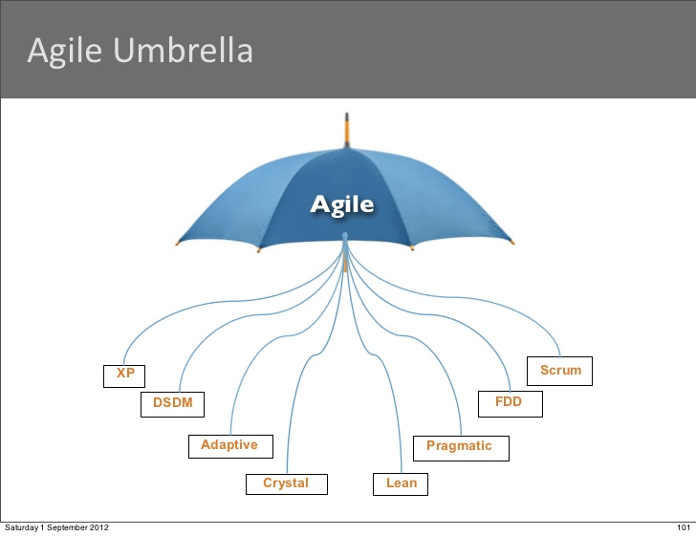

Agile has many things we call that umbrella under that we can see there are many types of them and each one is used to a specific goal in a special project, for example we use lean to reduce the mistakes or we use XP to give product every while or to be more dynamic we use scrum so it is depending on how we want to work so in agile there are more than one methodology and all of them called agile unlike the traditional method

Agile is a mind-set that help us to deliver valuable software despite uncertainty and risk, so because of the uncertainties and we do not know everything from the begin we need validation and that to make sure every step we validate it. we have to provide values, then when we check with the customer and do validation normally we would have to change things so we need to change the plan frequently to respond the validation and provide a value, we need two things to do that first thing we need to deliver parts as fast as we can parts that we do validation on them and then we make sure that we are getting values then we change the plan and we deliver fast because of that the second point is to deliver frequently, so we deliver many and fast then we do validation to make sure we are getting values and we deliver again.

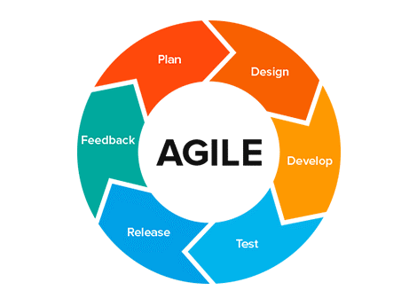

# 

# Tools

We were using Teams as a communication tool to contact each other and keep all the updates, and the leader was setting up the meetings and make video calls and that was our main communication and also we were using WhatsApp as second tool to contact also sometimes we use mobile phone if we need to and they were helpful in all the time because sometimes not all of us can be online in the same time.

We did use Trello as Kanban board to see where we were working on which part, when we finish the part we are at and there we would see if any updates or any complete part and “repl” a tool to share our code there and to be all connected to the same server and be able to look on other work also we did use the chat in repl during the work time

I was testing each part by itself manually and check the values

# Team work

Benefits of team work, there are a lot of benefits if we work in a good team like for example when we work in teams the product can be done faster than one person also the work will be easier and organised special for big projects it has to be done by a team or more depends on the size of the project more than mind in the work and that is good more solutions sharing ideas getting helps from each other.

Difficulties, it depends on how is the team working in the work time if one of the team members does not do the work properly the team will be late or get stress and that effect all the team and the project will take more time then the work will be messed.

It is difficult to be all on the same line some they would be bit late or not working as they should and they don’t get all the same work each one has different mission.