Stepperature Getting Started Guide

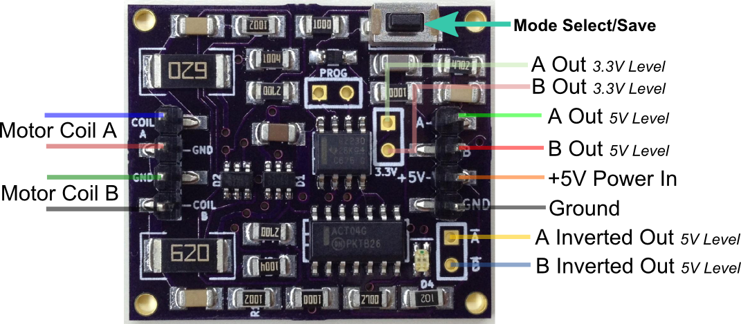

Wiring Diagram

**Power:**

Stepperature requires a 5V 500mA power supply. Voltage can range between 4.5V and 5.5V, but a well regulated and filtered 5V power supply is recommended for best performance.

**Signal Input:**

Stepperature requires a bipolar hybrid stepper motor. These generally have a cube-like shape to them, and have four wires. One pair of these wires is hooked to one coil inside the motor, and the other pair of wires is hooked to another coil. Throughout this manual, these coils will be referred to as "Coil A" and Coil B."

Some hybrid steppers are wired to allow for either unipolar or bipolar configurations, and so have six or eight wires. The six-wire motors are wired like a center-tapped transformer, and can still be used with Stepperature by leaving the center tap of each coil disconnected. Eight-wire motors have four independent coils, and could probably be made to work with Stepperature by connecting two pair of these coils in series, thus making two coils, A and B.

Coil A of the stepper motor should be connected between the pins labeled "Coil A" and "Gnd" on the left side of the Stepperature board. Connect Coil B in a similar way. (See diagram above for details.) Note that if you plug into the Stepperature board using a 4 pin female connector, you can easily change the direction of the output signal relative to the direction you spin the motor by reversing this connection (turning it 180 degrees so A becomes B and B becomes A.)

**Signal Output:**

Stepperature has two 5V logic-level outputs available on the pre-soldered connector. These are labeled A and B on the right side of the Stepperature board. (See diagram above for details.) Also available as holes ready for soldering are inverted versions of A and B, indicated with lines over the letters. These four outputs are driven by an "ACT-series" logic chip, which can sink or source 24mA. "High" is within a volt of the supply voltage, and "low" is very close to ground.

In addition, 3.3V signal outputs are provided as holes in the board. These are labeled "3.3v" underneath the pair of holes, and these A and B outputs are lined up with the 5V A and B outputs, respectively. Note that these 3.3V outputs are connected directly to the on-board MPU and are not as robust as the ACT-driven outputs. In particular, the 3.3V regulator has very limited capacity, so care should be taken to not source too much current through these.

**Modes:**

Stepperature has four modes of operation. These are described below:

1. Quadrature: Outputs quadrature signal on A and B outputs. This type of signal is used for Mach3 and other industrial control applications.

2. Step and Direction: Outputs step signal on A, direction signal on B. The direction pin changes state a split second before the step pin does. This type of signal can be used to control a stepper motor controller, for example.

3. Step A and Step B: Outputs one pulse per step on A when going one way, and one pulse per step on B when going the other way. Some stepper motor controllers use this type of signal, and it may be handy for other custom applications.

4. Asynchronous Serial Output: This signal is output only on A. The B output is not used in this mode. The format of the data is non-inverted TTL, 9600 baud, 1 start bit, 8 data bits, 1 stop bit, no parity. A "+" character is sent out for every step taken in one direction, and a "-" character is sent out for every step taken in the opposite direction. This signal allows connecting Stepperature to a microcontroller, or to almost anything with a USB port by using a USB-to-serial converter.

To cycle through the four modes, click the button at the corner of the Stepperature board. Verify that you are in the correct mode by spinning your stepper motor back and forth and watching the LEDs. The green LED is connected to the A signal, and the red LED is connected to the B signal. A distinctive pattern can be seen for each mode by watching the LEDs. In serial mode, the green LED will appear to be on all the time, and the red LED will remain off.

When you have configured Stepperature to use the correct mode for your application, you will want to save this mode to non-volatile memory so that Stepperature will use that mode next time it is powered on. To save the current mode, hold down the button for more than one second. You will see the LEDs flash when the settings have been saved and that will tell you when to release the button.