RPG Town Design Doc (Draft two?)

Table of Contents will go here eventually.

Overview

RPG Town is going to be a game that should replicate the feeling of the old Final Fantasy on the NES games. But we are not to replicate the experience entirely. While we are going to be using the old-school JRPG (Japanese Role-Playing Game) format, we are going to be updating it with some features that should make the game feel like new experience.

Story

This section will be more fleshed out later once we get the story in. For now, All we know is that there are 4 heroes, each one with their own class which is set. The classes will influence their personality and how they interact with each other. There will be some sort of evil that the heroes must vanquish, and there will be no Na'vi/Airy type helper thing because fuck those things.

Controls

The following are the controls for the game and hopefully they will be simple enough for any player to understand. If the controls are somehow bad for a JRPG I think something may have gone somewhat horribly wrong. However there will be multiple control setups because not every person's setup is the same. There should also be an arrow to indicate what one would be selecting.

Keyboard only
- WASD/Arrow Keys for movement and menu navigation.
- E for player interaction in the world.
- Enter for a “confirm” button. A menu progression button if you will.
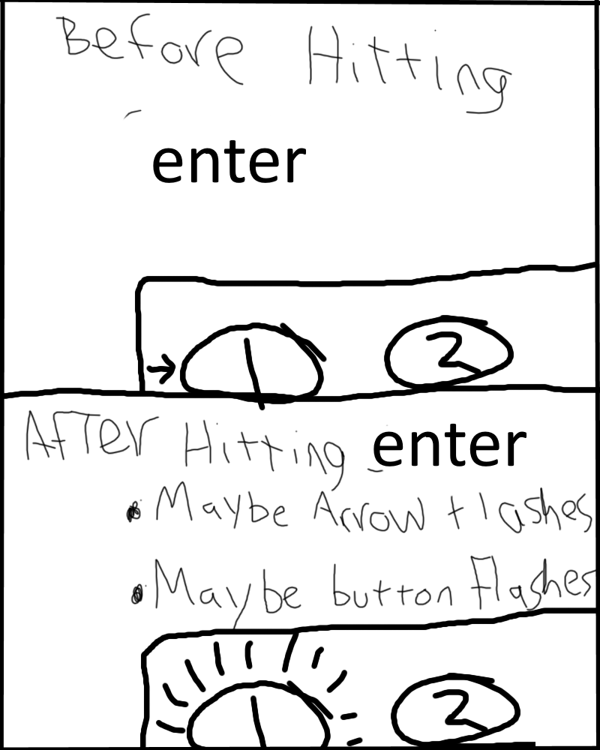
  - What I mean by this is when that if you want to select an option, you would press space. Crappy Paint.net pic below to demonstrate what I mean.
- ESC to access the main menu.
- I to access the in-game menu (subject to change.)

Keyboard and Mouse

In this control setup the mouse with be used to make selections, but movement is still handled by the keyboard, because we aren't programming a “Diablo-style” movement scheme.

- WASD for movement.
- Mouse-over to highlight an option.
  - Make the thing you would be selecting light up.
  - Also, there should be some sort of on screen mouse cursor, and there shouldn't be an arrows to show what a selection is. Image below to show what I mean by this.
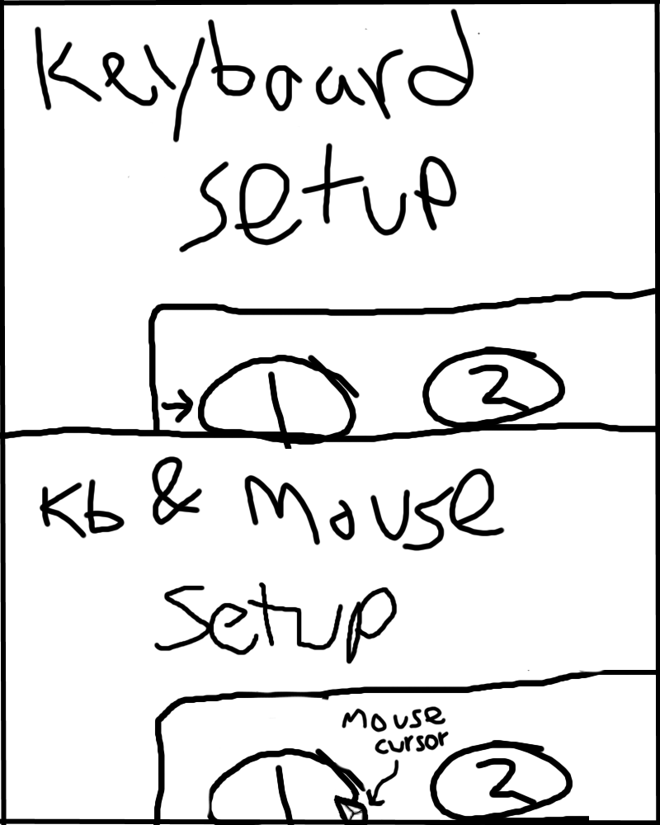
- Left Click to confirm selection/interact with world.
  - The left click would end up taking over the role of two separate keys from the keyboard only control scheme.
- ESC to access the main menu.
- I to access the in-game menu.

Controller Support

We should look into developing controller support sometime in the future, but we should figure out how to implement the current control schemes we have designed now, and then we can come back to this specific case.

User Interface

There are many different types menus that we will need to create and implement. The following are the ones I could come up with at the time of writing:

- The buttons that will be used to access the menus.
- Main menu with options like settings and exiting the game.
- In-game menu with the player's party, inventory, etc.
- Dialog boxes and how they will be displayed.

Dialog Boxes

There are multiple ways of creating dialog boxes in RPGs, one of which is to just have a box appear on the screen that shows a picture of who is talking, their name, and what they are saying. Below is an image to show an example.
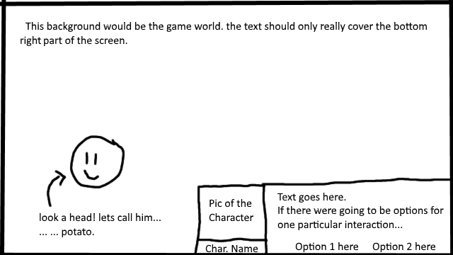
So what should this style of dialog box accomplish?
- The player must be shown an image of the character that is talking and their name.
  - Because we are going to be having an image shown for the character, we can have different expressions for them based on whether characters emotion. Like if they are saying something nice, maybe show a happy expression, or if they are mad, show an angry face.
  - The name must also be changed when ever another character is talking.
- When an NPC is communicating, it should say a line and then come to a stop, where the player must then hit the “confirm” button (Spacebar or Left-Click) to get to the next line of text, like in old Final Fantasys and such.
- In the event that there is an option to make, like when talking to an innkeeper or something, the text window should be cleared, and then the NPC should say a line that incites the user to make a choice. Image on the next page.
- There should be a sound that plays as the text is displayed. And there should be different sounds for different characters and NPCs.
- Hitting the confirm button before something is done speaking should fill in the box immediately, and then the user should be able to hit again to go on to the next line.
  - Because of this, I understand that the writer will have some issues, because if a line is too long then words are going to be cut off. This needs to be accounted for when we are putting the lines into the game.
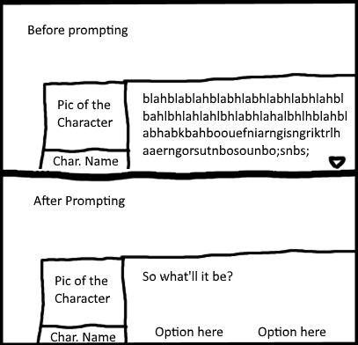
In-Game Menu (Inventory)

The in-game menu will be the menu the player will access to deal with things like party formation, equipment, status, their inventory, etc. An example of how it looks is below.
- Item Menu
  - This is where the player will be able to see all of the items the have in their inventory.
  - There will be three things the player can do here: Browse and use items in their inventory, Browse their “Key Items”, and Sort their main item list.
    - Sorting will put the type of item the player wants first (consumable, armor, and weapons) and then sort those by the items strength (potion > hi-potion > mega potion > elixer).
- Magic Menu (image on the next page!)
  - This is where the player will be able to use any spells that the party acquires throughout their journey.
  - Any healing magic should be able to be used here (cure to restore HP, any spell which removes debuffs).
  - There will be three parts: Spell menu, Spell description, and Casting choices
    - The “Spell menu” is just a list of spells that the player can scroll through.
    - The “Spell description” shows the name of the spell and a brief description of what the spell does.
    - The “Casting menu” is when the player chooses a spell and wants to cast it on either a single party member or all of them.
- Party Menu
  - This menu should show the individual party member's HP, MP, Status (shows if the party is has a status effect), EXP to next level, stats, and current equipment.
- Equipment Menu
  - This menu allows players to equip their party with any armor and weapons they find on their journey. It should show one party member at a time, alongside a list of equipment the the party member is able to equip.
- Save Game
  - Press this button to save the game. Will take the player to a save screen which shows them their save slots.
- Quick-Save
  - Prompts the player with a window that tells them that quick-saving will exit them out of the game while holding their position until they start the game up again, and that if they load a previous save file, the quick-save data will be erased.

Menu Images Go Here because holy shit format.

In-Game Menu Main Screen
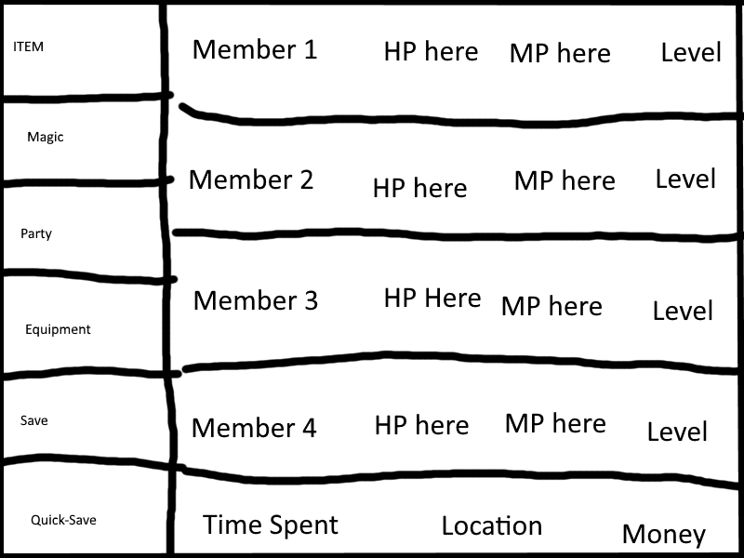

Item Menu Image
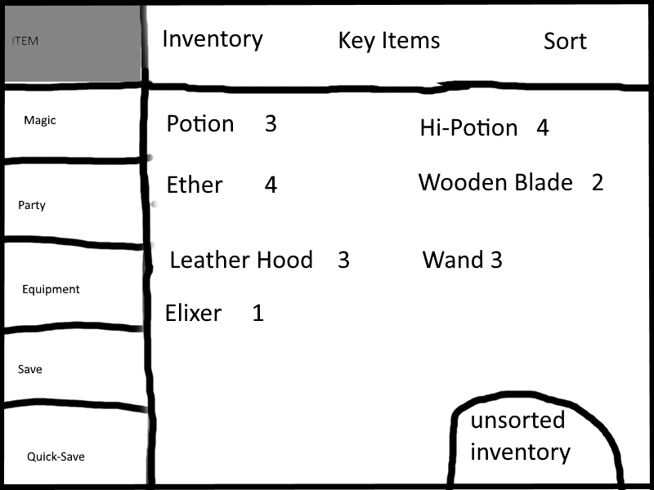

Magic Menu!
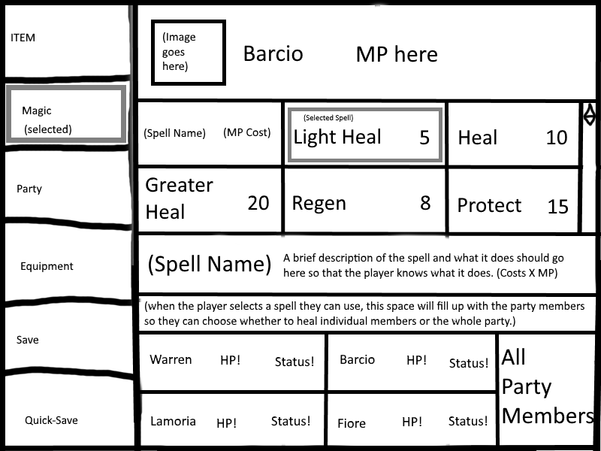

Party Menu!

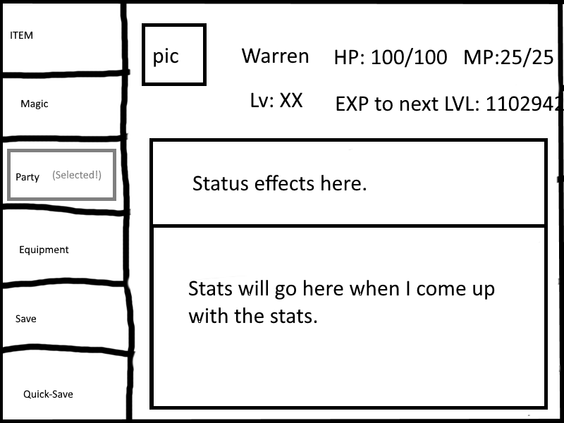
Equipment Menu!
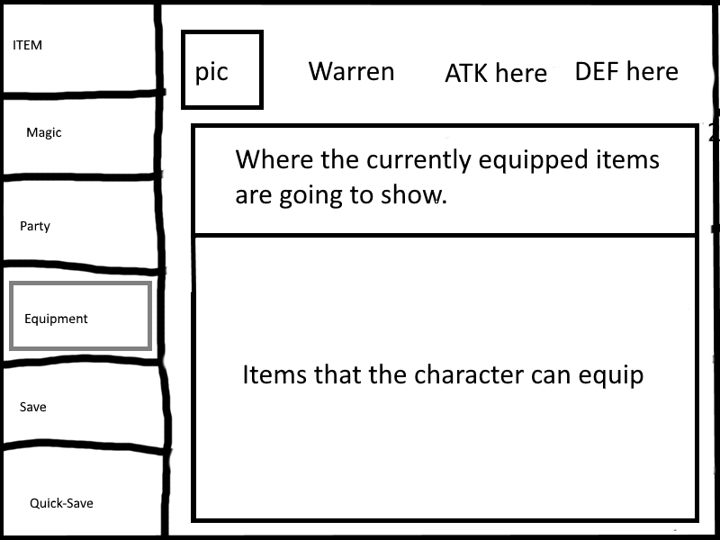
Save Menu!
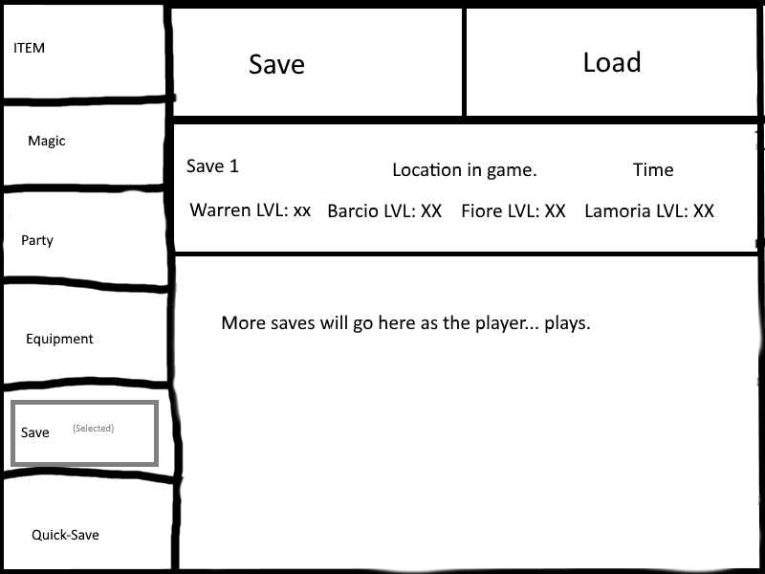
Main Menu

The main menu is in essence just the pause screen with a box on it. There should be two options in the main menu:
- Settings
  - This is where players can adjust various settings under different categories like: Audio, Video, and Game
    - Audio should deal with volume levels and allow the player to adjust: Master Volume, Background Music (BGM) Volume, Sound Effects (SFX: like speech blips, menu sounds, or battle sounds) Volume.
- Quit Game.
  - Allows the player to quit the game.
  - Should first remind the player that any unsaved progress will be lost and after the player confirms again, the game should quit.

On-Screen Menu Access Buttons

These would be buttons that are on-screen during gameplay that the player can click to access the main and in-game menu. The buttons should represent the menu the play is going to be accessing. Or they can just say “Main Menu” and “In-Game Menu” (or “Inventory”)

Character Stats

Before getting into the combat system, it is imperative to discuss how the stats system is going to work. This section will go over the four main stats and the five modifier stats. I made this distinction because the modifier stats exist to modify the main stats. The main stats are listed below:

- Health – how long the character will be able to last in combat.
- Mana – A resource used to cast spells.
- Weapon Damage – The damage that an equipped weapon can deal.
- Armor – how resilient a character is to enemy attacks.

Here are the modifier stats:

- Strength – Increases damage done in combat.
- Intellect – Increases damage done by spells
- Spirit – Increases healing done by spells
- Agility – effectively higher initiative and dodge chance.
- Dexterity – Increase critical chance.

Health and Mana are going to grow independently of the modifier stats, and can be influenced by armor. A character will start out with a relatively small pool of health and mana, but they will increase as the characters increase in level. The rate at which health and mana increase should also go up in level as well.
For example, between levels 1 and 10, a character could start with 100 HP, and gain around 20-45 HP per level. Then, starting in the level 10-20 bracket, they could have ~350-550 HP and gain 65-90 HP per level. This can possibly continue forever, or until the character reaches some arbitrary limit like 9999. Mana will function in the same way, but instead of being in the thousands, it will be in the hundreds.
All of the modifier stats will also increase with level, but at a rate that is dependent on the role of character. Warren, for example, could start as level 1, with the stats 5,3,3,2,4, each number respective to the list of modifier stats above. When he levels up his strength stat will go up more than the other stats. Because if he got 1 strength and 4 intellect, that is effectively a wasted level. For every character, their main stat would go up anywhere between 3-5 points, and their stats would increase between 1-3 point weighted to occur more in the 2-3 range. This is to insure that the other stats don't fall to far behind with regards to the other stats.
Weapon Damage and Armor are completely independent of the character, and are instead decided by the equipment the character wears. Armor should also have the capacity to modify modifier stats. A wooden sword with 5 weapon damage will get the character, 5 weapon damage. A helmet could offer +5 defense, and +350 Health, or a wizard robe +3 defense and +25 Intellect!

Stat Interactions

This section is going to roughly go over how stats are going to work in combat. The following is a list that shows how stats will interact will each other in combat. Various equations for damage are going to have to be made, as weapon attacks and spells are different, but also need to make sense for the character's current level.

- Weapon Damage and Strength are combined in a way to deal damage.
- Dexterity will work with RNG during a character's attack to determine if they will get a critical strike.
- Intellect will be factored into spells to determine spell damage.
- Mind will be factored into spells to determine spell healing.
- Armor will be factored into an enemies attack to determine how much damage a character will take.
- Agility will determine initiative at the start of combat.

Combat Mechanics

The Combat shall be take place in two stages: Planning and Action. The combat will happen via random encounters. As the player moves around the world, something should run in the background to determine whether or not the player will engage in a random encounter. This is something that is to be restricted to the overworld and dungeons. The image on the next page is an example battle scene.

Planning Stage

This is where the player gives orders to the characters in the party. They will be shown the order in which the enemies are going to be attacking, as indicated by the bar on the left. This will be determined comparing the AGILITY stat of every entity participating in the fight, with higher agility. The player will then select an action for a character, which the character will then carry out in the action stage (Considering having this happen immediately in an effort to keep the combat fluid.)

Action Stage

After every character has their commands issues, every command will be played out the order of the initiative bar on the side. After this ends, we go back to the planning stage. (If we want we could add timed hits and timed dodging into this stage as well.)

Picture of what the battle scene should look like.

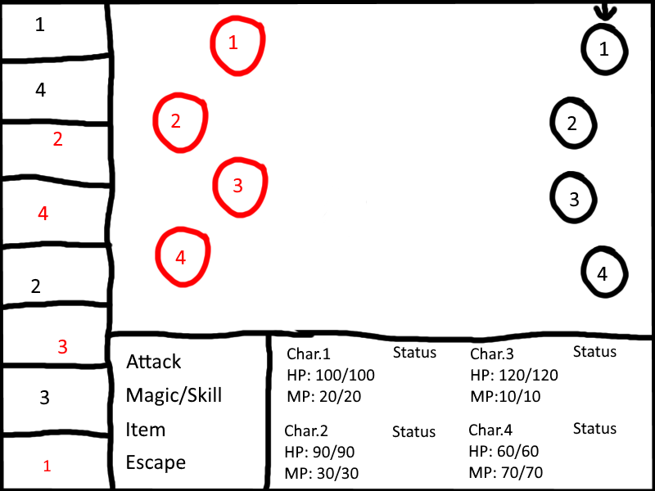

Types of Encounters

There are three types of random encounter. The normal engagement which starts out normally and should be the one the player see the most often. The surprise attack gives the enemy a free turn to attack and should occur rarely (1/100 or less). The preemptive strike will occur as rarely as the surprise attack and will allow for the player to get a free turn of attacks instead of the enemy.

Overworld
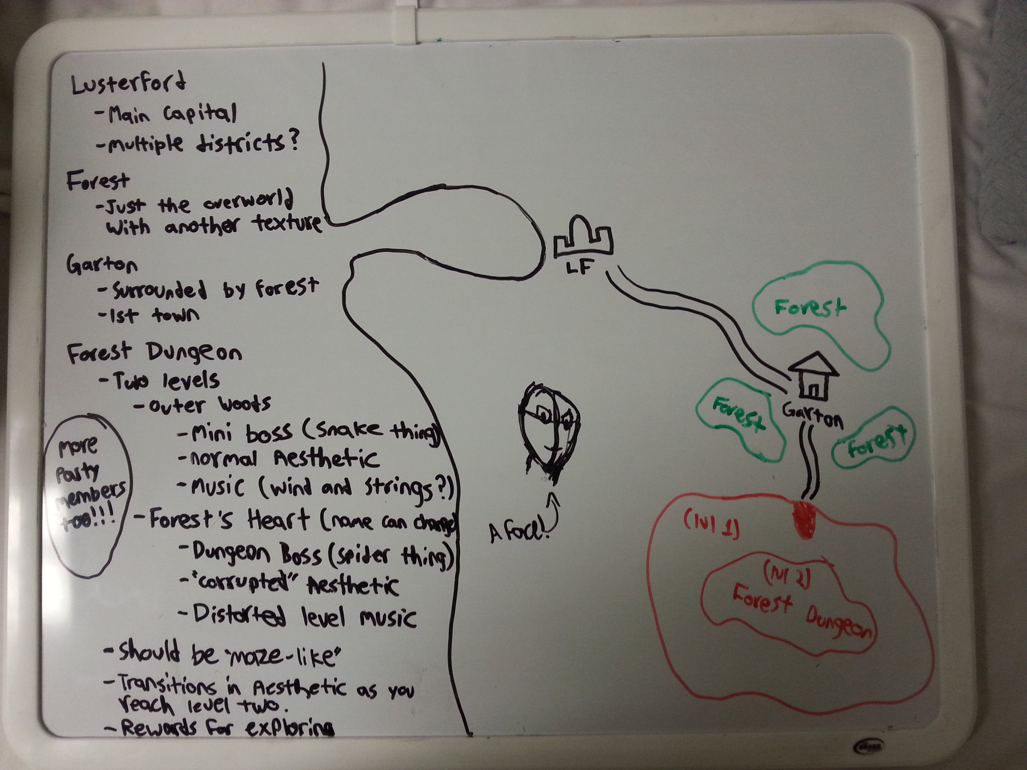
The overworld for the demo. The important locations are marked on the map: Lusterford, Garton, the Forest Dungeon (name subject to change). Lusterford is where the player will start. Garton is the town that the player will go to. The Forest Dungeon (name subject to change) is where the player will go through and get acquainted with how dungeons will be played and designed.
There will be forests on the overworld, but they wont have a different encounter rate. However, if a player encounters an enemy in the forest, they background needs to change, along with the monster that they encounter (A forest backdrop, and giant insects). All the forest serves to be is just something to differentiate the look of the overworld.
The face is not something that needs to be drawn. But we do need the following assets:
- Water tiles (animated is preferable)
- Sand tiles (for the coastline)
- Grass tiles
- Forest tiles
- Corrupted Forest tiles (for the dungeon).
  - Because there are two levels, maybe two corrupted tiles.
- Maybe mountain tiles to force segmentation for the demo.
The overworld also needs music to accompany it. It should convey a sense of adventure and foster wonderment in the player. Not much else to say here.
One question I have been debating is whether or not to have multiple entrances to the Forest Dungeon (name subject to change). On one hand, this would allow for an interesting way to approach the dungeon for the play. On the other hand, it may be overwhelming for the player to offer them that much choice, and make the dungeon more confusing to implement in code. So, in the interest of keeping the scope within our grasp, there will be one entrance, and the player won't be able to enter from any other side other than the designated entrance.

City/Town Designs

Lusterford

The overall aesthetic should be feel like a medieval town. Homes made of stone and wood, streets of cobblestone. Something reminiscent of Stormwind City in both aesthetic and design. There will be four main areas in Lusterford: the Main District, the Mage District, the Trade District, and the Castle District.

Main District
- The Main District will be general NPC housing. A bunch of homes with some furniture and people.
Trade District
- The Trade District is where the player will be able to go to various stores. The Potion Shop will sell potions (what else would it sell?), the blacksmith will sell weapons and armor.
Mage District
- The Mage District is where the mages in the city go to learn and practice magic. There will be a temple in the center of this district, with two floors. The first floor will be a library and magic lab. The basement is a testing area, which should look a bit weathered from testing, with maybe a broken vial or some scrolls scattered along the ground.
Castle District
- The Castle District is going to have a massive castle in the center that the player can enter. To the side of the castle there will be a barracks and a training ground.
  - Inside the castle there are 5 rooms: The Foyer (the room the player is in when they first enter the castle), a Study and Mess Hall (to the sides of the Foyer), the Throne Room (going in between the stairwell towards the back of the Foyer), and the King's bedroom (up the stairs in the Foyer).

The following images are sketches of the location of everything in relation to each other.

Lusterford Design Sketch
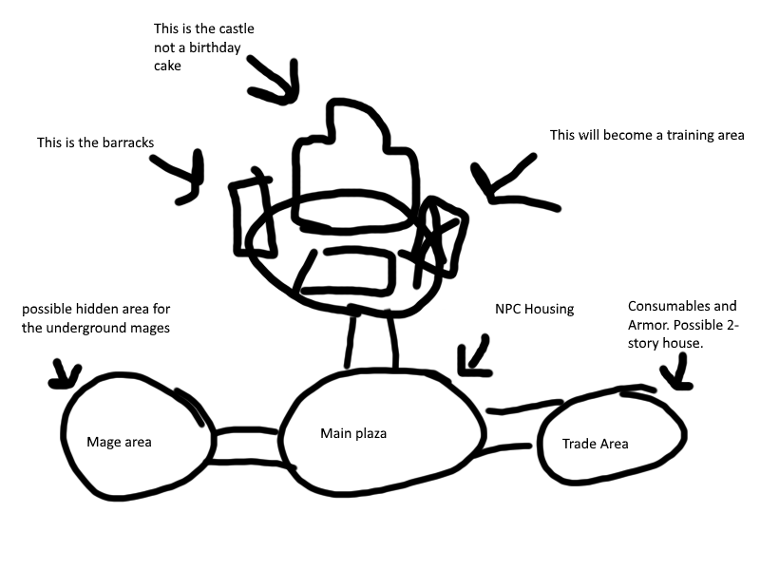

Main District Design

To be made.

Trade Distict Design

To be made

Mage District Design

to be made

Castle Area Design
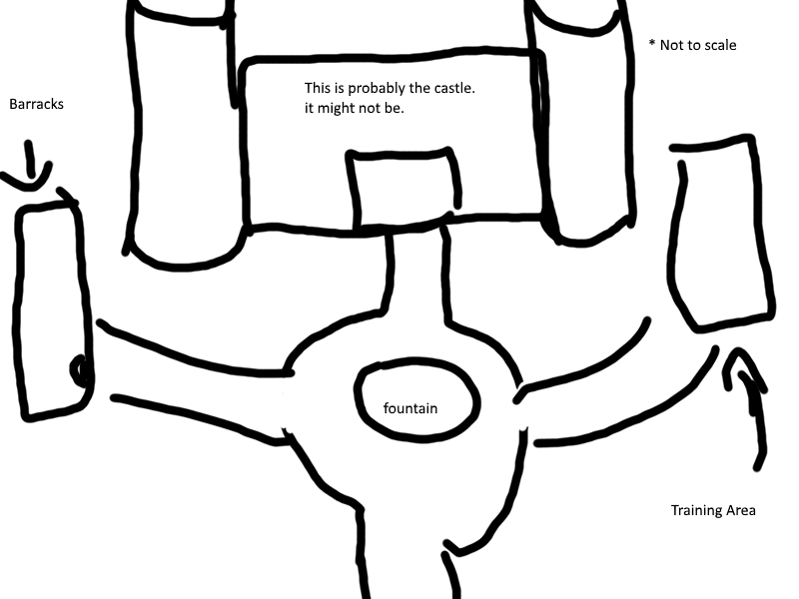

Castle Interior Design

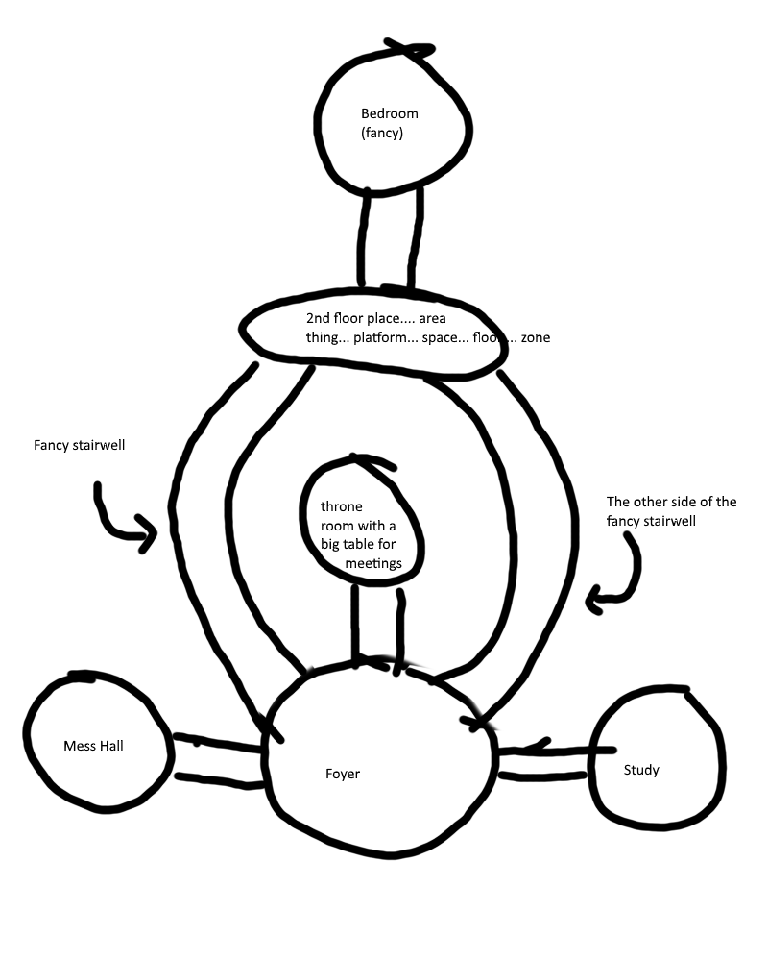
List of assets needed for Lusterford
- General NPC housing (Main District)
    - Wooden frame, Stone walls.
  - Shop Buildings (Trade Districts)
    - Two-story, lower floor is the shop, second floor is the house. (two-story house is going to be most likely optional.)
    - Signs to show what the shop sells (Potions [open for change], Blacksmith [weapons and armor])
      - For the blacksmith have assets that would be in a forge (Furance, anvils, barrels w/water.)
  - A mage temple (Mage District)
    - Two Floors: First floor and Basement
      - First Floor: Library, should be look like a magic lab.
      - Basement: Should look like a magic testing area. Maybe some scorch marks on the wall from failed fire spells, broken vials, papers with symbols on ground.
    - Some special housing npcs. Make it look magical (match the district theme).
  - Castle Art (for the Castle)
    - A Foyer
    - A Study
      - Bookcases
      - Leather Bound Books (good luck)
    - A Mess Hall
      - Tables
      - Dishes
      - Bar (maybe)
    - The Throne Room (Tablecloth Room)
      - A really big table (like an oval)
        - fancy tablecloth is 100% necessary.
      - A Throne.
    - The Kings Bedroom
      - A bed.
      - Windows, A bowls of apples, and a stuffed penguin (maybe his kid left it in there)
    - Fancy Stairs
    - Fancy Rugs
    - Fancy Vase with fancy flowers
    - Fancy Walls
    - Fancy Pillars
  - Barracks (for the Castle District, not the castle.)
    - Beds (not many. This is where officers will be).
    - Possible changing area (can't be in armor all the time.)
  - Training area (a patch of dirt in the Castle District)
    - Training dummies,
    - Targets with arrows in them.
    - Wooden swords in barrels.

Garton

Dungeon Designs

There will be two levels for the dungeon. Both will be maze-like in order to make the player explore. In order to give the player something to navigate them through the forest, there should be somethings that stick out to the player immediately in order to tell them where they are, and that they have been their before. Also there will be treasure hidden throughout the dungeon to reward exploring, just enough to make them do it, but not so much that seems meaningless.
The dungeons will also have a theme for the monsters. The theme for the Forest Dungeon (name subject to change) is giant insects. So, something like flying beetles, giant spiders, huge ants, anything that would live in a forest.
There will also be a mini-boss for the forest, in the form of a Snake Person (Name to be added later). They will be fighting a soon-to-be member of the party, and so the player will help them, and a mini-boss fight will be initiated. There should be a different song from the standard battle music to make the player know that this foe is much stronger and more capable than the previous ones.
The mechanics of the fight will be worked out later.
As the player approaches the second level the aesthetic should begin to change, which should also give a hint as to what lies ahead. The theme in the second level is for there to be a Spider Person (Name to be added later) that was responsible for the corruption of the forest. The level should look like a spider has made its home their, with spider webs that go from tree to tree and the enemies should change to even more spider creatures (preferably not palette swaps, but if needed than do it). The music should also resemble the first level, but be distorted to signify that an ancient evil has made its home in the heart of the woods.
The player will get one more party member and then they will go to fight the boss of the dungeon. The music for this fight should be off-putting, maybe even disturbing. The player should feel fear and intimidation, but also a vague sense of hope. Hopefully that makes sense, but if all else fails, just make some intense boss music that makes the player think, “Ok, that's a boss, but that no problem. I can do this if I try hard enough!”

