Wah Pedal Project

Eric Walden & CJ Tulowiecki

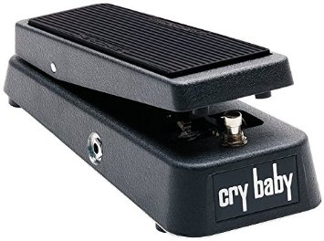

# Summary

# Objectives

The objective of this project is to design and build a digital “wah” pedal effect that can be implemented into a guitar audio processing chain. A “wah” pedal consists of a filter that sweeps its cutoff frequency in response to the movement of the expression pedal by the user. A potentiometer will be used to sense the position of the expression pedal. Different filter models can be used that provide different sound characteristics. Students will initially design one filter model and expand to other filter models if time permits.

# Hardware

# Software

# Test Results

# Lessons Learned

# Final Notes