**INTRODUCTION TO DATABASE**

**SECTION: C**

**PROJECT TITLE: UNIVERSITY MANAGEMENT SYSTEM DATABASE**

**PRESENTED TO: REZWAN AHMED**

**GROUP MEMBER**

|  |  |
| --- | --- |
| NAME | ID |
| MUNTASIR RAHMAN | 20-43763-2 |
| LIMA AKTER | 20-43806-2 |
| SHEK IFTIER ISLAM | 20-43757-2 |

**INTRODUCTION**

A great university management system guarantees improved academic delivery, working efficiency and better student achievements. It provides several advantages for candidates, staff, and the corporation. Because the training panorama is experiencing a constant alternate, it has become essential for universities to apply an innovative college management system to overcome gift and future troubles. There are a lot of benefit from the management system.

Key economic advantages of a university management system:

**1. Time, money and resource saving:** A great university management system gets the student, teacher and staffs to save a lot of amounts of time and resources saving. And it’s a lot more efficient.

**2. E-learning:** The management itself is a great way for learning community. Cause it’ll contain all the data and information of the university. Moreover, there can be notes, results, notice, books and instruction uploading through the managing system.

**3. Improved database:** A great university management contains a great efficient of database system to manage all the data of the system.

**4. Backup:** The data can be backup through clouds or other way. Which makes it more reliable.

**5. Self-service:** This type of management system lets people to have self-service. Such as: enrolment, course choosing, course selection or registration, a portal community for teachers and staff to manage their schedule and develop the system furthermore.

**6. Improved communication:** The management system is a great platform to create a great eternal communication community through the student-teacher portal hub.

**OVERVIEW OF THE MANAGEMENT SYSTEM**

The department table has the information about the department and the faculty members working for the department the table has a unique id D_ID

Every department has many students. To store student information the studet_info table das same attributes the primary key of the table is S_ID and other attributes are S_NAME, D_OF_B, CITY, AGE, C_ID, DEPARTMENT, CGPA.

One student have many courses and one course can be taken by many student so that we have a course table that has attribute C_ID, C_NAME, CREADIT, ROOM_NO here C_ID is the primary key

There is a classroom table to store the information about course schedule and the course instructor it has ROOM_NO, SCHEDULE_, F_ID where ROOM_NO is the primary key

Every department has many faculty member but one faculty member have only one department to work for so we have a table to store information about the faculty members that has a primary key F_ID and other attributes F_NAME, F_EMAIL, F_COURSE, SAL

**ER DIAGRAM**

**NORMALIZATION**

***Table:*** DEPARTMENT (D_ID, D_NAME, FACULTY_MEMBER)

1NF: No multivalued attributes.

2NF:

|  |  |
| --- | --- |
| D_ID | D_NAME |

|  |  |
| --- | --- |
| D_ID | F_ID |

3NF: There is no transitive dependency

|  |  |
| --- | --- |
| D_ID | D_NAME |

|  |  |
| --- | --- |
| D_ID | F_ID |

Finally,

|  |  |
| --- | --- |
| D_ID | D_NAME |

|  |  |
| --- | --- |
| D_ID | F_ID |

***Table:*** STUDENT (S_ID, S_NAME, D_OF_B, CITY, AGE, C_ID, DEPARTMENT, CGPA)

1NF: No multivalued attributes.

2NF:

|  |  |  |  |  |  |
| --- | --- | --- | --- | --- | --- |
| S_ID | S_NAME | D_OF_B | CITY | AGE | D_ID |

|  |  |  |
| --- | --- | --- |
| S_ID | C_ID | CGPA |

3NF: There is no transitive dependency

|  |  |  |  |  |  |
| --- | --- | --- | --- | --- | --- |
| S_ID | S_NAME | D_OF_B | CITY | AGE | D_ID |

|  |  |  |
| --- | --- | --- |
| S_ID | C_ID | CGPA |

Finaly,

|  |  |  |  |  |  |
| --- | --- | --- | --- | --- | --- |
| S_ID | S_NAME | D_OF_B | CITY | AGE | D_ID |

|  |  |  |
| --- | --- | --- |
| S_ID | C_ID | CGPA |

***Table:*** FACULTY(F_ID, F_NAME, F_EMAIL, F_COURSE, SAL)

1NF: No multivalued attributes.

2NF:

|  |  |  |  |
| --- | --- | --- | --- |
| F_ID | F_NAME | F_EMAIL | F_SAL |

|  |  |
| --- | --- |
| F_ID | C_ID |

3NF: There is no transitive dependency

|  |  |  |  |
| --- | --- | --- | --- |
| F_ID | F_NAME | F_EMAIL | F_SAL |

|  |  |
| --- | --- |
| F_ID | C_ID |

Finaly,

|  |  |  |  |
| --- | --- | --- | --- |
| F_ID | F_NAME | F_EMAIL | F_SAL |

|  |  |
| --- | --- |
| F_ID | C_ID |

**FINAL TABLE LIST:**

|  |  |
| --- | --- |
| Table name | atribute |
| department | D_ID, D_NAME |
| faculty_members | D_ID, F_ID |
| student_info | S_ID, S_NAME, D_OF_B, CITY, AGE, D_ID |
| student_courses | S_ID, C_ID, CGPA |
| course_info | C_ID, C_NAME, CREADIT, ROOM_NO |
| class_info | ROOM_NO, SCHEDULE_, F_ID |
| faculty_info | F_ID, F_NAME, F_EMAIL, F_SAL |
| faculty_courses | F_ID, C_ID |

**TABLE CREATION**

**1. department table:**

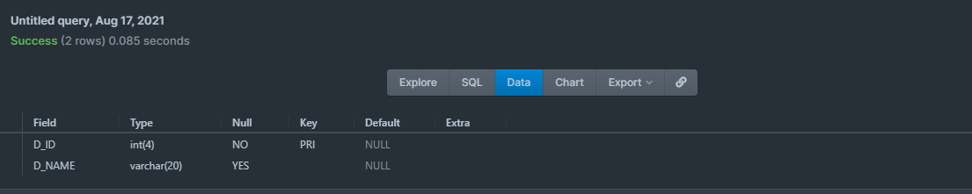

**2. faculty_members table:**

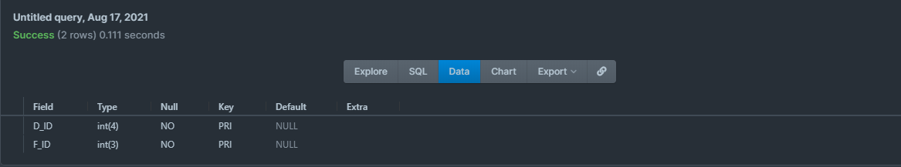

**3. student_info table:**

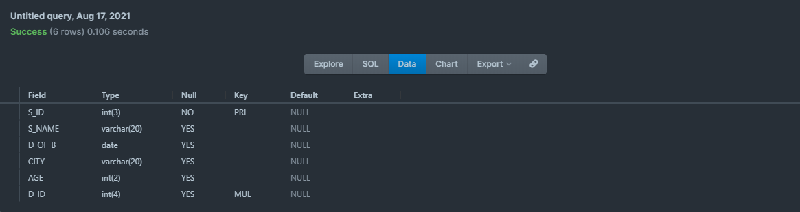

**4. student_courses table:**

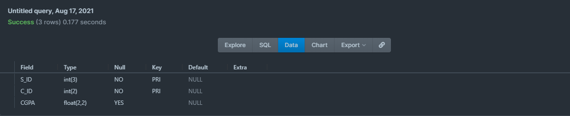

**5. faculty_info table:**

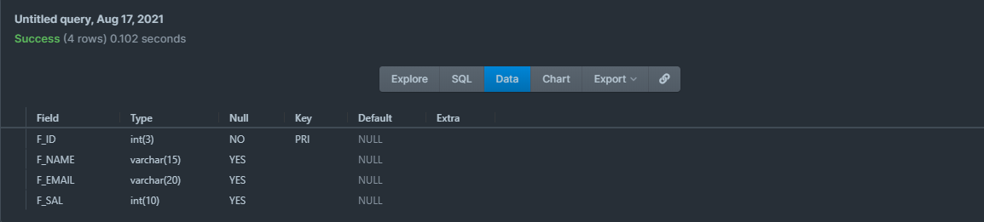

**6. class_info table:**

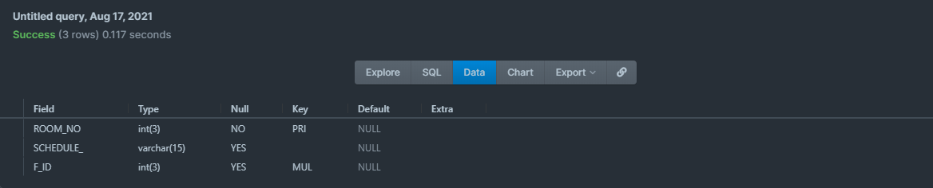

**7. course_info table:**

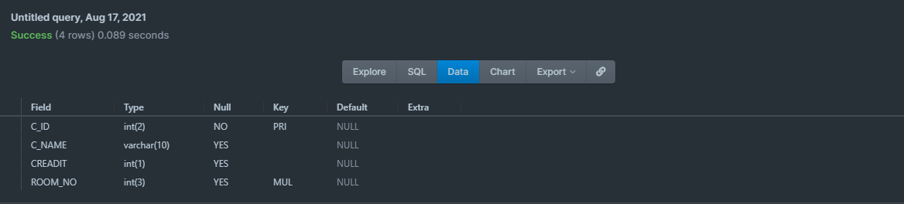

**8. faculty_courses table:**

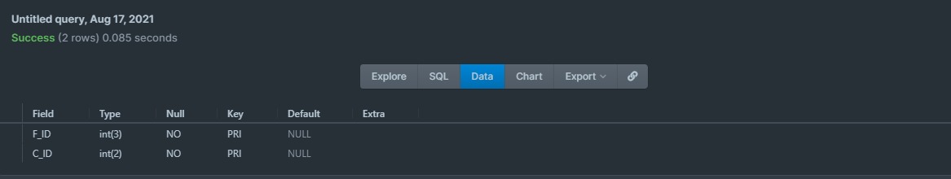

**DATA INSERTION**

**1.department :**

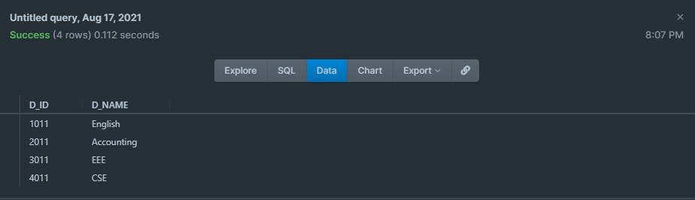

**2.faculty_members :**

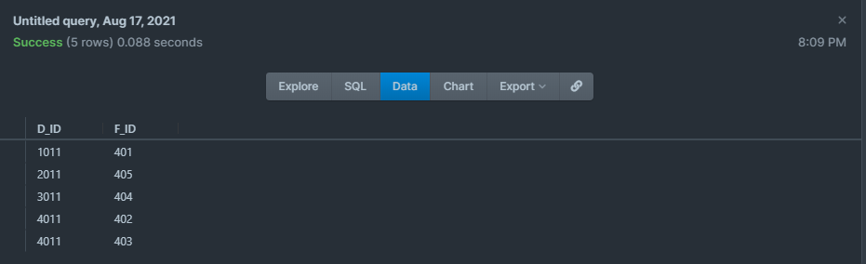

**3.student_info :**

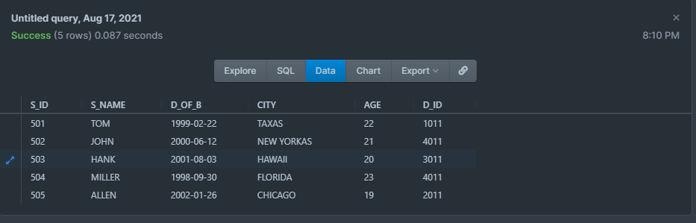

**4.student_courses :**

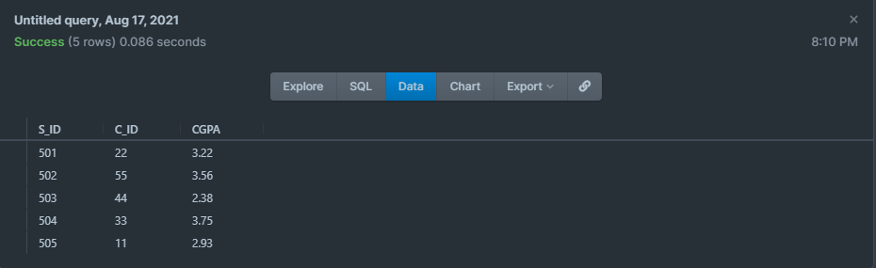

**5.faculty_info :**

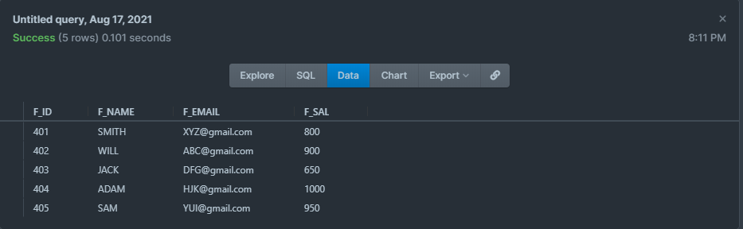

**6.class_info :**

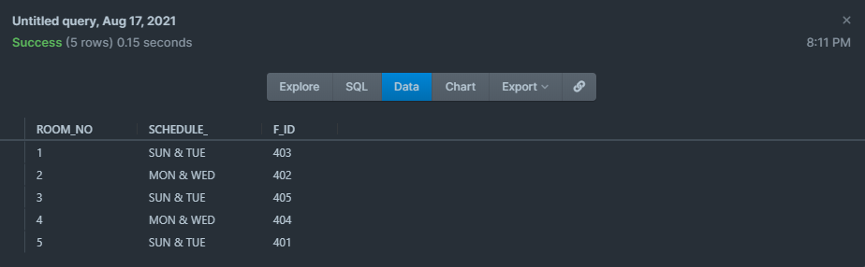

**7.course_info :**

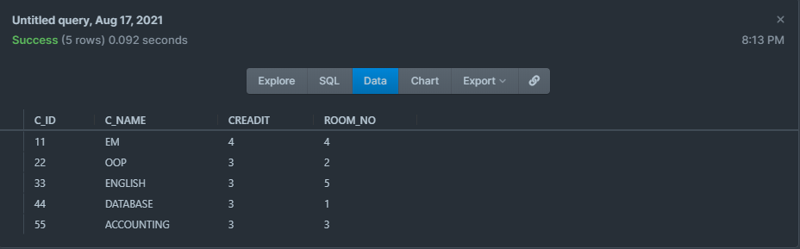

**8.faculty_courses :**

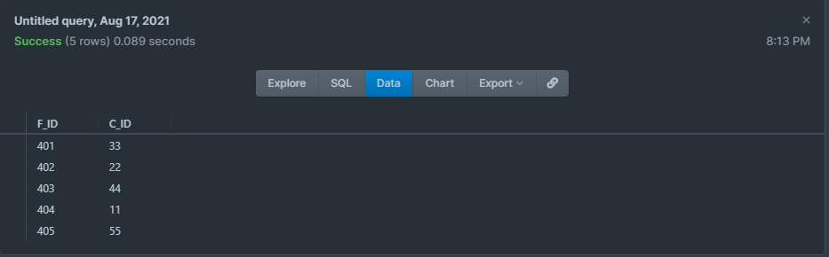

**QUERY**

**-- 1) Show all the student details of the university**

= SELECT *FROM student_info

**-- 2) Show all the student from CSE department**

= SELECT student_info.* FROM student_info,department

WHERE student_info.D_ID = department.D_ID AND D_NAME = 'CSE';

**-- 3) Show all the faculty members of CSE department**

= SELECT *FROM faculty_info

WHERE F_ID IN (SELECT F_ID FROM faculty_members WHERE D_ID = (SELECT D_ID FROM department WHERE D_NAME = 'CSE'))

**--4) Show all the courses available in the university that have not more than 3 credits**

= SELECT *FROM course_info WHERE CREADIT<4

**--5) Show all the courses available in the university**

= SELECT c_name FROM course_info

**--6) Which faculty take class in the room number 002 show his/her details**

= SELECT *FROM faculty_info

WHERE F_ID = (SELECT F_ID FROM class_info WHERE ROOM_NO = 002)

**--7) How many students are in the university show department wise**

= SELECT COUNT(*),D_NAME FROM student_info,department

WHERE student_info.D_ID = department.D_ID GROUP BY D_NAME

**--8) Show the highest paid faculty member**

= SELECT *FROM faculty_info WHERE F_SAL = (SELECT MAX(F_SAL) FROM faculty_info)

**--9) Show the class schedule of faculty id 403**

= SELECT SCHEDULE_ FROM faculty_info,class_info

WHERE class_info.F_ID = faculty_info.F_ID AND faculty_info.F_ID = 403

**--10) Create a view and query the view**

= CREATE VIEW faculty_contact AS

SELECT F_NAME,F_EMAIL

FROM faculty_info;

SELECT * FROM faculty_contact

**PART B:**

From this database project we learned about sql language, ER-Diagrams, Tables, inserting data into tables and Normalization. We also faced some problems while doing normalizations and specially creating the table student_courses in that table there is an attribute that store students cgpa of a particular subject, for that we have to create a Colom so that it can hold double type variable but by mistake we created the column with wrong data type [float (size, d)] as a result we had to face some problem while inserting data in to that table after realizing the mistake we had to use altar table command to modify the data type. In the end we have achieved skills on creating ER-Diagrams and Normalizing. From this particular project we have learned new things and in the near future, we can develop more advanced management systems.