CS2111 Final Project Summary
INSTRUCTIONS: Type out your answer directly below each question. If a question does not apply to your project, type in N/A. When finished, save this file as a PDF and upload it to the Blackboard.

BASICS
Your group members?
- Afnan Kamel - S2208066
- Aya Mohammed - S21207588
- Jana Mufti - S21106991
- Afrah Bashaddadah - S22107697
What is the topic of your final project?
This is an Anime Streaming/Database Platform called "OTAKU METER" that allows users to browse, rate, and manage their anime watchlist.
Who is the intended audience?
Anime fans and enthusiasts who want to:
- Discover new anime content
- Track their watchlist
- Rate and comment on shows
- Engage with other anime fans
Provide a brief summary of the functionalities of your project.
OTAKU METER is a dynamic anime platform that provides secure user authentication with password hashing and session management. The interface features a responsive home page with carousels and grid layouts displaying anime content. Users can search for content in real-time and manage their personal watchlist. The platform includes a rating and comment system with a 10-star rating scale. Security is implemented through CSRF protection and SQL injection prevention, while the user experience is enhanced by responsive design and notification systems.
Detailed Functionality Breakdown:
- User Management System
- User registration with validation
- Secure login with session handling
- Password hashing for security
- Session timeout handling
- Logout mechanism
- Profile update functionality
- Content Display and Navigation
- Home page with anime carousel
- Series and movies sections
- Grid-based content layout
- Responsive navigation system
- Search System
- Real-time search functionality
- Title-based anime search
- Results displayed in dropdown
- Debounced search implementation
- Error handling for searches
- Watchlist Management
- Add/remove anime from watchlist
- Real-time watchlist updates
- Current watchlist status display
- Empty watchlist state handling
- Rating and Review System
- 10-star rating system
- Comment submission and display
- Average rating calculation
- Comment deletion functionality
- Timestamp display for comments
- Interactive Interface
- Modal windows for anime details
- Dynamic content loading
- Notification system
- Mobile-responsive design
- Animated transitions
- Profile update interface
- Database Integration
- Secure MySQL connections
- Prepared statements
- Basic error handling
- Data validation
- Backend Endpoints
- Comment submission and retrieval
- Watchlist management
- Search functionality
- User authentication
- Profile update handling
- Security Features
- CSRF protection
- Input validation
- SQL injection prevention
- Session security
- Password hashing
- Profile update security
- Interface Design
- Responsive design
- Loading states
- Error messages
- Success notifications
- Form validation feedback
FRONT-END
What is the total page count?
Total Page Count: 4 pages
- Login/Signup (users.php)
- Home (Home.php)
- Series (series.php)
- Movies (movies.php)
List the names of any external stylesheet used in this project below.
- styles.css - Main site styling and layout
- user.css - Login/signup page styling
List any CSS libraries/frameworks used in this project (e.g. Bootstrap) below.
- Bootstrap 5.3.3 - Core framework for responsive layout
- Font Awesome 6.0.0-beta3 - Icon library
- Boxicons - Additional icon library
List any JavaScript libraries/frameworks used in this project below.
- Bootstrap JS Bundle - Core Bootstrap functionality
- Custom JavaScript Files:
- Home1.js - Home page interactions
- series.js - Series page functionality
- movies.js - Movies page functionality
How does your project meet the Interactivity requirement?
- Dynamic Content Loading
- Carousel navigation with smooth transitions
- Real-time search functionality with instant results
- Dynamic watchlist updates without page refresh
- User Interactions
- Interactive comment system with real-time updates
- 10-star rating system with visual feedback
- Add/remove watchlist functionality
- Add/delete comments functionality
- Modal windows for detailed anime information
- Search functionality with debounced input
- Profile update system with real-time validation
- Form Validation & Handling
- Login/Signup form validation
- Comment submission and management
- Search input handling
- Error state management
- Profile update validation
- Visual Feedback
- Notification system for user actions
- Loading states during operations
- Animated transitions for UI elements
- Interactive button states and hovers
- Data Management
- Real-time comment updates
- Dynamic watchlist management
- Search result filtering
- Rating calculations and updates
- Profile information management

BACK-END
Attach a screenshot of the final database diagram (just the diagram, do not include any records) below.
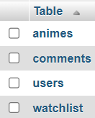
- Tables:

- Animes:
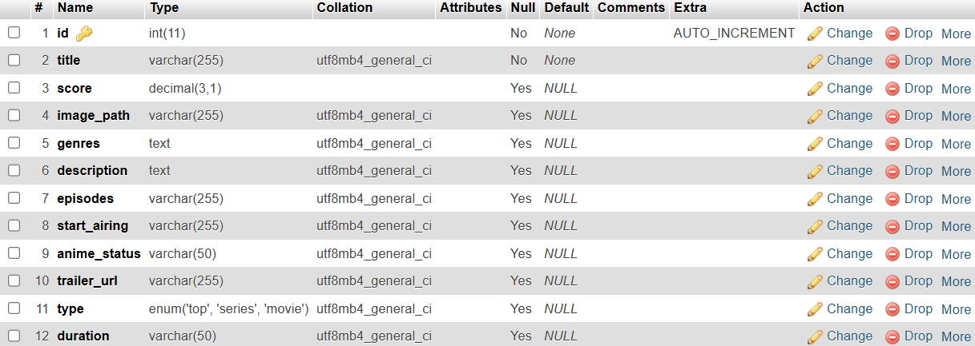

- Comments:
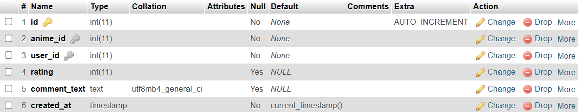

- Users: We encrypted the passwords.
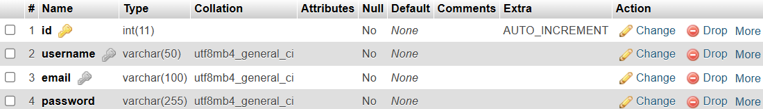
- Watchlist:
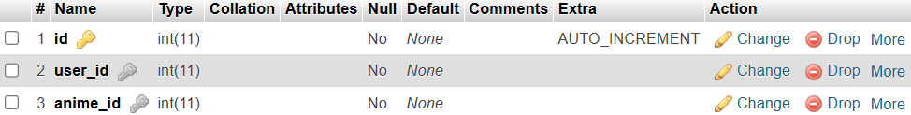

Where in your project do you insert a record to the database (the ‘C’ in CRUD)?
Records are inserted into the database in three main locations in the project:
- User Registration (users.php)
  - Creates new user accounts when people sign up
  - Inserts username, email, and hashed password into user’s table
- Comment System (submit_comment.php)
- Adds new comments when users review anime
- Inserts anime_id, user_id, rating, and comment text into comments table
- Watchlist Management (update_watchlist.php)
- Creates watchlist entries when users add anime to their list
- Inserts user_id and anime_id into watchlist table
Where in your project do you search and display record(s) from the database (the ‘R’ in CRUD)?
Key locations where records are searched and displayed from the database:
- Home Page (Home.php):
  - Displays animes by type (top 10, series, movies)
  - Retrieves user's watchlist items
- Comments System (get_comments.php):
- Retrieves comments for specific anime
- Shows user ratings and timestamps
- Search Functionality (search.php):
- Searches anime titles based on user input
- Displays matching anime details
- Watchlist Display (get_watchlist.php):
- Displays user's saved anime list
- Shows watchlist items with details
- User Authentication (users.php):
- Verifies login credentials
- Retrieves user information for session
Where in your project do you update and existing record(s) the database (the ‘U’ in CRUD)?
- Profile Update (users.php):
- Allows users to update their account information
- Updates username and email details
- Optional password update functionality
- Uses UPDATE queries to modify user records
Where in your project do you delete existing record(s) from the database (the ‘D’ in CRUD)?
There are 2 locations where records are deleted from the database:
- Watchlist Management (update_watchlist.php):
- Deletes anime from user's watchlist when they remove it
- Uses DELETE query to remove the watchlist entry
- Comment System (delete_comment.php):
- Allows users to delete their own comments
- Removes the comment record from the database
MISC
If your project requires any admin credentials (i.e. only admin users can access a certain page), list the credentials below.
N/A: An administrative system was not required for this project as all users have equal access to features after logging in. The platform is designed to be self-managing through user authentication and accountability, with pre-populated anime content eliminating the need for content management.
Provide any other information that you think the grader/instructor should know when grading your final project below.
The following technical overview demonstrates how OTAKU METER implements modern web development practices and user-centric design principles through its architecture and feature set.
- Core JavaScript Files:
- Home1.js - Main page interactions and carousel
- series.js - Series catalog and grid management
- movies.js - Movies interface and interactions
- Key Features:
- Real-time search with debouncing for performance
- Dynamic star rating system (1-10 scale)
- Interactive watchlist management
- Live comment updates
- Animated notifications
- Notable Technical Implementations:
- CSRF protection for security
- Prepared statements for database queries
- Session management
- Mobile-first responsive design
- Modern CSS with custom variables
- Error handling across all operations
- Transaction management for data integrity
- Framework Integration: The project utilizes custom modular code architecture for easier maintenance and future scalability, supported by:
- Bootstrap for responsive layouts
- Font Awesome and Boxicons for icons

Screenshots
- Login, sign in, and update profile pages:
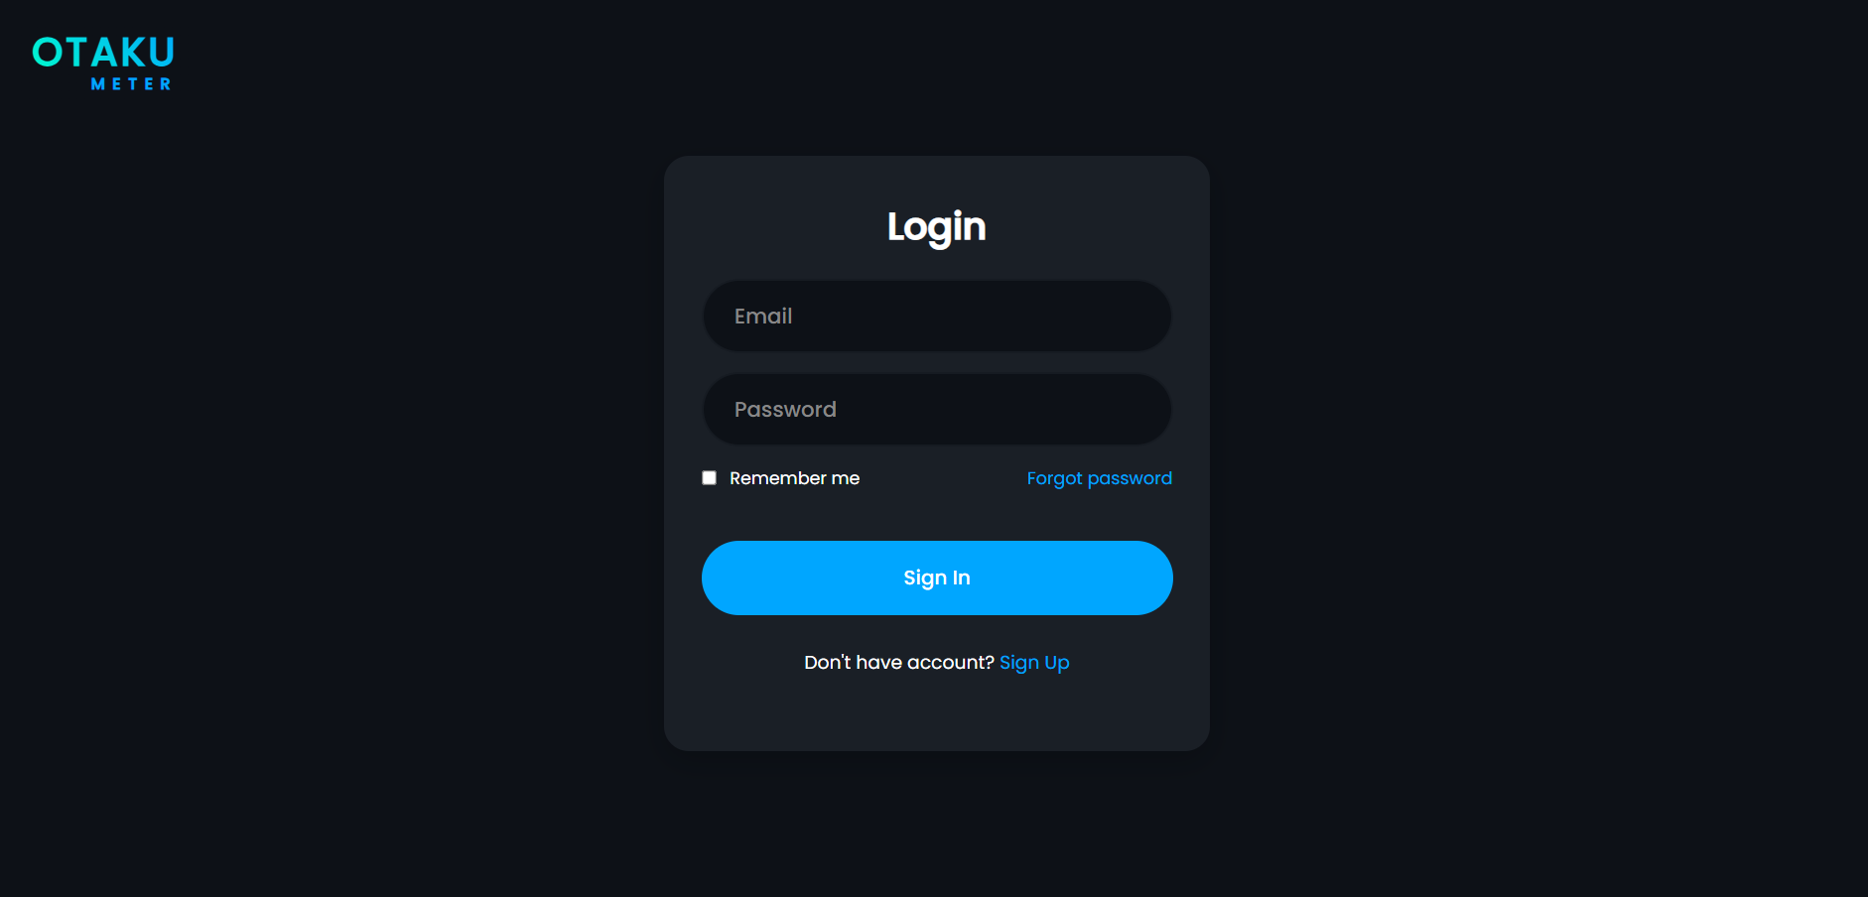

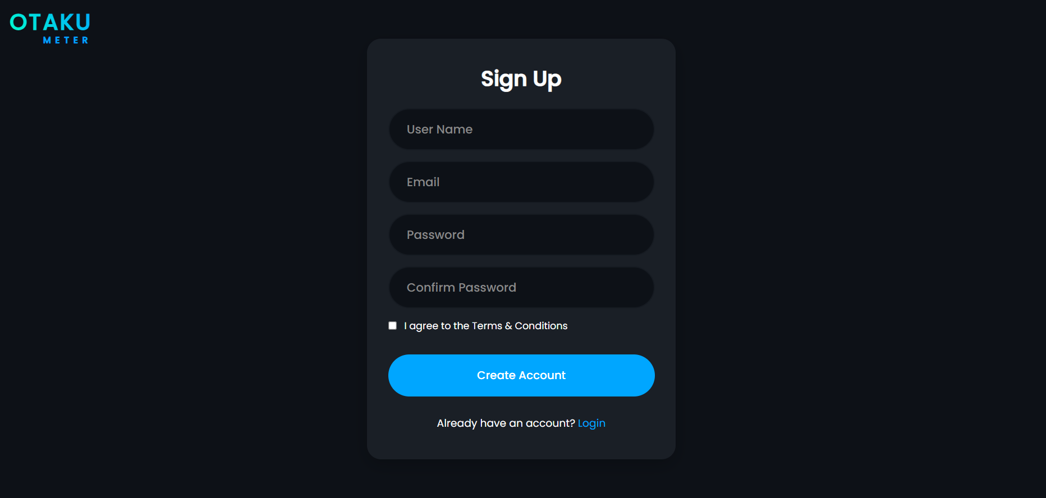

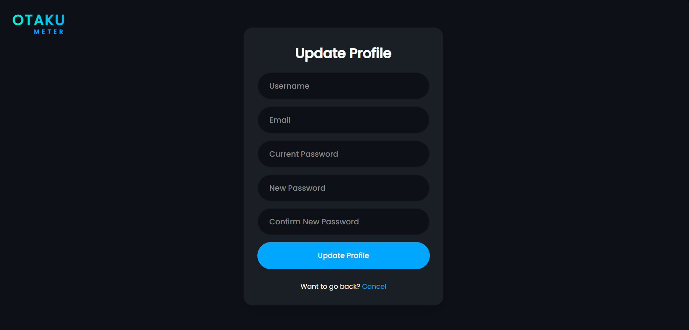

- Footer:


- Navbar and front page:


- Cards of the top 10, watchlist, series, and movies:

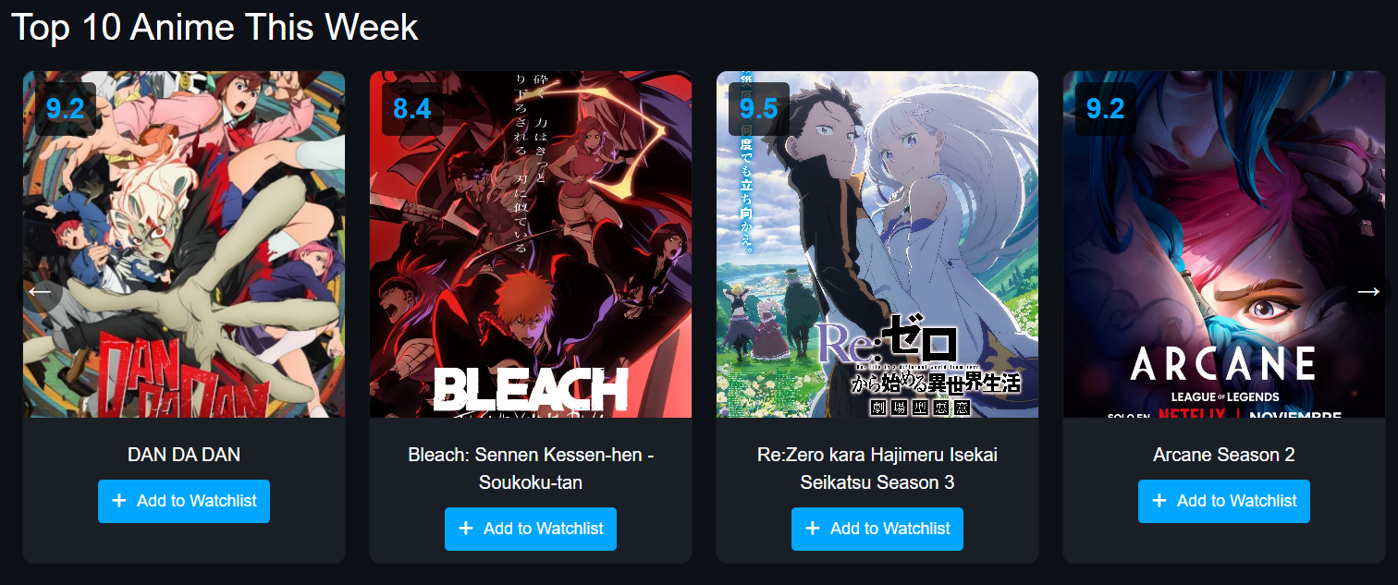

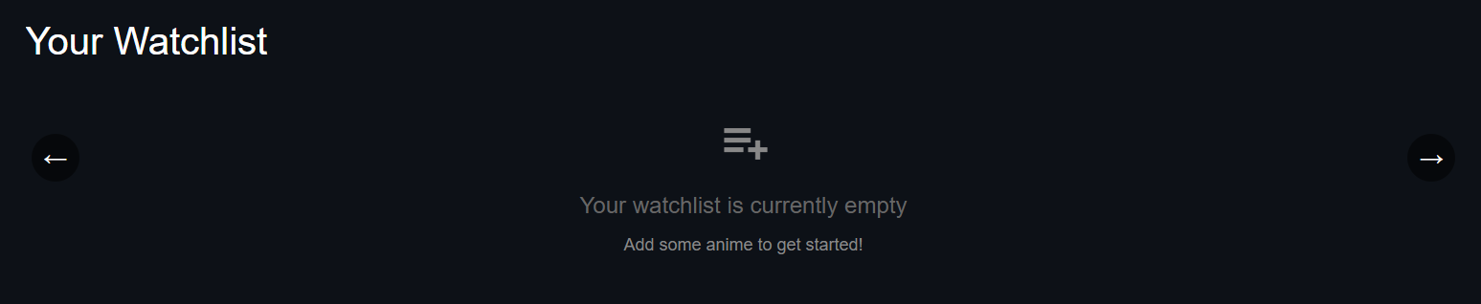





- One of the popups of the animes with the comment section and rating feature:

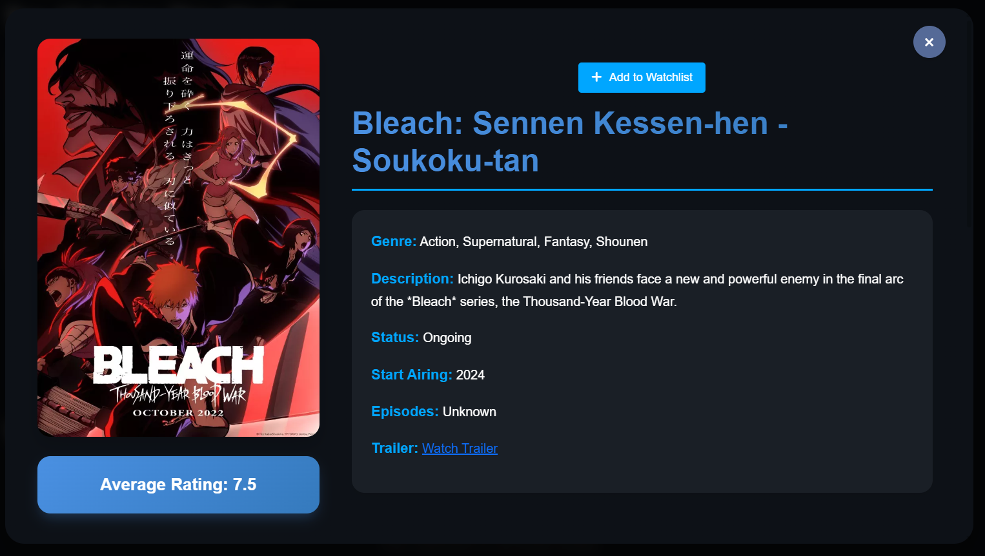

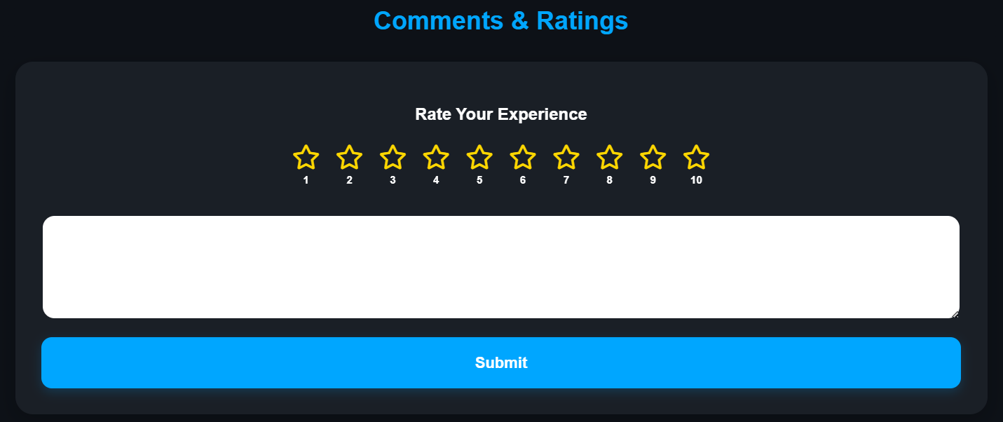

- Series and movies pages:
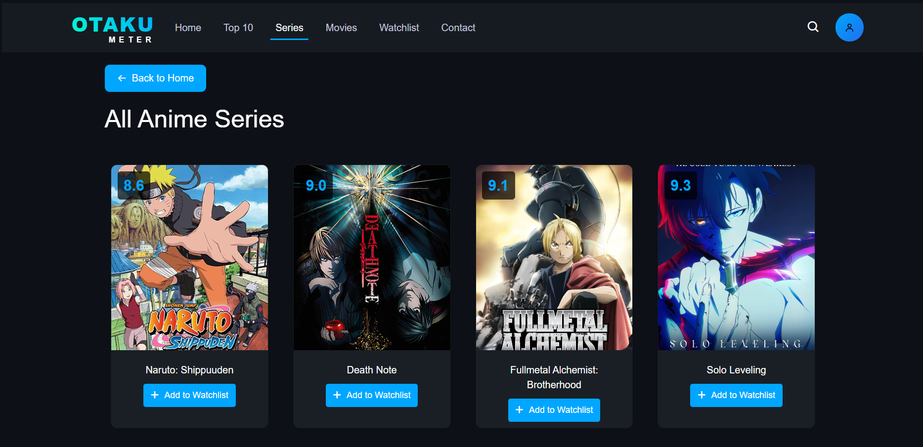

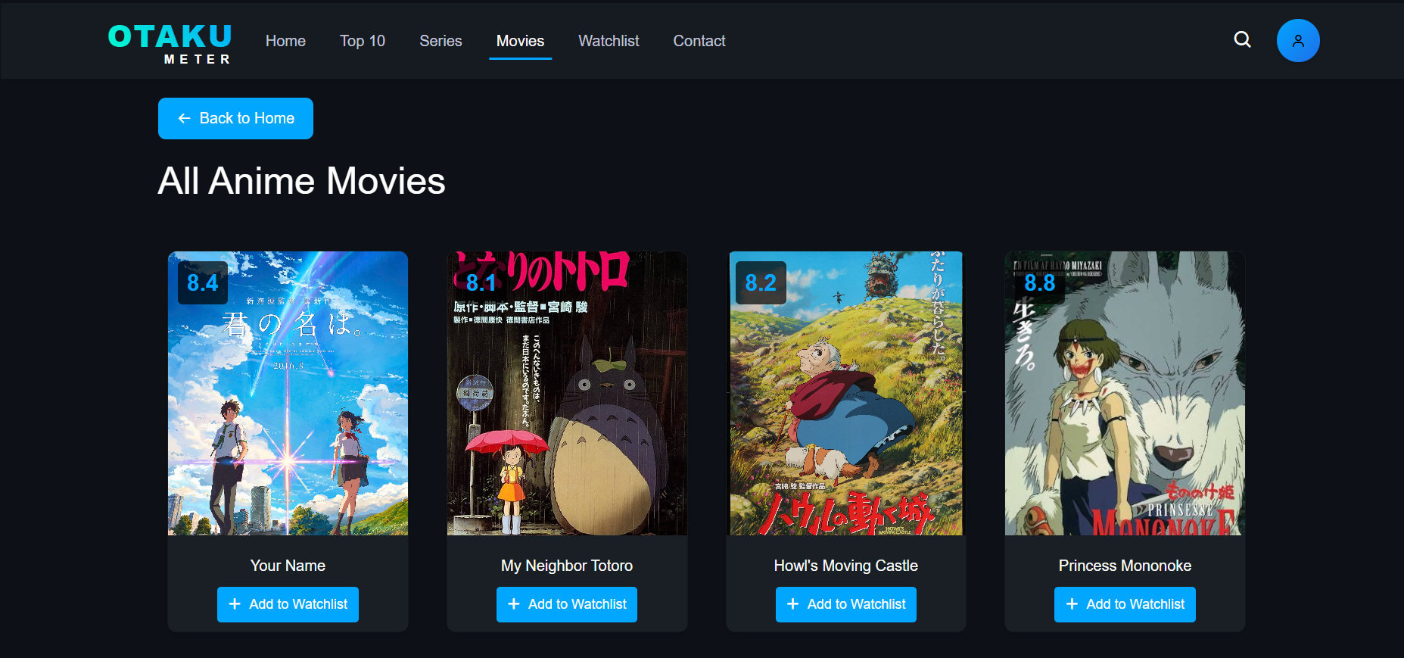

- Some of the comments:
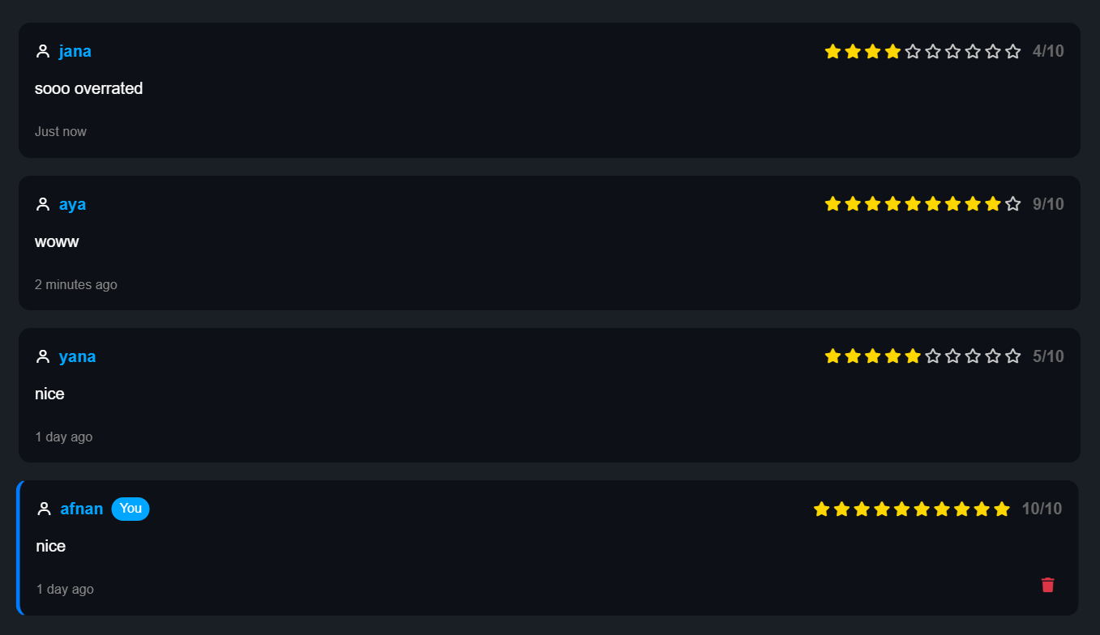

- Search toggle:
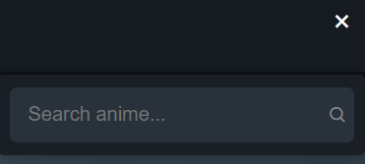

- Profile toggle and update profile:

