
Department of Computer Science & Engineering

Software Requirement Specification

Course Code – CSE 3411
Course Title – System Analysis & Design
Project Title – EmpowerHub

Submitted To
Didarul Islam Didar
Lecturer, Dept. of CSE, UIU

Submitted By
Team Incredible
Afnan Shahriar – 011213001 Md. Habibullah – 011221260
Tamanna Islam – 011221318 Md. Jana Alam – 011221353
Nazmul Alam – 0112230914 Khondokar Marzia – 0112310464

Date of Submission – 21th October, 2025

Abstract
EmpowerHub is an innovative e-learning platform aimed at redefining the learning experience by combining education, collaboration, and well-being. The platform allows learners to acquire diverse skills from professional instructors while also engaging in peer-to-peer knowledge exchange through a unique credit-swapping system. Beyond skill development, EmpowerHub addresses the vital aspect of mental health by providing access to professional counseling services. It integrates a variety of features such as course offerings, online software tools, skill matchmaking, nearby instructor discovery, community forums, review and rating mechanisms, and a reward badge system to foster active participation. The platform supports five interconnected roles—students, instructors, organizations, counselors, and administrators—working collaboratively to create a holistic and engaging learning ecosystem.

Acknowledgement
We would like to express our deepest gratitude to all those who supported and guided us throughout the development of EmpowerHub. Our sincere thanks go to our respected faculty members for their valuable advice, encouragement and constructive feedback during each stage of this project. We are also grateful to our peers and friends who shared insightful suggestions and inspired us to refine our ideas. Finally, we acknowledge the collaborative effort of our team members, whose dedication, creativity and commitment made this project possible.

1 Introduction
1. 1 Overview
EmpowerHub is an innovative e-learning platform designed to empower learners with the opportunity to acquire diverse skills from experienced instructors. In addition to learning, the platform fosters collaboration by enabling learners to exchange their skills with others through a unique credit-swapping system. Recognizing the importance of mental health in the learning journey, EmpowerHub also provides access to mental counseling services from professional counselors.
The platform offers a rich variety of courses, online software products, skill matchmaking, and finding nearest instructors, forums, review-rating mechanisms, and a reward badge system to encourage engagement and recognize achievements. Five distinct roles work collaboratively to drive the platform: students, instructors, organizations, counselors, and administrators.
1.2 Problem Statement
Modern e-learning platforms often focus solely on content delivery, overlooking critical aspects such as community collaboration, learner mental health, and personalized engagement. Traditional models lack effective mechanisms for learners to monetize their skills or gain recognition for their contributions. Additionally, the absence of integrated mental health support can leave learners feeling isolated or demotivated during their educational journey.
1.3 Objective
The primary objective of EmpowerHub is to create a holistic and inclusive e-learning ecosystem where:
- Learners can develop and skill exchange
- Mental health support is seamlessly integrated
- A community driven environment encourages collaboration, growth and recognition.
- Organizations can upskill their workforce efficiently.
1.4 Motivation
The motivation behind EmpowerHub stems from the growing demand for personalized, community-driven learning solutions that cater to both skill development and emotional well-being. By addressing these needs, EmpowerHub aims to stand out as a transformative platform, bridging gaps in the e-learning space while fostering a sense of belonging and achievement for its users.

2 System Development Life Cycle (SDLC)
The development of EmpowerHub follows the System Development Life Cycle (SDLC), ensuring a structured and systematic approach to building the platform. The steps are outlined below:
2.1 Planning
In this phase, the project scope, objectives, and resources were identified. The primary goal was to design an e-learning platform that integrates skill development, collaboration and mental health support. Stakeholders, including students, instructors, organizations, counselors and administrators, were identified as the core users of the system.
2.2 System Information
Detailed requirements were collected through surveys, interviews and document reviews. Both functional (course enrollment, credit-swapping, counseling booking, forums, reward system) and non-functional requirements (security, scalability, user-friendliness) were gathered.
2.3 Analysis
The collected requirements were analyzed to identify gaps in existing e-learning platforms and to ensure that EmpowerHub addresses critical needs such as collaboration, recognition and mental health integration. Feasibility in terms of technology, finance and user adoption was also assessed.
2.4 Design
The system design phase involved creating architectural blueprints and interface mockups. The design covered:
- Database schema using MySQL.
- Front-end interface with HTML, CSS, Tailwind and Bootstrap for responsiveness.
- Backend workflows using PHP for server-side logic.
- User roles and permissions (students, instructors, organizations, counselors, administrators).
2.5 Development/Coding
The system was developed using the chosen technologies. Frontend modules (course pages, forums, dashboards) and backend modules (credit-swapping engine, counseling scheduling, admin panel) were coded in alignment with the design documents.
2.6 Testing
Unit testing, integration testing and user acceptance testing (UAT) were conducted. Test cases ensured correct implementation of functionalities like course enrollment, credit transactions, counseling booking and review-rating mechanisms. Security and performance testing were also prioritized.
2.7 Deployment
The platform was deployed on a secure hosting server, making it accessible to the intended user groups. Necessary configurations for scalability, load balancing and security were set up during this stage.
2.8 Post-implementation & Maintenance
Continuous monitoring and maintenance ensure bug fixes, system updates and new features to make enhancements. User feedback loops (via surveys and forums) are established to refine the system and improve user experience over time.
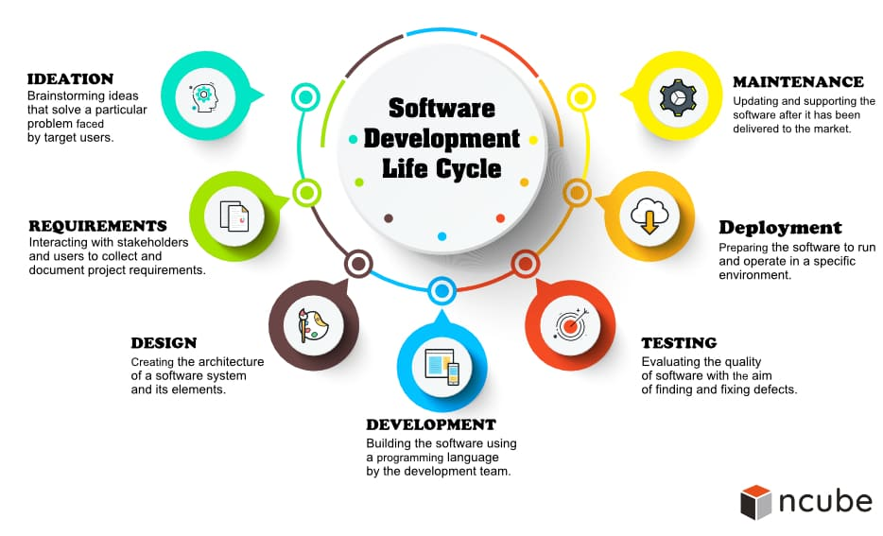

3 Requirement Analysis
3.1 Vision
To become the leading e-learning platform that not only empowers individuals with skills but also fosters a collaborative, supportive, and mentally enriching learning environment.
3.2 Mission
- Providing high quality, diverse courses led by experienced instructors.
- Introducing innovative mechanisms like credit swapping for skill exchange.
- Integrating mental health support as a core component of the learning process.
- Encouraging community engagement through forums, reviews, and rewards.
- Ensuring seamless interaction and coordination among students, instructors, organizations, counselors, and administrators.
3.3 Goals
- Develop a user-friendly platform with robust features such as course enrollment, credit swapping, and mental health appointment scheduling.
- Provide tools for instructors to create and manage engaging courses.
- Implement reward mechanisms to enhance user motivation.
- Build a secure and scalable system capable of handling large volumes of users and data.
- Foster a supportive community through active forums and transparent review systems.
3.4 Information Sources
To gather requirements for EmpowerHub, only external information sources were used.
- External Sources: Market research reports, literature reviews on e-learning trends, competitor platform analysis and professional counselor networks.
3.5 Information Gathering Tools
The following tools and techniques were used to gather system requirements:
- Review of Documents, Procedures and Forms – Analyzing existing e-learning systems and academic records.
- Interviews – Conducting discussions with students, instructors and counselors to identify their needs.
- Questionnaires – Distributing surveys to potential users for broader input.
- Online Sources – Benchmarking existing platforms, studying research papers and reviewing forums/blogs for best practices.

3.6 Benchmark Analysis
For the benchmark study we collected data from 9 similar platforms. These platforms are: Skillshare, Udemy, Coursera, LinkedIn Learning, BetterHelp, Calm, Headspace, Talkspace, Duolingo

Following is our conducted benchmark analysis:
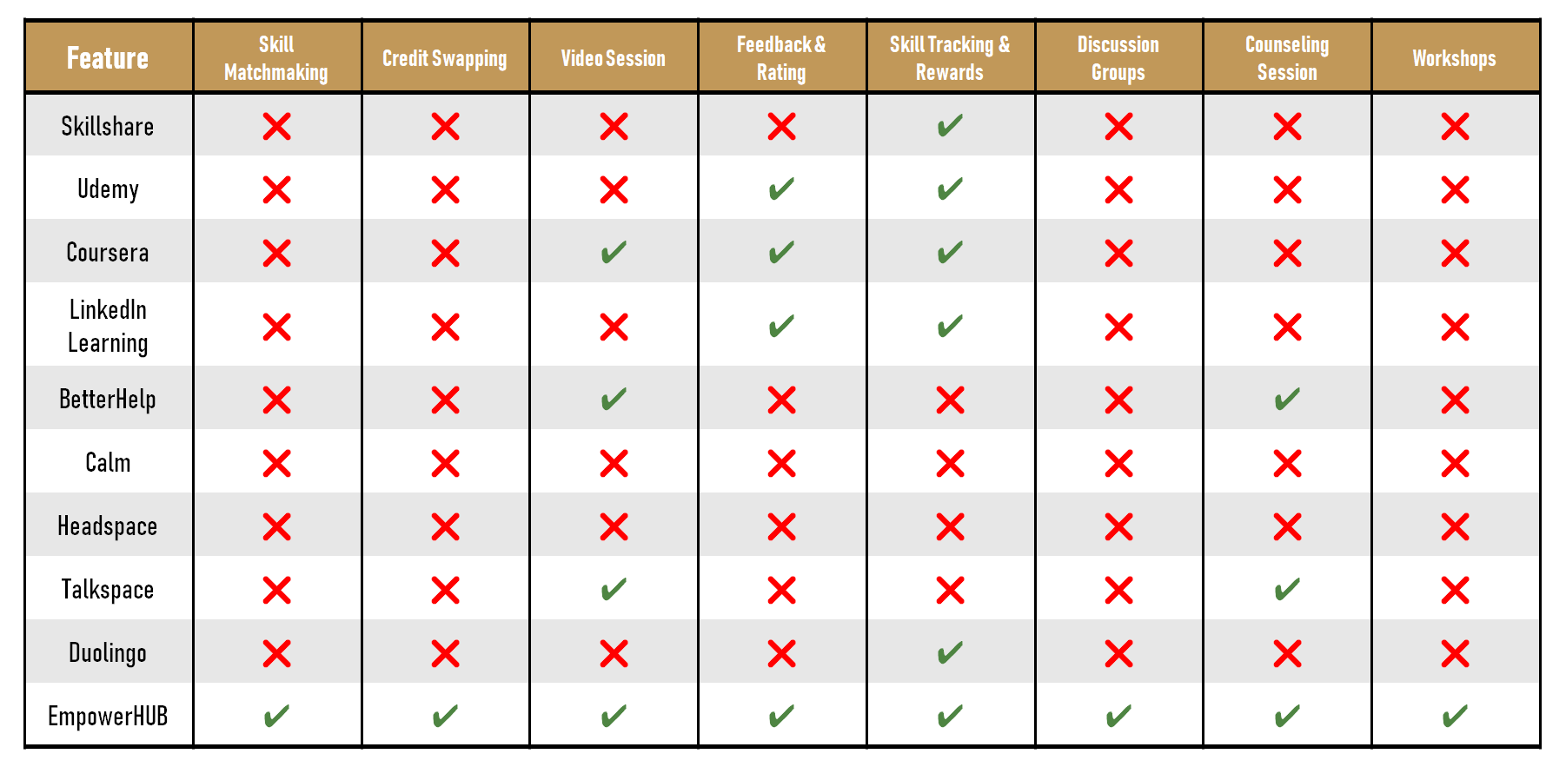
3.6 Gap Analysis
From the above benchmark analysis, we have encountered some of the common problems that users usually face during in a learning process. In this segment, we have described all of the gaps and show some solutions to remove the gaps as well.
3.6.1 Current Challenges
- Limited opportunities for learners to exchange their skills or gain recognition.
- Lack of integrated mental health support in traditional e-learning platforms.
- Ineffective reward systems that fail to motivate learners or track progress effectively.
- Minimal collaboration among various stakeholders (students, instructors, organizations, counselors, and admin).
3.6.2 Desired State
- A platform where learners can not only gain skills but also exchange them seamlessly.
- Integrated mental health services accessible to all learners.
- Comprehensive reward and recognition systems to celebrate milestones and contributions.
- Strong community engagement through forums and other interactive tools.

3.6.3 Approach to Bridge the Gap
- Design and implement a credit-swapping mechanism to enable skill exchange.
- Partner with certified mental health counselors for seamless appointment scheduling.
- Develop an intuitive interface with robust functionalities for each user role.
- Introduce inspiring elements like reward badges and to encourage participation and excellence.
- Build a scalable infrastructure to support a growing user base while maintaining data security and performance.
3.7 Feature List Fixation
After the benchmark and gap analysis, we have decided to fix the following features:
- Skill Matchmaking: Allow users to create profiles showcasing skills
- Discussion Groups: Community focused group discussion
- Credit Swap: Balanced exchange of learning and teaching
- Feedback & Rating: After each exchange, users can provide feedback
- Skill Progress & Rewards: Motivate users with badges & milestones
- Finding Instructors: Students can find instructors by matching their provided locations
- Counseling Session: Mental wellness check-ins, resources & suggestions

4 Feasibility Analysis
The feasibility of EmpowerHub was examined in multiple aspects to ensure successful implementation:
4.1 Technical Feasibility
Our web project is built with the cool quartet - HTML, CSS, Tailwind and JavaScript, spiced up with Bootstrap for that extra style and responsiveness. On the back end, we’ve got PHP for specific tasks. We use MySQL as our database.
4.2 Economic/Financial Feasibility
The project is cost-effective as it uses open-source technologies like HTML, CSS, Tailwind, Bootstrap, PHP and MySQL, reducing software licensing costs. Hosting and maintenance expenses are manageable within projected budgets.
4.3 Human Resources Feasibility
The project team possesses the necessary expertise in web technologies, database management and UI/UX design. Additional support from mental health professionals and instructors ensures holistic system functionality.
4.4 Behavioral/Market Feasibility
There is strong demand for platforms that blend skill development with mental health support. Current trends in online learning show increased interest in community-driven platforms, ensuring high adoption potential.
4.5 Legal/Political Feasibility
The system complies with copyright laws, privacy regulations and user data protection standards. Counseling services are aligned with professional ethics and legal guidelines for mental health support.
4.6 Schedule Feasibility
The project timeline is realistic, with SDLC phases mapped out and tasks distributed among team members. Agile methods ensure timely progress and adaptability to changes.
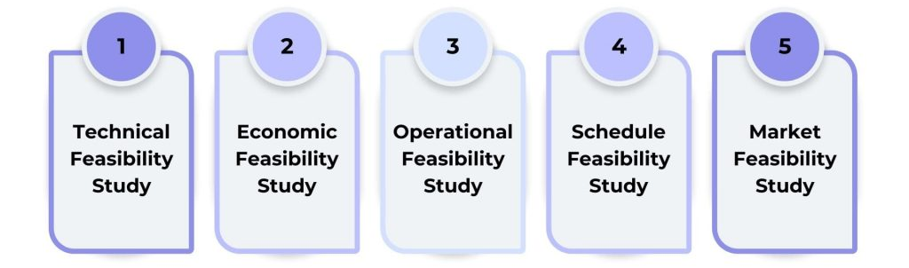

5 SWOT Analysis
Here is the detailed strength, weakness, opportunities and threats that can be faced to implement the project by the time.
5.1 Strengths
- Unique credit-swapping system for skill exchange.
- Integration of mental health support for learners.
- Diverse roles ensuring comprehensive functionality.
- Reward and recognition mechanisms enhancing engagement.
5.2 Weakness
- Initial development may be resource-intensive.
- Requires high-quality mental health professionals and course instructors.
- Dependence on user activity for community-building features.
5.3 Opportunities
- Growing demand for personalized e-learning platforms.
- Potential partnerships with organizations for workforce upskilling.
- Expansion into niche skill areas and global markets.
5.4 Threats
- Competition from established e-learning platforms.
- Privacy and security concerns for user data.
- Reliance on user retention and engagement for success.

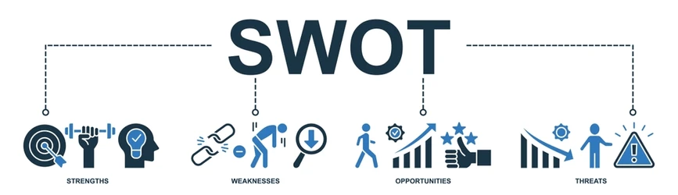

6 Cash Flow
Following is the breakdown of our revenue and expenses and then our cash flow analysis (in $dollar) for 2 years, where each column represents a quarter of a year, i.e. 3 months.
6.1 Revenue Calculation
The major revenue heads that we considered are:
- Course Subscriptions (individual learners)
- NGO Partnerships (bulk course purchases for their beneficiaries)
- Government Funding (education grants and skill-building initiatives)
- Advertisements (promotional slots on the platform)
Quarters | Year 1 |  |  |  | Year 2
Quarters | Q1 | Q2 | Q3 | Q4 | Q5 | Q6 | Q7 | Q8
Course Subscriptions | 15k | 18k | 22k | 30k | 35k | 40k | 50k | 60k
NGO Partnerships | 10k | 12k | 15k | 20k | 25k | 30k | 35k | 40k
Government Funding | 25k | 25k | 25k | 25k | 25k | 25k | 25k | 25k
Advertisement | 5k | 7k | 8k | 10k | 12k | 15k | 18k | 20k
Total Revenue | 55k | 62k | 70k | 85k | 97k | 110k | 128k | 145k

6.2 Expense Calculation
Likewise, major expense heads are mentioned below:
- Development Costs (initial platform setup, feature upgrades)
- Marketing (social media ads, outreach campaigns, partnerships)
- Instructor Fees (course content creation and delivery)
- Hosting & Operations (server costs, IT support)
- Administrative Costs (staff salaries, office expenses)
Quarters | Year 1 |  |  |  | Year 2
Quarters | Q1 | Q2 | Q3 | Q4 | Q5 | Q6 | Q7 | Q8
Development Cost | 20k | 15k | 10k | 5k | 5k | 5k | 5k | 5k
Instructor Fees | 8k | 10k | 12k | 15k | 18k | 20k | 25k | 30k
Marketing | 5k | 6k | 8k | 10k | 12k | 15k | 18k | 20k
Hosting & Operations | 5k | 6k | 7k | 8k | 9k | 10k | 11k | 12k
Administrative Costs | 10k | 10k | 12k | 12k | 12k | 12k | 12k | 12k
Total Expense | 48k | 47k | 49k | 50k | 56k | 62k | 71k | 79k
6.3 Cash Flow Analysis
Quarters | Year 1 |  |  |  | Year 2
Quarters | Q1 | Q2 | Q3 | Q4 | Q5 | Q6 | Q7 | Q8
Total Revenue | 55k | 62k | 70k | 85k | 97k | 110k | 128k | 145k
Total Expense | 48k | 47k | 49k | 50k | 56k | 62k | 71k | 79k
Net Cash Flow | 7k | 15k | 21k | 35k | 41k | 48k | 57k | 66k
Cumulative Cash | 7k | 22k | 43k | 78k | 119k | 167k | 224k | 290k
6.4 Net Present Value Calculation
Assuming a 10% annual discount rate (2.5% per quarter)
NPV = $\sum_{t=1}^{8}{\frac{{(Net Cash Flow)}_{t}}{{(1+r)}^{t}}}$
NPV = $7,000 + $14,634 + $20,001 + $32,731 + $38,704 + $44,222 + $51,343 + $58,145
= $266,780
From the above NPV calculation, we can assure that the profit is positive ($266,780), and cumulative cash flow consistently grows, confirming that the project’s revenue exceeds expenses. The project is financially viable and should be pursued.

7 System Design
7.1 Context Diagram
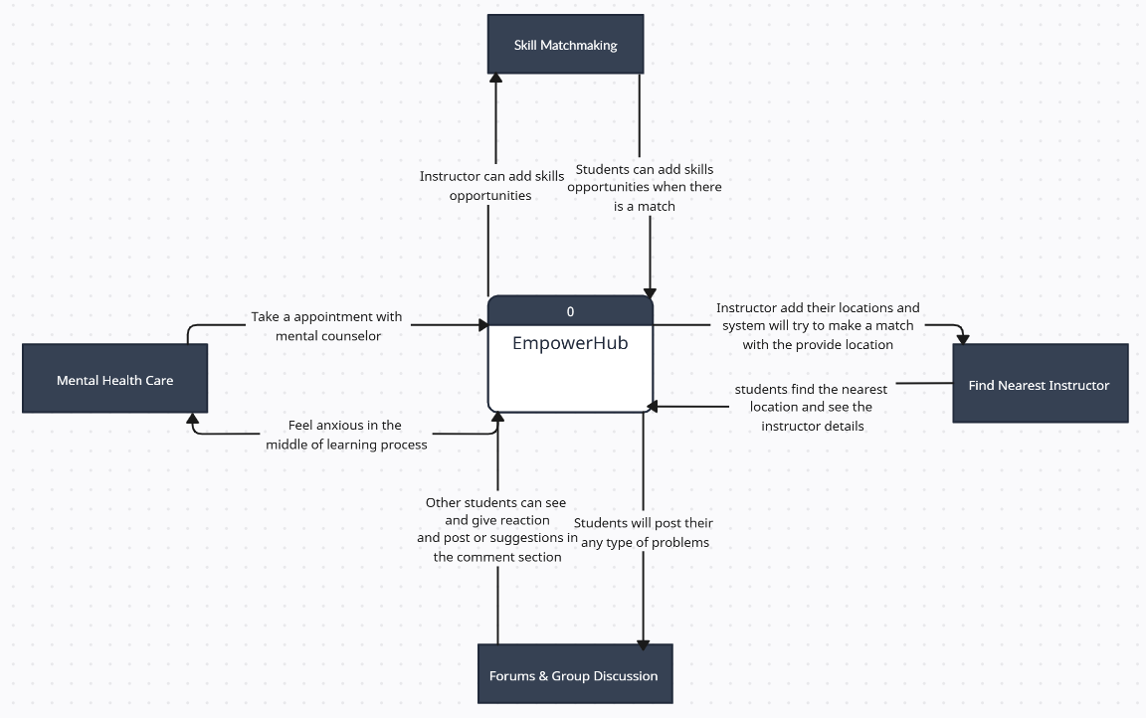
7.2 Data Flow Diagram
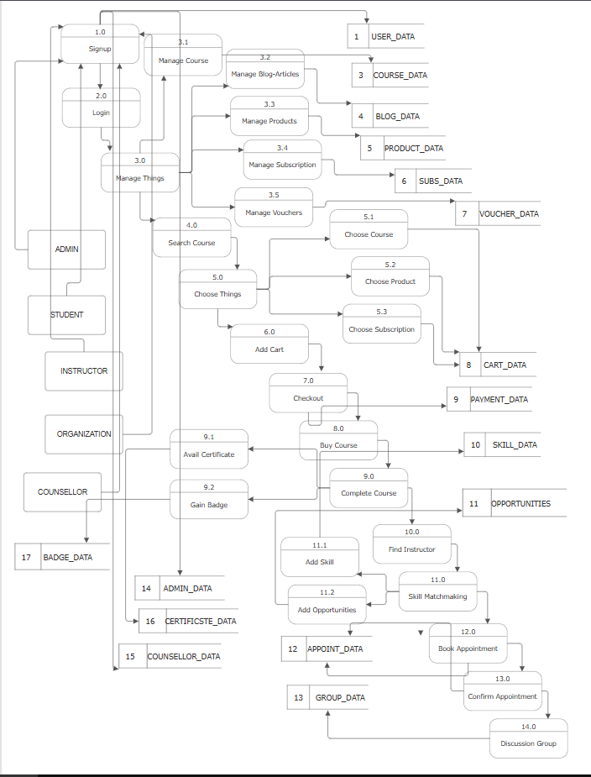
7.3 Use Case Diagram
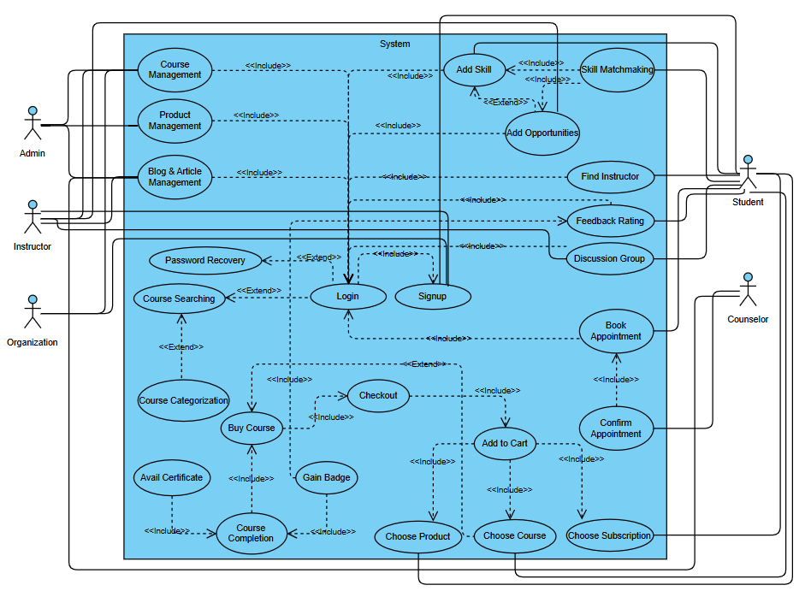
7.4 Use Case Descriptive Form
Use Case 1: Skill Matchmaking
Description: Student can express their learning interest and the system will make matches with the skilled instructors’ opportunities.
Primary Actor: Student
Stakeholder & Interest: Student will add their skill and instructor will add their proficiency as an opportunity.
Pre-condition: Both student and instructor will have to create an account with corresponding role. At least 1 student and 1 instructor will need to be available.
Main Success Scenario: Student will navigate to ‘Add Skills’ in the dashboard and add his skills (what he/she know). Likewise, instructor will navigate to ‘Add Opportunities’ in the dashboard and add his skills as an opportunity to the student with specific pre-requirements. When there will be a match between these two objects, student will see the instructor profile & contact info in the ‘Opportunities’ section.
Alternative Scenario: At any time system can fail. For that, user can refresh the page and request for the previous state. If no skills can fill up the requested opportunities, system will show a message ‘No opportunities available at this moment.’ Users have to wait for a time being to match with the skill exchanging.
Post-condition: The student's skills are successfully matched with an instructor's opportunities, and the student can view the instructor's profile and contact information in the ‘Opportunities’ section. Both student and instructor are notified about the successful match.

Use Case 2: Finding Nearest Instructor
Primary Actor: Student
Stakeholder & Interest: Student & Instructor will update their location.
Pre-condition: Both student and instructor will have to create an account with corresponding role. At least 1 student and 1 instructor will need to be available.
Main Success Scenario: Student will navigate to the dashboard and update his location. The instructor will also update his location as well. When there will be a match between these two locations, student will see the instructor profile & contact info in the ‘Find Nearest Instructors’ section.
Alternative Scenario: At any time system can fail. For that, user can refresh the page and request for the previous state. If no location gets matched, system will show a message ‘No instructors are available nearby your location at this moment.’ Users have to wait for a time being to match with the provided location.
Post-condition: The student's location is successfully matched with an instructor's location. The student is able to view the instructor's profile and contact information in the ‘Find Nearest Instructors’ section. Both student and instructor are notified of the successful location-based match.

Use Case 3: Forums & Group Discussion
Primary Actor: Student
Stakeholder & Interest: Student will post their any type of problems in the forum wall. Other students will see and give suggestions to get rid of the problems.
Pre-condition: Student will have to create an account with corresponding role. At least 2 students will need to be available.
Main Success Scenario: Student will navigate to ‘My Forum’ in the dashboard and post his problem that he is facing. Also he can see his own post in the main web forum wall. Other students can see his post, they can react and comment.
Alternative Scenario: At any time system can fail. For that, user can refresh the page and request for the previous state. If no post found, system will show a message ‘No posts are available at this moment.
Post-condition: The problem and all associated suggestions are stored in the forum for future reference. The student gains insights or a solution to their problem. Active participation enhances community engagement within the platform.

Use Case 4: Counseling Support
Description: Student can book an appointment with a professional counselor to discuss personal, academic, or emotional challenges and receive guidance.
Primary Actor: Student
Stakeholder & Interest: Student seeks mental health support for stress, anxiety, or personal challenges. On the other hand, counselor provides professional counseling sessions to help the student manage well-being.
Pre-condition: Both student and counselor must have an account with their respective roles. But at least one counselor must be available and active in the system.
Main Success Scenario: Student navigates to the “Counseling” section in the dashboard viewing the list of available counselors, including their specialization and availability. Student selects a counselor and requests an appointment by choosing a suitable time slot. The counselor receives the request, reviews availability and confirms the appointment. Student receives confirmation and attends the counseling session (online or offline depending on the platform’s setup).
Alternative Scenario: If no counselors are available at the selected time, the system shows: “No counselors are available at this moment. Please try again later.” If system failure occurs, users can refresh and retrieve their previous state. If the counselor cancels, the student is notified and asked to reschedule.
Post-conditions: The counseling appointment is successfully booked and recorded in the system. Both student and counselor are notified of the scheduled session. Session details are stored for future follow-up or reference.

7.5 Activity Diagram
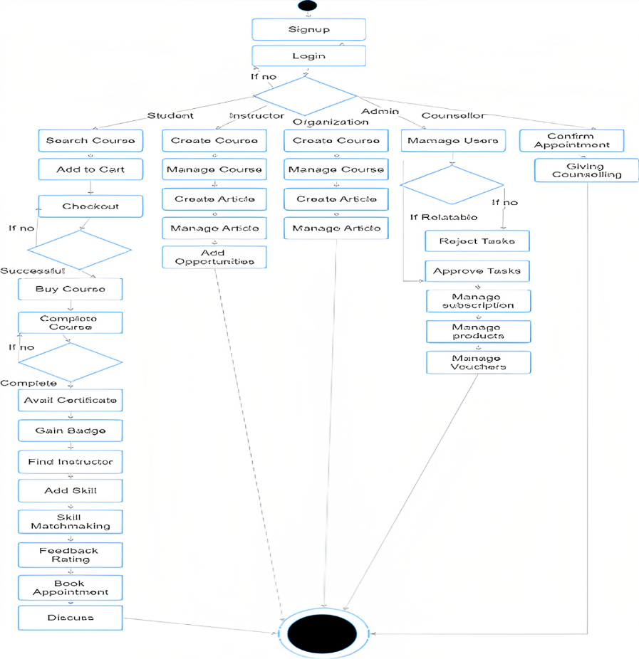
7.6 Swimlane Diagram
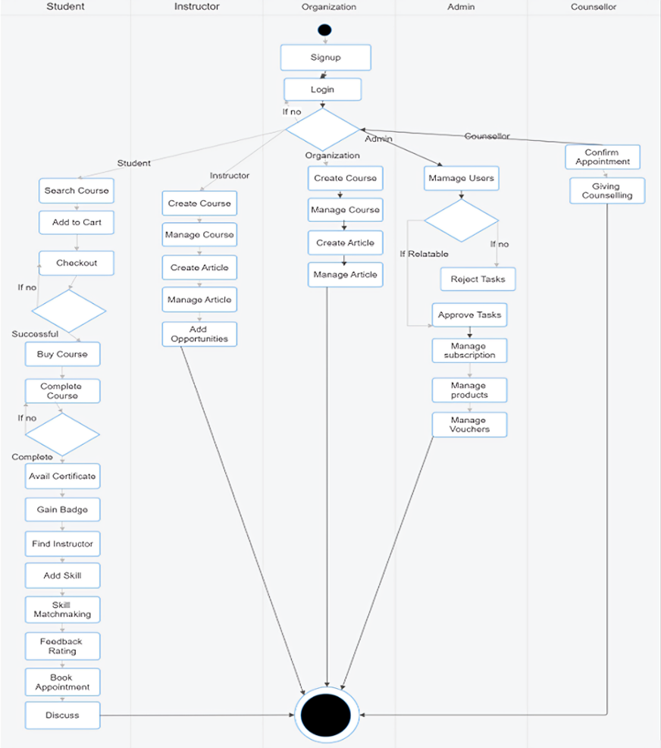
7.7 Class Diagram
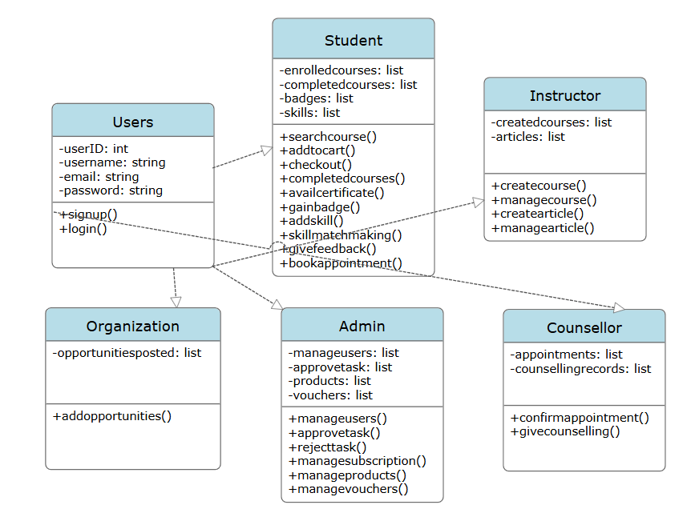
7.8 Sequence Diagram
Use Case: Buy Course
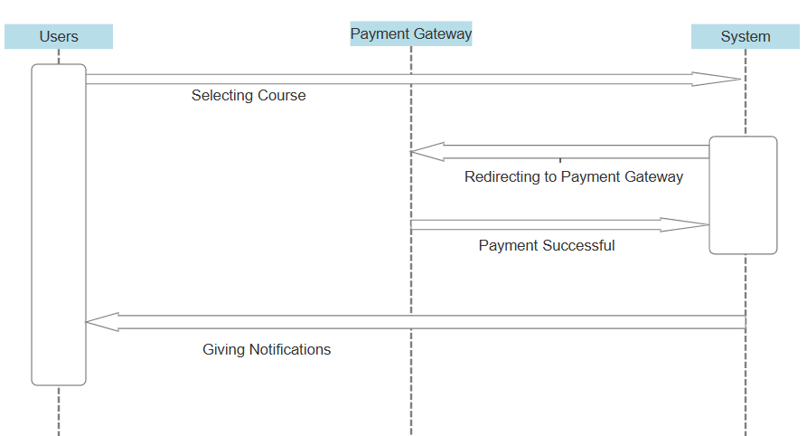
Use Case: Course Completion
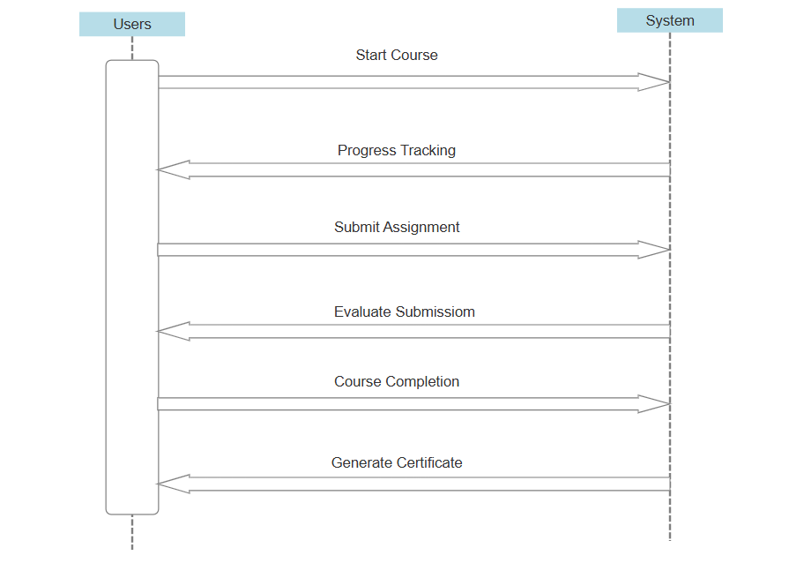
7.9 State Diagram
Use Case: Skill Matchmaking
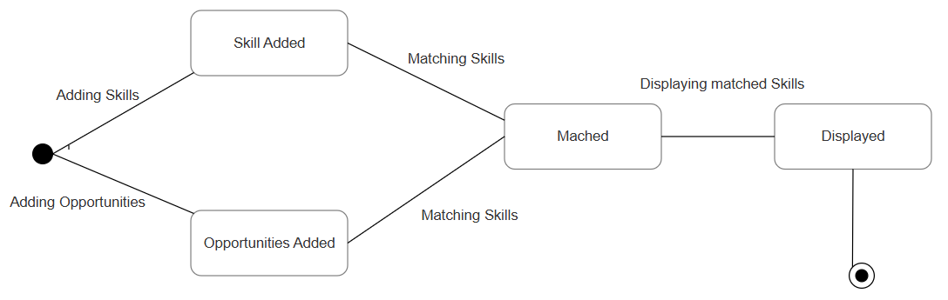
Use Case: Buy Course
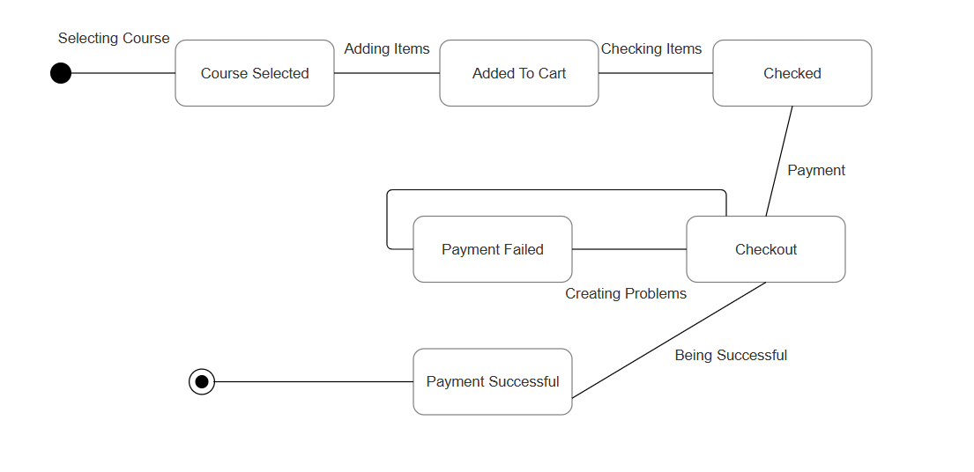
Use Case: Course Completion
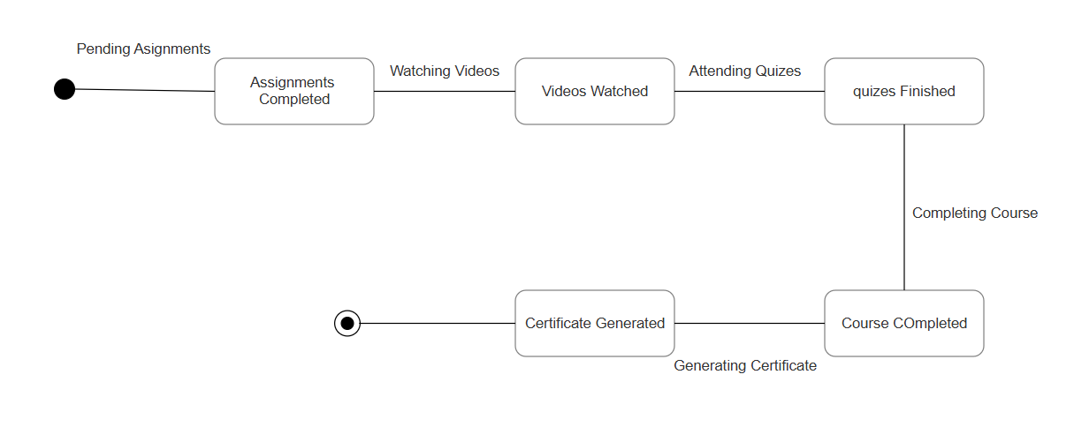

8 UI Design [Figma Link]
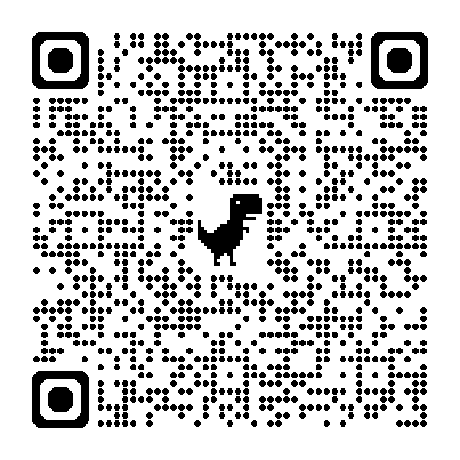
Feature: Skill Exchange
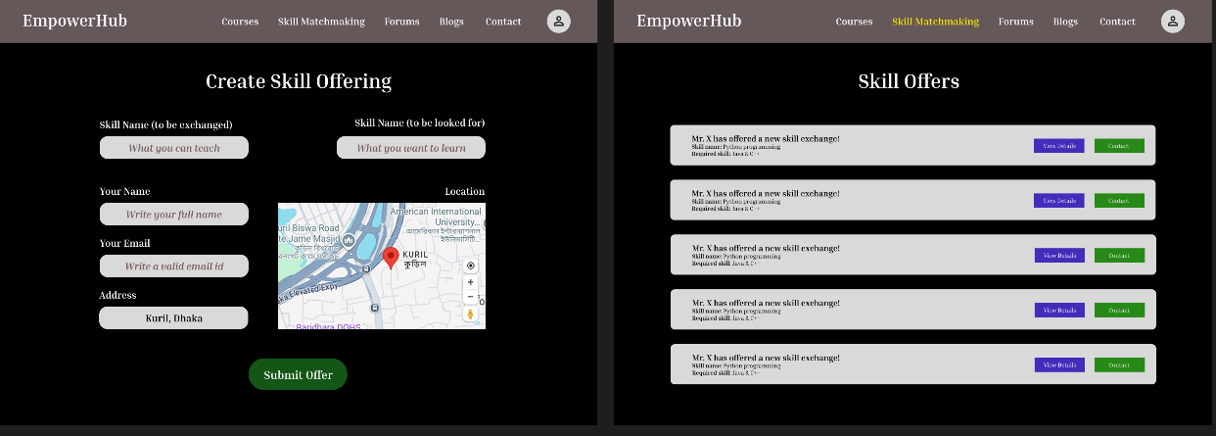
Feature: Appointment Booking with Mental Health Counselor
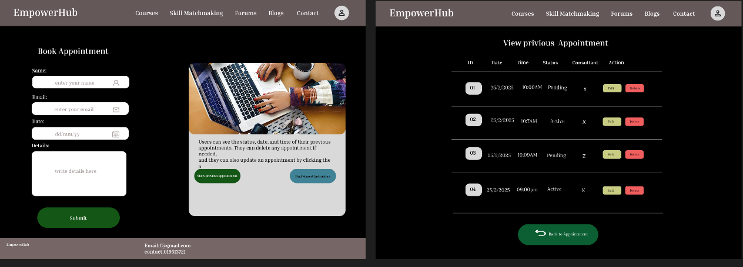
Feature: Find Nearest Instructor & Forums and Group Discussion
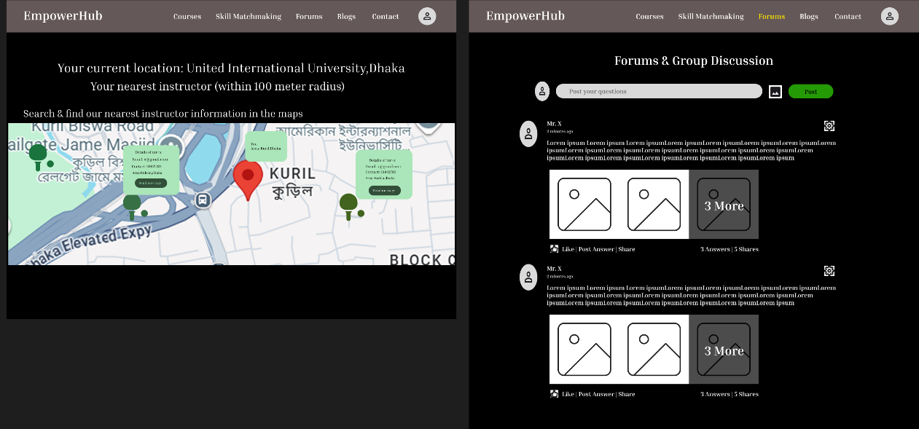

9 Non-Functional Requirements
9.1 Performance
The system should be able to handle a large number of users and transactions efficiently without experiencing significant degradation in response time. Response times for critical operations, such as skill matchmaking, finding nearest instructors processing should be minimal to ensure a seamless user experience.
9.2 Security
The system should maintain industry-standard security practices to safeguard sensitive user data, such as personal information, financial transactions and course-related data. This includes implementing encryption for data transmission, robust authentication and authorization mechanisms and also regular security audits to identify and mitigate potential performance.
9.3 Scalability
The system should be designed to scale horizontally and vertically to accommodate future growth in terms of user base, data volume and system complexity. This includes the ability to add additional servers or resources dynamically to handle increased load during peak usage periods without impacting system performance or reliability. Scalability should be achieved through the use of distributed architectures, load balancing and efficient resource utilization strategies.
9.4 Usability
The system should have an intuitive and user-friendly interface that accommodates users of all technical skill levels. Features like easy navigation, clear labels and responsive design should ensure accessibility across various devices, including desktops, tablets and smartphones.
9.5 Availability
The system should maintain high availability, ensuring it is operational and accessible to users at least 99.9% of the time. This includes implementing redundancy, failover mechanisms and backup systems to minimize downtime during maintenance or unexpected failures.
9.6 Maintainability
The system should be maintainable, allowing developers to efficiently update, debug and extend the application. This involves clear documentation, modular code structure, adherence to coding standards and the use of version control systems to manage changes. Regular maintenance schedules and monitoring tools should also be in place to ensure smooth operation over time.

10 Conclusion
EmpowerHub is an innovative e-learning platform that combines skill development, collaboration, and mental well-being. It introduces unique features like credit-swapping, mental health counseling, and reward systems to create a supportive learning community. Built with cost-effective technologies, it is technically feasible, financially viable, and scalable. Overall, EmpowerHub aims to provide a holistic and engaging learning experience that empowers learners both academically and emotionally.

----------The End----------

