Modern Education Society’s
College of Engineering, Pune

NAME OF STUDENT: CLASS:
SEMESTER/YEAR: ROLL NO:
DATE OF PERFORMANCE: DATE OF SUBMISSION:
EXAMINED BY: EXPERIMENT NO: HPC- 05

ASSIGNMENT – Mini Project
AIM: Mini Project Implementation

TITLE: Evaluate performance enhancement of parallel Quicksort Algorithm using MPI.

OBJECTIVES:

To illustrate the concepts of High performance computing.

APPRATUS:
- CygWin for installing Open MPI packages.
- C compiler and tools.
THEORY:
Similar to MergeSort, QuickSort uses a divide-and-conquer strategy and is one of the fastest sorting algorithms; it can be implemented in a recursive or iterative fashion. The divide and conquer is a general algorithm design paradigm and key steps of this strategy can be summarized as follows:

- Divide: divide the input data set S into disjoint subsets S₁, S₂, S₃…S_{k}.
- Recursion: solve the sub-problems associated with S₁, S₂, S₃…S_{k}.
- Conquer: combine the solutions for S₁, S₂, S₃…S_{k} into a solution for S.
- Base case: the base case for the recursion is generally sub-problems of size 0 or 1.
In order to sort N items; it will take the QuickSort an average running time of O(NlogN). The worst-case running time for QuickSort will occur when the pivot is a unique minimum or maximum element, the worst-case running time for QuickSort on N items is O(N²). These different running times can be influenced by the inputs distribution (uniform, sorted or semi-sorted, unsorted, duplicates) and the choice of the pivot element. Here is a Pseudocode of the QuickSort algorithm:
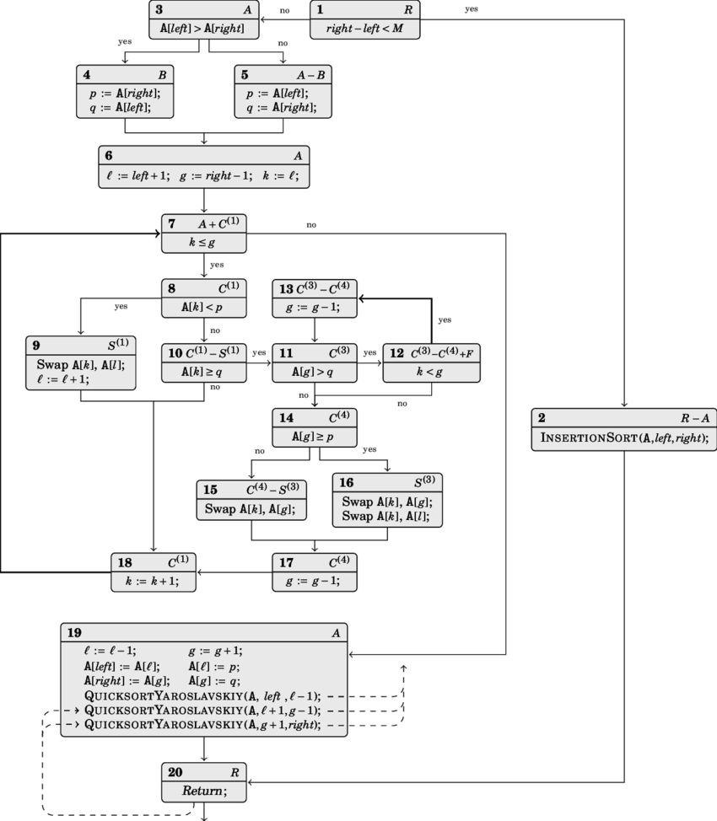
Quick Sort Control Flow

function quicksort(array)
less, equal, greater := three empty arrays
if length(array) > 1
pivot := select any element of array
for each x in array
if x < pivot then add x to less
if x > pivot then add x to greater
if x = pivot then add x to equal
quicksort(less)
quicksort(greater)
array := combine(less, equal, greater)
We have made use of Open MPI as the backbone library for parallelizing the QuickSort algorithm. In fact, learning message passing interface (MPI) allows us to strengthen our fundamentals knowledge on parallel programming, given that MPI is lower level than equivalent libraries (OpenMP). As simple as its name means, the basic idea behind MPI is that messages can be passed or exchanged among different processes in order to perform a given task. An illustration can be a communication and coordination by a master process which split a huge task into chunks and share them to its slave processes. Open MPI is developed and maintained by a consortium of academic, research and industry partners; it combines the expertise, technologies and resources all across the high performance computing community. MPI has two types of communication routines: point-to-point communication routines and 6 collective communication routines.
Algorithm and Implementation of QuickSort with MPI:
Algorithm used here to perform QuickSort with MPI is as follows:
- Start and initialize MPI.
- Under the root process MASTER, get inputs:
  - Read the list of numbers L from an input file.
  - Initialize the main array globaldata with L.
  - Start the timer.
- Divide the input size SIZE by the number of participating processes npes to get each chunk size localsize.
- Distribute globaldata proportionally to all processes:
  - From MASTER scatter globaldata to all processes.
  - Each process receives in a sub data localdata.
- Each process locally sorts its localdata of size localsize.
- Master gathers all sorted localdata by other processes in globaldata.
  - Gather each sorted localdata.
  - Free localdata.
- Under MASTER perform a final sort of globaldata.
  - Final sort of globaldata.
  - Stop the timer.
  - Write the output to file.
  - Sequentially check that globaldata is properly and correctly sorted.
  - Free globaldata.
- Finalize MPI.
Performance Evaluation:
Array Size | Sequential Performance (in seconds) | Parallel Performance(in seconds)
20 | 0.210354 | 0.199893
100 | 5.430120 | 4.980196
1000 | 33.530000 | 6.699294
10000 | 48.234955 | 15.987456
100000 | 89.987923 | 24.234906

OUTPUT (SCREENSHOTS OF IMPLEMENTATION):

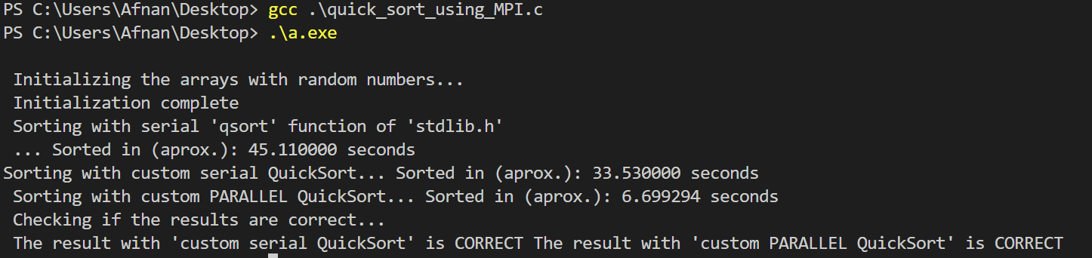

CONCLUSION:

To conclude this project, we have successfully implemented the sequential QuickSort algorithm

both the recursive and iterative version using the C programming language.

