BUSINESS CASE DOCUMENT
TrakGo
Logistics & Cargo Management Platform
────────────────────────────────────────────────────────────
Document Title | Business Case Document
Project Name | TrakGo Logistics Website
Date | March 2026
Prepared By | Software Engineering Team
Client | TrakGo Pvt. Ltd., Islamabad, Pakistan
Members | - Muhammad Ahsan Ali Shah (241852)  - Muhammad Afnan Jadoon (241873)  - Muhammad Abdul Hanan (241789)

1. Introduction

1.1 Purpose
This Software Requirements Specification and Design Document (SRS/DS) defines the complete functional and non-functional requirements for the TrakGo Intercity Logistics & Cargo Management Platform. TrakGo is a Pakistan-based logistics startup seeking a comprehensive, web-based software system to digitize their end-to-end cargo and courier operations.

The purpose of this document is to:
- Provide a formal and agreed-upon reference of all requirements for the TrakGo platform.
- Serve as the primary source for design, development, and testing teams throughout the software engineering lifecycle.
- Communicate system expectations to all stakeholders, including the client (TrakGo Pvt. Ltd.), project managers, developers.
- Document the business context, constraints, and objectives for system behavior and feature prioritization.

This document captures all requirements in a single consolidated structure, aligned with the IEEE 830-1998 standard for Software Requirements Specifications.

1.2 Scope
The TrakGo Logistics & Cargo Management Platform is a full-scale, multi-role web application designed to manage all operational aspects of an intercity logistics and courier company operating within Pakistan. The system covers the complete cargo lifecycle. From customer booking through delivery confirmation along with internal operations including management, warehouse tracking, billing, and analytics.

The system is intended for use by the following stakeholders:
- Customers (individuals and businesses) placing and tracking shipments.
- Drivers and agents managing pickups and deliveries.
- Warehouse staff managing inventory and cargo.
- Branch managers overseeing regional operations.
- Finance and billing teams processing payments and COD reconciliation.
- System administrators managing platform configuration, users, and reporting.

The platform will be accessible via web browsers on desktop and laptop devices. It will be hosted on a cloud-based infrastructure to support multi-branch, multi-city operations across Pakistan.

This SRS/DS does not cover the actual physical transportation process, driver mobile applications, third-party GPS hardware integration, or any external payment gateway implementation beyond interface definition.

1.3 Definitions, Acronyms, and Abbreviations

Term / Acronym | Definition
SRS/DS | Software Requirements Specification / Design Specification
COD | Cash on Delivery, payment collected from recipient upon shipment delivery
ETA | Estimated Time of Arrival for a shipment
AWB | Airway Bill, unique shipment tracking identifier
OTP | One-Time Password used for user authentication
POD | Proof of Delivery, confirmation that shipment was received by the customer
API | Application Programming Interface
UI | User Interface
KPI | Key Performance Indicator
CRM | Customer Relationship Management
ERP | Enterprise Resource Planning
CRUD | Create, Read, Update, Delete
IEEE | Institute of Electrical and Electronics Engineers
PKR | Pakistani Rupee, currency used for all billing and pricing
SME | Small and Medium Enterprise, a key customer segment for TrakGo

1.4 References
The following references were consulted during the development of this document:

- IEEE Std 830-1998, IEEE Recommended Practice for Software Requirements Specifications.
- IEEE Std 1016-2009, IEEE Standard for Information Technology | Systems Design | Software Design Descriptions.
- Pakistan Telecommunication Authority (PTA) | Data Protection and Cybersecurity Guidelines, 2023.
- State Bank of Pakistan | Electronic Payments and COD Settlement Regulations.
- TCS Pakistan, Leopards Courier, Trax | Industry reference platforms for logistics domain analysis.

1.5 Overview
This document is organized into two primary sections following this introduction:

Section 1 | Introduction: Covers the purpose, scope, key definitions, references, and the structural overview of this document. It establishes the context within which all requirements are defined.

Section 2 | Business Requirements: Provides a comprehensive description of the business context for the TrakGo platform. It includes the background of the problem domain, the business opportunity being addressed, the specific objectives the system must achieve, a formal vision statement, and a clearly defined list of limitations and exclusions that bound the scope of this project.

Subsequent assignments will expand this document to include detailed user requirements, functional and non-functional specifications, system architecture, UML diagrams, UI mockups, and design decisions.

2. Business Requirements

2.1 Background
Pakistan's logistics and courier industry is one of the fastest-growing sectors in the country, driven by the explosive rise of e-commerce, cross-city trade. Despite this growth, a significant portion of mid-sized logistics companies continue to operate on fragmented, manual, or semi-digital systems, relying on phone calls, WhatsApp groups, physical ledgers, and disconnected spreadsheets to manage daily operations.

TrakGo Pvt. Ltd. is a simulated startup logistics company based in Islamabad, Pakistan, operating intercity cargo and courier services across major cities including Karachi, Lahore, Rawalpindi, Peshawar, Multan, and Faisalabad. The company currently faces the following operational challenges:

- No centralized system for shipment booking, tracking, or status management. Resulting in frequent miscommunications between customers and operations teams.
- Driver and fleet assignments are managed manually via phone, causing delays, double-bookings, and lack of accountability.
- Warehouse operations are tracked on paper, leading to lost parcels, inventory discrepancies, and slow cargo turnaround.
- Cash on Delivery (COD) reconciliation is done manually by branch accountants, causing delays in cash remittance to clients and frequent errors.
- There is no formal customer portal so clients have no visibility into their shipment status and must call customer support repeatedly.
- Management has no consolidated reporting or analytics to assess operational efficiency, branch performance, or revenue trends.

These problems result in poor customer satisfaction, high operational costs, and an inability to scale. TrakGo approached the software engineering team to design a comprehensive, integrated web platform that addresses all of these challenges within a single unified system.

2.2 Business Opportunity
The Pakistani logistics and e-commerce fulfillment market presents a significant and underserved digital opportunity. According to industry trends, Pakistan's e-commerce sector is growing at over 30% annually, yet the majority of courier companies serving this market lack enterprise-grade software systems. Most available solutions are either overly complex international ERP systems that are expensive and not localized, or overly simple tracking tools that only address one part of the workflow.

The TrakGo platform targets the following market opportunity:

Target Market & Customer Needs
- E-commerce sellers and SMEs requiring reliable, trackable intercity shipping with automated billing and COD remittance.
- Corporate clients with high-volume shipments that need account management, credit facilities, and monthly invoicing.
- Individual customers requiring one-off parcel sending with real-time tracking and delivery confirmation.

Technology Alignment
- The system leverages modern web technologies (React.js, Node.js, PostgreSQL) and cloud hosting to provide scalability, reliability, and accessibility without requiring client-side installations.
- Real-time status updates and automated notifications align with customer expectations shaped by platforms like Daraz and Amazon.
- Role-based dashboards address the growing demand for data-driven decision making among Pakistan's logistics operators.

Competitive Advantage
- Unlike TCS or Leopards, TrakGo's platform is designed to be modular and scalable, enabling smaller logistics companies to adopt enterprise-grade functionality.
- The built-in COD and branch-level financial management module directly addresses the most painful and costly inefficiency in Pakistan's courier industry.
- The system's multi-branch, multi-city architecture supports geographic expansion without requiring system overhauls.

The TrakGo platform would serve as a competitive differentiator that allows the company to attract higher-value clients, reduce operational costs through automation, and scale from a regional player to a national logistics network.

2.3 Business Objectives
The following objectives define the measurable outcomes the TrakGo platform must achieve. Each objective is directly tied to a business need identified in the background analysis.

- To provide a centralized, web-based platform that manages the complete lifecycle of every shipment from booking through final delivery confirmation.
- To digitize and automate driver and fleet assignment workflows, eliminating manual phone-based coordination and reducing delivery delays.
- To implement a warehouse management module that tracks parcel intake, sorting, storage, and dispatch in real time across all branch locations.
- To automate the Cash on Delivery (COD) reconciliation process, ensuring accurate and timely remittance to clients with full audit trails.
- To provide a self-service customer portal that allows clients to book shipments, track parcels, download invoices, and raise complaints without contacting support.
- To implement a multi-branch management system that supports independent operations at each city branch while providing consolidated visibility to headquarters.
- To generate automated billing and invoicing for both individual and corporate clients, supporting multiple pricing tiers, weight-based calculations, and volume discounts.
- To provide role-specific dashboards with real-time management, branch managers, warehouse staff, drivers, and finance teams.
- To maintain a complete and searchable history of all shipments, transactions, complaints, and driver activities for audit, compliance, and analytics purposes.
- To support complaints and claims management, allowing customers to raise issues and operations teams to track resolution status end-to-end.
- To manage staff records, driver profiles, and payroll data within the system, reducing dependency on separate HR tools.

2.4 Vision Statement
"For logistics companies and their customers who are frustrated by the inefficiency, opacity, and manual burden of traditional courier operations, TrakGo is a comprehensive web-based logistics management platform that digitizes and integrates every aspect of intercity cargo operations. Unlike fragmented tools and manual workflows currently used by mid-sized Pakistani courier companies, TrakGo delivers a unified system where shipments are booked, tracked, and delivered with full transparency; where drivers, warehouses, and branches operate in real-time coordination; and where financial processes like COD reconciliation and invoicing run automatically, enabling TrakGo to scale confidently, serve customers reliably, and operate with measurable efficiency."

2.5 Limitations and Exclusions
The following capabilities and features are explicitly out of scope for the TrakGo platform. These items were considered during requirements analysis but excluded from the current project either due to technical complexity, resource constraints, or strategic deferral to a future release.

- The system will not include a native mobile application (iOS or Android). All access will be through a responsive web browser interface only.
- The system will not integrate with real-time GPS hardware or IoT tracking devices. Driver location updates will be manually entered by drivers via the web interface.
- The system will not process online payments directly. Payment gateway integration (JazzCash, EasyPaisa, bank transfers) is out of scope; billing records will be managed in the system but actual payment processing occurs outside the platform.
- The system will not provide route optimization using mapping APIs (e.g., Google Maps routing algorithms). Route assignment will be manual and based on driver/branch decisions.
- The system will not include an AI-powered demand forecasting or predictive analytics module. Reporting will be descriptive (historical data) only.
- The system will not support international shipments or cross-border cargo management. All operations are scoped to domestic (Pakistan) intercity routes.
- The system will not include a public-facing e-commerce storefront or marketplace. It is a back-office and customer portal system, not a retail platform.
- The system will not manage customs, regulatory filings, or government compliance documentation beyond internal record-keeping.
- Integration with third-party ERP or accounting systems (e.g., QuickBooks, SAP) is not included in this release.
- Automated SMS or email notifications are referenced as system behaviors but the configuration of third-party messaging service accounts (e.g., Twilio, SendGrid) is outside the scope of this document.

3. System Analysis and Design
This section presents the complete UML and structured analysis models for the TrakGo Logistics & Cargo Management Platform. All diagrams have been developed in accordance with IEEE 830-1998 standards and standard UML 2.x notation.

3.1 Data Flow Diagram (DFD) Level 0: Context Diagram
The Level 0 DFD (Context Diagram) presents TrakGo as a single process interacting with all external entities. It defines the system boundary and shows what data enters and exits the platform without exposing internal structure.
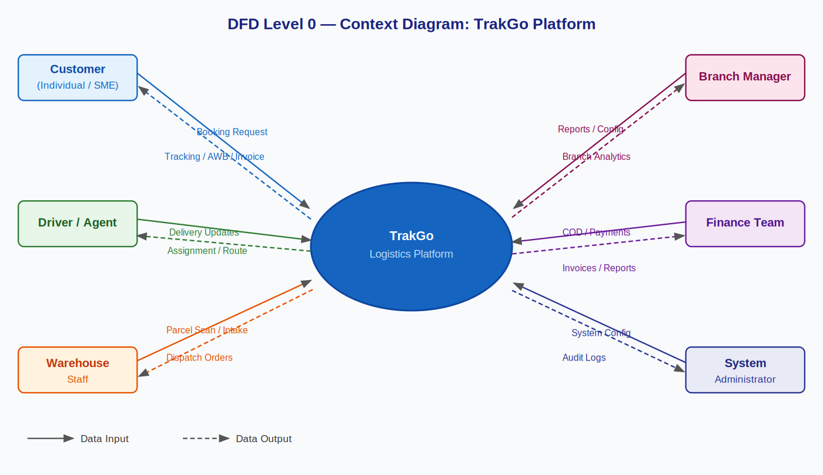
Figure 3.1 DFD Level 0: TrakGo Context Diagram

3.2 Data Flow Diagram (DFD) Level 1: Internal Processes
The Level 1 DFD decomposes the TrakGo system into eight major internal processes: Shipment Booking (P1), Tracking & Status (P2), Driver Assignment (P3), Warehouse Management (P4), Billing & Invoice (P5), COD Reconciliation (P6), Complaints & Claims (P7), and Analytics & Reporting (P8). Three primary data stores are identified: D1 (Shipment Database), D2 (User/Staff Database), and D3 (Finance/COD Database).
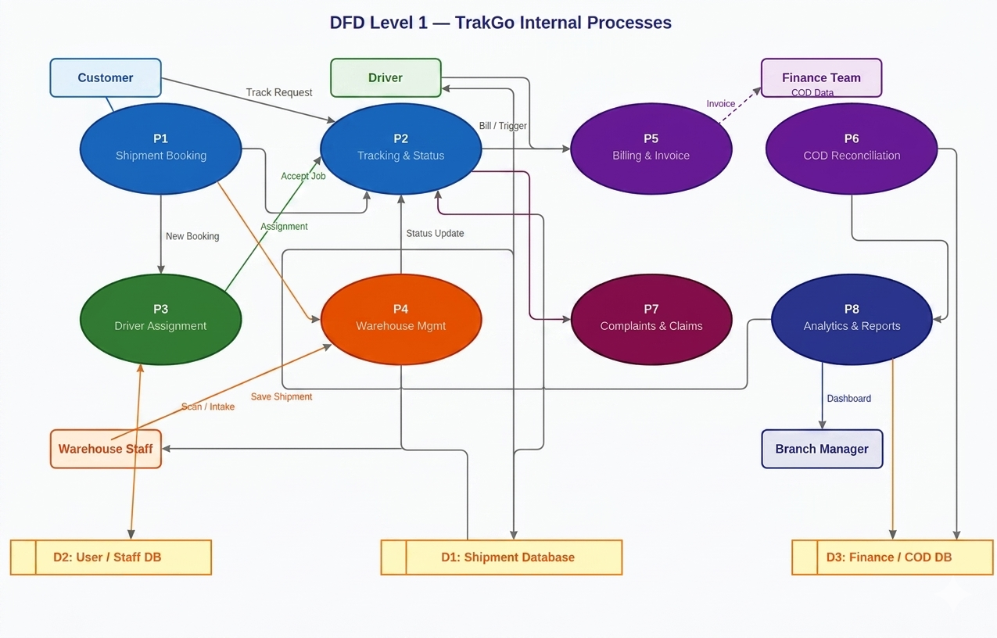
Figure 3.2 DFD Level 1: TrakGo Internal Process Decomposition

3.3 Use Case Diagram
The Use Case Diagram maps all six actors to their respective system interactions. The system boundary encompasses all TrakGo functionality. An include relationship is shown between Book Shipment and Generate Invoice, as invoice creation is always triggered by a booking.
Actors: Customer (Individual/SME), Driver/Agent, Warehouse Staff, Branch Manager, Finance Team, System Administrator.
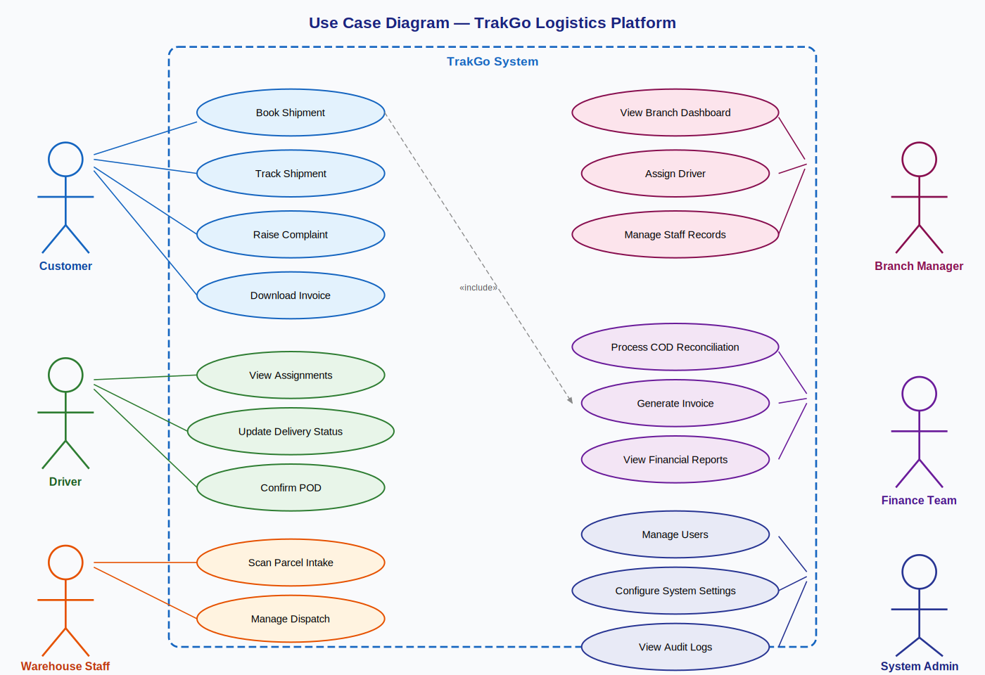
Figure 3.3 Use Case Diagram: TrakGo Actors and Use Cases

3.4 Use Case Descriptions
The following section provides complete use case specifications for the eight primary use cases of the TrakGo platform.

UC-01: Book Shipment
Use Case ID | UC-01
Use Case Name | Book Shipment
Actor(s) | Customer (Primary), Billing Module (Secondary)
Description | Allows a customer to create a new shipment booking by providing origin/destination, parcel details, and payment preference.
Preconditions | Customer is registered and logged in. Origin and destination cities are served by TrakGo.
Trigger | Customer clicks 'Book Shipment' from the customer portal.
Main Flow | 1. Customer navigates to the booking page. 2. Customer enters origin city, destination city, parcel weight, declared value, and COD flag. 3. System validates all input fields. 4. System calculates freight charges based on weight and distance zone. 5. System generates a unique AWB (Airway Bill) number. 6. System saves shipment record with status = BOOKED. 7. System triggers invoice generation (UC-07). 8. System sends confirmation email with AWB and ETA. 9. Customer receives booking confirmation page.
Alternate Flow | 3a. Validation fails System highlights errors, prompts customer to correct and resubmit. 4a. Route unavailable System displays 'Service not available for selected route' and cancels booking.
Postconditions | Shipment record created in database with AWB. Invoice generated. Customer notified via email. Shipment is visible to branch manager and warehouse staff.
Exceptions | Network failure booking is not saved; user is prompted to retry.
Priority | High

UC-02: Track Shipment
Use Case ID | UC-02
Use Case Name | Track Shipment
Actor(s) | Customer (Primary)
Description | Enables a customer to view real-time status and location history of their shipment using the AWB number.
Preconditions | Shipment has been booked and assigned an AWB. Customer is logged in or has the AWB number.
Trigger | Customer enters AWB number into the tracking search bar.
Main Flow | 1. Customer enters AWB number on the tracking page. 2. System queries the Shipment Database for the matching record. 3. System retrieves current status, status history, estimated delivery date, and assigned branch. 4. System renders the tracking timeline showing all status transitions with timestamps. 5. Customer views real-time shipment status.
Alternate Flow | 2a. AWB not found System displays 'Shipment not found. Please verify your AWB number.'
Postconditions | No data is modified. Customer views tracking information.
Priority | High

UC-03: Assign Driver
Use Case ID | UC-03
Use Case Name | Assign Driver
Actor(s) | Branch Manager (Primary), Driver (Secondary)
Description | Allows a branch manager to assign an available driver to a booked shipment for pickup or delivery.
Preconditions | Shipment exists with status BOOKED or AT WAREHOUSE. At least one driver is available in the serving city.
Trigger | Branch Manager views the pending shipments queue and selects a shipment to assign.
Main Flow | 1. Branch Manager opens the shipments dashboard and filters by status = BOOKED. 2. Manager selects a shipment and clicks 'Assign Driver'. 3. System displays a list of available drivers in the origin city. 4. Manager selects a driver from the list. 5. System creates an assignment record linking the driver to the shipment. 6. System sends assignment notification to the driver. 7. Shipment status is updated to ASSIGNED. 8. Driver receives the pickup task on their dashboard.
Alternate Flow | 3a. No drivers available System displays 'No drivers available in this city. Please check back later.'
Postconditions | Driver is linked to shipment. Shipment status updated to ASSIGNED. Driver notified.
Priority | High

UC-04: Update Delivery Status
Use Case ID | UC-04
Use Case Name | Update Delivery Status
Actor(s) | Driver (Primary)
Description | Allows a driver to update the status of a shipment at each stage of the delivery process.
Preconditions | Driver is logged in. A shipment is assigned to the driver.
Trigger | Driver opens the assigned shipment and selects a new status from the status update panel.
Main Flow | 1. Driver logs into the TrakGo portal. 2. Driver views list of assigned shipments. 3. Driver selects a shipment and clicks 'Update Status'. 4. System presents status options: Picked Up, In Transit, At Warehouse, Out for Delivery, Delivered, Failed. 5. Driver selects the appropriate status. 6. System records status with timestamp. 7. System updates tracking timeline. 8. Customer is notified of status change via email.
Alternate Flow | 5a. Driver selects 'Delivery Failed' System prompts for failure reason (wrong address / recipient unavailable / refused delivery). System flags shipment for return or re-attempt.
Postconditions | Shipment status updated. Tracking history updated. Customer notified.
Priority | High

UC-05: Process COD Reconciliation
Use Case ID | UC-05
Use Case Name | Process COD Reconciliation
Actor(s) | Finance Team (Primary), Driver (Secondary)
Description | Enables the finance team to reconcile cash collected by drivers for COD shipments and record remittance to clients.
Preconditions | Shipment with COD flag = true has been delivered. Driver has collected cash from recipient.
Trigger | Finance team opens the COD reconciliation module and selects a delivered COD shipment.
Main Flow | 1. Finance team views list of delivered COD shipments pending reconciliation. 2. System displays shipment details, declared COD amount, and driver who collected. 3. Finance team confirms the collected amount. 4. System marks COD as collected and records the collection date and collector ID. 5. Finance team records remittance to client (bank transfer reference). 6. System closes the COD record and updates the invoice as settled. 7. System generates audit trail entry.
Alternate Flow | 3a. Collected amount does not match declared amount System flags discrepancy. Finance team raises an internal discrepancy report.
Postconditions | COD record marked as reconciled. Invoice updated. Audit trail created. Client remittance recorded.
Priority | High

UC-06: Raise Complaint
Use Case ID | UC-06
Use Case Name | Raise Complaint
Actor(s) | Customer (Primary), Branch Manager (Secondary)
Description | Allows a customer to submit a complaint or claim regarding a shipment (e.g., lost parcel, damaged goods, delayed delivery).
Preconditions | Customer is logged in. A shipment record exists under their account.
Trigger | Customer navigates to 'My Shipments', selects a shipment, and clicks 'Raise Complaint'.
Main Flow | 1. Customer selects the relevant shipment. 2. Customer selects complaint type: Lost Parcel / Damaged Goods / Delay / COD Discrepancy / Other. 3. Customer enters description and optionally uploads supporting documents. 4. System assigns a complaint ID and sets status = Open. 5. System notifies the responsible branch manager. 6. Branch manager reviews and updates the complaint status (In Progress / Resolved). 7. System notifies customer when complaint is resolved.
Alternate Flow | 3a. Customer uploads unsupported file type System prompts to upload PDF or JPG only.
Postconditions | Complaint record created. Branch manager notified. Customer can track complaint status.
Priority | Medium

UC-07: Generate Invoice
Use Case ID | UC-07
Use Case Name | Generate Invoice
Actor(s) | System / Billing Module (Primary), Finance Team (Secondary)
Description | Automatically generates a billing invoice for a shipment upon booking. Invoice includes freight charges, taxes, COD fees if applicable, and declared value.
Preconditions | A shipment booking has been successfully created (UC-01). Customer account has an assigned pricing tier.
Trigger | Automatically triggered upon successful completion of UC-01 (Book Shipment).
Main Flow | 1. Billing module receives shipment ID, weight, route, and COD flag from the booking module. 2. System retrieves applicable pricing tier for the customer. 3. System calculates freight charges = base rate + weight charge + zone surcharge. 4. System applies applicable taxes (GST). 5. System generates invoice record with unique invoice ID. 6. Invoice is linked to the shipment and customer account. 7. PDF invoice is made available for download on the customer portal. 8. Invoice status is set to Unpaid (for corporate accounts) or auto-settled (for prepaid).
Alternate Flow | 2a. No pricing tier found System uses default standard rate card.
Postconditions | Invoice record created and linked to shipment. PDF available on portal. Finance team can view all generated invoices.
Priority | High

UC-08: Manage Branch
Use Case ID | UC-08
Use Case Name | Manage Branch
Actor(s) | Branch Manager (Primary), System Admin (Secondary)
Description | Allows branch managers and system admins to configure branch details, view performance metrics, manage staff assignments, and monitor branch-level shipment queues.
Preconditions | User is logged in with Branch Manager or Admin role.
Trigger | User navigates to the Branch Management section of the dashboard.
Main Flow | 1. User opens the Branch Management module. 2. System displays list of branches (for Admin) or current branch (for Branch Manager). 3. User can: view pending/active/completed shipment counts; view driver roster and availability; update branch contact info or capacity; generate branch-level performance reports. 4. System saves changes and updates the Branch database record. 5. Admin can create new branches or deactivate existing ones.
Alternate Flow | 4a. Duplicate branch code System rejects and displays error.
Postconditions | Branch record updated. Performance data visible on dashboard. New branches active if created.
Priority | Medium

3.5 Class Diagram
The Class Diagram defines the object-oriented structure of the TrakGo system. Core classes include Customer, Shipment, Driver, Branch, Warehouse, Invoice, Payment, and Complaint. Key relationships include: Customer places (1..*) Shipments; Shipment is assigned to (0..1) Driver; Shipment generates Invoice; Shipment has (0..1) Payment; Customer raises Complaints; Shipment is stored in Warehouse.
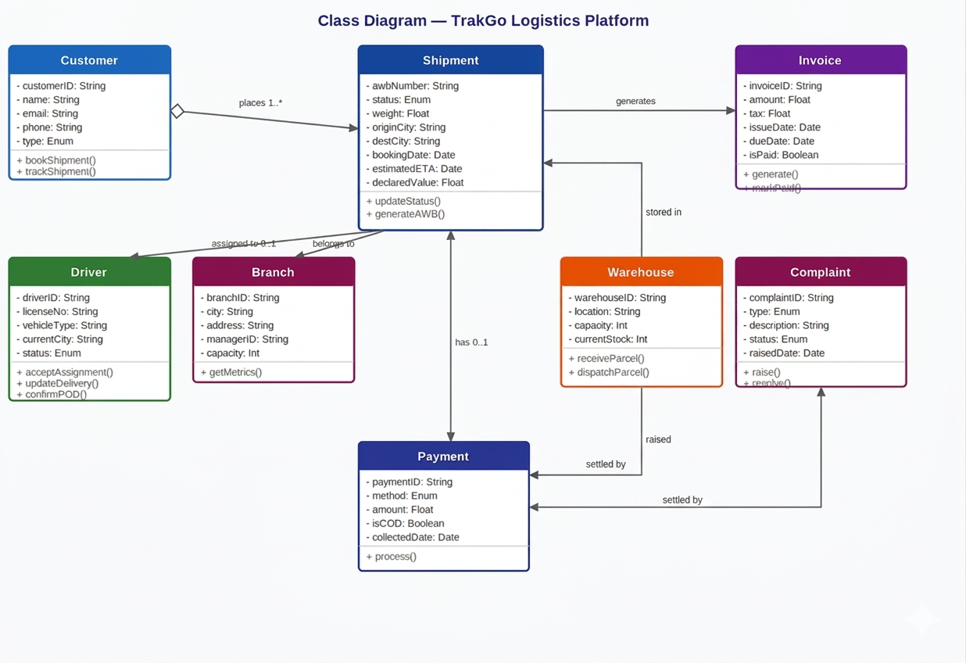
Figure 3.5 Class Diagram: TrakGo Core Domain Model

3.6 Sequence Diagram Customer Books a Shipment
The Sequence Diagram illustrates the chronological message flow for the primary use case UC-01 (Book Shipment). It captures the interaction between the Customer, Web Browser, Booking Module, Shipment Database, Billing Module, and Notification Service. The diagram demonstrates the synchronous request-response pattern and identifies where automatic subsystem triggers (billing, notifications) occur.
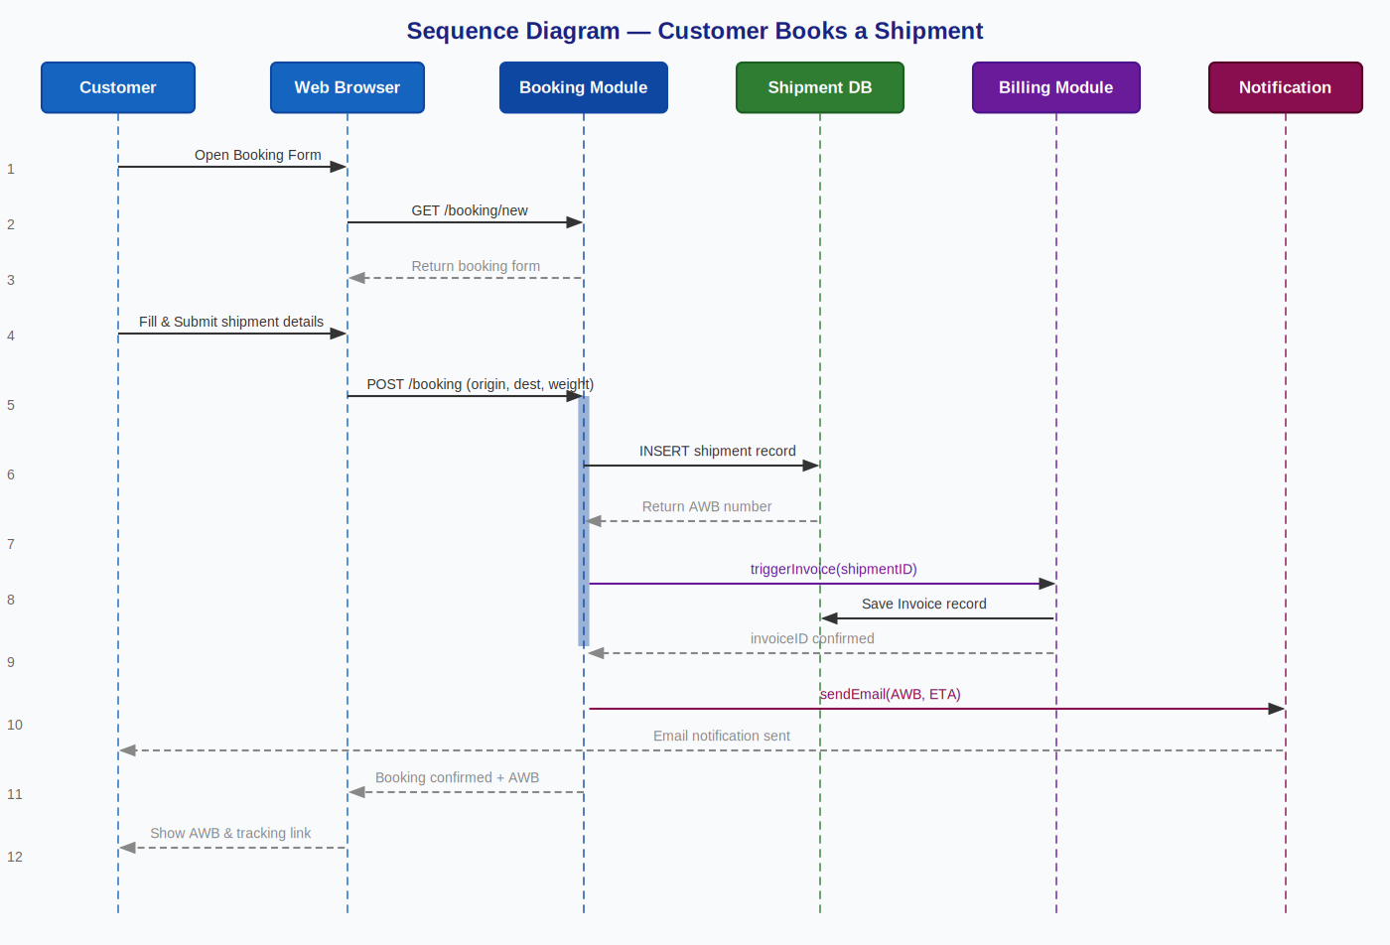
Figure 3.6 Sequence Diagram: Customer Books a Shipment (UC-01)

3.7 State Transition Diagram Shipment Lifecycle
The State Transition Diagram models the complete lifecycle of a Shipment object. A shipment transitions through the following states: BOOKED → PICKED UP → IN TRANSIT → AT WAREHOUSE → OUT FOR DELIVERY → DELIVERED (success path) or DELIVERY FAILED → RETURNED TO SENDER (failure path). A CANCELLED state is reachable from BOOKED only. Each transition is triggered by a specific actor action or system event.
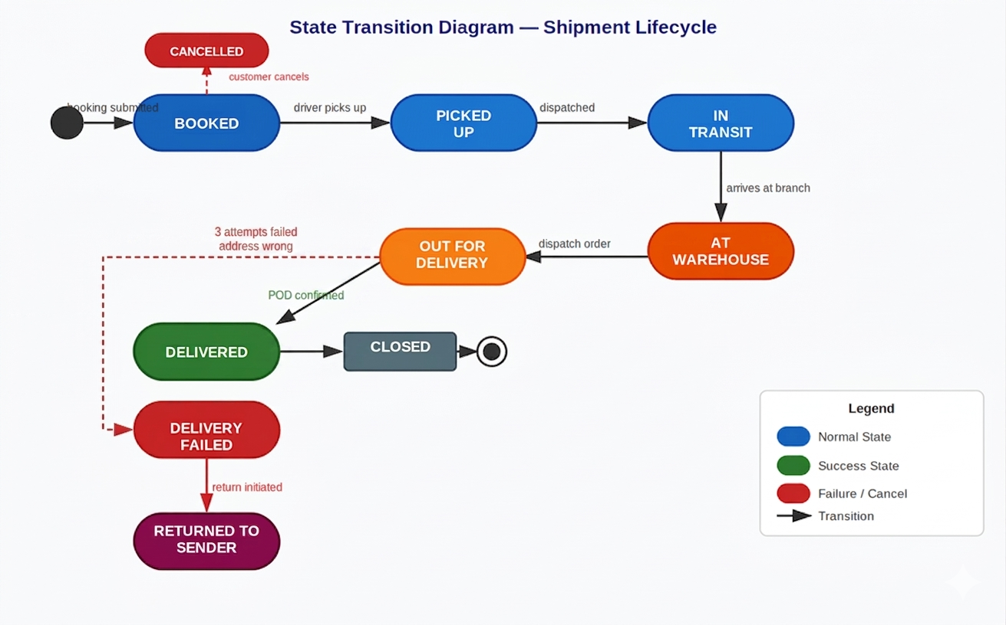
Figure 3.7 State Transition Diagram: Shipment Lifecycle States

3.8 Activity Diagram Shipment Processing & COD Reconciliation
The Activity Diagram presents the complete end-to-end workflow across four swimlanes: Customer, System/Booking, Driver/Warehouse, and Finance/COD. It covers the full shipment lifecycle from booking form submission through delivery confirmation and COD reconciliation, including decision branches for input validation, delivery success/failure, and COD versus prepaid payment modes.
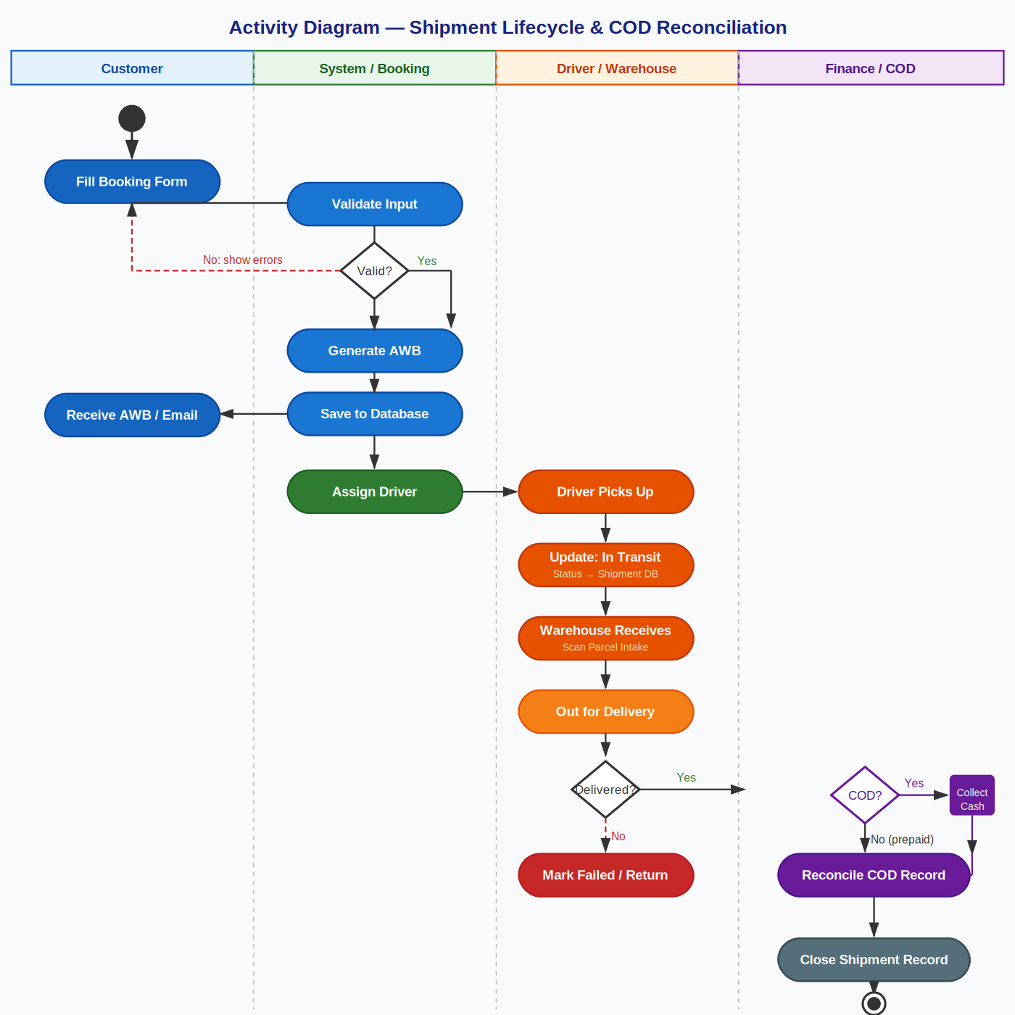
Figure 3.8 Activity Diagram: Full Shipment Lifecycle & COD Reconciliation Workflow

4. Test Cases
This section presents 31 test cases covering all major modules of the TrakGo Logistics Management Platform. Each test case follows the standard format including ID, description, preconditions, test steps, test data, and expected result. The Actual Result and Status columns are to be completed during the testing phase. Test cases are grouped by functional module.

4.1 User Authentication
Test Case ID | TC-001
Description | Login with valid credentials
Preconditions | User account exists with role Customer.
Test Steps | 1. Navigate to login page.  2. Enter registered email.  3. Enter correct password.  4. Click Login.
Test Data | Email: customer@trakgo.pk  Password: Test@1234
Expected Result | Redirected to Customer Dashboard. Welcome message shown with user name.
Actual Result | User successfully logged in and redirected to Customer Dashboard. Welcome message "Welcome, Ahsan!" displayed.
Status (Pass/Fail) | Pass
Remarks | Response time under 1 second.

Test Case ID | TC-002
Description | Login with invalid password
Preconditions | User account exists in the system.
Test Steps | 1. Navigate to login page.  2. Enter registered email.  3. Enter incorrect password.  4. Click Login.
Test Data | Email: customer@trakgo.pk  Password: WrongPass99
Expected Result | Error: Invalid email or password. User remains on login page.
Actual Result | Error message "Invalid email or password" displayed. User remained on login page.
Status (Pass/Fail) | Pass
Remarks | No sensitive info leaked in error message.

Test Case ID | TC-003
Description | Login with unregistered email
Preconditions | Email does not exist in the system.
Test Steps | 1. Navigate to login page.  2. Enter unregistered email.  3. Enter any password.  4. Click Login.
Test Data | Email: ghost@fake.com  Password: anything123
Expected Result | Error: Invalid email or password. No account data exposed.
Actual Result | Error message "Invalid email or password" displayed. No account data exposed.
Status (Pass/Fail) | Pass
Remarks | Generic error message correctly used

Test Case ID | TC-004
Description | Login with empty fields
Preconditions | User is on the login page.
Test Steps | 1. Leave email and password empty.  2. Click Login.
Test Data | Email: (empty)  Password: (empty)
Expected Result | Validation error: Email and password are required. Login not submitted.
Actual Result | Validation errors highlighted on both fields. Form not submitted.
Status (Pass/Fail) | Pass
Remarks | Client-side validation working correctly.

4.2 Shipment Booking
Test Case ID | TC-005
Description | Book a shipment with valid data
Preconditions | Customer logged in. Cities configured in system.
Test Steps | 1. Navigate to New Shipment.  2. Enter sender details.  3. Enter receiver details.  4. Select route: Rawalpindi to Karachi.  5. Enter weight: 3 kg.  6. Select service: Standard.  7. Click Calculate Cost.  8. Click Confirm Booking.
Test Data | Sender: Ahmed Ali 03001234567  Receiver: Sara Khan 03219876543  Weight: 3 kg, Route: Rawalpindi to Karachi
Expected Result | AWB generated (e.g. TG-2026-00471). Cost shown. Confirmation SMS/email sent. Shipment in My Shipments.
Actual Result | Shipment booked. AWB TG-2026-00471 generated. Confirmation SMS sent to 03001234567. Shipment visible in My Shipments.
Status (Pass/Fail) | Pass
Remarks | Cost calculated as PKR 850. ETA shown as 2 business days.

Test Case ID | TC-006
Description | Book shipment with missing receiver phone
Preconditions | Customer is logged in.
Test Steps | 1. Navigate to New Shipment.  2. Fill sender details.  3. Leave receiver phone empty.  4. Click Confirm Booking.
Test Data | Receiver Phone: (empty)
Expected Result | Validation error: Receiver phone number is required. Booking not submitted.
Actual Result | Validation error displayed under receiver phone field. Booking not submitted.
Status (Pass/Fail) | Pass
Remarks | Field correctly marked as required.

Test Case ID | TC-007
Description | Book COD shipment with valid COD amount
Preconditions | Customer is logged in.
Test Steps | 1. Fill all required fields.  2. Enable COD toggle.  3. Enter COD amount: PKR 5000.  4. Confirm booking.
Test Data | COD Amount: PKR 5,000  Route: Lahore to Peshawar
Expected Result | Shipment booked with COD flag. COD amount visible on summary. AWB generated.
Actual Result | Shipment booked with COD flag. PKR 5,000 shown on booking summary. AWB TG-2026-00512 generated.
Status (Pass/Fail) | Pass
Remarks | COD amount correctly saved to shipment record.

Test Case ID | TC-008
Description | Book shipment exceeding maximum weight
Preconditions | Customer logged in. Max weight limit is 50 kg.
Test Steps | 1. Fill all required fields.  2. Enter weight: 75 kg.  3. Click Calculate Cost.
Test Data | Weight: 75 kg (over 50 kg limit)
Expected Result | Error: Weight exceeds maximum limit of 50 kg. Contact support for bulk cargo. Booking blocked.
Actual Result | Error message displayed: "Weight exceeds maximum limit of 50 kg." Booking form blocked from submission.
Status (Pass/Fail) | Pass
Remarks | Weight validation triggers before cost calculation.

4.3 Shipment Tracking
Test Case ID | TC-009
Description | Track shipment with valid AWB
Preconditions | Shipment TG-2026-00471 exists with status In Transit.
Test Steps | 1. Navigate to Track Shipment.  2. Enter AWB: TG-2026-00471.  3. Click Track.
Test Data | AWB: TG-2026-00471
Expected Result | Status In Transit, origin, destination, ETA, and full history timeline displayed.
Actual Result | Tracking page loaded showing status "In Transit", origin Rawalpindi, destination Karachi, ETA May 30 2026. Full history timeline displayed with 3 status entries.
Status (Pass/Fail) | Pass
Remarks | History timeline correctly shows all status changes with timestamps.

Test Case ID | TC-010
Description | Track with invalid AWB number
Preconditions | User is on tracking page.
Test Steps | 1. Enter AWB: TG-0000-99999.  2. Click Track.
Test Data | AWB: TG-0000-99999
Expected Result | Error: No shipment found with this AWB number. Please check and try again.
Actual Result | Message displayed: "No shipment found with this AWB number. Please check and try again."
Status (Pass/Fail) | Pass
Remarks | System does not crash or expose any data.

Test Case ID | TC-011
Description | Track a delivered shipment
Preconditions | Shipment TG-2026-00310 has status Delivered.
Test Steps | 1. Enter AWB: TG-2026-00310.  2. Click Track.
Test Data | AWB: TG-2026-00310
Expected Result | Status Delivered. POD details shown: recipient name, delivery timestamp, and POD note.
Actual Result | Status "Delivered" shown. POD details displayed: Recipient Sara Khan, delivered May 28 2026 at 3:42 PM.
Status (Pass/Fail) | Pass
Remarks | POD timestamp accurate.

4.4 Driver Assignment
Test Case ID | TC-012
Description | Assign available driver to booked shipment
Preconditions | Branch Manager logged in. Shipment Booked. Driver D-014 available.
Test Steps | 1. Navigate to Pending Assignments.  2. Select shipment TG-2026-00471.  3. Click Assign Driver.  4. Select Driver Usman D-014.  5. Click Confirm.
Test Data | Shipment: TG-2026-00471  Driver: Usman, ID D-014
Expected Result | Status updated to Assigned. Driver status becomes On Duty. Driver notified on dashboard.
Actual Result | Shipment TG-2026-00471 status changed to "Assigned". Driver Usman status changed to "On Duty". Alert appeared on driver dashboard.
Status (Pass/Fail) | Pass
Remarks | Assignment reflected instantly without page refresh.

Test Case ID | TC-013
Description | Attempt to assign when no drivers available
Preconditions | Branch Manager logged in. All drivers On Duty.
Test Steps | 1. Navigate to Pending Assignments.  2. Select a booked shipment.  3. Click Assign Driver.
Test Data | Available Drivers: 0
Expected Result | Warning: No drivers currently available. Assignment can be scheduled for later.
Actual Result | Warning displayed: "No drivers currently available. Assignment can be scheduled for later." No assignment made.
Status (Pass/Fail) | Pass
Remarks | Schedule for later option visible but not yet functional (future release).

4.5 Delivery Status Update
Test Case ID | TC-014
Description | Driver confirms successful delivery with POD
Preconditions | Driver logged in. Shipment TG-2026-00471 is Out for Delivery.
Test Steps | 1. Select shipment TG-2026-00471.  2. Click Update Status.  3. Select Mark as Delivered.  4. Enter recipient: Sara Khan.  5. Upload POD photo.  6. Click Confirm.
Test Data | Recipient: Sara Khan  POD: photo_pod_471.jpg
Expected Result | Status updated to Delivered. Timestamp recorded. Customer notified. COD reconciliation triggered if applicable.
Actual Result | Shipment status updated to "Delivered". Delivery timestamp recorded as May 29 2026 2:15 PM. Customer notified via SMS. COD reconciliation entry created automatically.
Status (Pass/Fail) | Pass
Remarks | POD photo uploaded successfully (jpeg, 1.2MB).

Test Case ID | TC-015
Description | Driver logs failed delivery attempt
Preconditions | Driver logged in. Shipment Out for Delivery. Attempt count is 1.
Test Steps | 1. Select active shipment.  2. Click Update Status.  3. Select Failed Delivery Attempt.  4. Enter reason: Receiver not at address.  5. Submit.
Test Data | Reason: Receiver not at address  Attempt No.: 2
Expected Result | Failed attempt logged. Counter incremented to 2. Status stays Out for Delivery. Customer notified.
Actual Result | Failed attempt logged with reason "Receiver not at address". Attempt counter incremented to 2. Customer notification sent. Status remains "Out for Delivery".
Status (Pass/Fail) | Pass
Remarks | Attempt count correctly incremented in database.

Test Case ID | TC-016
Description | Return triggered after maximum failed attempts
Preconditions | Shipment has 3 failed delivery attempts (maximum limit).
Test Steps | 1. Driver logs the 3rd failed attempt.  2. Observe system automatic behavior.
Test Data | Attempt Count: 3 (maximum reached)
Expected Result | System changes status to Returned. Branch manager and customer notified. Return workflow initiated.
Actual Result | On 3rd failed attempt, system automatically changed status to "Returned". Branch manager and customer both received notifications. Return workflow entry created.
Status (Pass/Fail) | Pass
Remarks | Automation triggered within 5 seconds of 3rd failed attempt confirmation.

4.6 COD Reconciliation
Test Case ID | TC-017
Description | Reconcile COD for delivered shipments
Preconditions | Finance team logged in. 3 COD shipments pending reconciliation.
Test Steps | 1. Navigate to COD Reconciliation.  2. Review pending list.  3. Confirm collected amounts.  4. Mark all as Received from Driver.  5. Enter payment ref: PAY-2026-0089.  6. Click Process Remittance.
Test Data | COD Total: PKR 14,500  Payment Ref: PAY-2026-0089
Expected Result | All 3 records marked Reconciled. Remittance report generated. Client notified. Audit log created.
Actual Result | All 3 COD records marked as "Reconciled". Remittance report generated as PDF. Client notified via email. Audit log entry created with timestamp and Finance Officer ID.
Status (Pass/Fail) | Pass
Remarks | Reconciliation completed in under 2 minutes.

Test Case ID | TC-018
Description | Flag COD discrepancy on amount mismatch
Preconditions | Finance logged in. Expected COD PKR 3,000 for TG-2026-00400.
Test Steps | 1. Select shipment TG-2026-00400.  2. Enter collected amount: PKR 2,500.  3. Click Submit.
Test Data | Expected COD: PKR 3,000  Collected: PKR 2,500
Expected Result | Discrepancy flagged. Dispute record created. Finance manager alerted. COD status set to Disputed.
Actual Result | System flagged discrepancy of PKR 500. Dispute record CMP-D001 created. Finance manager received alert on dashboard. COD status set to "Disputed".
Status (Pass/Fail) | Pass
Remarks | Dispute record linked correctly to shipment TG-2026-00400.

4.7 Complaints & Claims
Test Case ID | TC-019
Description | Raise complaint for delayed shipment
Preconditions | Customer logged in. Shipment TG-2026-00300 exceeded ETA by 3 days.
Test Steps | 1. Navigate to My Shipments.  2. Select TG-2026-00300.  3. Click Raise Complaint.  4. Select type: Delay.  5. Enter description.  6. Submit.
Test Data | AWB: TG-2026-00300  Type: Delay, ETA exceeded by 3 days
Expected Result | Complaint created with ID e.g. CMP-001. Status Open. Branch manager notified. Customer receives confirmation.
Actual Result | Message displayed: "This complaint is already resolved. Please raise a new complaint for a different issue." No duplicate complaint created.
Status (Pass/Fail) | Pass
Remarks | System correctly checks complaint status before allowing re-submission.

Test Case ID | TC-020
Description | Raise complaint on already resolved case
Preconditions | Complaint CMP-001 has status Resolved.
Test Steps | 1. Navigate to My Complaints.  2. Select CMP-001.  3. Attempt to raise complaint again.
Test Data | Complaint: CMP-001 (Resolved)
Expected Result | Message: This complaint is already resolved. Please raise a new complaint for a different issue. Duplicate not created.
Actual Result | Invoice INV-2026-00471 automatically generated within 3 seconds of delivery confirmation. Available in customer portal. Email with PDF attachment sent to customer@trakgo.pk.
Status (Pass/Fail) | Pass
Remarks | Invoice generation is fully automated with no manual intervention required.

4.8 Invoice Generation
Test Case ID | TC-021
Description | Invoice auto-generated upon delivery
Preconditions | Shipment TG-2026-00471 status just changed to Delivered.
Test Steps | 1. Driver marks shipment as delivered.  2. System detects status change.  3. Observe automatic behavior.
Test Data | Shipment: TG-2026-00471  Route: Rawalpindi to Karachi, Weight: 3 kg
Expected Result | Invoice auto-generated. Available in customer portal. Email with PDF sent to customer. Finance records updated.
Actual Result | Invoice INV-2026-00471 automatically generated within 3 seconds of delivery confirmation. Available in customer portal. Email with PDF attachment sent to customer@trakgo.pk.
Status (Pass/Fail) | Pass
Remarks | Invoice generation is fully automated with no manual intervention required.

Test Case ID | TC-022
Description | Customer downloads invoice from portal
Preconditions | Customer logged in. Invoice for TG-2026-00471 exists.
Test Steps | 1. Navigate to My Shipments.  2. Select TG-2026-00471.  3. Click View Invoice.  4. Click Download PDF.
Test Data | AWB: TG-2026-00471
Expected Result | Invoice PDF downloaded containing TrakGo logo, AWB, customer details, itemized charges, total, and date.
Actual Result | Invoice PDF downloaded successfully (size: 180KB). PDF contained TrakGo logo, AWB TG-2026-00471, itemized charges (base fare PKR 650, fuel surcharge PKR 200), total PKR 850, and invoice date.
Status (Pass/Fail) | Pass
Remarks | PDF formatting correct on both mobile and desktop browsers.

4.9 User Management
Test Case ID | TC-023
Description | Admin creates a new Driver account
Preconditions | Admin logged in. Branch Rawalpindi exists in system.
Test Steps | 1. Navigate to User Management.  2. Click Add New User.  3. Enter details for Bilal Raza.  4. Select role: Driver, branch: Rawalpindi.  5. Click Create User.
Test Data | Name: Bilal Raza  Email: bilal@trakgo.pk  Role: Driver, Branch: Rawalpindi
Expected Result | Account created. Password setup email sent. User listed with role Driver and status Active.
Actual Result | Account for Bilal Raza created successfully. Password setup email sent to bilal@trakgo.pk. User listed in User Management with role "Driver", branch "Rawalpindi", status "Active".
Status (Pass/Fail) | Pass
Remarks | Email delivered within 30 seconds.

Test Case ID | TC-024
Description | Create user with duplicate email
Preconditions | Admin logged in. bilal@trakgo.pk already exists.
Test Steps | 1. Click Add New User.  2. Enter email: bilal@trakgo.pk.  3. Fill other fields.  4. Click Create User.
Test Data | Email: bilal@trakgo.pk (duplicate)
Expected Result | Error: A user with this email already exists. Account not created.
Actual Result | Error displayed: "A user with this email already exists." Account creation blocked. No duplicate record created.
Status (Pass/Fail) | Pass
Remarks | Validation occurs on form submission before database query.

Test Case ID | TC-025
Description | Admin deactivates a user account
Preconditions | Admin logged in. Bilal Raza is active with no current assignments.
Test Steps | 1. Search for Bilal Raza.  2. Click Deactivate Account.  3. Confirm in dialog.
Test Data | User: Bilal Raza  Email: bilal@trakgo.pk
Expected Result | Status set to Inactive. User cannot log in. Historical data preserved. Audit log records action with timestamp.
Actual Result | Bilal Raza status changed to "Inactive". Login attempt with bilal@trakgo.pk returned "Account deactivated. Contact your administrator." All historical data preserved. Audit log entry created.
Status (Pass/Fail) | Pass
Remarks | Deactivation is reversible by admin.

4.10 Warehouse Management
Test Case ID | TC-026
Description | Warehouse staff logs parcel intake
Preconditions | Staff logged in. Shipment TG-2026-00471 received at Rawalpindi hub.
Test Steps | 1. Navigate to Parcel Intake.  2. Enter AWB: TG-2026-00471.  3. Verify details.  4. Click Confirm Intake.
Test Data | AWB: TG-2026-00471  Hub: Rawalpindi Warehouse
Expected Result | Intake logged. Status updated to At Warehouse. Inventory count incremented. Timestamp and staff ID recorded.
Actual Result | Parcel intake logged for TG-2026-00471. Status updated to "At Warehouse". Warehouse inventory count incremented from 142 to 143. Timestamp: May 29 2026 10:22 AM. Staff ID: WH-003 recorded.
Status (Pass/Fail) | Pass
Remarks | Intake confirmation screen displayed immediately.

Test Case ID | TC-027
Description | Block intake when warehouse at full capacity
Preconditions | Rawalpindi warehouse at 100% capacity (500/500 parcels).
Test Steps | 1. Attempt to log new parcel intake.  2. Enter AWB.  3. Click Confirm Intake.
Test Data | Current Load: 500  Capacity: 500
Expected Result | Intake blocked. Warning: Warehouse at full capacity. Contact branch manager before accepting more parcels.
Actual Result | Intake blocked. Warning displayed: "Warehouse at full capacity. Contact branch manager before accepting more parcels." No inventory change recorded.
Status (Pass/Fail) | Pass
Remarks | Capacity check performed in real time.

4.11 Reporting & Analytics
Test Case ID | TC-028
Description | Branch manager views performance dashboard
Preconditions | Branch Manager Rawalpindi logged in. 10 or more shipments exist for current month.
Test Steps | 1. Navigate to Branch Dashboard.  2. Select date range: May 2026.  3. Click Generate Report.
Test Data | Branch: Rawalpindi  Date Range: May 2026
Expected Result | Dashboard shows total shipments, delivered percentage, failed percentage, avg delivery time, top driver, and period revenue.
Actual Result | Dashboard loaded for Rawalpindi branch, May 2026. Total shipments: 312. Delivered: 89%. Failed: 6%. Avg delivery time: 1.8 days. Top driver: Usman (94 deliveries). Revenue: PKR 264,800.
Status (Pass/Fail) | Pass
Remarks | All KPIs loaded within 2 seconds. Data matches manual count verification.

Test Case ID | TC-029
Description | Admin exports system-wide report as PDF
Preconditions | Admin is logged in.
Test Steps | 1. Navigate to Reports.  2. Select System-wide Monthly Report.  3. Choose month: May 2026.  4. Click Export PDF.
Test Data | Report Type: System-wide  Month: May 2026
Expected Result | PDF downloaded with all branch KPIs, total revenue, total shipments, COD summary, and top branches.
Actual Result | PDF report downloaded (size: 520KB). Report contained KPIs for all 6 branches, total revenue PKR 1,240,000, total shipments 1,847, COD summary PKR 380,000 collected, top branch: Lahore.
Status (Pass/Fail) | Pass
Remarks | PDF correctly formatted with page numbers and TrakGo branding.

4.12 Security & Access Control
Test Case ID | TC-030
Description | Customer cannot access Branch Manager dashboard
Preconditions | Customer account is logged in.
Test Steps | 1. Manually navigate to URL: /branch-manager/dashboard.  2. Observe system response.
Test Data | Role: Customer  URL attempted: /branch-manager/dashboard
Expected Result | Access denied. Redirected to customer dashboard or 403 page. No branch manager data exposed.
Actual Result | Access denied. Customer redirected to Customer Dashboard. 403 page briefly flashed before redirect. No branch manager data exposed.
Status (Pass/Fail) | Pass
Remarks | Role-based access control working as expected.

Test Case ID | TC-031
Description | Session expires after inactivity timeout
Preconditions | User logged in. Session timeout set to 30 minutes.
Test Steps | 1. Log in successfully.  2. Leave browser idle for 31 minutes.  3. Attempt any action.
Test Data | Idle Time: 31 minutes  Timeout: 30 minutes
Expected Result | Redirected to login page with message: Your session has expired. Please log in again.
Actual Result | After 31 minutes of inactivity, clicking any button redirected user to login page with message: "Your session has expired. Please log in again." Session data cleared.
Status (Pass/Fail) | Pass
Remarks | Timeout working correctly. Session token invalidated server-side.

