

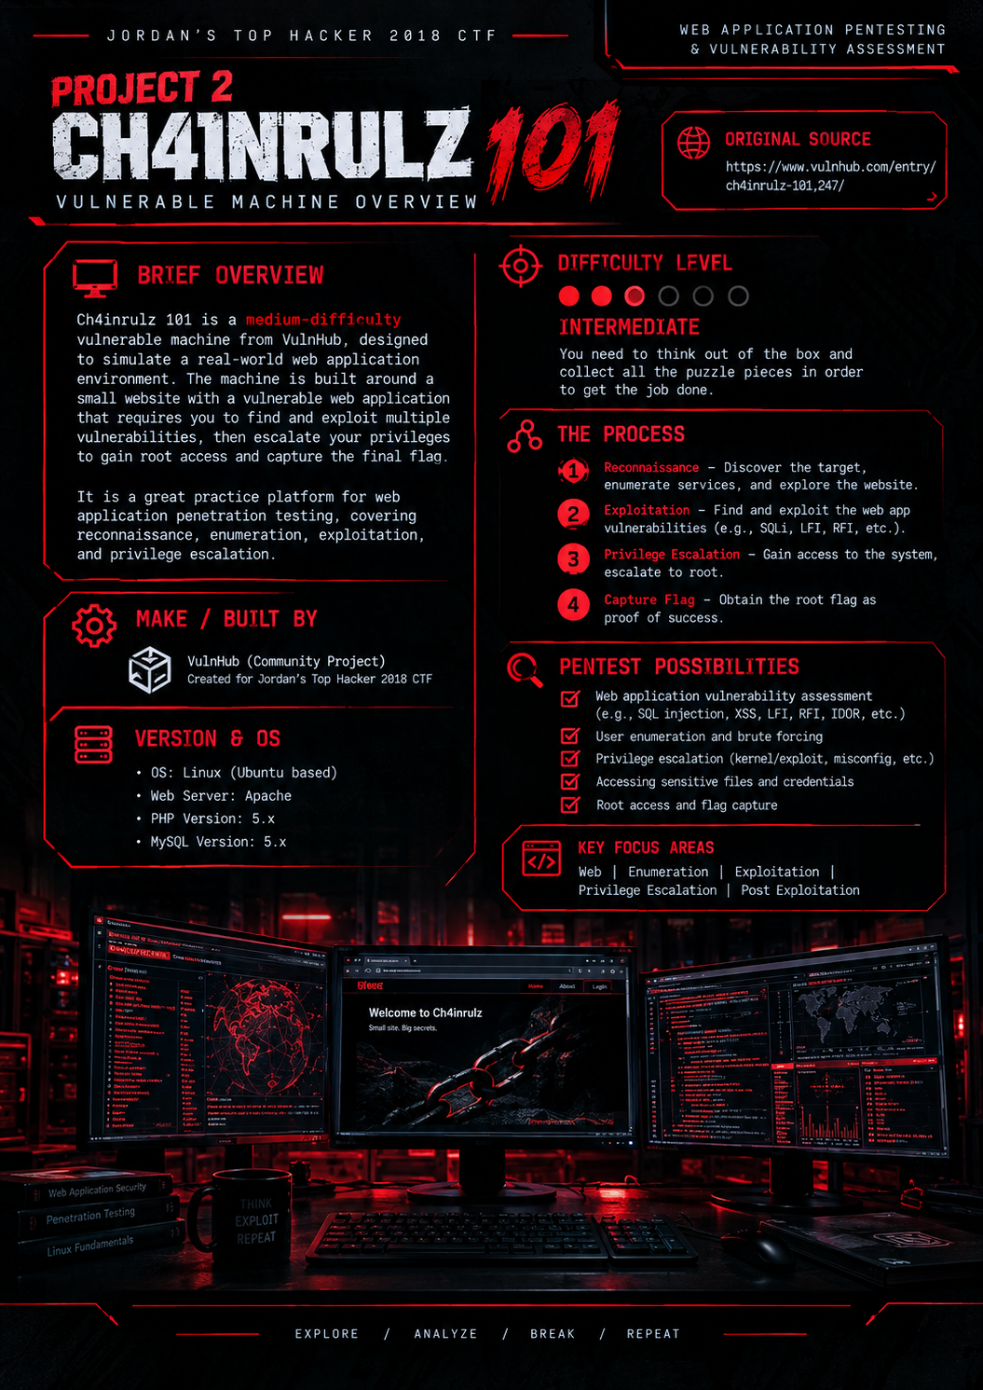

Table of Contents

1 Enumeration
1.1 Network Discovery and Service Enumeration
1.2 FTP Service Assessment
1.3 Web Application Enumeration
1.4 Development Server and API Discovery
1.5 Web Server Scanning and Credential Discovery
1.6 Authenticated Area and Uploader Discovery

2 Exploitation
2.1 File Upload Vulnerability
2.2 Request Manipulation and File Path Testing
2.3 Reverse Shell Trigger and Initial Access
2.4 User Level Access

3 Privilege Escalation
3.1 Local Enumeration
3.2 Meterpreter Payload and Root Access

4 Conclusion

1 Enumeration
ENUMERATION
Firstly, to attack any target, we must first go through the steps of footprinting, enumeration and scanning to recognize and identify possible vulnerability of a system. We can identify the network ip address by sudo netdiscover -I eth0:
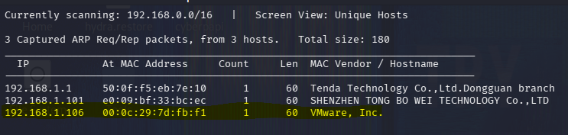

1.1 Network Discovery and Service Enumeration
We have identified the ip address 192.168.1.106. Now lets run a complete nmap scan on this IP with version and port scans.
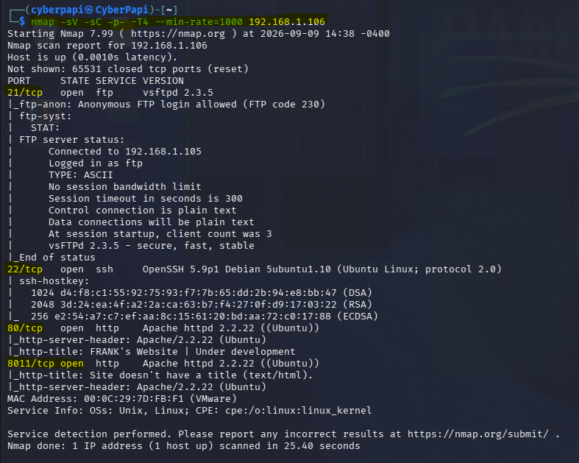
We have identified several ports that are open; port 21 tcp, port 80 tcp there is a possible ssh bruteforce entry point in one of this ports. It also tells us anonymous login allowed. Nmap is telling us FTP service is using default username and password, we can start by exploiting the FTP service.
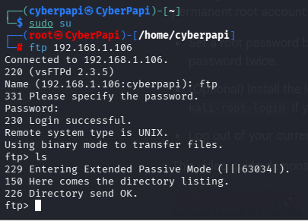

1.2 FTP Service Assessment
After using default ftp username and password I am able to login successfully, however when I try to find any files and look for available directories, there was zero results. But there is a clue here, we can use. The vsFTPd 2.3.5 backdoor is an out dated one and we can exploit and try gaining root access.
We are using Metasploit for this.
Msfconsole>search exploit/unix/ftp/vsftpd_234_backdoor>set LHOST> set RHOSTS> exploit:
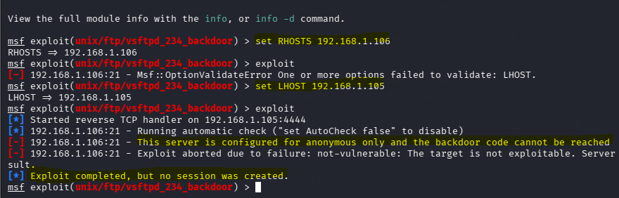
Unfortunately we couldn’t access the backdoor and exploit couldn’t open a shell session. So we are skipping this.

1.3 Web Application Enumeration
Since port 80 was found open we can check ways to exploit that. Lets first view the webpage and past the target ip on our browser.
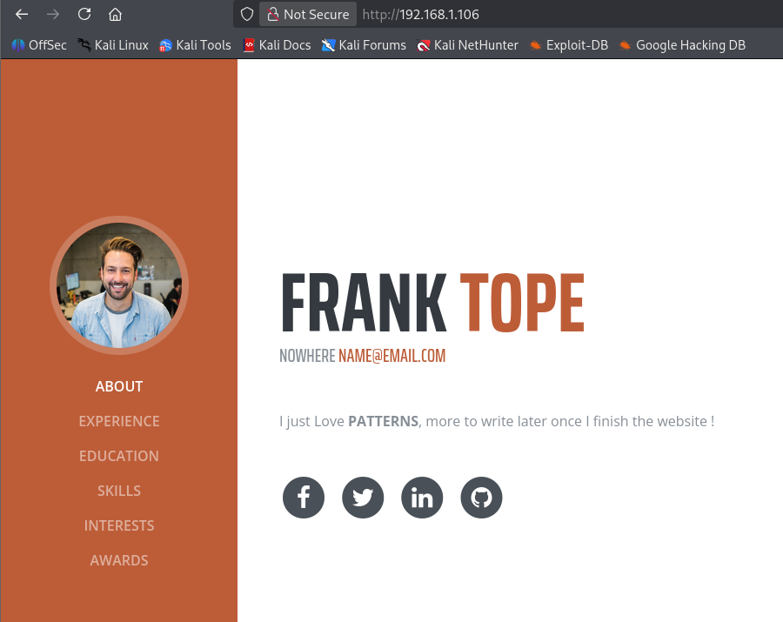
We have come across this beautiful web page of the developer. Lets examine the page source. Upon investigating the page source. Nothing interesting was found. So we go for further investigation using Dirb> Dirb http:/192.168.1.106
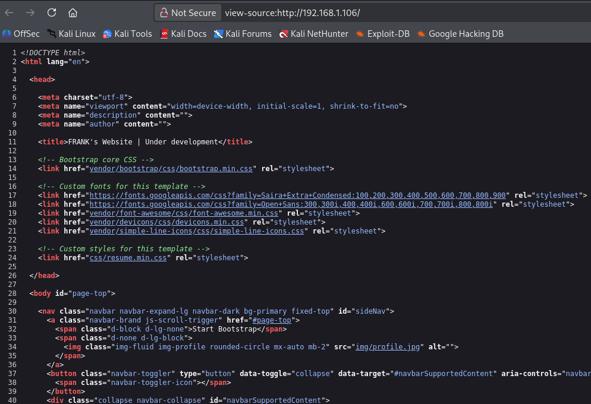
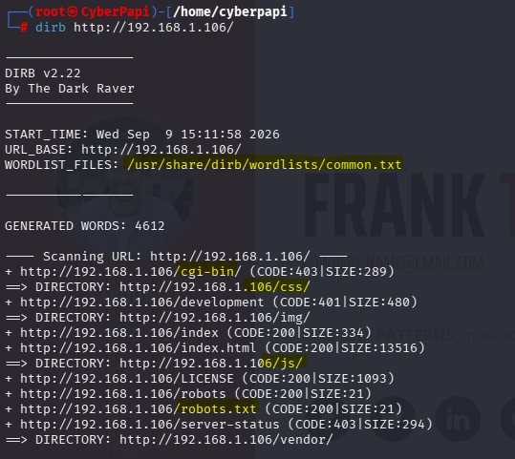
Upon further investigation we have found several interesting pages in which we find a particular interest http://192.168.1.106 when we try to open the link in browser we get prompted with a login pop up which requires username and password. 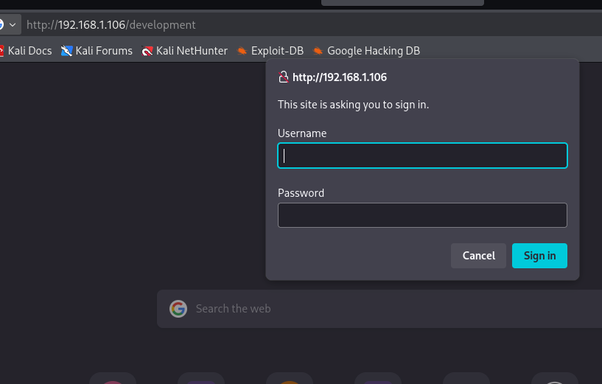
After trying some failed attempts with combinations of user and passwd, we can skip this for the time being and moving on to exploit the open ports.

1.4 Development Server and API Discovery
Previously we know that port 8011 is open so lets see what we can get after opening it in browser. We have come across the Development server, we can further scan this port using Dirb
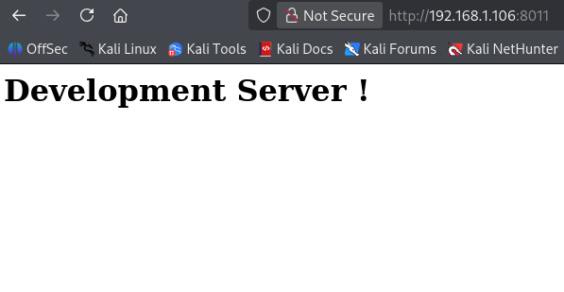
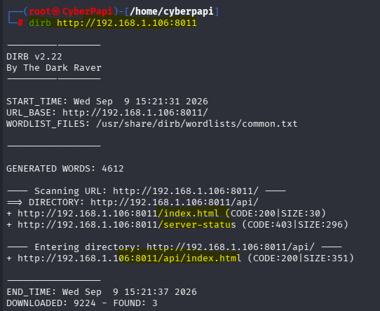
We can see the API directory from the scan results and now can browse this.
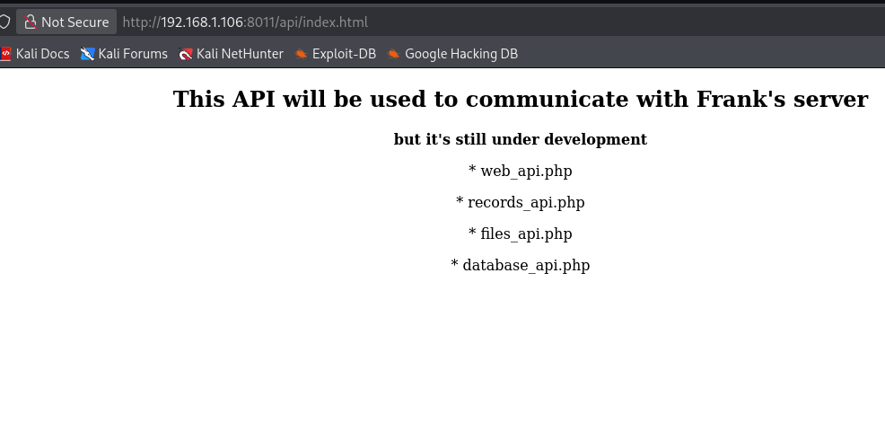
We can see some php files and after some browsing I can see the files_api.php showing some errors.
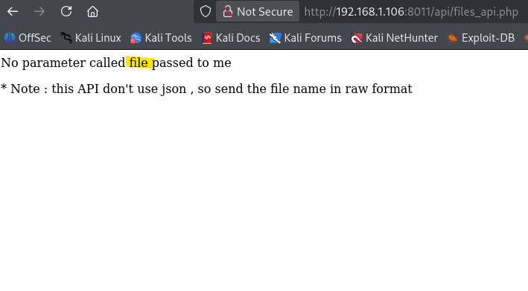

1.5 Web Server Scanning and Credential Discovery
So now we are going to do further enumeration using automated scanning tool nikto.
Nikto -h http:/192.168.1.106 and we have found some very interesting results.
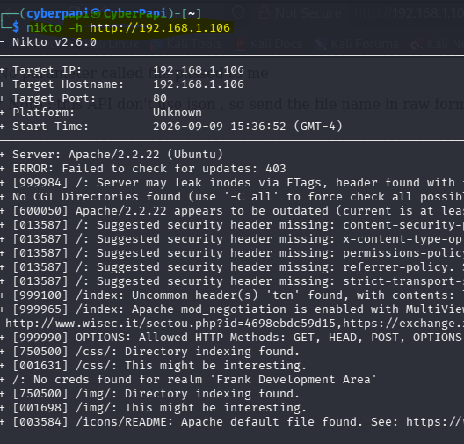
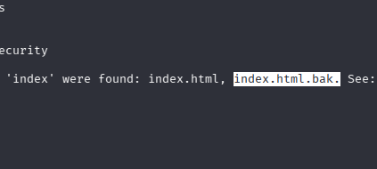
Lets further check this interesting html backup in our server.
Using curl we are able to identify a possible username and password record:
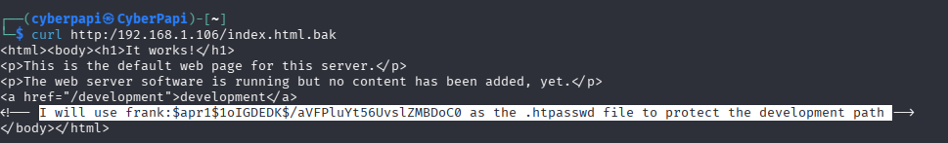
This is an ecrypted # value we can decrypt using john the ripper.
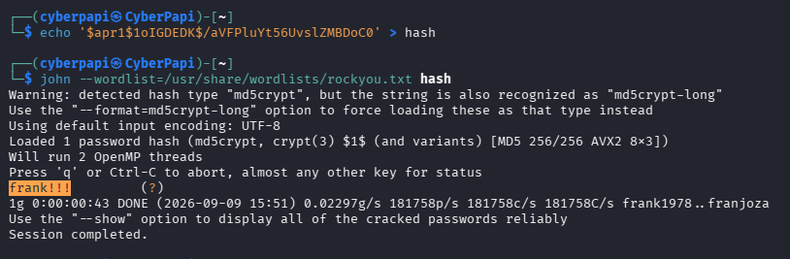
We have successfully decrypted the has file using the john’s wordlist. Now we know where to apply these cracked credentials in our previously found development page.
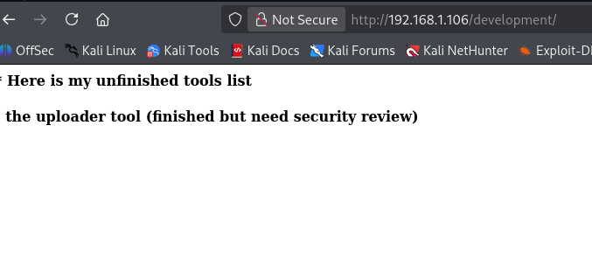

1.6 Authenticated Area and Uploader Discovery
We’re in, but this is a mere clue, so we need to find the uploader tool . lets use gobuster to find any web directory named uploader tool.

Using gobuster and the common wordlist in kali we are looking for html, php filer uploader, obviously we need to provide the credentials and we came up with the result.
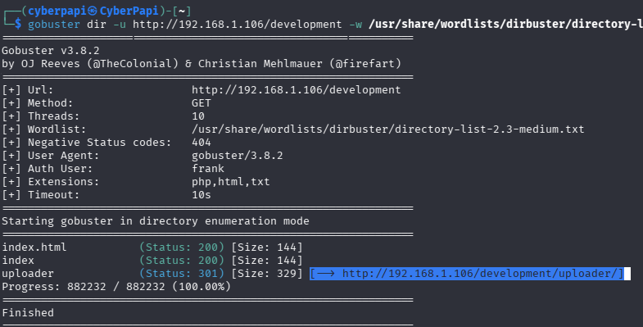
The uploader page directory. Now we can look up in the browser and see where it leads us.

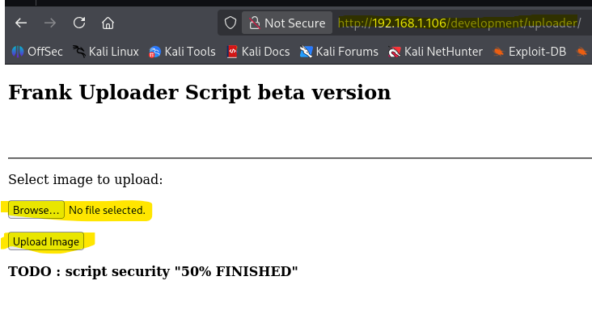

2 Exploitation

2.1 File Upload Vulnerability
We have a POST tab available. So we need to find the vulnerabilities of these file uploads. So we can get a malicious code injected into the upload files for that we need to modify a php reverse shell and hide it as a gif file.
So we copy the php.reverse_shell.php files from usr directory and modify it and add our own ip (kali) and change the port to 5555.
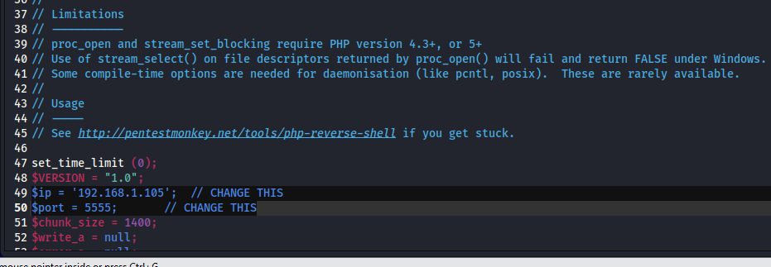
So in order to upload we need to mimic this into a gif file.
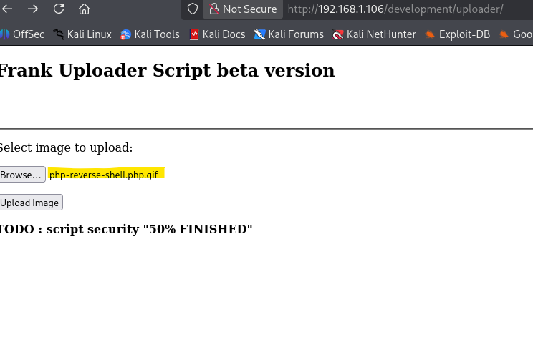
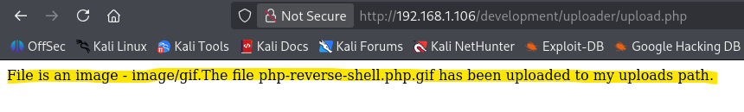
Image uploaded successfully. However we do not know where the file is uploaded. So we need to find out the directory where it is.
So next we can set up the listener using netcat sudo nc -nlvp 5555. Still we couldn’t find any directory.

2.2 Request Manipulation and File Path Testing
So we turn on our proxy and launch burpsuite. Turn on proxy and intercept on.
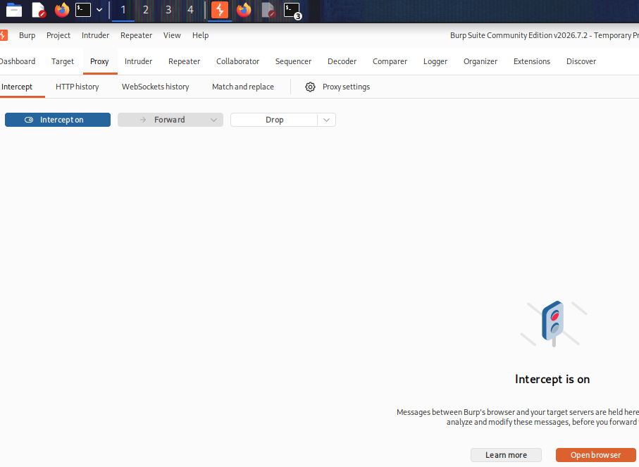
Then refresh the API page>send to repeater> change value to post>
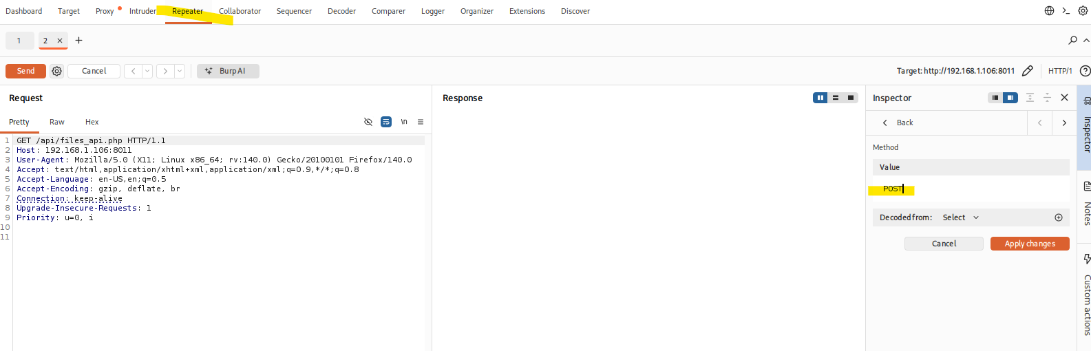
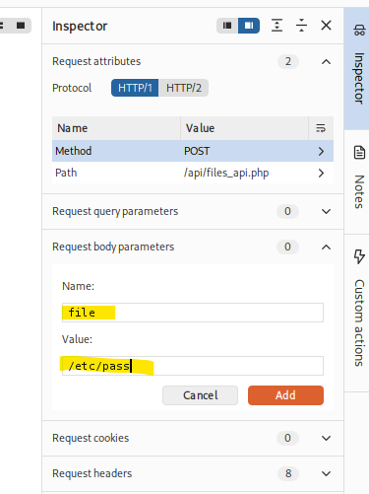 then we change the body parameters to file and /etc/passwd/.
And then send.
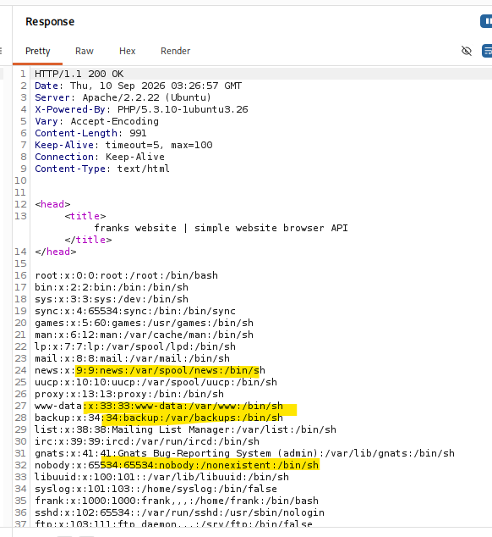
However we don’t have much vulnerability here to exploit or access any files.
So we cannot access or retrieve the log file.

2.3 Reverse Shell Trigger and Initial Access
But we remember the shell gif file we uploaded, so we change the body value to /var/www/development/uploads/FRANKuploads/shell.gif
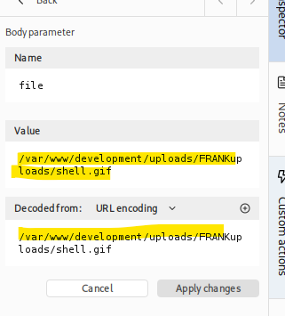
Next we need to set up a listener.
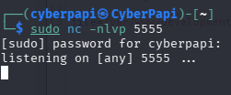
And now we can send the packets.
First we identify the path and run the command:
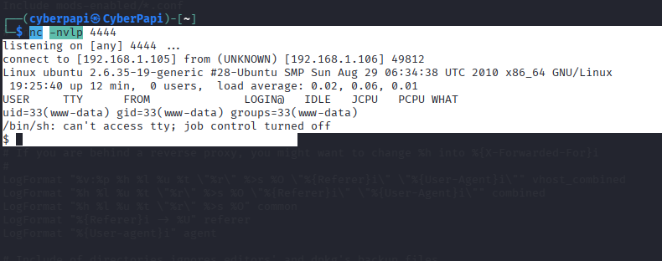
We are in!
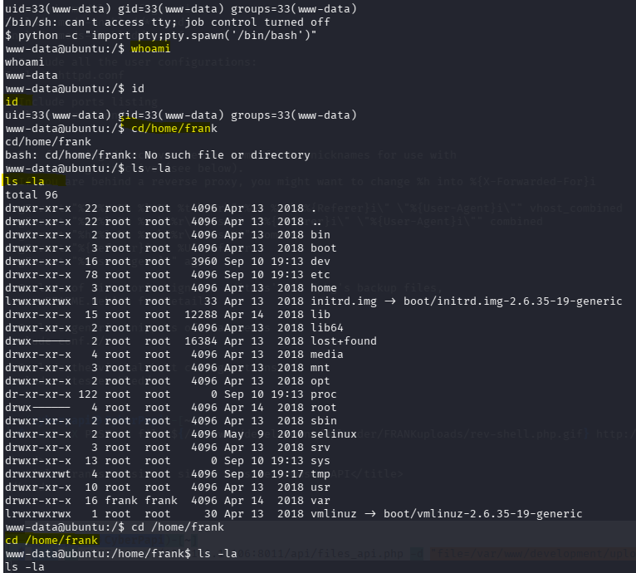

2.4 User Level Access
Running the cat txts
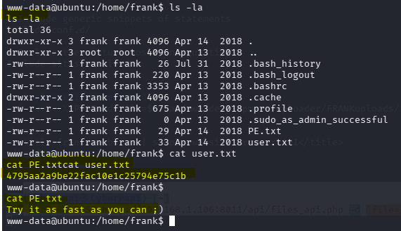
We escalated user by downloading a latest shell and running the command we got the flag!

3 Privilege Escalation

3.1 Local Enumeration
Escalate privilege: We need to run some commands to see we could get in with the kron/jobs so we try to find out some local vulnerabilities.
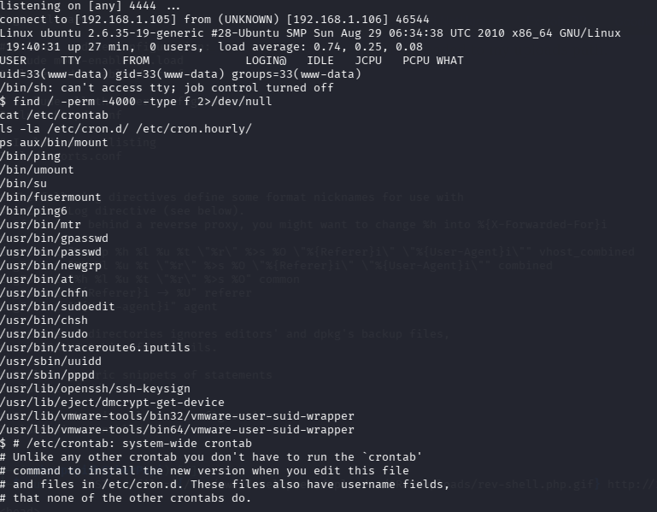
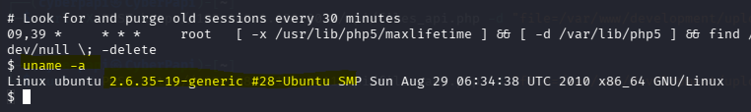
We also got the version name.

3.2 Meterpreter Payload and Root Access
Using msfvenom we are able to create a payload for meterpreter php. And inject into the fake gif.
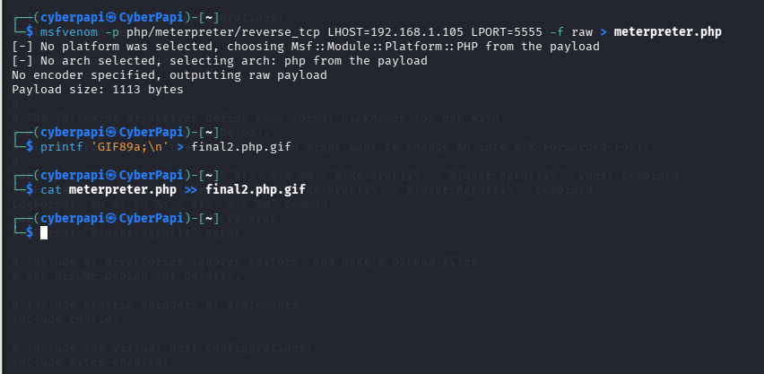
Now in msfconsole we are going to start a listener using multi handler.
Msfconsole> use exploit/multihandler> set payload php/meterpreter/reverse_tcp
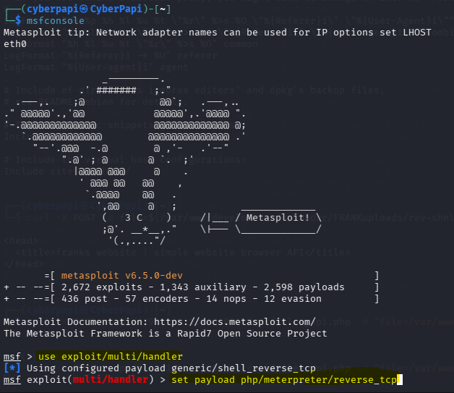
Now to trigger the payload we run on a different terminal: curl -X POST http://192.168.1.106:8011/api/files_api.php -d "file=/var/www/development/uploader/FRANKuploads/final2.php.gif"
Then we open a server from kali and upload the exploit file and once downloaded and run we get root.
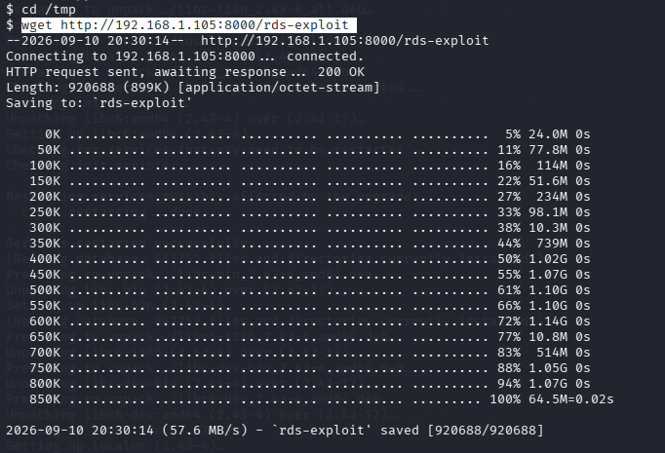
Running the file
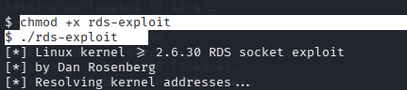
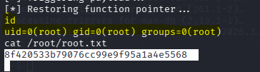
The root flag : 8f420533b79076cc99e9f95a1a4e5568

4 Conclusion
Conclusion
In conclusion, the ch4inrulz 1.0.1 machine demonstrated a realistic chain of vulnerabilities that required methodical enumeration, exploitation, and privilege escalation to achieve full system compromise. Initial reconnaissance revealed two web services running on ports 80 and 8011, leading to the discovery of a file read API and a password-protected development directory. Through further enumeration, a cracked MD5 hash exposed valid credentials, granting access to a file upload functionality. By bypassing the upload filter using a double extension and GIF magic byte header, a PHP reverse shell was successfully uploaded and executed via the vulnerable API endpoint, establishing an initial foothold as the www-data user. From there, the kernel version was identified as Linux 2.6.35-19, an outdated and unpatched build vulnerable to CVE-2010-3904, a local privilege escalation flaw in the RDS protocol. Exploiting this vulnerability elevated privileges to root, completing the full compromise of the target. This exercise highlighted the critical importance of keeping systems patched and up to date, restricting unnecessary network services, implementing robust file upload validation, and securing sensitive credentials — all of which contributed to the successful exploitation of this machine.

