Project Overview

In a server environment, a user may only browse pages in the ‘public’ directory. In order to uphold good security and programming practice, the contents of this directory should be minimal. Anything the browser needs to access, must be in this folder, so that is why I imoved the resources here.

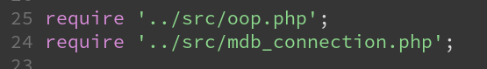
Within the php scripts in this folder, there should be little to no processing. Instead we import the functions from outside of the doccument root. The path names are relative so this works on both of our setups:

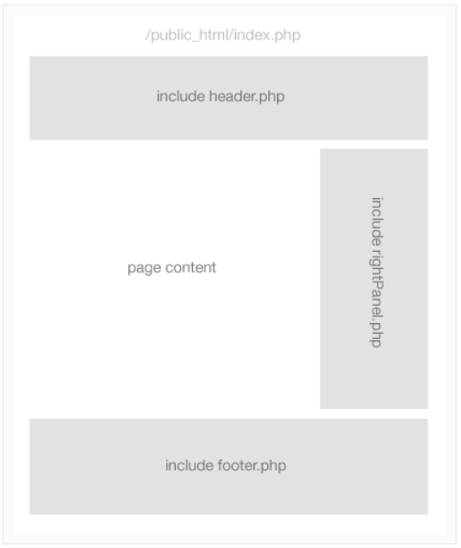
These are functions we can use. Later on we actually import the components of our page within the body tags:

This happens on the home page like this:
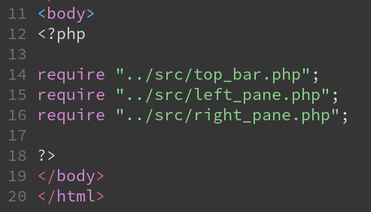

This means everything is modular, secure, dynamic and compartmentalised.

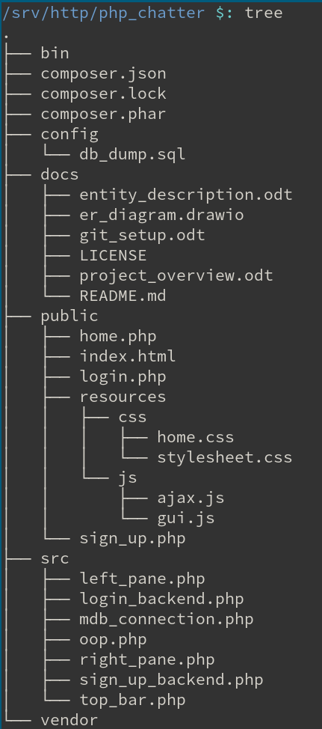

Ideally we create a new directory called templates. Functions and code snippets do in src/ but the actual html goes in templates/

