Entity Descriptions:

user (id, username, password, salt, last_login)
chat_user (user_id, chat_room_id, approved, chat_owner, chat_admin)
chat_room (id, name, pin)
message (id, owner_id, chat_room_id, text, time_stamp)
message_attachment (message_id, attachment id)
attachment (id, path, time_stamp)

Diagram:

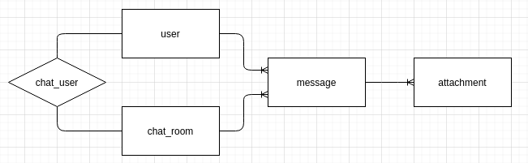

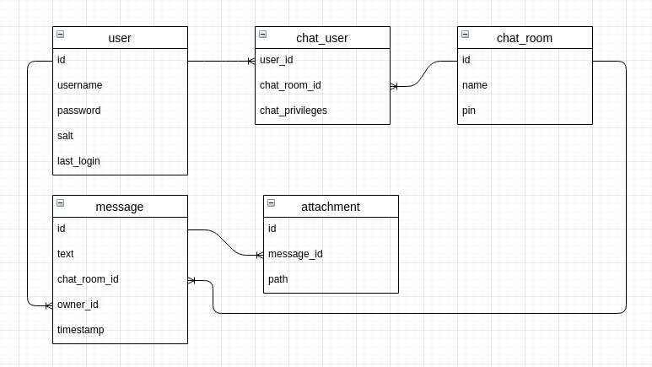

Normalisation:

The data is in first normalised form as no field in the database has more than one value.

The data is in second normalised from as each record has a unique identifier. e.g. user(id)

The data is in third normalised form as the data within tables depend on the key, the whole key and nothing but the key.
Data Dictionary:

user:

Field Name | Data Type | Constraints | Purpose
Id | int(255) | PRIMARY KEY  NOT NULL AUTO_INCREMENT | Unique identifier used to referece this user within other tables
username | varchar(255) | UNIQUE NOT NULL | This is unique as it is used to login to the site, however it is not used as an identifier within the system.
password | varchar(255) | NOT NULL | This stores the hashed concatenation of the password and the salt.
salt | int(255) | NOT NULL | stores the salt which was concatenated with the unhashed password.
last_online | timestamp | DEFAULT CURRENT_TIMESTAMP ON UPDATE CURRENT_TIMESTAMP | Used to identify when the user was last online.

chat_room:

Field Name | Data Type | Constraints | Purpose
id | int(255) | PRIMARY KEY  NOT NULL AUTO_INCREMENT | Used to identify this chat_room by other tables in the database.
name | varchar(255) | NOT NULL | Name is not unique identifier. Users can share the id to join, as well as the pin.
pin | varchar(255) | NOT NULL  DEFAULT ‘’ | Can be left blank. ‘’ does not equal NULL, so an empty string is used as no pin rather than NULL.

chat_user:

Field Name | Data Type | Constraints | Purpose
user_id | int(255) | NOT NULL  FOREIGN KEY (user_id) REFERENCES user (id)  ON DELETE CASCADE  ON UPDATE CASCADE | References a user record in the user table.
chat_room_id | int(255) | NOT NULL  FOREIGN KEY (chat_room_id) REFERENCES chat_room (id) ON DELETE CASCADE  ON UPDATE CASCADE | References a chat room in the chat_room table.
privileges | tinyint(1) | NOT NULL  DEFAULT ‘0’ | Defines a users privileges over chat. ‘0’ not approved; ‘1’ approved; ‘2’ admin; ‘3’ owner.

Message:

Field Name | Data Type | Constraints | Purpose
id | int(255) | NOT NULL AUTO_INCREMENT  PRIMARY KEY | Unique identifier for the message
owner_id | int(255) | NOT NULL  FOREIGN KEY (owner_id) REFERENCES user (id)  ON DELETE CASCADE  ON UPDATE CASCADE | Idenifies the sender by referencinfg a record in the user table.
chat_room_id | int(255) | NOT NULL  FOREIGN KEY (chat_room_id) REFERENCES chat_room (id)  ON DELETE CASCADE  ON UPDATE CASCADE | Idetifies the room which this message was sent in by referencing a record in the chat_user table.
message_text | text | NOT NULL | The contents of the message
time_stamp | timestamp | DEFAULT CURRENT_TIMESTAMP  ON UPDATE CURRENT_TIMESTAMP | Identifies when the message was sent.

attachment:

Field Name | Data Type | Constraints | Purpose
id | int(255) | PRIMARY KEY  NOT NULL  AUTO_INCREMENT | Unique identifier for an attachment (referenced in other table)
message_id | int (255) | FOREIGN KEY (message_id)  REFERENCES message (id) ON DELETE CASCADE  ON UPDATE CASCADE | Identify the message the attachment belongs to.
path | varchar(255) | NOT NULL | The path to where the file is stored on the server.

mysql / mariadb commands to create database:
mariadb –-version: mariadb Ver 15.1 Distrib 10.5.8-MariaDB, for Linux (x86_64) using readline 5.1

CREATE TABLE user (id int(255) NOT NULL AUTO_INCREMENT, username varchar(255) UNIQUE NOT NULL, password varchar(255) NOT NULL, salt int(255) NOT NULL, last_online timestamp DEFAULT CURRENT_TIMESTAMP ON UPDATE CURRENT_TIMESTAMP, PRIMARY KEY (id)) ENGINE = InnoDB;

CREATE TABLE chat_room (id int(255) NOT NULL AUTO_INCREMENT, name varchar(255) NOT NULL, pin varchar(255), salt int(255), PRIMARY KEY (id)) ENGINE = InnoDB;

CREATE TABLE chat_user (user_id int(255) NOT NULL, chat_room_id int(255) NOT NULL, privileges tinyint(1) NOT NULL DEFAULT 0, FOREIGN KEY (user_id) REFERENCES user (id) ON DELETE CASCADE ON UPDATE CASCADE, FOREIGN KEY (chat_room_id) REFERENCES chat_room (id) ON DELETE CASCADE ON UPDATE CASCADE) ENGINE = InnoDB;

CREATE TABLE message (id int(255) NOT NULL AUTO_INCREMENT, owner_id int(255) NOT NULL, chat_room_id int(255) NOT NULL, message_text text NOT NULL, time_stamp timestamp DEFAULT CURRENT_TIMESTAMP ON UPDATE CURRENT_TIMESTAMP, PRIMARY KEY (id), FOREIGN KEY (owner_id) REFERENCES user (id) ON DELETE CASCADE ON UPDATE CASCADE, FOREIGN KEY (chat_room_id) REFERENCES chat_room (id) ON DELETE CASCADE ON UPDATE CASCADE) ENGINE = InnoDB;

CREATE TABLE attachment (id int(255) NOT NULL AUTO_INCREMENT, message_id int(255) NOT NULL, path varchar(255) NOT NULL, PRIMARY KEY (id), FOREIGN KEY (message_id) REFERENCES message (id) ON DELETE CASCADE ON UPDATE CASCADE) ENGINE = InnoDB;

