Running TORTOISE (v2.5.2) for DTI data pre-processing
by PA Taylor (Aug. 2016)

These are example instructions for using TORTOISE (at present, v2.5.2) for DWI preprocessing. We mostly make use of default options therein. This is not an official set of steps-- please see the TORTOISE website for those. These notes take up from the online AFNI-FATCAT help. We describe taking a set of AP and PA phase encoded DWI data sets (TORTOISE calls these blip-down and blip-up) and:
1) processing each for subject motion/eddy current/etc. distortion (→DIFF_PREP run on each);
2) gluing the AP and PA sets together (→ DR-BUDDI);
3) exporting the results to an AFNI/NIFTI format (with DIFF_CALC);
… after which results can be used for calculating DTs, DTI parameters and a basic tractography with AFNI-FATCAT (see online AFNI webpage tutorial).

NB: if you don't have both AP and PA data sets, these instructions can still be used to get you through the DIFF_PREP part for the single set, and then go to the DIFF_CALC part.

These instructions are long because they are verbose, show lots of screen images of the GUI and terminal, and cover a few different steps. It is probably overly didactic, and users will get comfortable quite quickly with TORTOISE and not need (or want) to refer to it. So, don't fret.

In preparation for processing, we need to have the following data sets for any subject:
+ a reference T2w structural scan-- if this is not available, but a T1w image is, then an 'imitation T2'
can be made (see online AFNI webpage tutorial);
+ a set of AP phase encoded DWIs;
+ (optional) a set of PA phase encoded DWIs with same grads as that of AP.

DWI formats/organization for any subject:
To start, we assume that each set of N AP and/or PA DWIs is sitting in its own directory, with only the following 3 files present and in these specific formats (essentially, resembling the output of dcm2nii):
1) a 4D volumetric data set of the N DWI images (includes b₀s); must be a *.nii file, not *.nii.gz;
2) a gradient (*.bvec) text file of 3 rows and N values per row;
3) a b-value (*.bval) text file of 1 row and N values per row.

Note: official TORTOISE documentation recommends loading DICOM files directly into the software, to reduce chances of misreading header information (orientation, slice order, voxel size, etc.). We have converted to NIFTI to be able to view+kick out bad volumes and visually inspect data afterwards to make sure nothing has gone wrong (if something does, then we know we might have to load DICOMs in directly).

LHS = lefthand side
RHS = righthand side

Comments:

1) In order to run, DIFF_PREP requires a "Settings File" (*.dmc), which TORTOISE will look for by default in the following directory:
~/DIFF_PREP_WORK/
There is an example online here:
https://science.nichd.nih.gov/confluence/display/nihpd/3.2.01+Sample+registration+settings+file
This is pretty much what I generally use; probably one thing that could be changed would be saving intermediate outputs, because they take up several gigabytes of space per run (but then it would be harder to troubleshoot any problems).

2) The final output spatial resolution of the DWI data can also be set in the *.dmc settings file. Based on advice from the TORTOISE gurus, a bit of upsampling is generally advisable. For example, I often go from 2 mm isotropic (acquired) to 1.5 mm isotropic (after processing). Upsampling a lot can lead to huge memory and time demands when processing.

3) If loading in DWIs as NIFTIs, there must be a directory with a single *.nii data file, *.bvec gradient file, and *.bval b-value file. TORTOISE looks for these specific extensions-- once you enter the *.nii file into the GUI, it will expect to be able to find the other two text files in the same directory. NIFTI files cannot be zipped.

4) TORTOISE will make a processing directory based on the name of the entered *.nii file (in DIFF_PREP) or the entered list file (if DR-BUDDI). For example, if the NIFTI is named “CHEESE_BURGER.nii” and in a directory called “FOOD_DWI/”, then the output directory will be called “CHEESE_BURGER_proc/”, and this will be parallel to “FOOD_DWI/”.

A) RUNNING TORTOISE: DIFF_PREP
NB: This DIFF_PREP step would be run separately on each the AP and PA set of DWIs (the filtered sets, if filtering was performed). In this example, we just go through the DIFF_PREP steps for the 'AP' set-- the same set of steps applies to the PA case. Both runs of DIFF_PREP could be run simultaneously on the AP and PA sets (subject to computational power/memory; there is no interaction among them, and you will need both for the next step).

A1) Starting DIFF_PREP: stage one, to be run on a set of DWIs, using T2w for reference.
Go to diffprep_main/ directory of TORTOISE on the computer, and start the virtual machine by typing “./prepvm” on the command line:
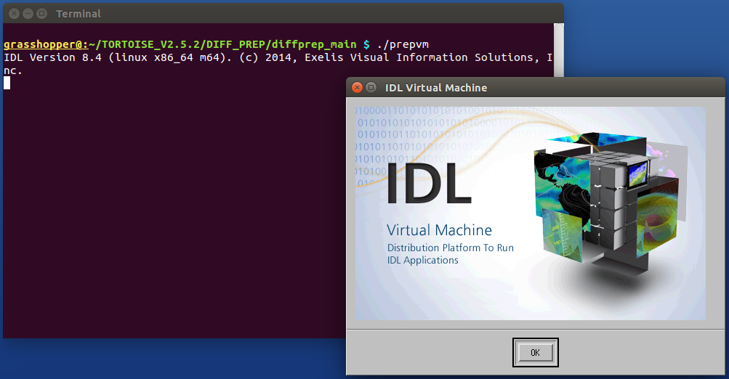
and start the IDL (ugh) virtual machine by hitting “OK”.

A2) The DIFF_PREP GUI: where basic information gets loaded in.
This will start a two step process: importing (DWI) data in the left column, and then the structural data and running options file in the right column.

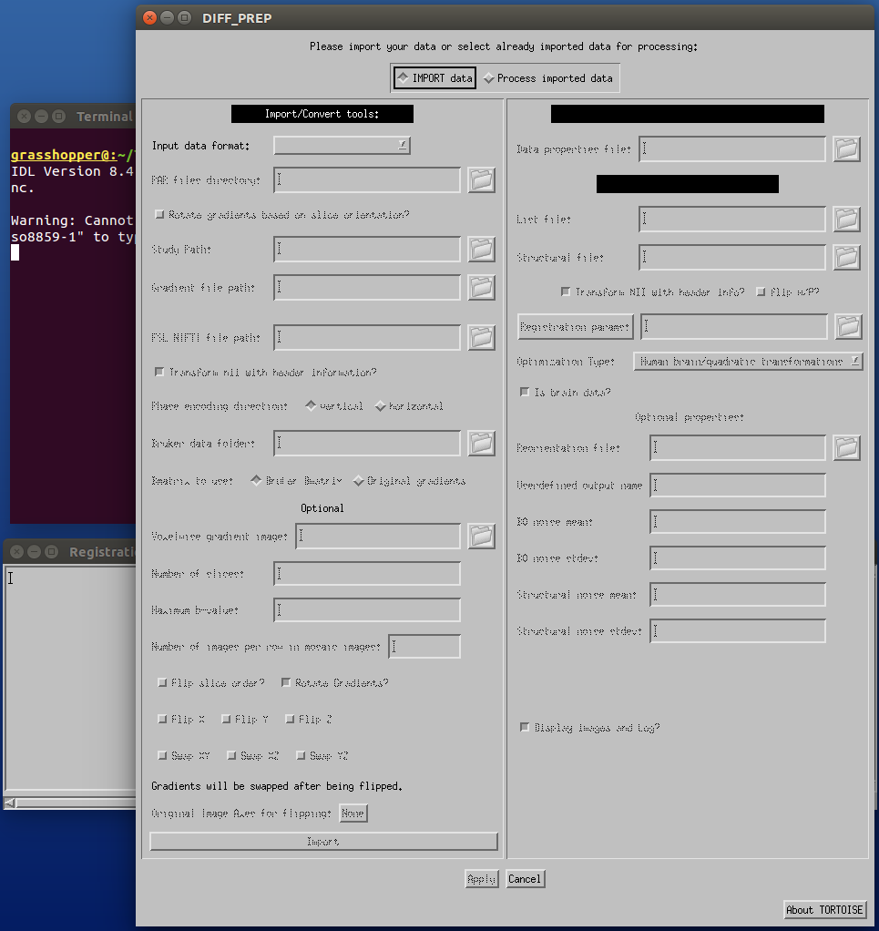

A3) DIFF_PREP GUI LHS: Import data.
From 'Input data format' dropdown list, select 'FSL 4D NIFTI'. This unfreezes the 'FSL NIFTI file path:' box, and click on the folder icon there. Then navigate in the file structure to where your input DWI NIFTI file of interest is (here, AP.nii). The *bval and *bvec files must be in the same directory, and the NIFTI file cannot be zipped (*.nii.gz). After selecting the correct file, click “OK”:
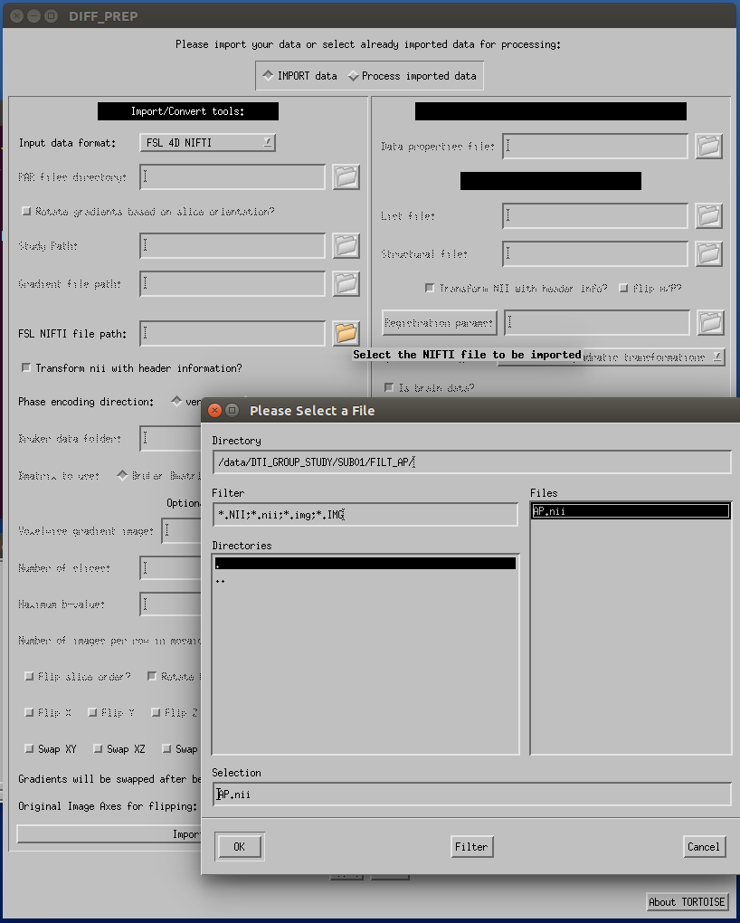
A4) DIFF_PREP GUI: Import data.
After the NIFTI file path has been given, (probably) nothing else has to be selected on the LHS, and you can select the 'Import' button at the bottom of the left column.
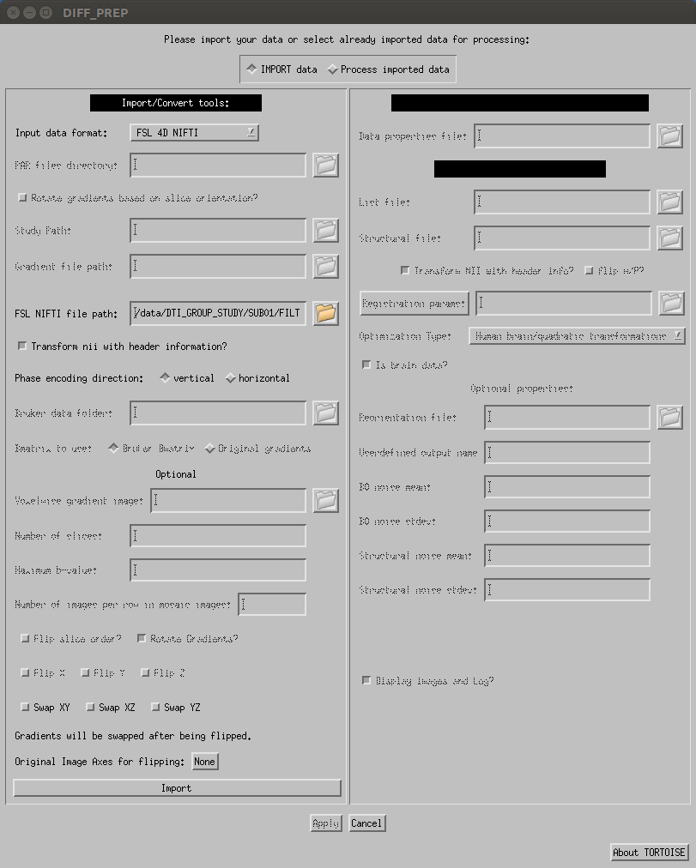
A5) DIFF_PREP GUI: Process imported data.
After importing the data successfully on the LHS of the GUI, the RHS (“Process imported data”) unfreezes. The 'List file' should have been automatically populated. At this point, we will just need to load in the 'Structural file' and the 'Registration params'. Start by clicking on the folder to the right of “Structural file,” and navigating the file structure to where the T2w reference anatomical is (again, unzipped NIFTI file, only). After selecting the correct file, click “OK”:
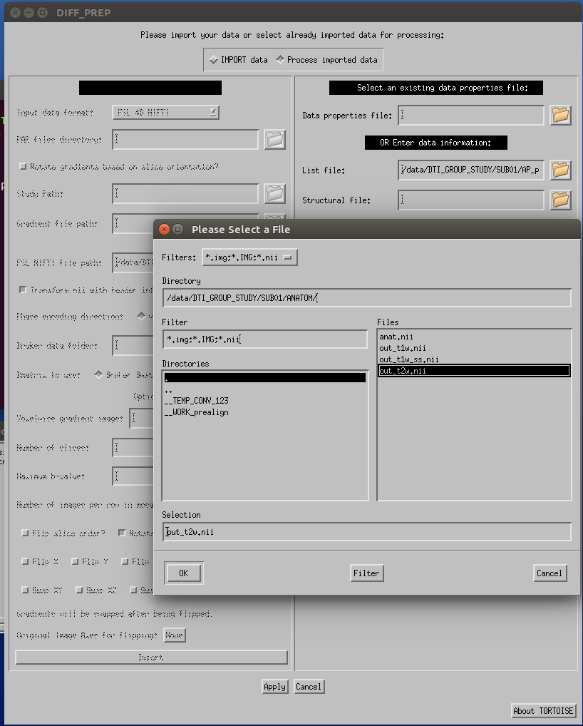

A6) DIFF_PREP GUI: registration parameters.
Click on the folder icon by the 'Registration params:' option. A selection GUI should open up the ~/DIFF_PREP_WORK directory. Select a desired file (here, “FOR_DIFF_PREP_T2REG_1.5.dmc”) and click “OK”. You are then all set, and you can click “Apply” at the bottom of the GUI (sometimes I first unselect “Display images and Log” of the bottom of the GUI just to not have windows opening).
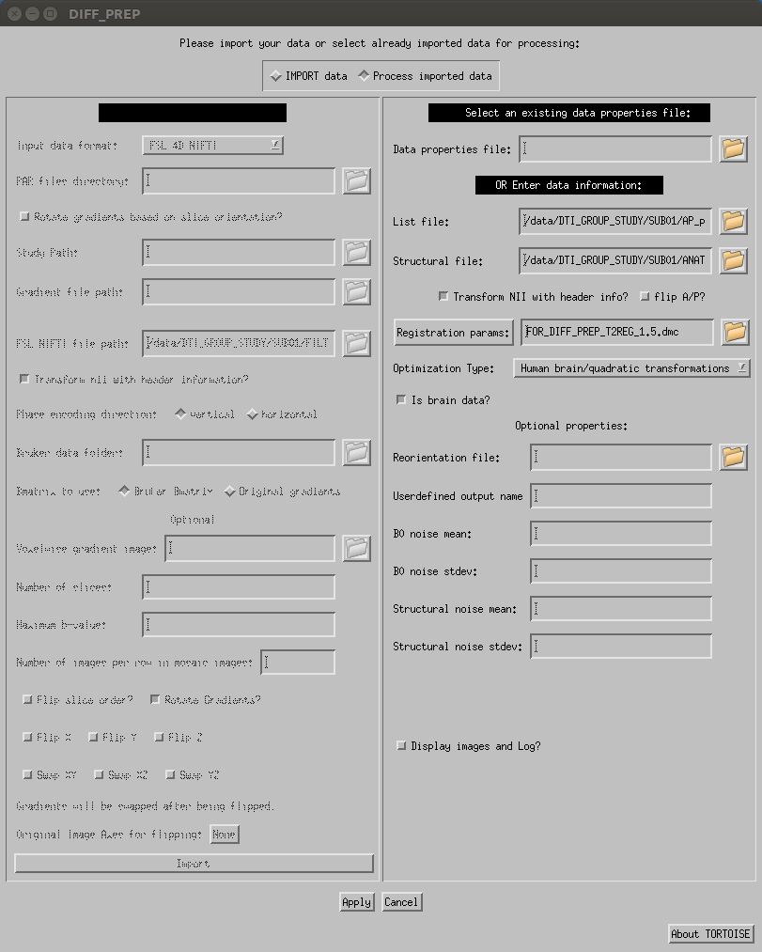
NB: The default *.dmc settings do keep a lot of intermediate files, which can take up 10GB or more per subject; likely not necessary to keep all those. I usually purge most of them afterwards. You could change what intermediate files are kept in the *.dmc settings file.
A7) DIFF_PREP running+finishing.
The large GUI closes, and the gray 'Registration Status Report Window' remains open, with things churning by in the terminal. It may take a few+ hours or more per data set, depending on the number DWIs, the spatial resolution, and the amount of distortion.

When DIFF_PREP has finished running successfully, the remaining gray GUI closes, and you WILL see an error about 'arithmetic error: Floating underflow' in the terminal. That's just part of the joy of IDL. The following is a standard example of the terminal output at the end:
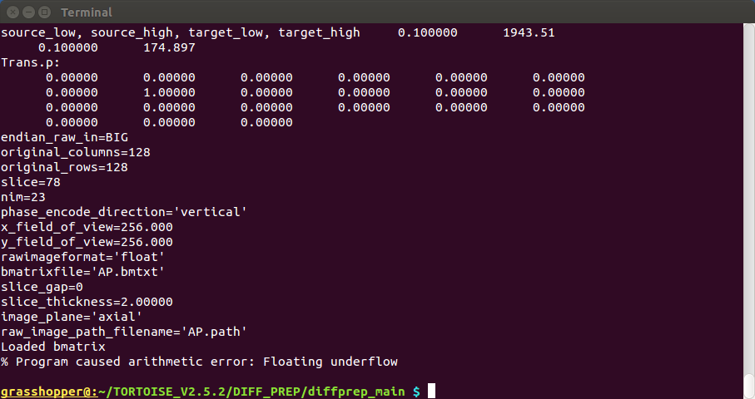
DIFF_PREP will have made a directory parallel to the one holding the input NIFTI data, whose name is composed of the name of the NIFTI file and the postfix '_proc' (in the case of this example, the output directory will be /data/DTI_GROUP_STUDY/SUB01/AP_proc/). This is an image of the AP_proc file structure (and you might notice SUB01 contains a PA_proc directory, because I ran DIFF_PREP on that separately):
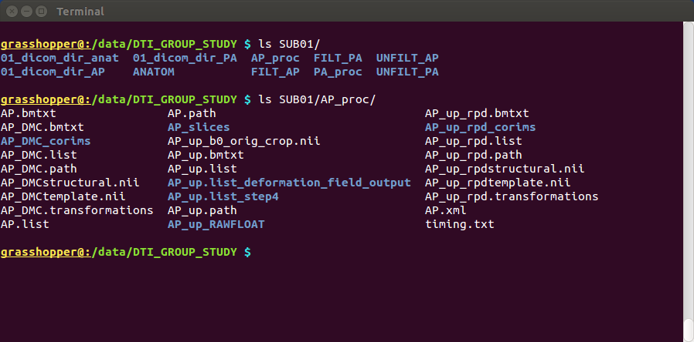
… And the DIFF_PREP stage is complete. If you don't have both AP and PA data, skip the the Part B “DR_BUDDI” and go to exporting data into usable formats in Part C “DIFF_CALC”.
B) RUNNING TORTOISE: DR_BUDDI
After DIFF_PREP has been run separately on the subject's AP and PA DWI sets, we can now perform the actual EPI distortion correction using TORTOISE's DR-BUDDI tool on the pair of sets (including the anatomical for reference/registration).

B1) open the DR-BUDDI GUI.
From the same DIFF_PREP/diffprep_main/ directory, fire up the IDL virtual machine using './dr_buddi_vm'.

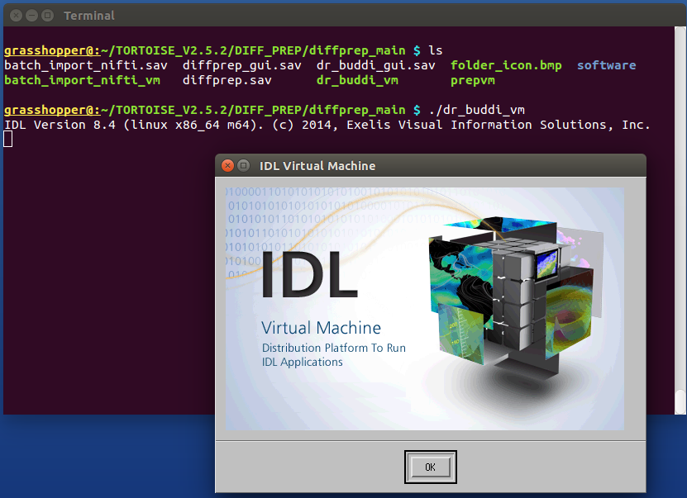

B2) DR-BUDDI GUI.
This opens the DR-BUDDI GUI:
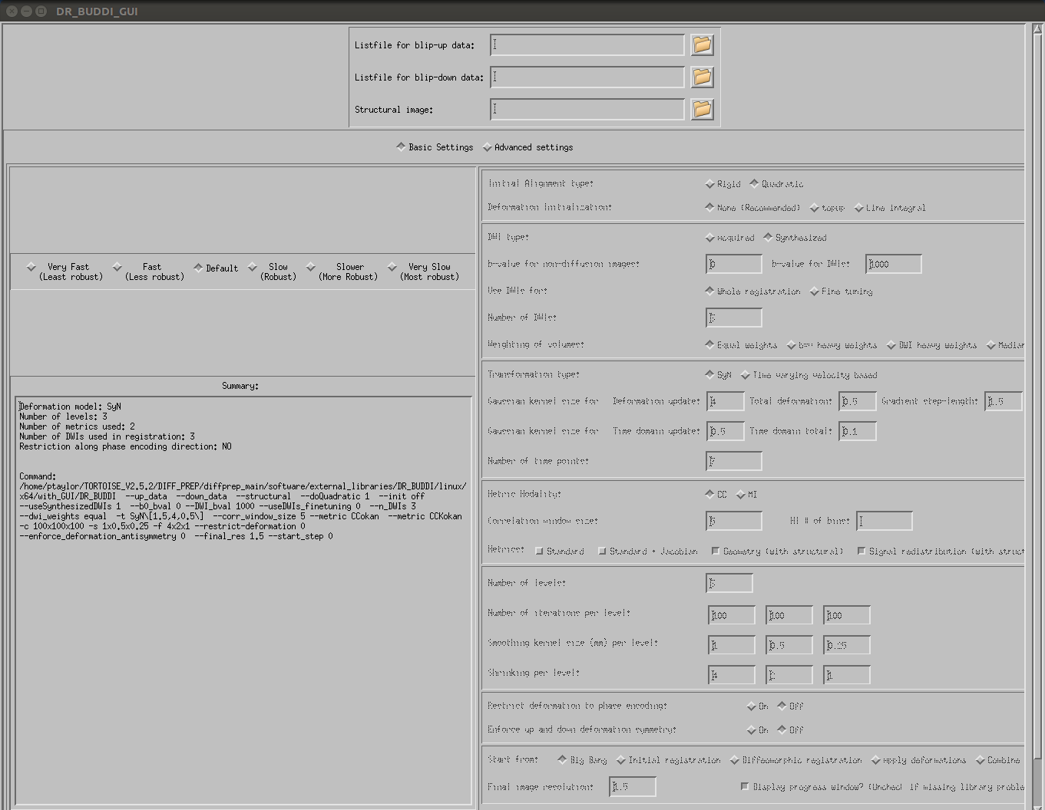
We will use pretty much all the defaults and just enter the locations of the “Listfiles” of the blip-up/blip-down (what we've mainly been calling AP/PA) data from the DIFF_PREP runs, as well as the T2w NIFTI volume that we had used previously.
B3) DR-BUDDI: blip-up data.
Click on the folder icon for loading in 'Listfile for blip-down data:'. For the subject being processed, go in to the DIFF_PREP-processed PA directory (SUB01/PA_proc/), and select the 'PA_up.list' there. Then click OK.
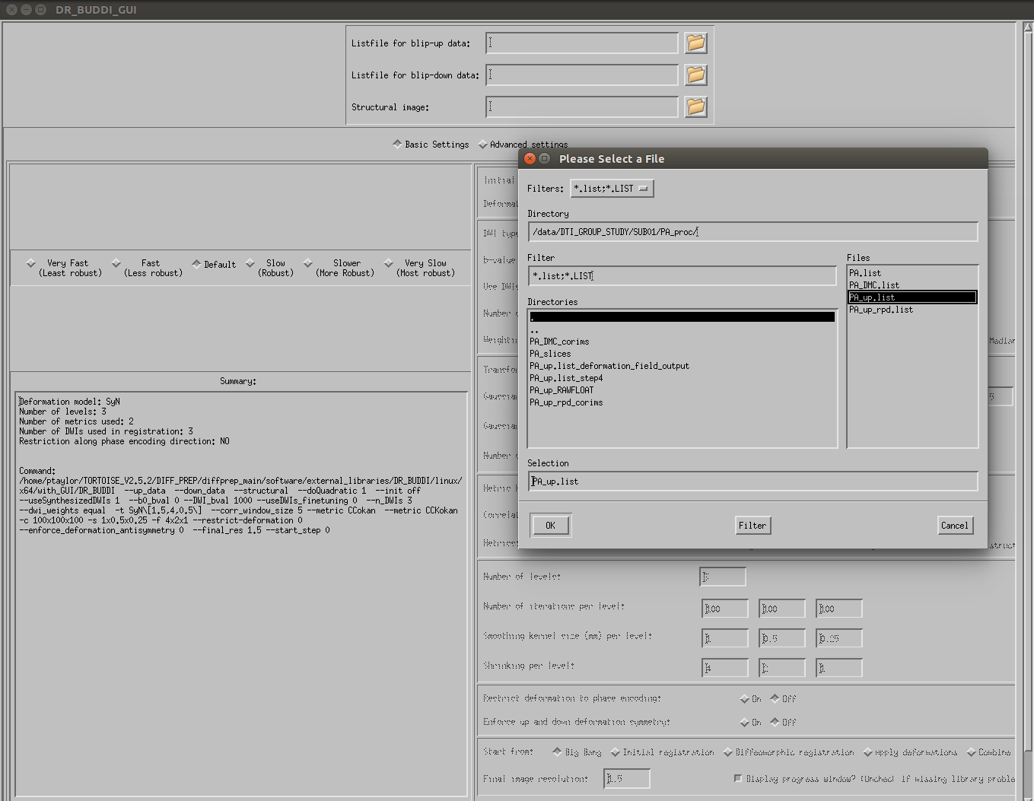
B4) DR-BUDDI: blip-down data.
Essentially, repeat the previous step for the other blipped data--
Click on the folder icon for loading in 'Listfile for blip-down data:'. For the subject being processed, go into the DIFF_PREP-processed AP directory ([somewhere]/AP_proc/), and select the 'AP_up.list' there. Then click OK.

B5) DR-BUDDI: structural data.
Click on the folder icon for loading in 'Structural image', and then click OK.
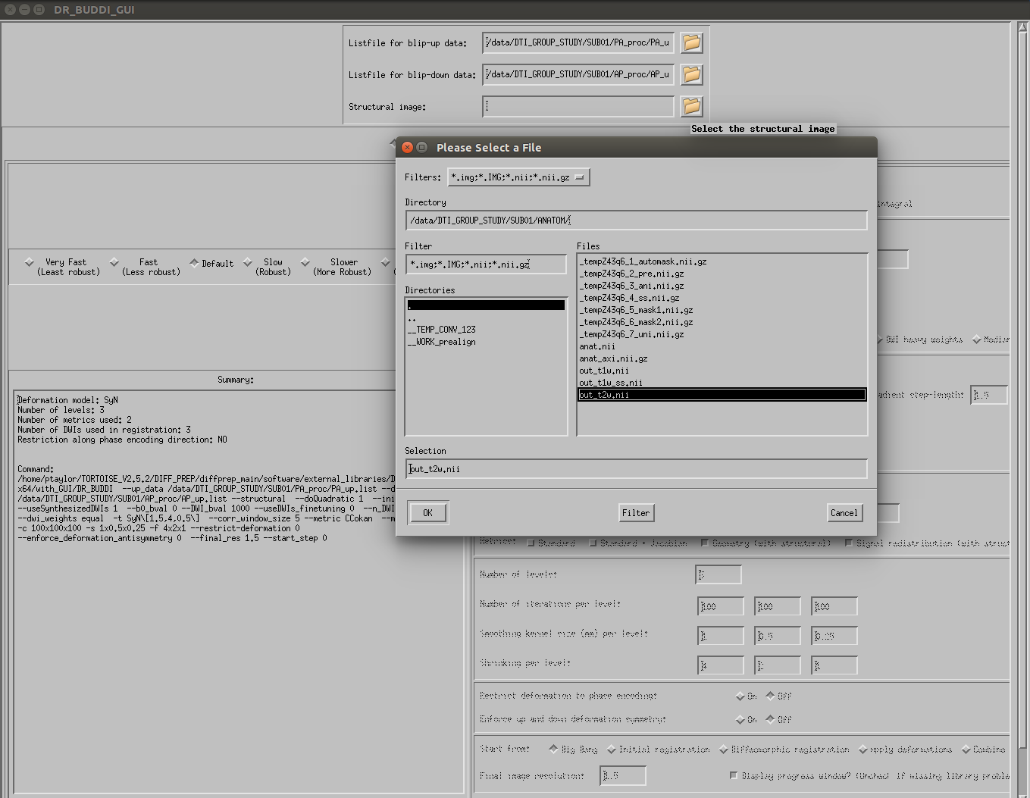

B6) DR-BUDDI: running.
I typically leave the remaining options/settings at their default values. You can select your degree of Fast/Default/Slow speed for the relative robustness you want. Then click 'Run' at the bottom (you might have to scroll down in the menu to see it, depending on your screen size/resolution):
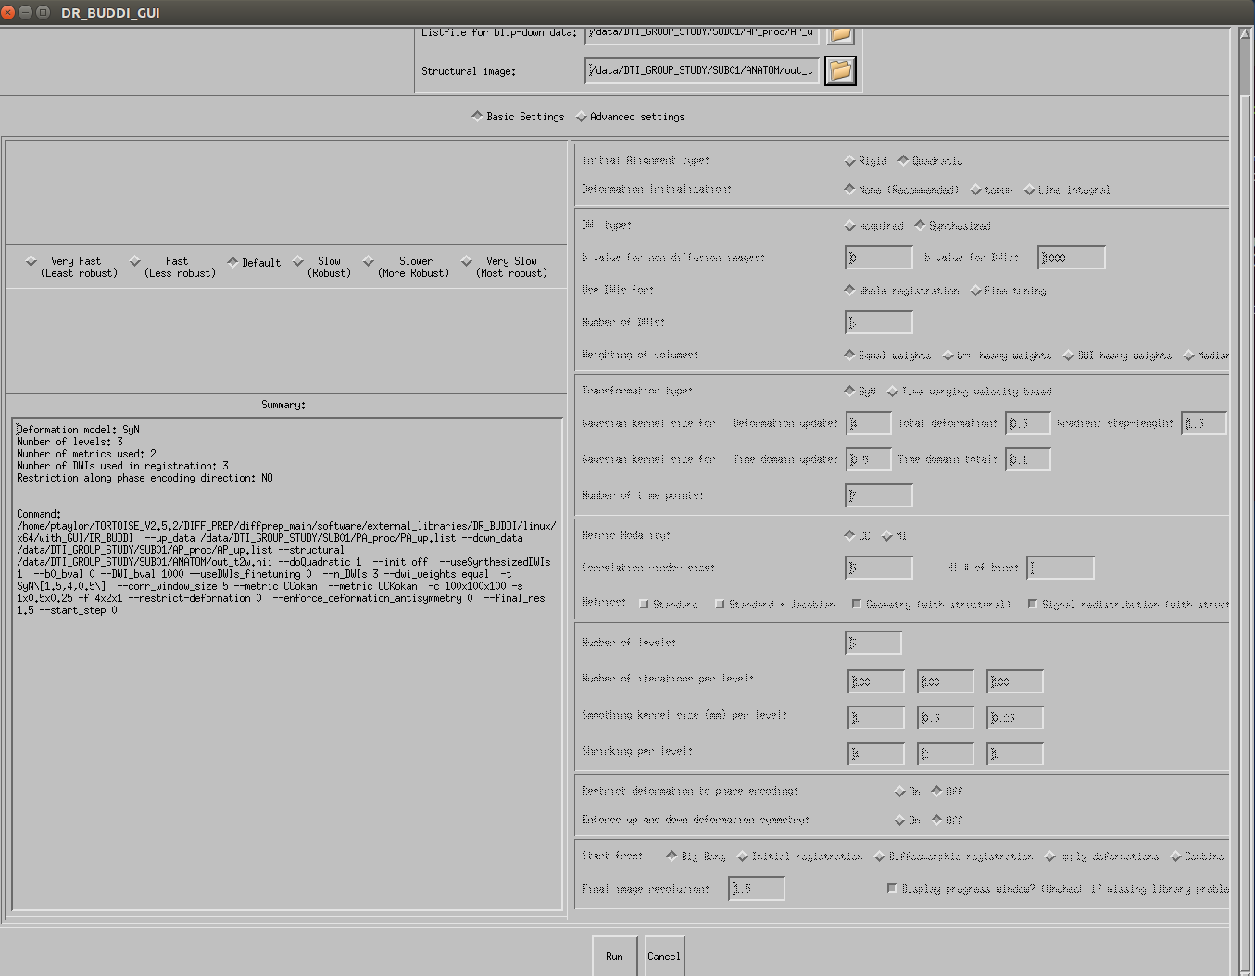
B7) DR-BUDDI: running/finishing.
Once running, the main GUI closes, some brain images might appear in a new window, and there is a stream of text in the terminal. DR-BUDDI will likely take many hours to run, again, depending on the number of DWIs, voxel resolution, quality of data, chosen method, etc. DR-BUDDI should finish with a relatively happy message:
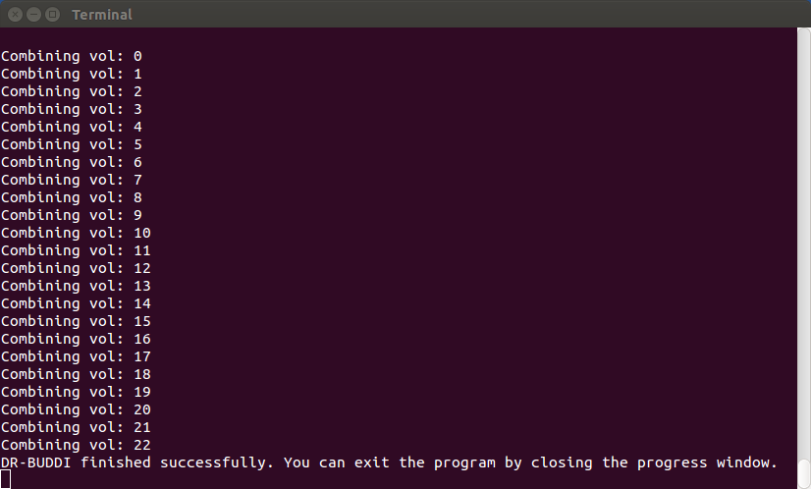
Note that earlier versions of TORTOISE finished more discreetly, without the final line's string.

The final results are stored in a TORTOISE-made directory, parallel to the DIFF_PREP-produced ones. The name will be derived from the blip-up filename, plus 'up_bupdown_proc' as a postfix:
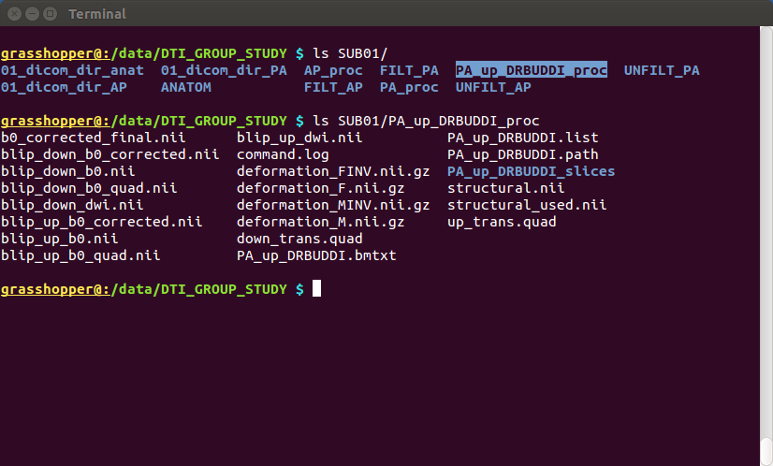
The next step will be to convert the results to usable NIFTIs...
C) RUNNING TORTOISE: DIFF_CALC
After finishing with either DIFF_PREP or DR-BUDDI, the processed data can now be exported. In this case, we will just use DIFF_CALC to export a DWI NIFTI file and the gradient information; we won't do further, fancier processing with RESTORE and tensor fits, etc. But that is possible, if you wish.

C1) Starting DIFF_CALC GUI.
Go into the DIFF_CALC/diffcalc_main/ directory within TORTOISE, and enter './calcvm' on the command line. Click “OK” on the text box to open the GUI:
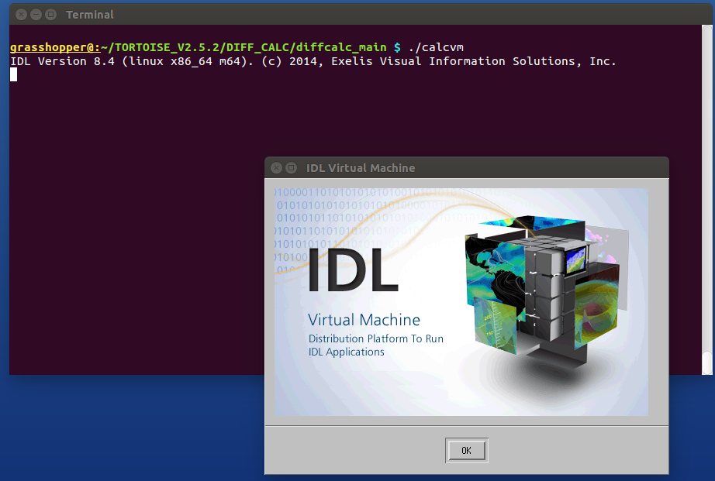
.
C2) DIFF_CALC GUI: loading in listfile of data to convert.
The following windows appear. Click on 'load listfile' to select the processed results you want to enter.
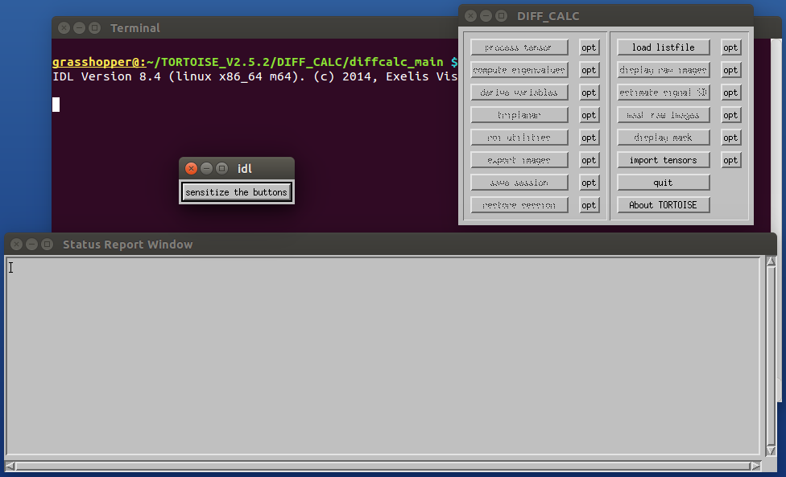
C3) Entering listfile of processed data.
In the window that opens, navigate to the *_proc/ directory that you want to export from.
A) If you are exporting data from DIFF_PREP, select the *_DMC.list listfile from that directory. This is an example of exporting data from DIFF_PREP (from AP_proc/), after which hit “OK”:
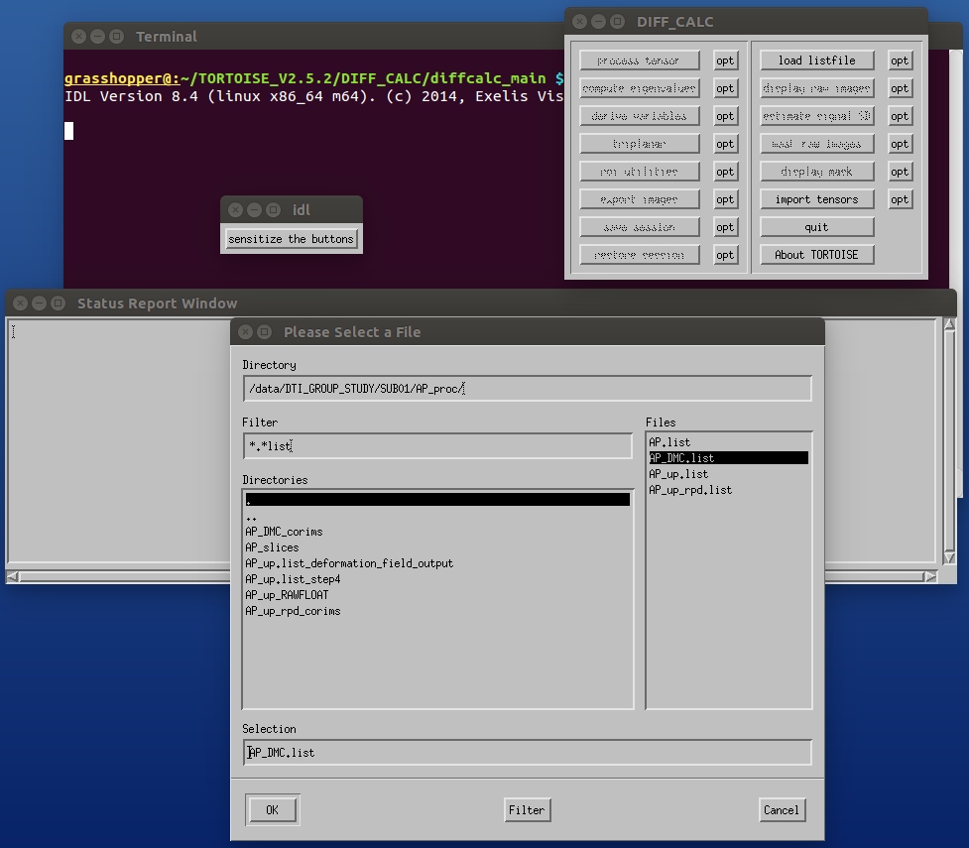
B) If you are exporting data from DR-BUDDI, select the *up_BUDDI.list file in the directory it created (here, from PA_up_DRBUDDI_proc/), and then hit “OK”:
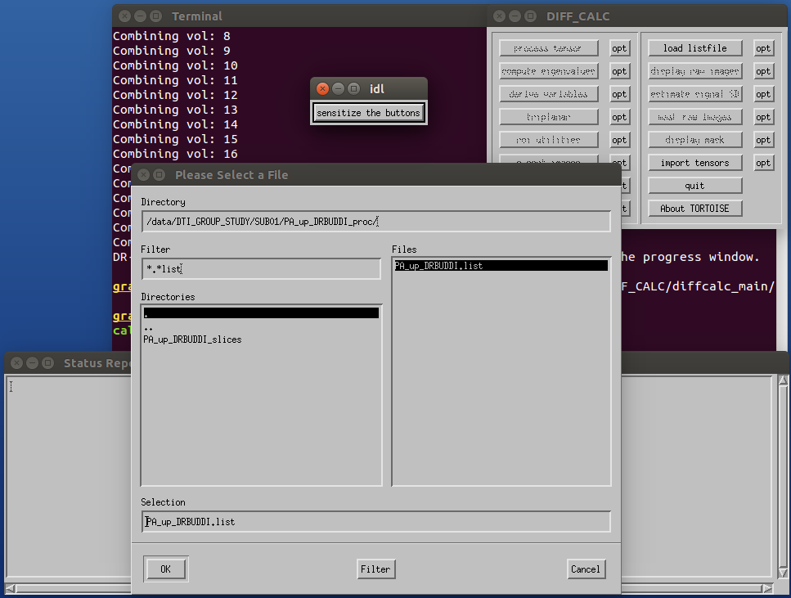

C4) Exporting images.
Whether you loaded a listfile from DIFF_PREP or DR-BUDDI, the left column should now have some unfrozen buttons. Click on the 'export images' button (LHS, third from the bottom) to get this menu:
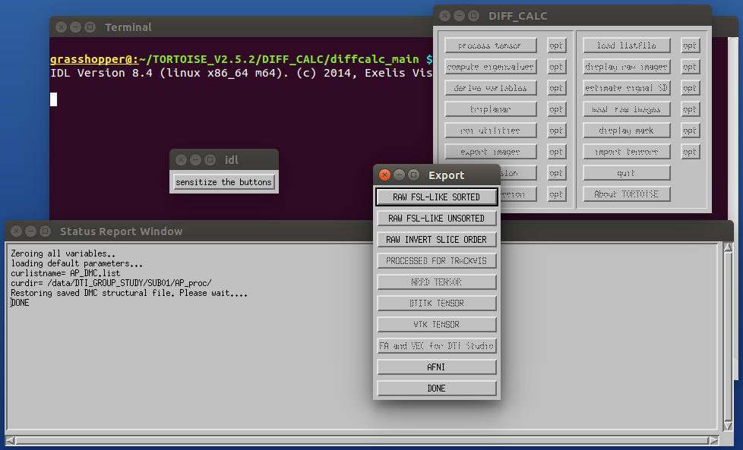
Click on “AFNI” for the basic export of the processed DWI volumes (called “DWI.nii”) and the gradient information (“BMTXT_AFNI.txt,” a single b-matrix file that holds both bvec and bval information). The gradients stored in the b-matrix file will have been updated during processing if rotation of a volume was performed (a good thing, maintaining consistency with the DWI volumes).
You may then hit the “DONE” button in the menu and enter a new list to export, or just close the thing.

These two files are exported into a single directory, a subdirectory of the current *_proc/ directory, ending in “_SAVE_AFNI” (again, this applies to either DIFF_PREP or DR-BUDDI export). An example of directories from DIFF_CALC export of DIFF_PREP output, within the AP_proc/ directory:
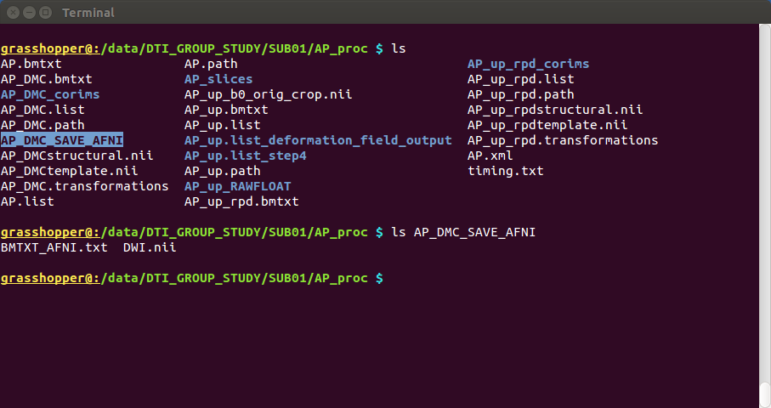
…. And that should be it for TORTOISE. See the online docs for more about checking results and continuing analysis in AFNI+FATCAT.

