**Software Project On**

**OrderOpus**

**Introduction:**

**"OrderOpus"** is an app which connects the restaurants with the consumers in a selected area within a certain radius. This app only does the job of connection and it has no delivery service, the delivery should be done by the individual restaurants. No commission will be taken from the foods sold by the restaurants rather a monthly service charge will be taken at the beginning of the month.

**Related Works:**

There has some existing app service like our app project.But our service is little different from these app as we don't take extra commission from customer on food and the restaurants owners will take the responsibility to deliver food.

Existing app links are given below-

**Foodpanda Link:**

<https://play.google.com/store/apps/details?id=com.global.foodpanda.android>

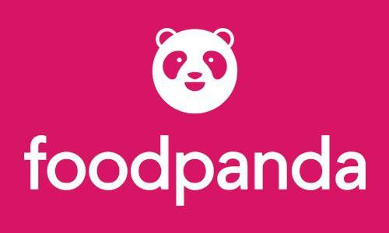

**Hungrynaki Link:**

https://play.google.com/store/apps/details?id=com.hungrynaki.deliveryapp& hl=en&gl=US



**Used tool from Uizard:**

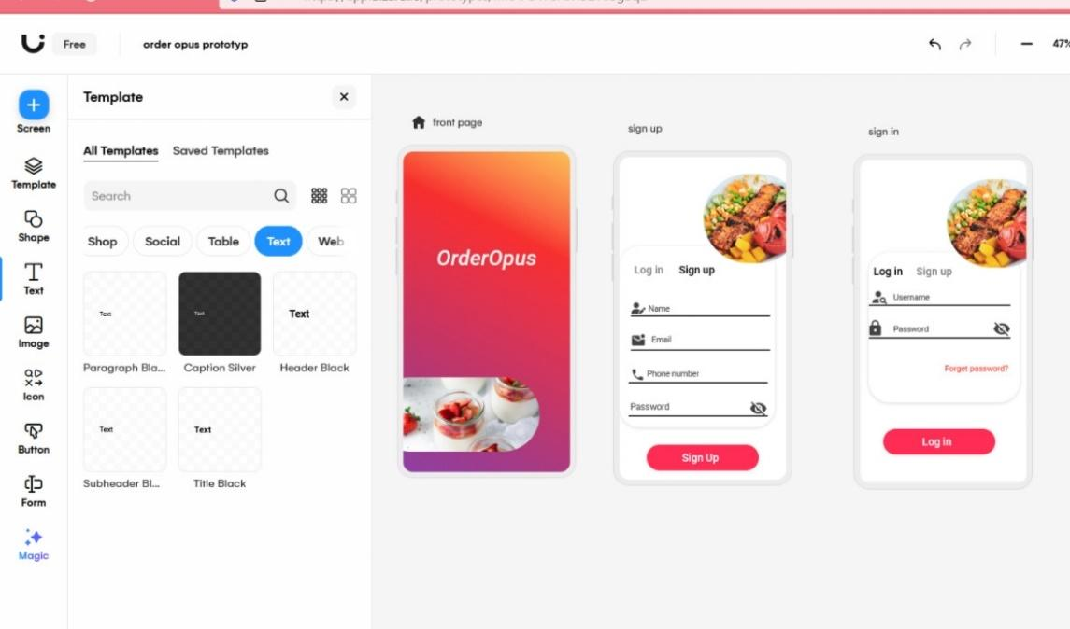

* Select the text you want to edit, and write the text inside the app and click on the 'Change alignment of text' option.

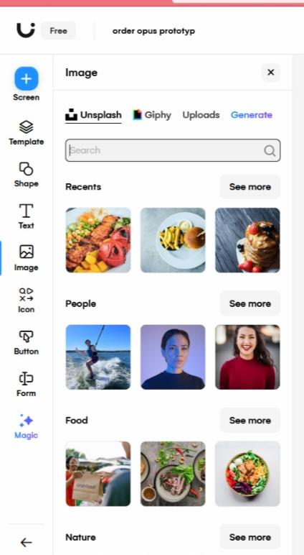

* The images required by the app are available from here

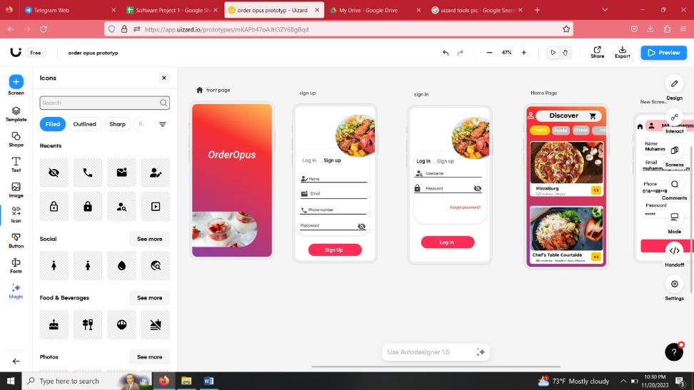

* Icon is a small graphical representation of a program or file. When we double-click an icon, the associated file or program will be opened.

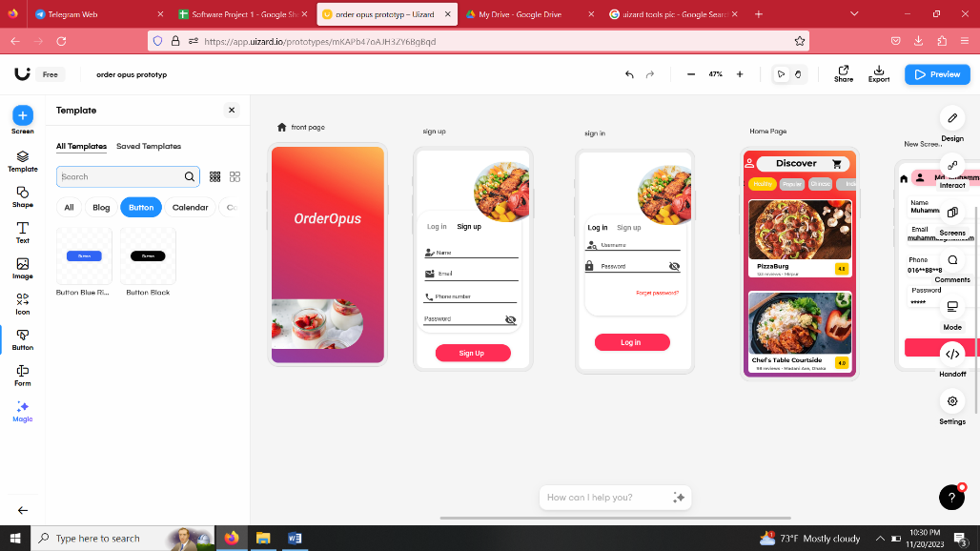

* Each button, when clicked by a user, sends a command message to the parent window. Typically, the buttons in a toolbar correspond to items in the application's menu, providing an additional and more direct way for the user to access an application's commands.

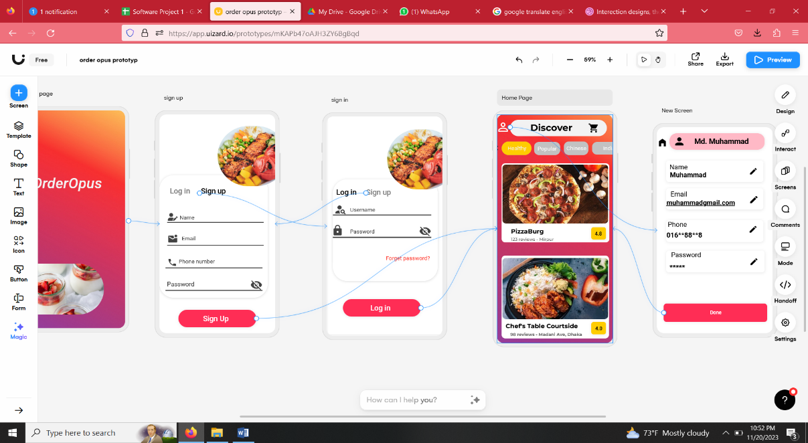

* This is interact function, this function indicates interact between one page function to another page function.

**Methodology:**

* Here is the **first page** and **sign up** page. User will create their account via sign up page. While using our application a user must have to sign up with providing required information like name, email, phone number & password.

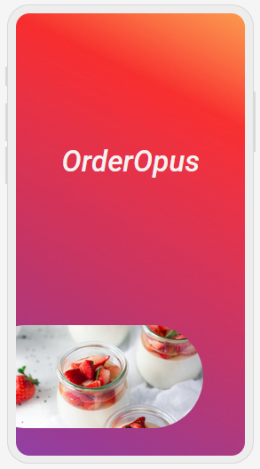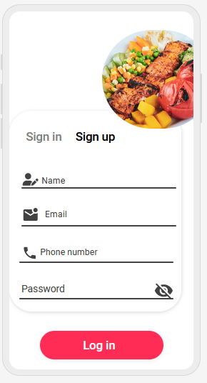



* After signing up a user can log in to our application, that user can easily log in to our apps just providing his name as user name and password. One thing to mention here, user name , mail & phone number in our system will be identical, any name/mail or phone number cannot be used twice by any other user.
* Also there will be a user's **profile information** page to give user's name, address & others necessary details & the profile information where user can easily edit and update his/her information stored in our database.

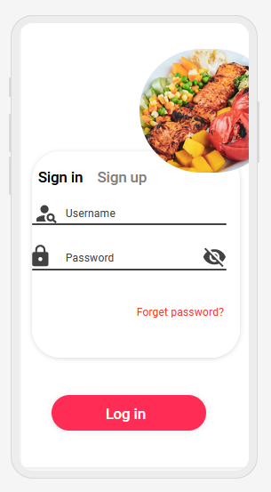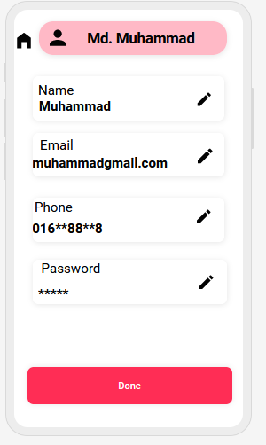

* The **homepage**, where a user can easily navigate through multiple way of categorization. Here a user can search and select desired food using live location or selective location. We have enabled review marking system where users can easily express their practical feedback so other user can oversee probable outcome. Also, user can easily pin complain to us about any difficulties or anomalies they are facing from the food vendors. And an user will be able to select food items from the **r food selection** page.

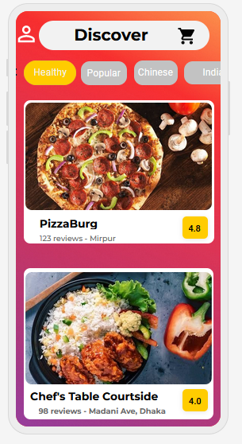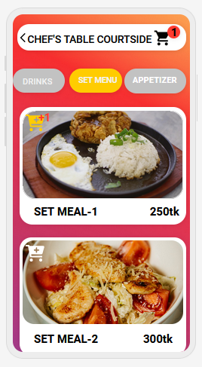

* This is a virtual **cart** where all of current orders of the user will be compiled together. This cart also act as pre invoice, where user can know total cost including all breakdown and variables. User can avail voucher discount offered by system or food vendor. the **order tracking system** in our application where an user can track live location and time duration as well expected delivery deadline. User can also see the details of deliveryman with contact number. We have also enabled review system for every deliveryman attached to our system.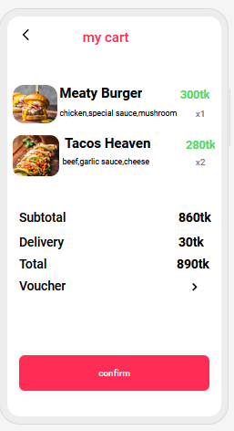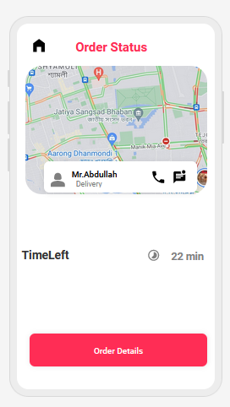

**Conclusion:**

This food service app represents a significant advancement in the way we approach dining experiences and culinary services. With its user-friendly interface, diverse menu options, and seamless ordering process, the app has successfully addressed the evolving needs of both consumers and food establishments. The convenience offered through features such as mobile ordering, real-time tracking, and personalized recommendations has undoubtedly enhanced the overall dining experience for users.

**Project link:**

<https://app.uizard.io/prototypes/mKAPb47oAJH3ZY6BgBqd>

**Team Members of the Project:**

Sumaiya Akter Nila (id:221-15-5181)

Nila Mony (id:221-15-4824)

Sumaiya Man-Ara (id:221-15-4671)