Benchmarking Surface-Code Decoders: Minimum-Weight Matching, Union-Find and Belief Propagation
Andrew Fogelis
https://github.com/afogelis/decoder-benchmark

Abstract
A benchmarking framework was developed to compare surface-code decoders on a level playing field, scoring each on accuracy, runtime and peak memory over identical batches of error syndromes. Minimum-weight perfect matching (via PyMatching) was compared against from-scratch implementations of a union-find decoder and a log-domain belief-propagation decoder. Across code distances three and five and physical error rates between 0.5% and 1.2%, matching achieved the lowest mean logical error rate, union-find was close on accuracy at near-linear time cost, and belief propagation was dominated on both accuracy and runtime. The framework reproduces the consensus of the decoder literature and exposes, by implementing the algorithms directly, why each behaves as it does.

Introduction
A decoder maps the syndrome produced by a quantum error-correcting code to a correction. Its quality determines how close a code operates to its theoretical threshold, and its speed determines whether decoding can keep pace with the measurement cycle in real time. The surface code admits several decoding strategies with different accuracy and latency trade-offs, so a fair comparison framework is valuable both pedagogically and practically.
This work implemented union-find and belief-propagation decoders from scratch, rather than calling compiled libraries, so that the benchmark could illuminate the algorithmic reasons behind each decoder's performance instead of treating it as a black box. Matching, the community-standard accuracy reference, was included through the established PyMatching library.

Materials and Methods
The detector error model emitted by each surface-code circuit was converted into parity-check and observable matrices shared by every decoder, ensuring that all decoders saw identical syndrome batches. Matching was performed with PyMatching. The union-find decoder implemented the Delfosse-Nickerson cluster-growth algorithm with spanning-forest peeling on the matching graph, which runs in almost-linear time. The belief-propagation decoder implemented the log-domain sum-product algorithm on the detector error model.
Each decoder was profiled for accuracy (logical error rate), runtime (microseconds per shot) and peak memory (via allocation tracking) over the same shots. Runs were summarised in a ranked leaderboard and an accuracy-versus-runtime Pareto frontier. The reported configuration covered code distances three and five at physical error rates of 0.5%, 0.8%, 1.0% and 1.2% with five thousand shots per point and a fixed seed.

Results
Minimum-weight perfect matching achieved the best mean logical error rate of the three decoders and the lowest runtime, reflecting its optimised compiled implementation. The union-find decoder was close to matching on accuracy while using markedly less memory, consistent with its near-linear design, but was slower than the compiled matching routine in this pure-Python implementation. Belief propagation was the weakest decoder, with the highest logical error rate and the highest runtime, leaving it dominated on both axes of the Pareto frontier.
The accuracy-versus-physical-error-rate curves at distance five reproduced the expected ordering across the full range of physical error rates studied, with matching and union-find defining the accuracy frontier and belief propagation trailing.
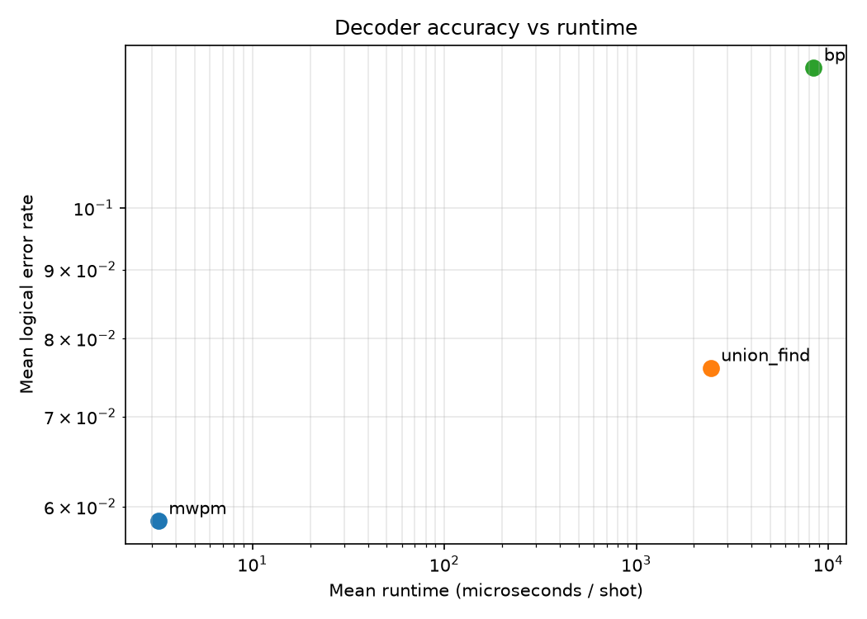
Figure 1. Accuracy-versus-runtime Pareto frontier. Matching and union-find define the accuracy frontier; belief propagation is dominated on both axes.
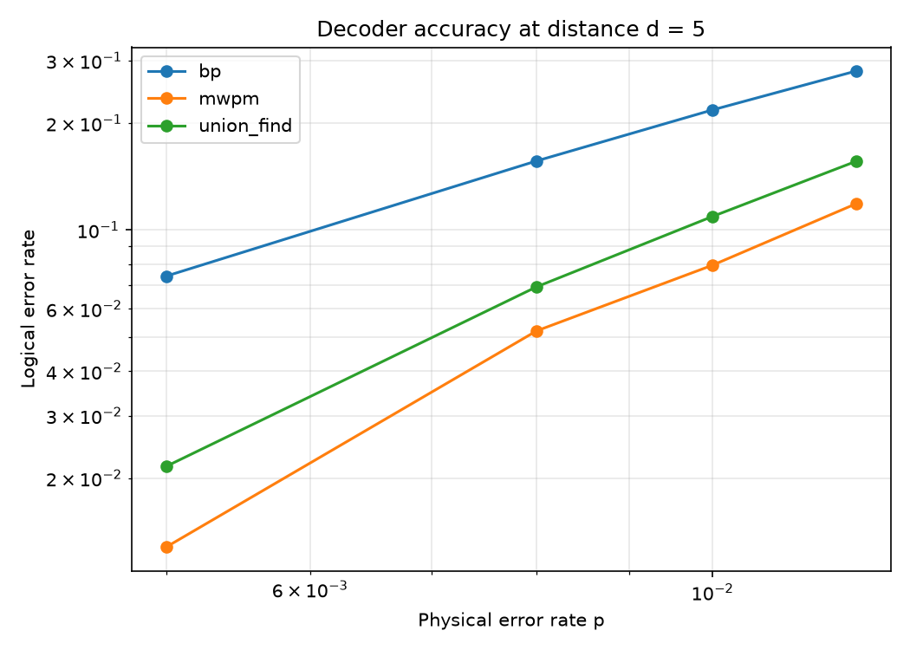
Figure 2. Logical error rate versus physical error rate at code distance five for each decoder.

Discussion
That plain belief propagation is dominated on the surface code is a known result, and reproducing it from a direct implementation clarifies the cause: the surface-code factor graph is highly degenerate and rich in short cycles, which prevents the message-passing iteration from converging to the correct marginal in the way it does for the sparse, loop-poor graphs of classical low-density parity-check codes. Belief propagation becomes competitive only when augmented, for example with ordered-statistics post-processing.
Union-find's strong accuracy at near-linear theoretical cost makes it attractive for real-time decoding; the runtime gap observed here reflects the pure-Python implementation rather than the algorithm itself. Future work includes adding belief propagation with ordered-statistics decoding and correlated matching, and compiling the union-find inner loop. The machine-learning decoders evaluated in the companion repository register into this same framework for direct comparison.

References
Dennis E, Kitaev A, Landahl A, Preskill J. Topological quantum memory. Journal of Mathematical Physics 2002; 43:4452-4505.
Delfosse N, Nickerson NH. Almost-linear time decoding algorithm for topological codes. Quantum 2021; 5:595.
Higgott O. PyMatching: A Python package for decoding quantum codes with minimum-weight perfect matching. ACM Transactions on Quantum Computing 2022; 3(3):16.
Fowler AG, Mariantoni M, Martinis JM, Cleland AN. Surface codes: Towards practical large-scale quantum computation. Physical Review A 2012; 86:032324.
Gidney C. Stim: a fast stabilizer circuit simulator. Quantum 2021; 5:497.

