D3 — Performance, Quality, and Ethical Consideration Report (DRAFT)
INFO53883 AI & ML Capstone · Team 2B · Ontario Smart-Shield AI
Status: PLANNING DRAFT with embedded evidence figures. Replace TEAM WRITE sections with original team prose. Do not submit GenAI-generated text. Target CopyLeaks GenAI < 10%.
Names / student numbers: ________________________________

1. Current Project Progress (0.5)
Suggested completion: ~85–90% of planned AI/ML + demo path (Final Technical Report / hosting polish remain).
Implemented: Toronto modelling (809,030×8), baselines + tuned RF, Stage A Fatal-vs-Not, fairness/geo audit, NLP T, Vision path (cache + live CCTV in demo), Safety Score fusion, SHAP, Flask demo.
Remaining: full GPU refresh logs if quoting Vision/DNN train metrics; public map hosting; Fatal precision improvements; final report.
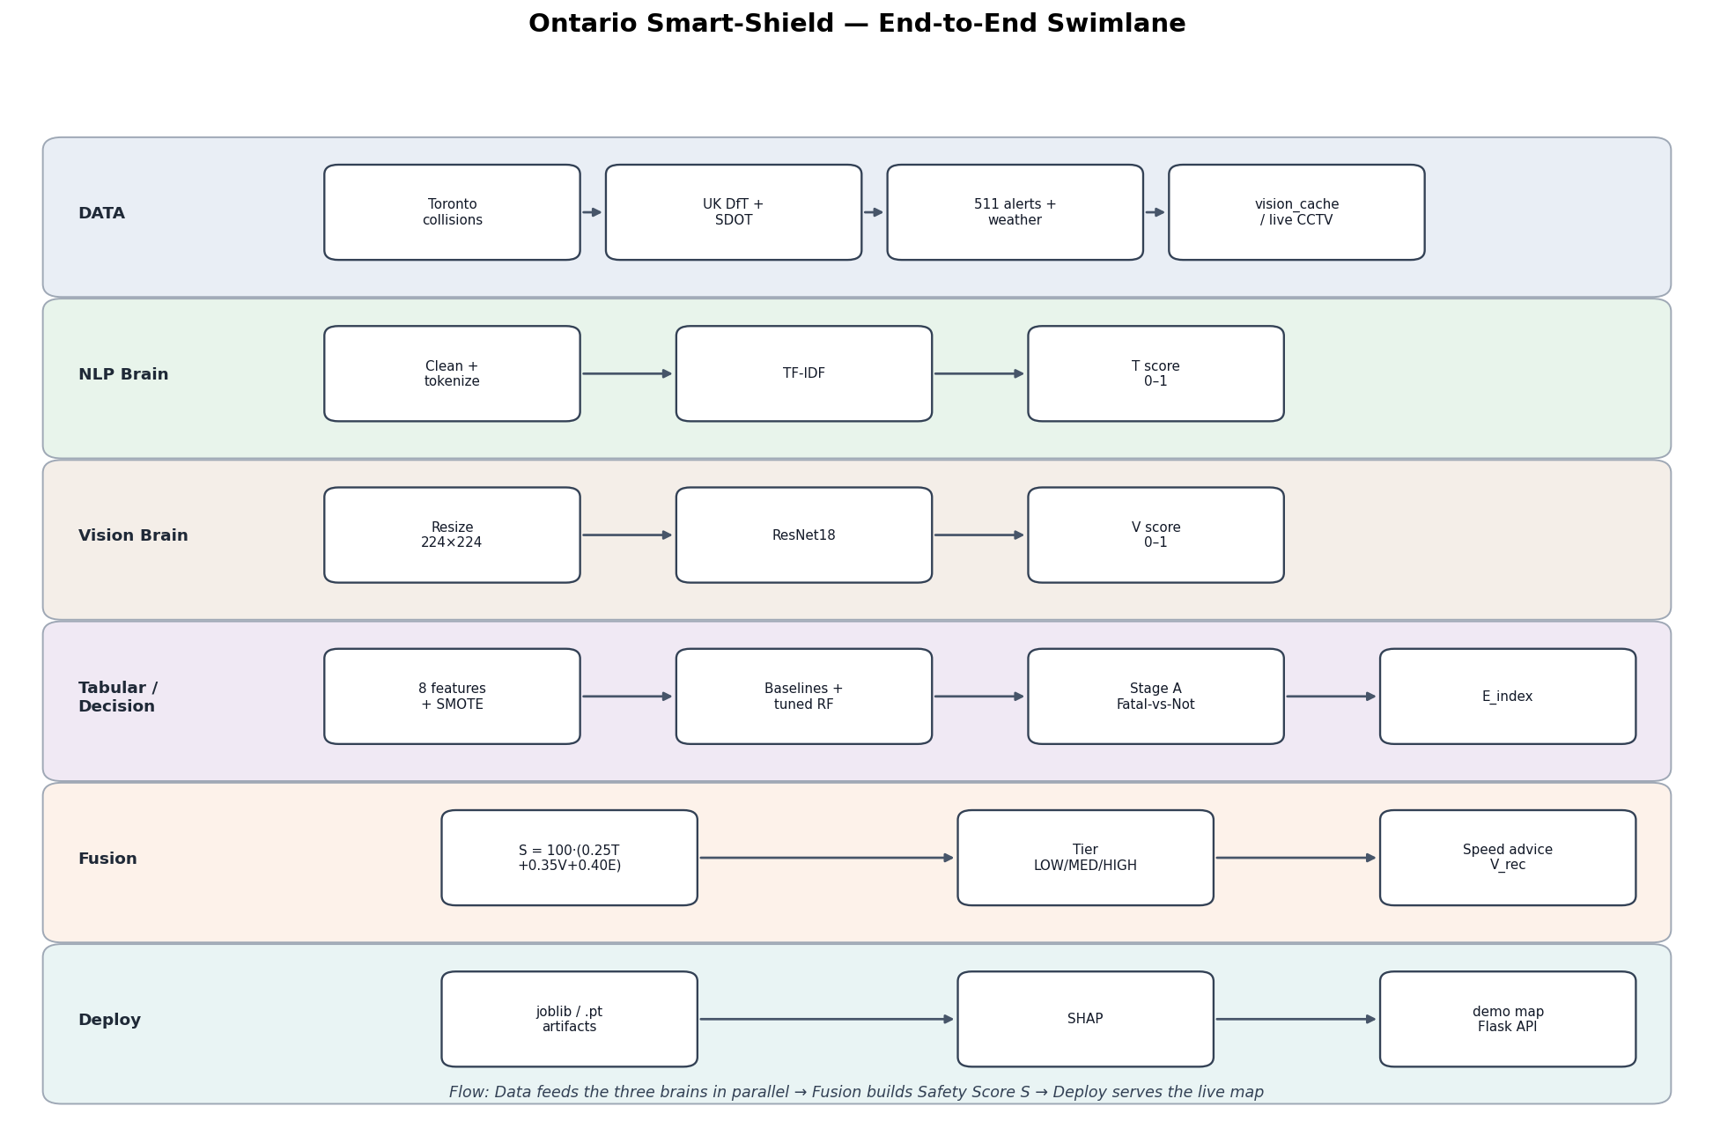
Figure 1. End-to-end Smart-Shield swimlane (notebook + demo lanes).
TEAM WRITE: Half-page overview in team voice. Do not repeat D1/D2 WBS/Gantt/architecture essays.

2. Performance Evaluation and Quality Assessment (3)

2.1 Tabular models
Baselines (test): KNN best MCC 0.3819 (Acc 0.8859). RF Acc 0.7671 MCC 0.1640. Tuned RF Acc 0.7672 MCC 0.1641 (deploy/explainability pick).
Stage A (LR @ 0.5): Fatal recall 1.000, precision 0.0008 — KPI ≥0.92 MET.
Final RF Fatal class: precision 0.0040, recall 0.5564 (support 133).
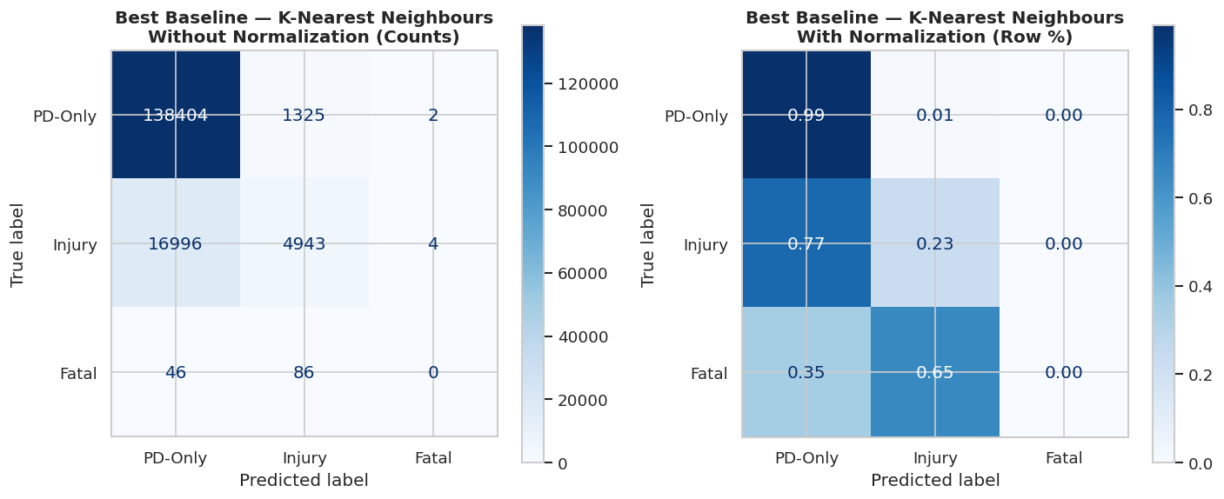
Figure 2. Baseline comparison charts.
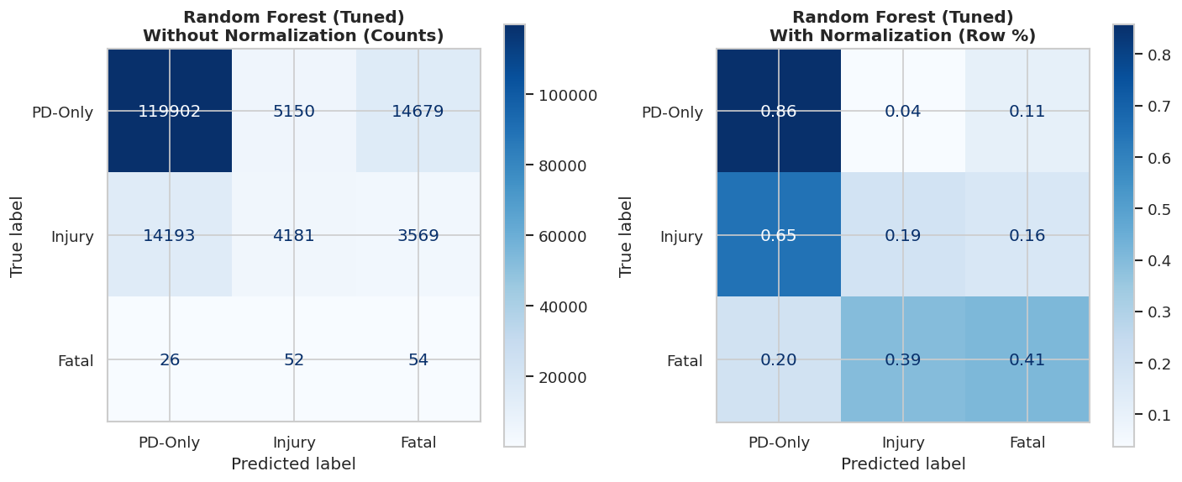
Figure 3. Confusion matrix — Random Forest (Tuned), deploy model.
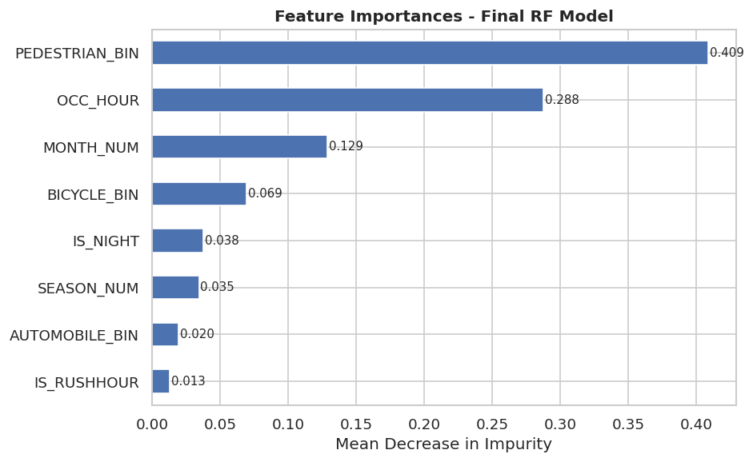
Figure 4. Final RF evaluation / Paper 2 comparison context.
TEAM WRITE: Explain what Acc/MCC/Fatal recall mean for a safety system. State why RF is chosen despite KNN MCC lead.

2.2 NLP, Vision, Fusion sample outputs
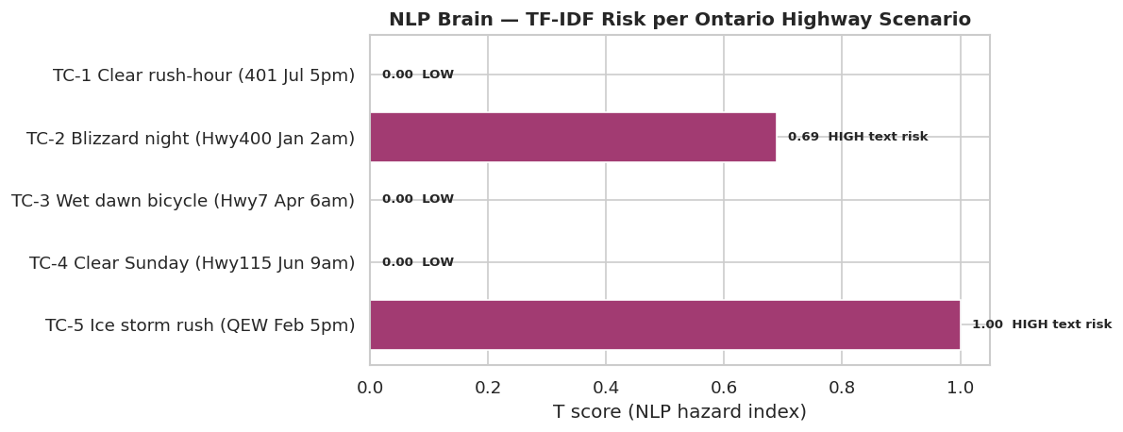
Figure 5. NLP Brain TF-IDF T-scores on Ontario TC scenarios.
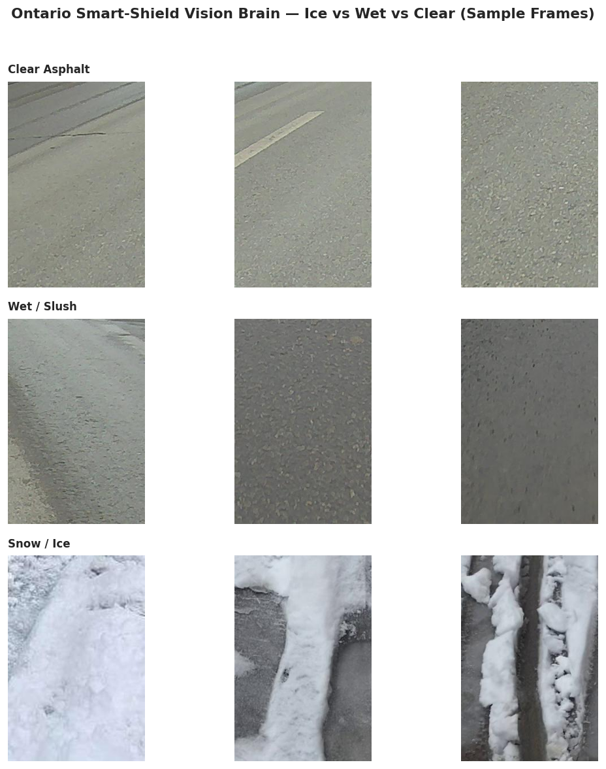
Figure 6. Vision sample road-condition images (disclose train/skip status).
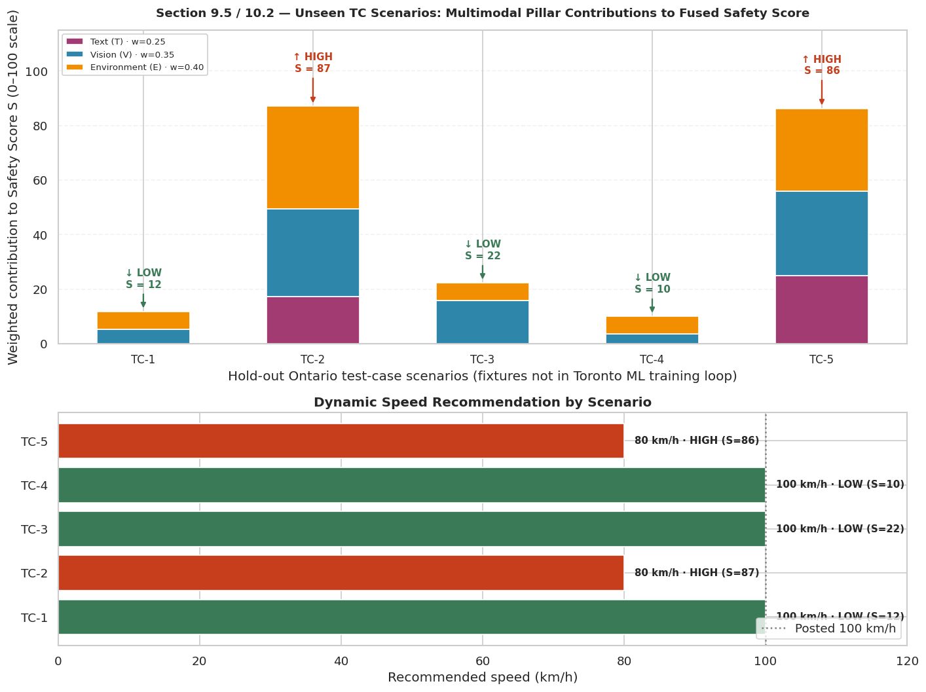
Figure 7. Canonical Safety Score fusion dashboard (T+V+E→S).
TEAM WRITE: Describe QA: provenance check, held-out test, TC fixtures, live API fallbacks, actions (SMOTE, Stage A, geo 8-feature fix).

3. Mathematical Justification of Model Performance (4)
See also docs/D3_MATH_WORKSHEET.md for full formula pack.
Required pattern for each metric: formula → plugged values → result → interpretation → limitation.

3.1 Example — Stage A Fatal F1
Precision P=0.0008, Recall R=1.0 → F1 = 2PR/(P+R) ≈ 0.0016.

3.2 Example — Safety Score TC-2
S = 100(0.25·0.688 + 0.35·0.92 + 0.40·0.940) = 100(0.172+0.322+0.376) = 87.0 → HIGH.

3.3 Example — Geographic parity gap
|0.7457 − 0.7844| = 0.0387 ≤ 0.05 → PASS on accuracy gap; still disclose Suburban Fatal recall 0.00.
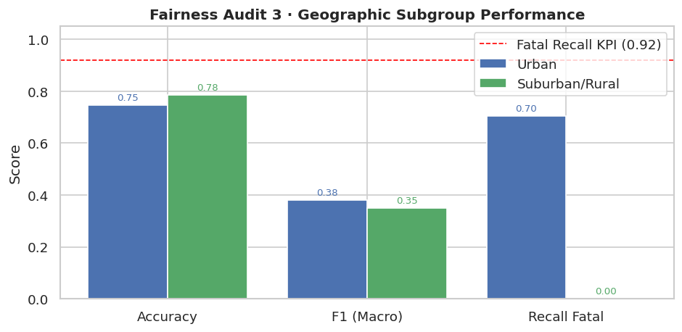
Figure 8. Geographic subgroup performance (supports fairness math).
TEAM WRITE: Expand math for Accuracy, Precision, Recall, F1, MCC (and S) in your own words. Second teammate verifies arithmetic.

4. Ethical Considerations and System Limitations (2)
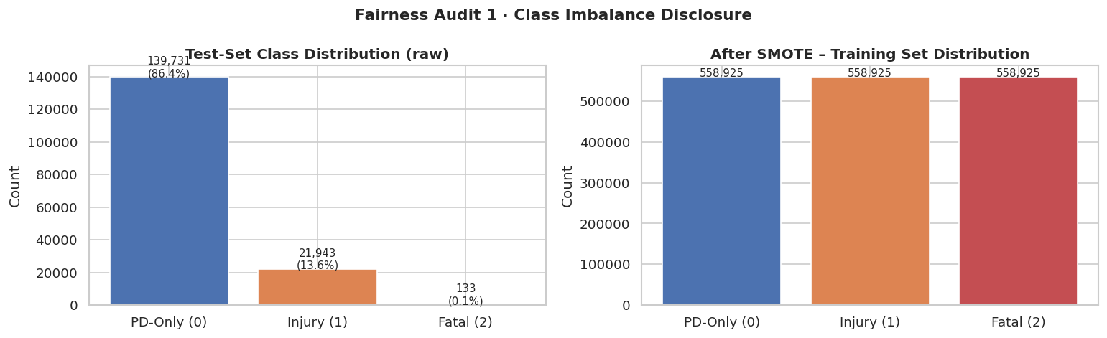
Figure 9. Class imbalance disclosure.
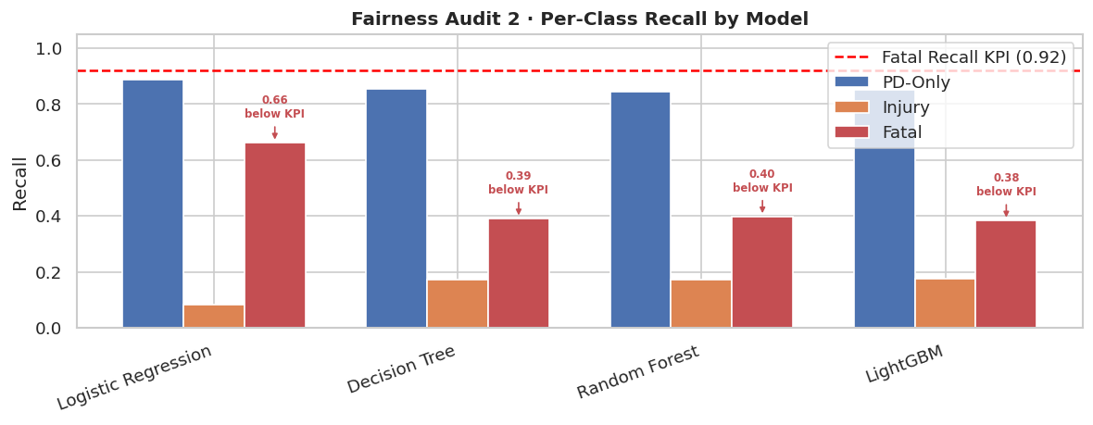
Figure 10. Per-class recall / equal opportunity view.
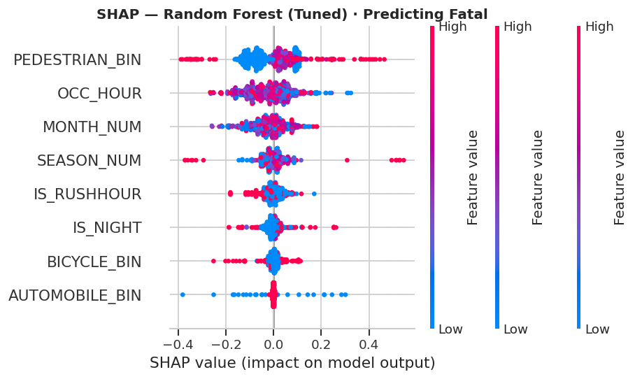
Figure 11. SHAP explainability for RF (transparency).
Cover: privacy (open data / public 511 & CCTV), fairness/bias, transparency (SHAP), human oversight on HIGH S / Stage A alerts, Canadian responsible AI, limitations + pre-final improvements.
TEAM WRITE: Use project-specific examples (TC-2/TC-5, geo Fatal recall disparity).

5. Reflection and Future Improvements (0.5)
TEAM WRITE: Challenge · key technical decisions · lessons from testing · realistic next steps before Final Technical Report (5–8 sentences total).

References / Acknowledgements
Datasets: Toronto open collision data; UK DfT; Seattle SDOT; Ontario 511; Open-Meteo. Libraries: scikit-learn, LightGBM, PyTorch, SHAP, Flask. Papers as cited in notebook/PR7.

