MEW_runEIGENSTRAT_2007_06_25.doc
Mike Weale
PG2, IGSP

A. Introduction
EIGENSTRAT is a new method (published in 2006) for correction for population structure in genetic association studies on unrelated individuals. The original paper was by Price et al. (“Principal components analysis corrects for stratification in genome-wide association studies” (2006), Nat Genet 38: 904-909), a follow-up paper was by Patterson et al. (“Population Structure and Eigenanalysis” (2006), PLoS Genetics 2: e190).

Briefly, the method proceeds by subjecting all your genotype data to a “principal components analysis”-style singular value decomposition. The resulting PC axes can be used as covariates in subsequent association analysis, on the assumption that they represent “axes of ancestry”. The advantage of this method over previous “genomic control” methods is that the adjustment each SNP to allow for ancestry is “tailored” individually to each SNP – i.e. by how much that SNP varies along each axis of ancestry. This allows one to correct not only for false positives but also for false negatives.

The method adopted within PG² for EIGENSTRAT differs in two key ways from that proposed in the above two papers:
- Instead of “Armitage Trend Test”-style testing, we enter EIGENSTRAT individual scores as covariates in either logistic or linear regression analyses (depending on phenotype). This is a more flexible approach that:
  - allows other covariates to be entered and accounted for;
  - gives P-values based on likelihood ratio testing (generally more accurate than the score testing approach of Armitage Trend Tests);
  - allows more appropriate permutation schemes to be applied (see separate notes on permutation testing)
- Instead of applying PCA analysis in a blanket fashion to all SNPs in our panel, we carefully screen which SNPs to include based on LD criteria, and we also apply the residual method proposed by Patterson et al. for further reduce LD problems. Finally, we inspect both individuals and SNPs for outliers, and reapply EIGENSTRAT accordingly if problems are found.

It should be noted that while EIGENSTRAT was originally proposed in the context of correction for ancestry, it will in fact pick up and “correct” for any source of correlation in the data. Such sources are:
Correlations among individuals
Shared ancestry (population stratification)
Shared ancestry (extended pedigrees)
Lab error
Correlations among SNPs
LD
Multiple causal SNPs (if there are enough of them)

A useful observation is that ancestry-based factors producing correlations among individuals such affect all SNPs in the genome equally. This leads to a prediction regarding the distribution of SNP loadings which is used below in evaluation of EIGENSTRAT axes.

B. Finding EIGENSTRAT PCA axes

- Apply “LD thinning” to your data, and remove any other “bad SNPs” from your data. This is an option in PLINK that allows you find a reduced set of SNPs from your data that are all in low LD with each other. I recommend the following settings.
/research/labs/goldsteinlab/software/PLINK_Vq64/plink --bfile yourdata --geno 0.1 --mind 0.1 --maf 0.01 --exclude badSNPs.txt --indep-pairwise 1500 150 0.2 --out yourdata

Note that the above command specifically sets exclusion criteria on SNPs and individuals with high levels of missing data (as EIGENSOFT copes with missing data in a fairly “basic” fashion, so it’s best to avoid too much missing data). “badSNPs.txt” is simply a list of SNPs to exclude from the dataset. Note that EIGENSOFT will fail if there are any mtDNA SNPs (“chr0” SNPs in PLINK) or Y SNPs (“chr24” SNPs in PLINK) in the dataset you pass to it, but conveniently these are screened out by the LD-pruning process anyway. So as a bare minimum, “badSNPs.txt” should contain all SNPs in known “trouble-spot” high-LD regions on the genome. To do this, copy over all SNPs listed in “highLDsnps_MEW_2007_02_23.txt”. Currently, this file contains all SNPs listed in the Illumina 650Y annotation file in the following regions:
Chromosome | lower limit (Build35) | Upper limit (Build 35) | Size (Mb)
chr8 | 8000000 | 12000000 | 4
chr6 | 25000000 | 33500000 | 8.5
chr11 | 45000000 | 57000000 | 12
chr5 | 44000000 | 51500000 | 7.5

The numbers after “--indep-pairwise” set, respectively, the window size (number of SNPs spanned), the step size (how many SNPs to move to right to set up next window), and the pairwise r² value (all SNPs in each window must have pairwise r² less than this in order to be kept after LD thinning). “1500” has been chosen as a window size because this corresponds to the largest known high-LD region (chr 8 inversion), when mapped with the Hap550 panel. I would make step size = 10% of the window size, as a good compromise on speed. I would set r2=0.2 for WGA panels, where we can afford to be stringent (typically, we still end up with many more than 20,000 SNPs (the number suggested by Price et al (2006) as a good threshold for efficient working of the EIGENSTRAT method).

Warning for people with non-WGA datasets. The current version of PLINK (version p) will not thin a chromosome if the number of SNPs on that chromosome is less than the window size. Also, you will have <20,000 SNPs to work with, so a less stringent LD-thinning is appropriate. Therefore, I suggest you set window = minimum number of SNPs on any one chromosome; step size = 1 or smallest number consistent with reasonable speed, and r2=0.8

- Prepare a BED file with Y, mtDNA, and certain high-LD regions of the genome removed, and with your phenotype data added, restricted just to your “LD thinned” SNPs. E.g.
/research/labs/goldsteinlab/software/PLINK_Vp64/plink --bfile yourdata --pheno yourpheno.phe --mpheno 1 --geno 0.1 --mind 0.1 --maf 0.01 --extract yourdata.prune.in --exclude badSNPs.txt --make-bed --out yourdata_4pca

Note that you need to add some sort of non-missing categorical phenotype data at this stage, otherwise EIGENSTRAT will fail. Quantitative data won’t do, and neither will missing data (any individuals with missing phenotype data will be excluded from EIGENSOFT analysis). If you don’t have real categorical phenotype data to hand, create a fake phenotype file in Excel using “yourfile.fam” as a basis to get subject ID’s (famID + IndID), and creating a column of “1”’s as your phenotype file. Note also the “--exclude badSNPs.txt” is there just for added security – it should be redundant if you included this option in the previous LD-thinning stage,

- Log on to ifrit2 (e.g. shh yourname@ifrit2.duhs.duke.edu). “ifrit2” is currently the only machine that runs EIGENSOFT properly. Call as follows (for more options open the “EIGENSOFTplus.txt” and read comments at start) (Note the following should be all on one line after the linux prompt, and there should be no spaces on either side of each “=” symbol):
R --vanilla --slave --args stem=yourdata_4pca nsnpldregress=5 < /research/labs/goldsteinlab/Mike/Docs/EIGENSOFTplus/ver9/EIGENSOFTplus.txt &

If you want info on more than the first 10 axes (e.g. first 20 axes), call EIGENSOFTplus as follows:
R --vanilla --slave --args stem=yourdata_4pca nsnpldregress=5 numoutevec=20 numgamma=20 numplot=20 < /reseach/labs/goldsteinlab/Mike/Docs/EIGENSOFTplus/ver9/EIGENSOFTplus.txt &

This calls “version 6” of EIGENSOFTplus.txt. Future versions will be placed in new “ver” directories as needed, so check for updates periodically.

Be warned!! This may take several hours if you have a big dataset! This will run “EIGENSOFTplus” as a background process on ifrit2. One way to check on its progress is to periodically “refresh” your directory contents. The file “yourdata_4pca.evec” will have 0 size while part (a) the program is running (as detailed below), and will have non-zero size once the program has completed. Likewise, “yourdata_4pca.gam” will not exist until part (d) has completed. All others parts should complete in a short space of time.

The “EIGENSOFTplus” call will do the following:
- Call EIGENSOFT, find PC axes based on your submitted dataset. If you set nsnpldregress=5 then PC axes will be found using residuals based on regression of genotype on previous 5 SNPs in the dataset. “Scores” for each individual for the 1st k PC axes (k set by default to 10), which are what you will use as covariates in subsequent analyses, are stored in “yourdata_4pca.evec”
- Generate p-values for each PC axis, based on Tracy-Widom method described in Patterson et al (2006). Also generate p-values for the association of phenotype with the 1st k PC axes. These results are stored in “yourdata_4pca.Sout”
- Generate a “scree” plot of eigenvalues for each of the 1st 100 PC axes
- Generate histogram plots for distribution of individuals against the 1st k PC axes. Examine this to look for individual outliers (follow up any you see – this could reflect cryptic relatedness or some genotyping problem for the outlier individuals). See “yourdata_4pca_hist.pdf”
- Generate a plot of PC1 scores vs PC2 scores, colour-coded according to the categories specified in your phenotype file.
- Calculate “SNP loadings” for the 1st k PC axes. These are stored in “yourdata_4pca.gam”
- Generate Q-Q plots for the distribution of SNP loadings against the 1st k PC axes. Examine this for evidence of axes with heavy tails (plots go near-vertically up and down at each end). These are stored in “yourdata_4pca_qq.pdf”
- Save a file storing information on SNPs with high loadings (abs. value >1) on each of the 1st k axes. Stored as “yourdata_4pca_SNPoutliers.txt”. Use this file to look for evidence that many outlier SNPs come from the same genomic region. If so, you should remove these SNPs from your dataset and re-apply EIGENSOFTplus.
- Save a file storing information on individuals with high scores (abs. value >0.1) on each of the 1st k axes. Use this file to identify individual outliers that may need to be removed from subsequent analyses. Outliers could indicate either (i) genuinely odd ancestry; (ii) cryptic relatedness; (iii) lab error.

C. Data cleaning and re-applying EIGENSTRAT

EIGENSTRAT analysis can be used to point to possible problems in your data, particularly in the form of “outlier individuals” who should be dropped from analysis. You may have to repeat EIGENSTRAT analyses once outlier individuals and SNPs have been removed, and thus iteratively arrive at the best set of axes to use for subsequent analyses.

Here are some things you should do.
- Look at your “*_hist.pdf” plot. Look for “outlier individuals” along any of the 1st 10 axes. Note that each plot is scaled to be the right size to include all individuals, so if you see what appears to be a histogram with “empty space” on either side, don’t be fooled – if you look closely you should see small bumps corresponding to “outlier individuals”. An example is given below. To find which individuals these are, open your “*.evec” file in Excel, use “Text to Columns” to separate out the axes, then sort on the axis in question (in this e.g, the 5th column). If 2 individuals have exactly the same scores across multiple axes, this suggests duplicates. Other levels of cryptic relatedness will also produce outliers (but not completely superimposed as with duplicates). Other possible causes of individual outliers are (i) people who are of “odd” ancestry, and (ii) some systematic genotyping error that affected just this individual. If the cause remains unknown even after investigation, it is still prudent to remove this individual from all subsequent analyses, and also to redo EIGENSTRAT with these individuals removed. However, this last step is optional if the problem only affects PC axes below those you wish to enter as covariates into subsequent analysis, as these axes are very unlikely to be strongly affected by removal and re-analysis.
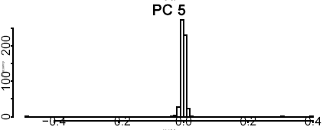
- Look at your “*_qq.pdf” plot. Look for axes that dominated by “outlier SNPs” (usually from a single high-LD region). An example is given below. Note how the tails lift up almost vertically at both ends. If you see an axis that looks like this, take a look at the corresponding “*outliers.txt” file, which give the SNPs and their loadings, sorted in descending order. An axis like the one below should be dominated by SNPs all from the same region of the genome. The numbers in the last column of the file (showing the genomic distance in bp to the next SNP in the “outlier” set) should be low - on the order of a few kb. As with (1), these regions should be excised from your data, and EIGENSTRAT re-applied if these axes lie above those you wish to include as covariates. If the axes are BELOW this set, then re-analysis is optional, for the same reasons as those given above in (1).

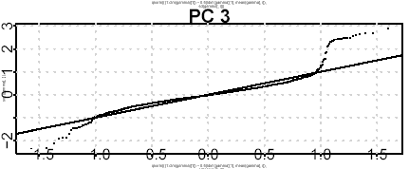

D. Assessing how many EIGENSTRAT PCA axes to include as covariates

Once the data-cleaning steps have been carried out, the final step is to determine which axes to include as covariates in subsequent analyses.

Here are some things you should do.
- Look at your “*.Sout” file. The bottom of this file will list the Tracy Widom statistic (“twstat”) and associated p-value (“p-value”) for each PC axes (for methodology see Patterson et al (2006)). There is no point in proceeding beyond any axes that have p>0.05
- Unfortunately, there may be a very large number of axes passed from (1) above – often dozens for data with many ethnic groups and/or data cleaning problems. Another approach is to look at the Scree plot (“_scree.pdf” file), which is simply a series plot of the eigenvalue for each axis. The eigenvalue is proportional to the “amount of variation explained” by that axis. Typically, only the first few axes have high eigenvalues, after which there is a qualitative change in the scree plot pattern, with all subsequent axes only declining slightly relative to the previous one. See example below. This motivates choosing just those axes which “stand out” as important influences on the data.
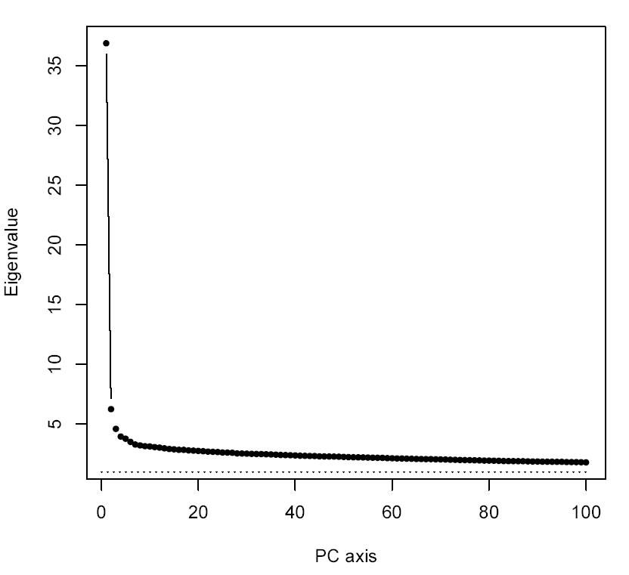
- If you have other ethnic label data (e.g. self-identified ethnicity or sampling location for a multi-center study), then you should perform ANOVA analyses on your top axes (usually, the top 10), to see which axes are closely associated with such axes. Here, a low p-value is a GOOD thing – you want your EIGENSTRAT axes to correspond to ethnic labels. The secondary question then arises of whether to include BOTH EIGENSTRAT and Ethnic labels as covariates in subsequent analyses. The procedure here is first to fit your chosen EIGENSTRAT axes to your phenotype of interest. Now add the Ethnic labels to the model. If the fit of the model improves significantly, then both EIGENSTRAT and Ethnic labels should be included as covariates
- You should also test your main phenotype of interest against each EIGENSTRAT axis (say the top 10 axes). Note this is done for you by EIGENSOFT if you specified a non-dummy phenotype in step B.(2) above, and you can find the results in your “*.Sout” file – otherwise you will have to do this yourself using the PX axis data in your “*.evec” file. Here, finding a low p-value is generally a bad thing – it indicates stratification of your phenotype with ancestry. If cases and controls have been genotyped on separate days, you should look into the possibility of a lab-related artifact.

