**CHAPTER ONE**

1. **INTRODUCTION**

The Student Industrial Work Experience Scheme (SIWES) or Industrial Training (IT) is a compulsory Skills Training Program designed to expose and prepare students of the Nigerian Universities for the industrial work situation they are likely to meet after graduation.

The scheme also affords students the opportunity of familiarizing and exposing themselves to the needed experience in handling equipment and machinery that are usually not available in their institution.

During the course of my IT, I was able to acquire the knowledge in the areas of Digital Marketing which involved: Copywriting, Graphics Design, Facebook Advertisements, Affiliate Marketing and Web Application which involved: HTML, CSS and JAVASCRIPT.

**CHAPTER TWO**

**Historical Review of SIWES and its Organization**

**2.0 Definition of SIWES**

The Students Industrial Work Experience Scheme (SIWES) is a compulsory skills training program designed to expose and prepare students of Universities, Polytechnics/Colleges of Technology/Colleges of Agriculture and Colleges of Education for the industrial work situation they are likely to meet after graduation. The scheme also grant student the opportunity of familiarizing and exposing themselves to the needed experience in handling equipment and machinery that are usually not available in their institutions. It is a cooperative industrial internship program that involves: Institutions of higher learning, industries, the Federal Government of Nigeria, Industrial Training Fund (ITF), and Nigerian University Commission (NUC)**.**

The Student Industrial Work Experience Scheme (SIWES) as an accepted skill training of the approved minimum academic standard for various under graduate degree programs in all Nigerian Universities also made an effect to bridge the gap that exist between blending theoretical and practical aspects of engineering and technology, science, agriculture, medicine, management with other professional educational programs in the Nigerian tertiary institutions.

This program involves the student, the University, and the industry. The Nigeria University Commission (NUC) made it mandatory for all Nigerian University students to undertake a minimum of six months SIWES training before graduation, most especially in technical courses.

## **2.1 History of SIWES**

The Industrial Training Fund (ITF) initiated the SIWES training in 1973 as a medium of blending theoretical and practical experience which, in some manner, was missing in the Nigerian educational system. The scheme was therefore skill-oriented program designed to expose and prepare students on the kind of work they may likely meet after their studies.

Being affiliated to the Federal Republic of Nigeria (FRN), ITF was established by the decree 47 of 1971 and charge with responsibility of performing and encouraging the acquisition of skill in industry and commerce, aiming at generating a pool of efficiently trained manpower to meet the need of the economy.

In 1978 a clause was indented in its policy statement no. 1 dealing with the issue to fund partial skill among locally trained professionals. The fund will seek to work out cooperative machinery with industry whereby student will be trained in industry compatible with their study. The fund will support such mild career attachment by contributing to the allowance payable to student undergoing any course that demands exposure to industrial activities and to promote the much-defined technical knowledge. (Agwuna, 2012).

## **2.2 Objectives of SIWES**

* Exposing student to work method and technique in handling equipment, tools, and machineries that are not available in their university.
* Preparing students for the work situation they may likely meet after graduation.
* Providing an avenue for student in Nigerian University to acquire industrial skill experience in their area of study.
* SIWES Provides students with an opportunity to apply their knowledge in real work situations thereby bridging the gap between theory and practice.
* Making the transition from the University to the world of work easier and thus enhancing student for later job placement after graduation.
* Providing student an opportunity to apply theoretical knowledge in a real situation thereby bridging between the University work and the actual practice.
* Exposing student to the right and proper attitude and the disciplinary measures to work.
* Creating and strengthening the employers of labour involvement in the educational processing preparing University graduates for employment in industry.
* SIWES provides the avenue for students in institutions of higher learning to acquire industrial skills and experiences in their course of study.
* Expose students to work method and techniques in handling equipment and machinery that may not be available in their institutions.

**2.3 BRIEF HISTORY OF ORGANIZATION**

Gi-Tech Academy is a subsidiary of Gi-Tech Consult Nigeria Limited; an Information Communication Technology (ICT) firm with head office in Abuja, was established in November, 2001 and fully incorporated in February, 2006 by the Corporate Affairs Commission, Abuja for the purpose of providing the needed specialist services in Information Communication Industries, through Software, Hardware and Human Resource Development for all strata of corporate existence, government establishment as well as interested individual.

The mission statement is to provide qualitative and effective services and product to prospective clients, students and employers and of a vision of building an ICT literate manpower and providing solution via key technologies, computer software and to be a leading player in the information communication industries.

The services rendered at Gi-Tech include but not limited to the following:

* Sales and Supply of Computer Hardware and Accessories
* Software Development
* e-Government and e-Commerce Services
* Carrier Training in in Information Technology
* Management Information Consultant
* Broadband Internet Services

**2.4 OBJECTIVE OF GITECH ACADEMY**

* To provide qualitative and effective services and products to our prospective clients, students and employers.
* To build an ICT literate manpower and providing solution via key technologies, computer software and to be a leading player in the Information Communication Industries.

**2.5 ORGANIZATIONAL CHAT OF GITECH ACADEMY**

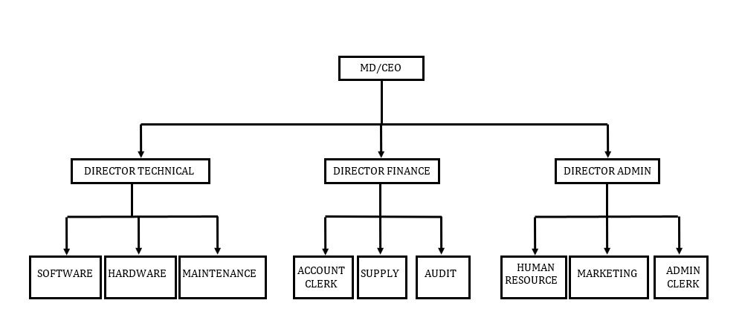

**Fig 2.0: Gi-tech academy organization chat**

**CHAPTER THREE**

**Activities during SIWES**

**3.0Web Development**

Web development is the building and maintenance of website; it’s the work that happen behind the scenes to make website looks great, work fast and perform well with a seamless user experience.

Web developers, or ‘devs’, do this by using a variety of coding languages. The language they use depends on the types of tasks they are performing and the platforms on which they are working (Marionletendart, 2018).

The field of web development is generally broken down into front-end (the user-facing side)

And back-end (the server side).

**Front-end development**

A front-end dev takes care of layout, design and interactivity using HTML, CSS and JavaScript the takes idea from the drawing board and turn it into reality

What you see what you use, such as the visual aspect of the website, the drop-down menus and the text, are all brought together by the front-end dev, who writes a series of programmes to bind and structure the element, make them look good and add interactivity. These programmes are run through a browser.

**Backend development**

This is where data is stored, and without this data, there would be no frontend. The backend consists of the server that hosts the website, and application for running it and a database to contain the data

The backend dev uses computer programmes to ensure that the server, the application and the database run smoothly together. This type of dev needs to analyse what a company’s needs are and provide efficient programming solutions. To do all this amazing stuff they use a variety of server-side languages, like PHP, VB, Ruby, Python and Java.

Main while full-stack developer take care of both frontend and backend

**3.WEB PAGE MARKUP LANGUAGE (HTML)**

HTML which stands for hypertext markup language is a standard mark-up language that is used for designing the structure of web pages, it is a language that web browsers use to interpret and then compose text, images, videos etc. into visual and audible web pages. A mark-up language is made up of markup tags and hence HTML documents can be described by these tags (HTML elements)

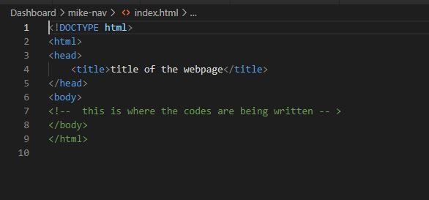

**Fig 3.0: Structure of HTML code**

Where <!DOCTYPE html> shows that the document type is HTML, the head tag contains the title tag which is used to give title to a particular webpage and that’s where internal stylings and linking are also done, the body tag is where we input the codes that we want to be visible on our webpage when viewed with a web browser.

**HTML TAGS**

HTML is made up of tags, these tags are **keywords** (tag names) surrounded by **angle brackets** and they are represented below:

<tagname>content</tagname>

HTML tags normally come **in pairs** like <p> and </p>, the first tag in a pair is the **start tag(opening tag),** the second tag is the **end tag(closing tag),** The end tag is written like the start tag, but with a **slash** before the tag name (html_intro.html, n.d.).

They are very many HTML tags but some examples of the tags are listed in the table below:-

|  |  |  |
| --- | --- | --- |
| S/N | HTML TAGS | USE OF THE TAG |
| 1 | <p>………</p> | Paragraph tag used for inserting paragraphs |
| 2 | <h1>…….</h1> | Heading one tag used for inserting a large header |
| 3 | <pre>…….</pre> | Preformatted tag used for displaying text on web browser exactly as they are written in the text editor |
| 4 | <label>…….</label> | Label tag used for inserting label name for form inputs |
| 5 | <form>……..</form> | Form tag they are used when we want to insert form elements into web pages(e.g. input box, submit button etc.) |
| 6 | <hr> | Horizontal rule tag used for drawing horizontal lines |
| 7 | <a href=”#”>…….</a> | Anchor tag to link one webpage to another |
| 8 | <style>…..</style> | Style tag used for internal CSS styling |
| 9 | <!-- ………… --> | Comment tag used for commenting codes in the text editor |
| 10 | <li>………..</li> | List tag used for inserting list of items in webpage which could be ordered list(ol) or unordered list(ul) |

**Fig 3.1: some examples of HTML tags**

* 1. **WEB PAGE STYLING LANGUAGE (CSS)**

CSS which stands for cascading stylesheet is used in Website Design and Development to determine the **presentation** of HTML documents, just from the name it can be used to apply styles to the structure which is written down with HTML (i.e., it describes how elements must be rendered on screen, on paper, or in other media). There are three ways of applying the style sheet which are: -

**External Styling:** in the external styling, the stylesheet that contains the codes for the effect to be applied to the HTML is saved in an external CSS document and connected to the HTML document using the link tag as shown below:-

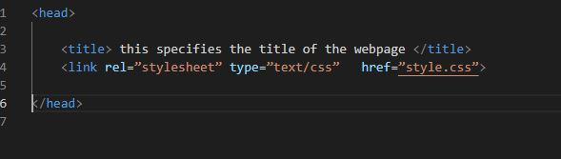

**Fig 3.2: the syntax that describes how external styling works**

Where rel stands for relationship, the type shows that we are working with CSS, and the href stands for hypertext reference which specifies the CSS document.

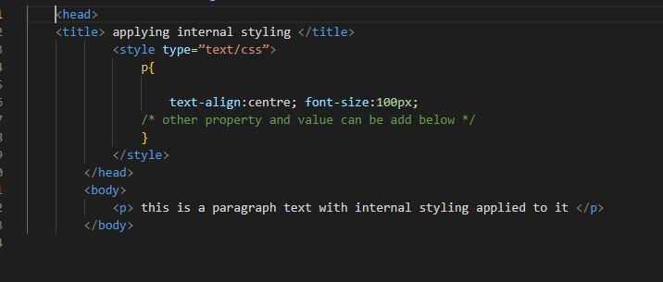**Internal Styling:** in internal styling the stylesheet codes are written in the same page where the HTML document exist, they are always defined within the <style> that is located inside the <head> tags HTML (w3schools/www.w3schools.com/css/css_howto.html) as shown below:-

**Fig 3.3: the syntax that describes how internal styling works**

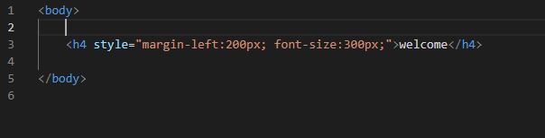**Inline styling:** from the name “inline”, the stylesheet are written on the same line as the HTML element that we want to apply the styling to, as shown below

**Fig 3.4: the syntax that describes how inline styling works**

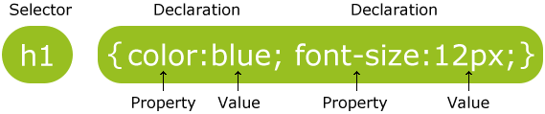The general syntax for applying CSS is given below: (css_syntax.html, n.d.)

**Fig 3.5: CSS rule-set**

**CSS selectors:** two basic ways in which CSS elements can be referenced is through the use of **class** and **id** where the classes can be referenced using a dot(.) within the style tag and the id is referenced using the hash(#) within the style tag.

<h1 class=”one”> welcome </h1> is referenced using .one {……..}

<h2 id=”two”> programmers’ hub </h2> is referenced using #two {……….}

**3.3 CLIENT-SIDE SCRIPTING LANGUAGE (JAVASCRIPT)**

JavaScript is a prototype-based, multi-paradigm scripting language that is dynamic, and supports object-oriented, imperative, and functional programming styles, JavaScript runs on the client side of the web, which can be used to design / program how the web pages behave on the occurrence of an event. since JavaScript is not a programing language it cannot run on the terminal but it output can be display in the browser by linking it with an html file

**INTERNAL JAVASCRIPT**

JavaScript can be used in the same file of an html by inserting the code between script as show in fig 3.6

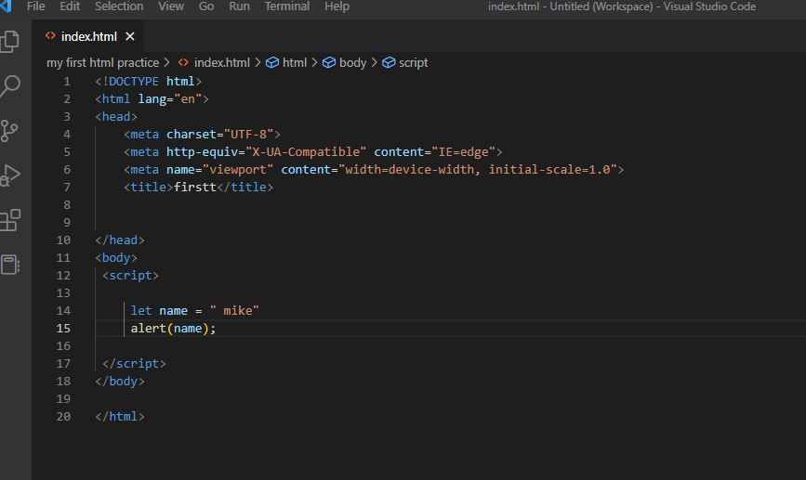

**Fig 3.6: Structure of an internal JavaScript code**

**EXTERNAL JAVASCRIPT**

JavaScript can separate in different file and linked with the link tag the file extension for JavaScript is .js e.g., script.js as show blow

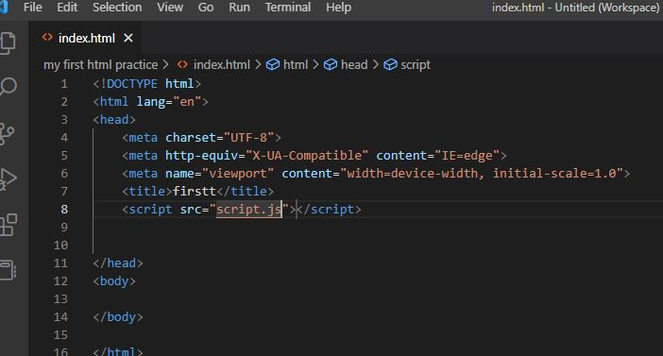

**Fig 3.7: Structure of external JavaScript**

**DATATYPE IN JAVASCRIPT**

* Number: number datatype consists of all number in a number set
* String: A string (or a text string) is a series of characters like "mike A"
* Object:
* Boolean: hold two values true or false

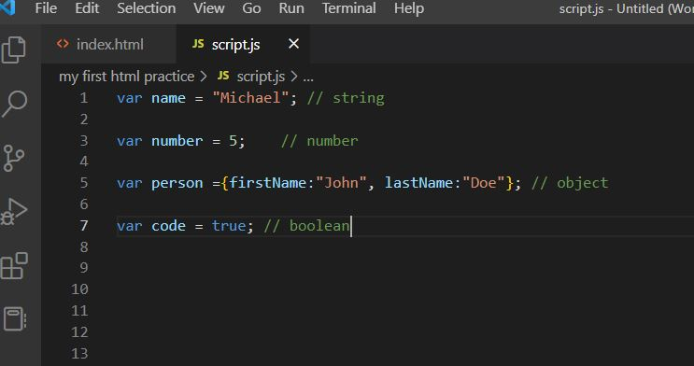

**Fig 3.8: Some JavaScript datatypes**

**VARIABLE**

Variable are container which takes up a memory location for data values in JavaScript they are three keywords to declare variable which include VAR, LET, AND CONST as seen below

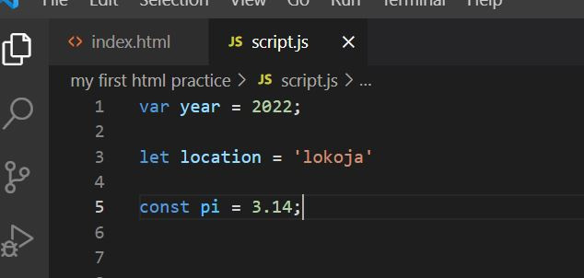

**Fig 3.9: Structure of declaring JavaScript variable**

**FUNCTION**

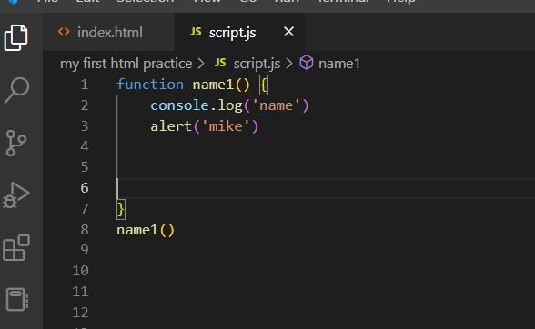JavaScript function are block of code designed to perform a particular task. JavaScript function is executed when “something” invokes it (call it). Function keyword is used to declare a function as seen below

**Fig 3.10: Structure of JavaScript function**

**3.4 JAVASRIPT LIBRARY (JQUERY)**

jQuery is a lightweight, "write less, do more", JavaScript library

The purpose of jQuery is to make it much easier to use JavaScript on your website.

jQuery takes a lot of common tasks that require many lines of JavaScript code to accomplish, and wraps them into methods that you can call with a single line of code.

jQuery also simplifies a lot of the complicated things from JavaScript, like AJAX calls and DOM manipulation (w3school, n.d.).

.

The jQuery library contains the following features:

* HTML/DOM manipulation
* CSS manipulation
* HTML event methods
* Effects and animations
* AJAX
* Utilities

## **jQuery Syntax**

The jQuery syntax is tailor-made for **selecting** HTML elements and performing some **action** on the element(s).

Basic syntax is: **$(*selector*). *action*()**

* A $ sign to define/access jQuery
* A (*selector*) to "query (or find)" HTML elements
* A jQuery *action*() to be performed on the element(s)

## **Adding jQuery to Your Web Pages**

There are several ways to start using jQuery on your web site. You can:

* Download the jQuery library from jQuery.com
* Include jQuery from a CDN (Content Delivery Network)., like Google

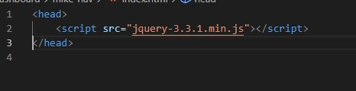

**Fig 3.11: Structure of linking download jQuery**

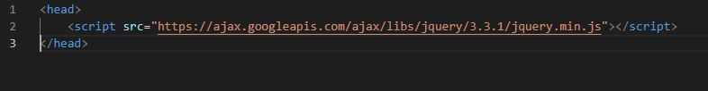

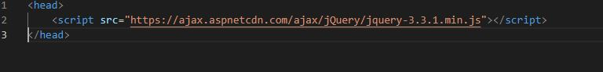**Fig 3.12: Structure of linking jQuery from Google CND**

**Fig 3.13: Structure of Microsoft CND**

**3.5 DATABASED MANAGEMENT (MYSQL)**

MySQL is a database system use on the web. It is a database system that runs on a server, MySQL uses standard SQL. SQL stands for Structured Query Language and it is the standard language for assessing database, MYSQL is an SQL DBMS (Database Management System). A database is a collection of related information in an organized manner.

The data in MYSQL database are stored in a table. Tables in database are collections of related data entries that are related to each other and arranged in rows and columns, where the row signifies records while the columns signify fields. Some of the functions of SQL are creating new database and tables in a database, executing queries against database, retrieving data from a database, inserting and updating records in a database, deleting records from a database etc.

**Database Tables**

Many databases are made of one or more tables, and each of the table is given a name which is used to identify the table and to describe what the table is created for. The figure below is an example of a table called “staff information” table:

|  |  |  |  |  |
| --- | --- | --- | --- | --- |
| Id | NAME | STATE OF ORIGIN | GENDER | DEPARTMENT |
| 001 | Mubarak Haruna | KADUNA | Male | Sales dept |
| 002 | Olayinka Amed | Osun | Male | Marketing dept |
| 003 | Ibe Emeka | Anambra | Male | Admin dept |

**Fig 3.14: a sample of a “staff information” table in MYSQL**

**Querying a database**

To query a database means to make certain requests to or from a database, a simple example of a database query is to select all the matric number of all the students from the table above, the code syntax is thus: “SELECT GENDER FROM staff information”. Below is the result for the selected query:

|  |
| --- |
| GENDER |
| Male |
| Male |
| Male |

**Fig 3.15: the result of the select query**

SQL is made up of two divisions and they are:

1. Data Definition Language (DDL): In this division we can; CREATE, DROP, ALTER, DELETE etc. They are basically used to define database schema.
2. Data Manipulation Language (DML): In this division we can; SELECT/FROM/WHERE, INSERT/INTO/VALUES, DELETE/FROM/WHERE. They are basically used for modifying the database.

**Creating a database:**

Below is the syntax to create a database:

CREATE DATABASE database name; e.g., CREATE DATABASE staff_ info;

Show database_name; e.g., Show staff_ info;

Use database_name; e.g., Use staff_ info;

**Creating a table:**

We can create a table from a database using the syntax given below:

CREATE TABLE table_name (column_name1 data_type(size)*,* column_name2 data_type(size), column_name3 data_type(size), .... ); e.g.

CREATE TABLE staff_info(staff_id INT(20) AUTO_INCREMENT PRIMARY, NAME VARCHAR(40), STATE OF ORIGIN VARCHAR(30), GENDER VARCHAR(10), DEPARTMENT VARCHAR(50) );

**Inserting data into a database:**

The syntax below is use to insert into a table that has been created in a database:

INSERT INTO table_name(field1, field2, field3,…) VALUES (‘value1’, ‘value2’, ‘value3’,...);

e.g. INSERT INTO staff_info(NAME, STATE OF ORIGIIN, GENDER, DEPARTMENT) VALUES (‘Moses Adejoh’, ‘Kogi’, ‘Male’, ‘Sales dept’);

**Updating data in a database:**

Updating data in database is to change the value of a particular record in a table, after the update query, the value is then changed to the updated one. The syntax is given below:

UPDATE table name SET column1=value1, column2=value2, … WHERE column target=column_value;

e.g. UPDATE staff_info SET NAME =’Lionel Messi’ WHERE Id=’001’;

After this query the full name for the staff with the Id 001 will be changed to Lionel Messi.

**Dropping a database:**

To drop a database means to delete that database from the MYSQL, once a database has been removed it cannot be seen in the MYSQL list of databases available on the server. The syntax to delete a database is given below:

DROP database_name; e.g., DROP staff_info.

**3.6 INTRODUCTION TO ASPX TECHNOLOGY**

ASPX stands for **Active Server Pages Extended** and these pages are displayed in web browser at user end when the URL is accessed. It is successor of ASP technology which are also generated at server end but does not use .NET framework.

Just in the same way office documents have various file extensions depending on the application required to open and edit them, the same goes for files meant for use on the web. Active Server Pages (ASPX) is a file format used by web servers and generated using the [Microsoft ASP.NET framework](http://www.itpro.co.uk/security/34793/leading-aspnet-host-crippled-by-ransomware-attack) – an [open-source](http://www.itpro.co.uk/open-source) development framework used by web developers to create dynamic web pages, often with the .NET and C# programming languages.

ASPX iterates on ASP, the technology which precedes ASPX, but does not use Microsoft’s .NET language and is instead written in other frameworks. ASPX is also commonly referred to as a .NET Web Form and you can determine whether a web page is written in ASPX when a ‘.aspx’ suffix is applied to the URL of the web page.

ASPX files typically contain various scripts or other open-source files that web browsers - the end-user - receive from web servers and these are the components of the web service that deliver dynamic, modern-looking elements on a page.

HTML allows web browsers to interpret display content written between tags. It allows images and objects to be embedded in the webpage. **ASP is used to design user-interactive or dynamic web pages.** **HTML is basically used to create static web pages**.

**HOW TO OPEN AN ASPX FILE**

A common occurrence when downloading a file from the web and onto a Windows machine is that it downloads as a .aspx file when you were expecting something else, such as a PDF. In these cases, a quick workaround that often works is to simply rename the file and change.

If you need to open and edit a .aspx file, then you can use Microsoft's free [Visual Studio](https://www.visualstudio.com/downloads/) to do so. You could also open up such a file using a normal text editor.

EXAMPLE OF ASPX

<%@ Page Language="VB" %>

<html>

<script runat="server">

Sub Button1_Click(ByVal sender As Object, _

ByVal e As System.EventArgs)

Label1.Text = "Welcome, " & TextBox1.Text

End Sub

</script>

<head runat="server">

<title>Basic ASP.NET Web Page</title>

</head>

<body>

<form id="form1" runat="server">

<h1>Welcome to ASP.NET</h1>

<p>Type your name and click the button.</p>

<p>

<asp:TextBox ID="TextBox1" runat="server"></asp:TextBox>

<asp:Button ID="Button1" runat="server"

Text="Click" OnClick="Button1_Click" />

</p>

<p>

<asp:Label ID="Label1" runat="server"></asp:Label>

</p>

</form>

</body>

</html>

**3.6 MOBILE APP DEVELOPMENT WITH CORDOVA**

Apache Cordova is defined as an open-source platform which is used for building mobile applications using **HTML, CSS and JavaScript.** It consists the set of pre-developed plugins that provide access to the device's camera, GPS, file system, etc. We can consider Cordova as an application container with the presence of web view that covers the entire screen of the device.

In 2011, Adobe acquired Nitobi and donated open-source core to Apache Software Foundation and it was rebranded as **Apache Cordova.**

**Fig 3.16: Apache Cordova logo**

The uses of the Apache Cordova are as follows:

* If you are a mobile developer and want to make your application compatible on more than one platform without the need to re-implement it with the language of each platform.
* If you are a web developer and want to deploy your web application on different store portals.
* If you are a mobile developer and want to mix native application components with a WebView for accessing the device-level APIs. You can also use it to develop plugin interface between native and WebView components.

Our Apache Cordova tutorial is designed for students and working professionals. It covers all the basic and advanced topics such as **PhoneGap, architecture, installation** etc., that will guide you on how to create mobile applications with ease.

Apache Cordova provides a set of API's that are responsible for providing the access to the native device features such as Camera, SIM card or the contacts lists. We can consider Cordova as an application container with the presence of web view that covers the entire screen of the device. The web view used by the Cordova is same as the native operating system. In iOS, by default **UIWebView** or a custom**WKWebView** class is used, whereas in Android, **android.webkit.WebView** is used.

Apache Cordova consists the set of pre-developed plugins that provide access to the device's camera, GPS, file system, etc. Following are the platforms where we can develop apps using Cordova:

* **Android**
* **iOS**
* **Windows**
* **Firefox OS**
* **Blackberry**
* **Tizen**
* **Web OS**
* **Symbian**
* **Ubuntu**

## FEATURES OF APACHE CORDOVA

Now, the Features of Apache Cordova are as follows:

* **Cordova Core Components:**  
  Cordova provides different core components that every mobile application needs. These components create base of an app that helps us to focus on implementing our own logic.
* **Command Line interface:**  
  This tool is responsible for building processes and installing plugins for different platforms. It is used for starting the projects and make the development process easier.
* **Cordova Plugins:**  
  It provides API for implementing native mobile functions to our JavaScript app. These plugins provide access to device capabilities in an application such as camera, battery, contacts etc.

## ADVANTAGES OF APACHE CORDOVA

The advantages of Apache Cordova are as follows:

* It is an open-source platform.
* It is easy to learn and used for developing a **cross-platform application.**
* It provides flexibility to build apps for multiple platforms without learning new programming languages.
* Development of applications in Cordova is fast because it transforms into app that is supported by other platforms.
* It is very quick to prototype.
* It consists the set of pre-developed plugins that provide access to the device's camera, GPS, file system.
* There are many community add-ons that provides several libraries and frameworks.

## DISADVANTAGES OF APACHE CORDOVA

The disadvantages of Apache Cordova are as follows:

* It is not optimal for large apps because hybrid apps are slower than native ones.
* Because of running its code in the web view, its performance become slow.
* It is not suitable for game application development, because it needs some higher-end plugins that are currently not available.

## **INSTALLING CORDOVA**

Cordova command-line runs on [Node.js](https://nodejs.org/) and is available on [NPM](https://npmjs.org/package/cordova). Follow [platform specific guides](https://cordova.apache.org/docs/en/latest/index.html#develop-for-platforms) to install additional platform dependencies. Open a command prompt or Terminal, and type npm install -g Cordova.

## CREATE A PROJECT

Create a blank Cordova project using the command-line tool. Navigate to the directory where you wish to create your project and type Cordova create <path>.

For a complete set of options, type Cordova help create.

## ADD A PLATFORM

After creating a Cordova project, navigate to the project directory. From the project directory, you need to add a platform for which you want to build your app.

To add a platform, type Cordova platform add <platform name>.

For a complete list of platforms, you can add, run Cordova platform.

## RUN YOUR APP

From the command line, run Cordova run <platform name>

**3.7 BLOOD MANAGEMENT SYSTEM**

**Introduction**

Blood is life and most times people fall extremely sick to the extent they need blood to survive their illness and sometimes is either they do not get donor quickly or do not even get donor at all this is why I decide to develop a system to bridge the gap between donor and receptor and also help hospital manage their blood bank with the knowledge in HTML, CSS, JAVASCRIPT, jQuery and MSQL using ASPX technology I came up with this project.

**Aim**

The main aim of blood management system is to ease the process of blood donation and also helps doctor or other health organization manage the process using MSQL as the databased to store records and data of the user and activities.

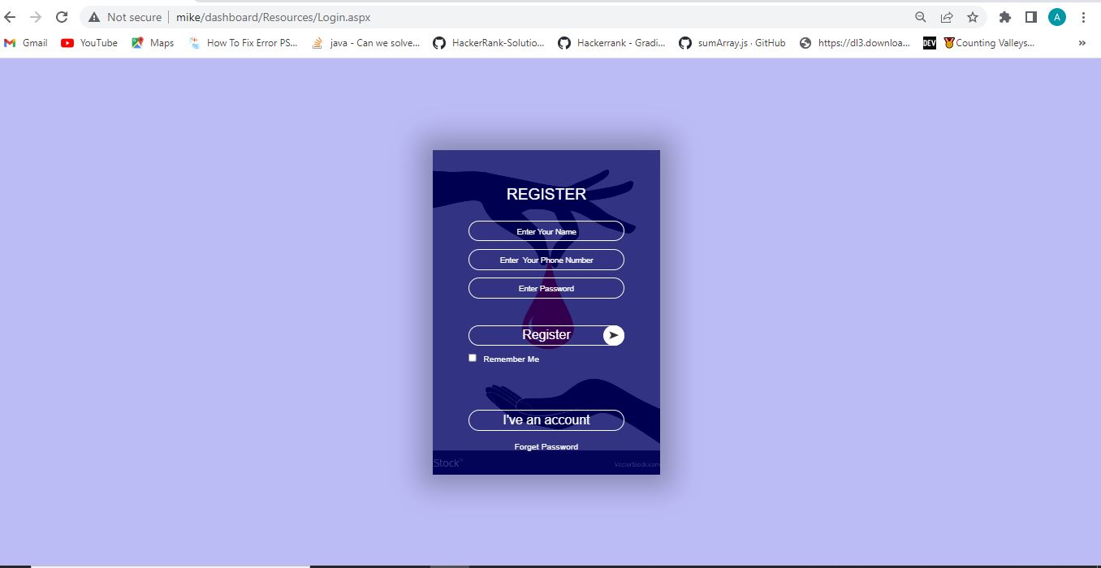

**Fig 3.17: register page for blood management system**

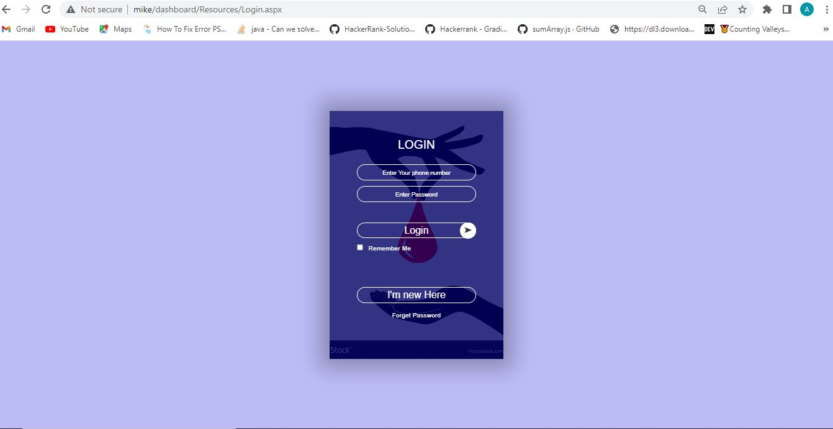

**Figure 3.0: login page for blood management system**

**Fig 3.18: login page for blood management system**

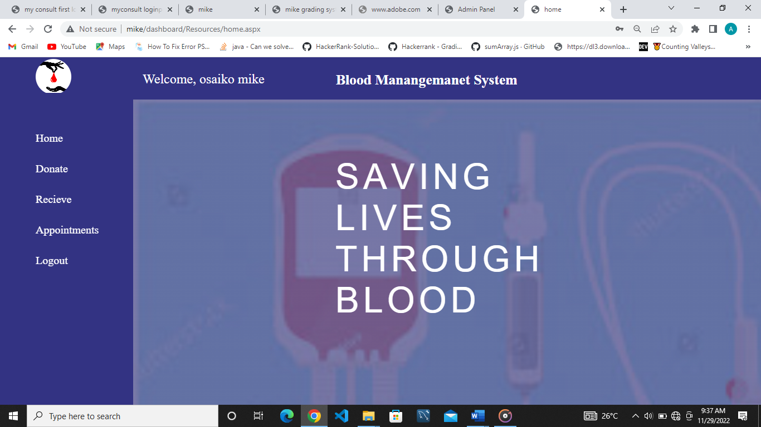

**Fig 3.19: user dashboard for blood management system**

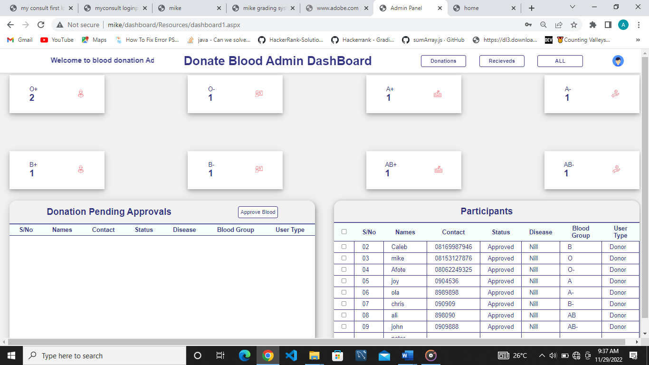

**Fig 3.20: admin dashboard blood management system**

**Summary Of the Project**

In this blood management system is developed so as to allow users create account then login as users where you can either donate blood or receive more also user can see the state of the activity perform, admin also can login to view the users’ activities admin can also approve the blood if it meets the requirement there is also a section in the admin dashboard where he/she can view amount of blood in bank.

**CHAPTER 4**

**4.1 SUMMARY**

Students Industrial Work Experience Scheme (SIWES) has helped me to gain knowledge in the

Software development and mobile application And I was able to developed a complete application titled “BLOOD MANAGEMENT SYSTEM”

**MAIN ACTIVITIES**

I was introduced to web development, what is needed to develop a web e.g. text editor and web browsers.

I was also introduced to mobile application, what is needed to develop a mobile app e.g. android studio and Gradle.

Get to know how the scripting language works (JavaScript) and also how to make a website attractive using the CSS Styling.

I get to know how information are been save, update and manipulated on database (MYSQL)

**4.2 CONCLUSION**

My 6month industrial attachment at GITECH ACADEMY was a huge success and a great time of acquisition of knowledge and skills. Throughout my training I was able to appreciate my chosen course of study even more, because I had the opportunity to blend the theoretical knowledge acquired from the school with the practical hand- on applications of knowledge gained here in the organization to perform very important tasks.

My training here has given me a view to the importance and relevance of computer science in the immediate society and the world as a whole, as I now look forward to impacting it positively after graduation. I have also been able to improve my communication and presentation skills and thereby developed good relationship with my fellow colleague at work. I have also been able to appreciate the connection between my course of study and other discipline in producing a successful result.

**4.3 RECOMMENDATION**

I use this means to make the following recommendations concerning the training of students in industrial attachments.

1. The ITF Official should ensure that payment of allowance is being made before or during training period as these incentive to the student serves as an encouragement (that is it helps offset some of the student problem such as transport, research and feeding while in the training ground).
2. ITF should provide a way whereby skills can be acquired by student from 100l
3. There should be award for must committed student so as to encourage them to be more serious in skill acquisition
4. Students should not pay fees before been absorbed into the industry or organization.
5. Industries or organization should provide effective internet access to the student, to enhance research which will in turn increase productivity.

**4.5 REFERENCE**

* Agwuna RN (2012) *influence of student’s industrial work experience*.
* Marionletendart (2018, March 28) web development definition. Openclassrooms

<https://blog.openclassroom.com> /en / 2018/03/28/web development-definition/

* W3schools. (n.d.). *jQuery introduction*. Retrieved December

6, 2022, from

www.w3schools.com/jquery/jquery_intro.html