Introduction

In this report, we explore and analyze a dataset related to traffic accidents in Catalonia. The objective is to gain insights into various aspects of road safety, including overall trends, characteristics of severe accidents, geographical patterns, and factors influencing accident occurrence.

Dataset Overview

The dataset spans from 2010 to 2021 and includes detailed information on traffic accidents. Key features include temporal data, location specifics, accident details, environmental conditions, road characteristics, and accident impact.

Analysis and Findings

1. General Trends

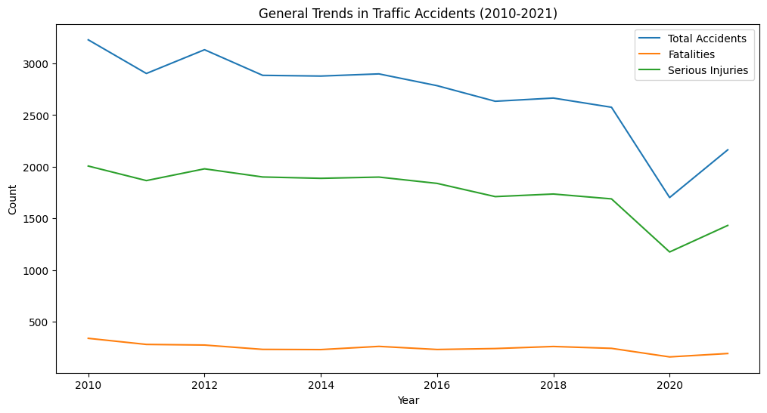

Findings:

Overall, there is an increasing trend in the total number of traffic accidents over the years.

Fatalities and serious injuries show varying patterns but tend to follow the overall trend.

2. Accident Characteristics

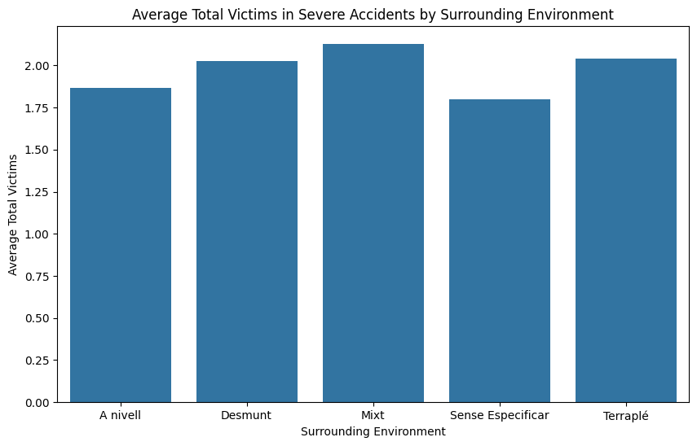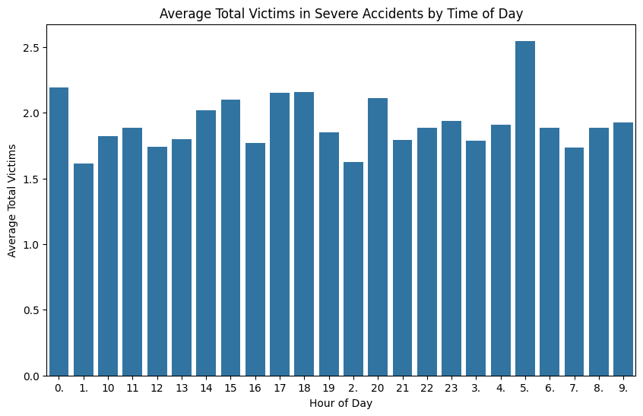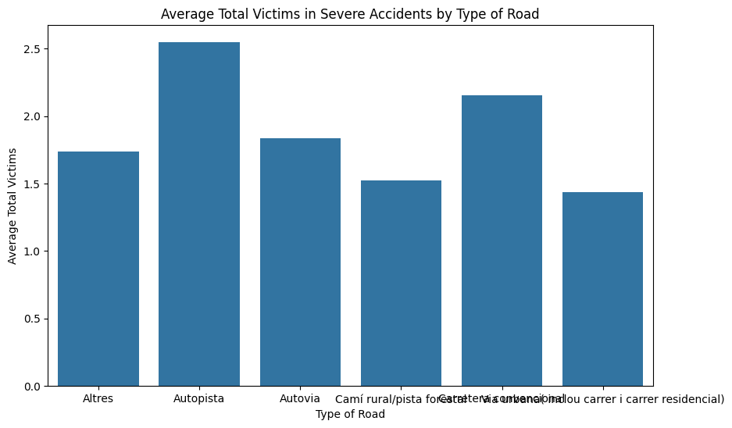

Findings:

Severe accidents tend to have higher average total victims during certain hours of the day.

Further investigation is needed to identify specific time periods with elevated risk.

3. Geographical Insights

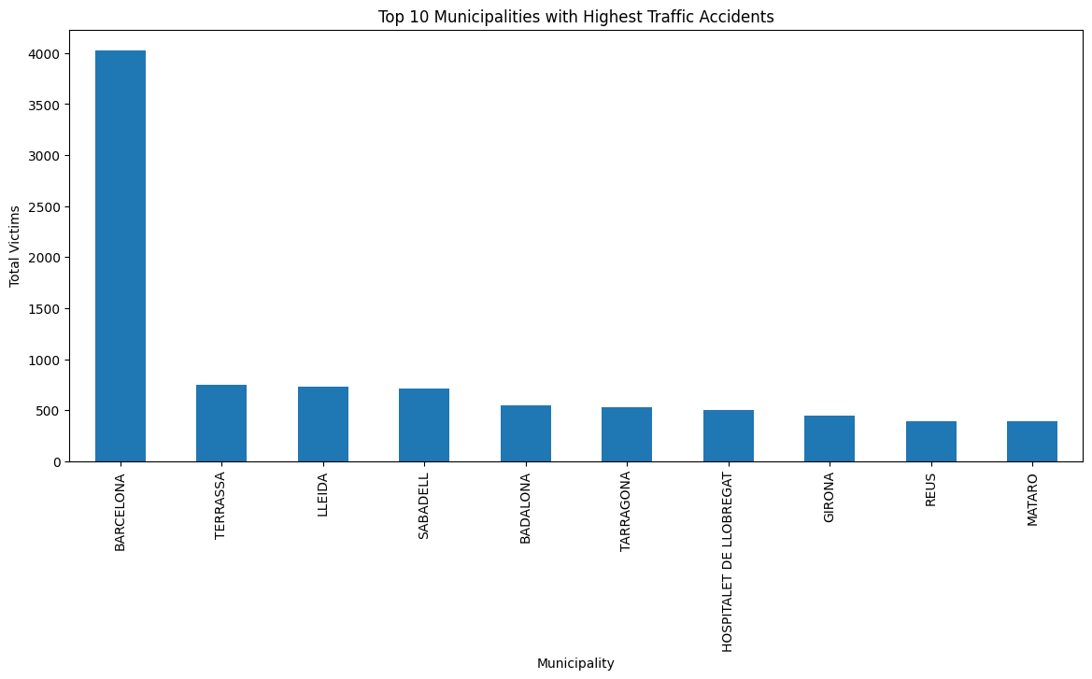

Findings:

Certain municipalities experience a higher incidence of traffic accidents, warranting targeted interventions in these areas.

4. Yearly Trends

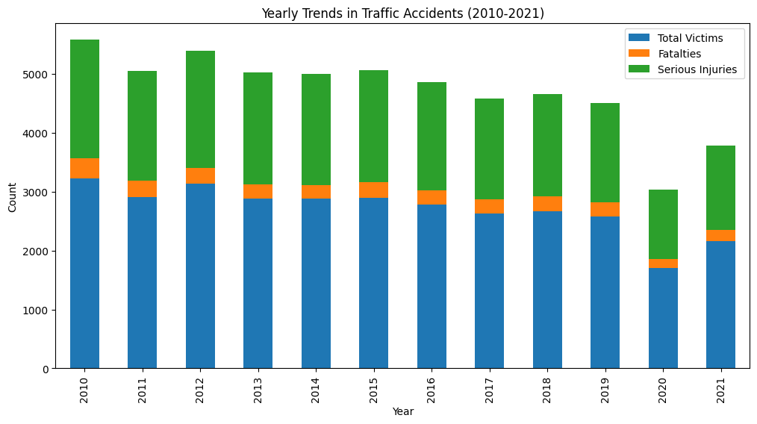

Findings:

Yearly trends show fluctuations in the total number of traffic accidents, fatalities, and serious injuries.

5. Day and Time Patterns

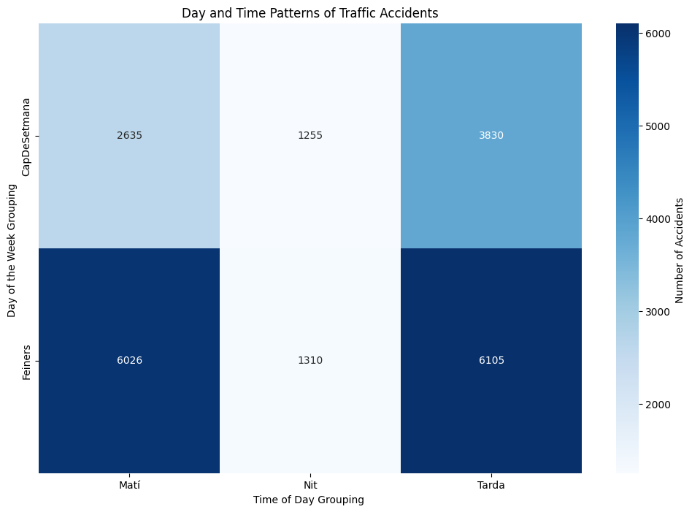

Findings:

Accidents show distinct patterns based on the day of the week and time of day, providing insights for targeted safety measures.

6. Environmental Impact

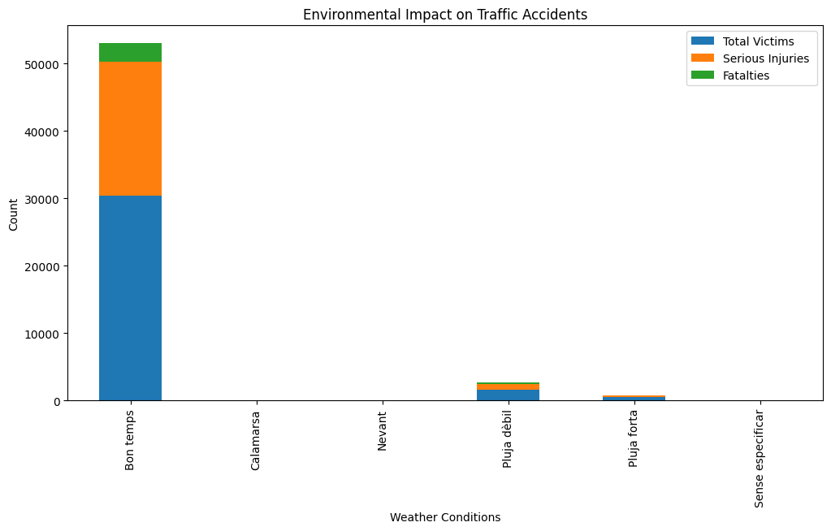

Findings:

Certain weather conditions contribute to higher total victims, serious injuries, and fatalities in traffic accidents.

7. Road and Traffic Features

Findings:

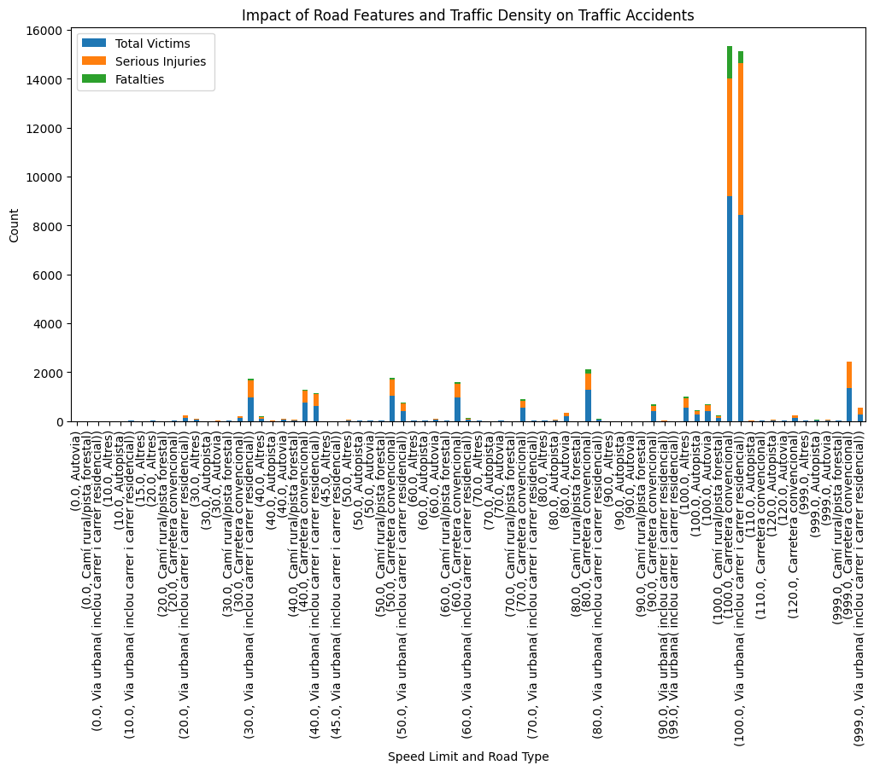

Road features, such as speed limits and road types, have varying impacts on the occurrence of traffic accidents.

8. Vehicle Types and Accident Severity

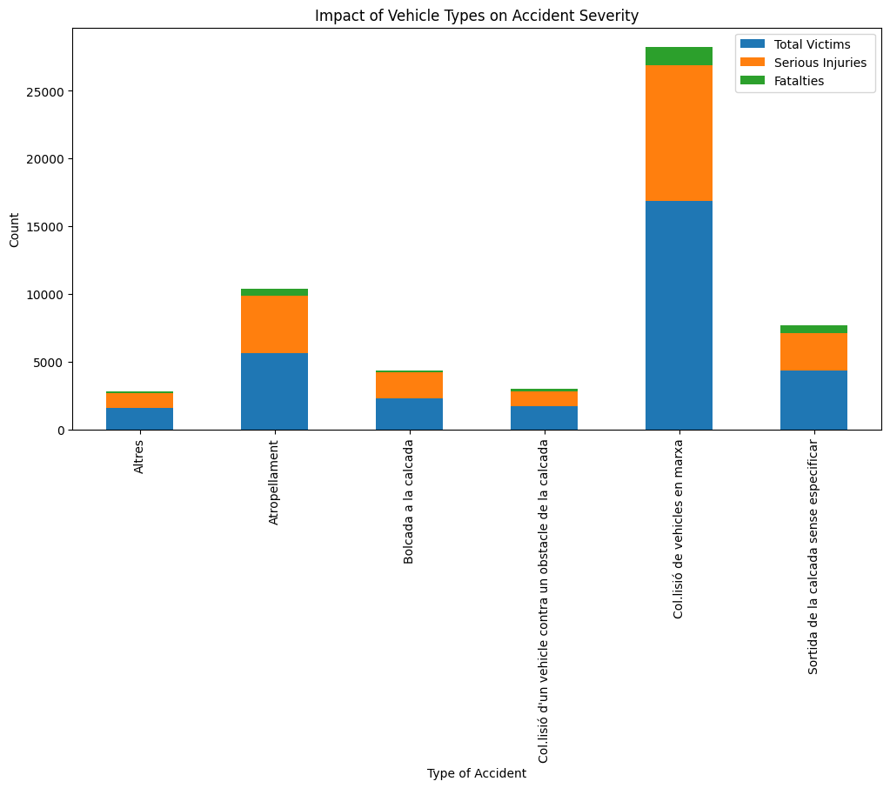

Findings:

Certain types of accidents involve higher total victims, serious injuries, and fatalities, emphasizing the need for targeted safety measures.

9. Time-Series Forecasting

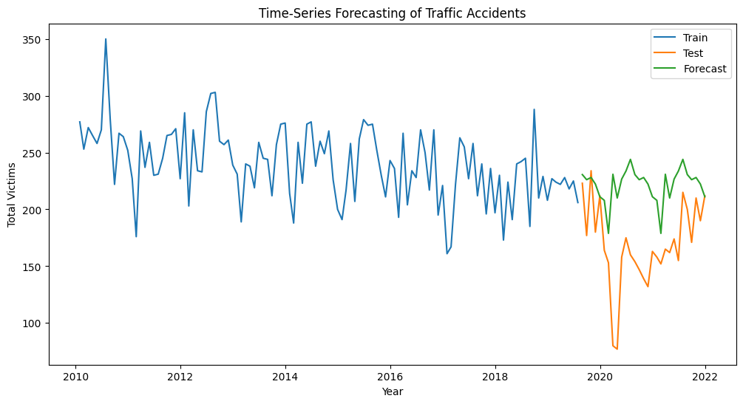

Findings:

The time-series forecasting model provides a tool for predicting the number of accidents, fatalities, or serious injuries for the upcoming year based on past trends.

**Correlation Analysis:**

We Calculate the correlation between each feature and the target variable .

Features with high absolute correlation values are more likely to be important.

Total Victims

Light Vehicles Involved 0.397713

Units Involved 0.291887

Fatalties 0.231872

Kilometer Point 0.200855

Motorcycles 0.117730

Heavy Vehicles Involved 0.098985

Bicycles Involved 0.061516

Pedestrains Involved 0.058234

Road Speed Limit 0.054529

Mopeds Involved 0.053747

Year 0.032813

Other Units Involved 0.014888

Hour of Day 0.011778

Serious Injuries

Light Vehicles Involved 0.177043

Light Injuries 0.128286

Units Involved 0.100722

Heavy Vehicles Involved 0.065623

Motorcycles 0.042630

Kilometer Point 0.037409

Pedestrains Involved 0.023675

Year 0.015578

Road Speed Limit 0.015005

Bicycles Involved 0.014457

Hour of Day 0.013745

Mopeds Involved 0.011840

Other Units Involved 0.008038

fatalties

Serious Injuries 0.355594

Total Victims 0.231872

Kilometer Point 0.169738

Heavy Vehicles Involved 0.157959

Road Speed Limit 0.081421

Light Vehicles Involved 0.077893

Motorcycles 0.069991

Light Injuries 0.068630

Mopeds Involved 0.068031

Units Involved 0.048455

Bicycles Involved 0.035844

Hour of Day 0.035538

Pedestrains Involved 0.034175

Year 0.012779

Other Units Involved 0.007932

**most important feature for people to know about accident**

Determining the most important feature in predicting or understanding traffic accidents can depend on various factors, including the specific goals of the analysis and the context of the dataset. However, I can provide a general perspective on features that are often considered crucial in studies related to road safety and accidents:

1. Road Speed Limit:

* The speed limit on a given road is a critical factor. Accidents often correlate with excessive speeds, and understanding this relationship is essential for implementing effective safety measures.

1. Environmental Conditions (e.g., Weather and Lighting):

* Weather conditions, visibility, and lighting can significantly impact road safety. Adverse weather, poor visibility, and inadequate lighting contribute to higher accident rates.

1. Road Type and Characteristics:

* Different road types (e.g., highways, urban roads) and characteristics (e.g., intersections, curves) can influence accident likelihood. Analyzing the impact of road design is crucial for improving safety measures.

1. Traffic Density:

* The density of traffic on a road is a key factor. High traffic density can lead to congestion and increase the risk of accidents.

1. Type of Accident:

* Understanding the types of accidents (e.g., collisions, run-off-road incidents) provides insights into specific risk factors and potential preventive measures.

1. Time of Day and Day of the Week:

* Accidents often exhibit patterns based on the time of day and day of the week. For example, rush hours or weekends may have different accident characteristics.

1. Road Surface Conditions:

* The condition of the road surface, influenced by factors such as rain or snow, can impact vehicle traction and contribute to accidents.

1. Involvement of Specific Vehicle Types:

* Analyzing the involvement of specific vehicle types (e.g., heavy trucks, motorcycles) in accidents can help identify areas of concern and tailor safety measures.

1. Temporal Clustering:

* Identifying specific periods (months, years) where accidents cluster significantly is essential for understanding seasonal variations or addressing recurring issues.

1. Speed Limit Information:

* Knowing the designated speed limit on a road is crucial for understanding the context of accidents and enforcing appropriate speed regulations.

It's important to note that the importance of these features may vary based on the specific dataset and local conditions. Machine learning models, statistical analyses, and domain expertise can all contribute to a more nuanced understanding of the relationships between these features and traffic accidents.

**suggestion to reduce accidents and its victims**

Reducing accidents and minimizing their impact on victims involves a multifaceted approach that considers various factors. Based on the provided dataset and features, here are several suggestions to enhance road safety and decrease the number of accidents and their victims:

1. Improve Road Infrastructure:

Evaluate road characteristics, such as the presence of intersections, road types, and altimetric layouts, to identify areas where infrastructure improvements can enhance safety.

2. Enhance Traffic Regulations and Enforcement:

Strengthen and enforce traffic regulations, especially regarding speed limits and special traffic measures. Implement measures to deter hit-and-run accidents.

3. Increase Visibility and Lighting:

Address factors influencing visibility and lighting conditions, especially in areas prone to accidents. Installing better lighting and maintaining clear visibility can reduce the likelihood of accidents.

4. Implement Weather-Specific Safety Measures:

Develop and implement safety measures tailored to specific weather conditions. For example, in adverse weather, consider reducing speed limits or implementing traffic management measures.

5. Promote Road Safety Education:

Launch educational campaigns to raise awareness about road safety, targeting both drivers and pedestrians. Emphasize the importance of following traffic rules and being cautious in high-risk areas.

6. Target High-Incidence Areas:

Identify municipalities or counties with the highest incidence of traffic accidents. Allocate resources and implement targeted interventions in these areas, considering population density and road network characteristics.

7. Address Time and Day Patterns:

Develop strategies to address specific days and times with higher accident rates. This could involve increased law enforcement presence during peak accident periods.

8. Improve Road Surfaces:

Enhance road surface conditions to minimize the impact of weather on driving. Regular maintenance and improvements can contribute to safer driving conditions.

9. Prioritize Traffic Density Management:

Explore measures to manage traffic density, especially during peak hours. This could include optimizing traffic flow, encouraging public transportation, or implementing congestion pricing.

10. Vehicle Safety Initiatives:

Collaborate with relevant authorities to promote vehicle safety initiatives. This may involve campaigns encouraging the use of safety features, regular vehicle maintenance, and adherence to safety standards.

11. Implement Temporal Clustering Strategies:

Investigate specific periods (months, years) with significant accident clusters. Identify and address the underlying causes, such as seasonal events or changes in road conditions.

12. Leverage Technology:

Explore the integration of technology, such as intelligent traffic management systems, real-time monitoring, and predictive analytics, to identify and mitigate potential risks.

13. Community Engagement:

Engage with local communities to gather insights into specific road safety challenges and involve them in developing and implementing safety initiatives.

14. Collaborate with Stakeholders:

Collaborate with law enforcement, local government, transportation agencies, and community organizations to create a comprehensive and coordinated approach to road safety.

15. Continuous Monitoring and Evaluation:

Establish a system for continuous monitoring and evaluation of road safety measures. Regularly review accident data, assess the effectiveness of implemented strategies, and make adjustments as needed.

Remember, the effectiveness of these strategies may vary based on the unique characteristics of the region and the specific challenges identified in the dataset. It's advisable to conduct a thorough analysis and involve stakeholders in the decision-making process to ensure a holistic and effective road safety plan.

**Conclusion**

This analysis aims to provide a comprehensive understanding of traffic accidents in Catalonia. By exploring various dimensions of the dataset, we can identify patterns, risk factors, and potential interventions to enhance road safety. It's crucial to continue refining analyses, incorporating domain expertise, and collaborating with stakeholders to implement effective measures for accident prevention and mitigation.

Feel free to adapt and expand upon this report based on your specific needs and the details of your dataset. If you have any further questions or if there's anything specific you'd like to explore, please let me know!