Arduino Lab Setup

Arduino Board Pins

* Pin 2 – Valve
* Pin 4 – Pump
* Pin 7 – Ignitor
* Pin 8 – Level sensor low
* Pin 10 – SD card
* Pin 13 – Level sensor high
* Analog 0-4 – Thermistors 1-5
* Analog 5 – Level sensor 4-20 mA
* 3.3V – Red line goes to power line on breadboard
* Ground – Black line goes to ground line on breadboard
* AREF – Red to positive line on breadboard (analog positive line)

Breadboard Connections

Thermistors

* One end of each goes to ground line (here connected to black wire)
* Other end goes in series of red wire – resistor – analog input wire
* Other end of resistor goes to power line
* Thermistor 1: Red C5, Resistor B5-Power 2, Analog A5-A0
* Thermistor 2: Red E8, Resistor C8-Power 7, Analog A8-A1
* Thermistor 3: Red C11, Resistor B11-Power 10, Analog A11-A2
* Thermistor 4: Red E14, Resistor C14-Power 12, Analog A14-A3
* Thermistor 5: Red C17, Resistor B17-Power 15, Analog A17-A4

Pump

* Pump relay signal – Pin 4
* Pump relay ground – Ground 6
* Pump relay power – Power 1

Level Sensor – Sends signal when below low and above high/analog 4-20 mA output

* Depth positive (red) – To power supply
* Depth negative (black) – To power supply
* Depth relay common (brown) – 0+13
* Depth relay high (purple) – Pin 8
* Depth relay low (yellow) – Pin 13
  + Or
* Negative line from sensor to B23, 100 Ω resistor C23 to D21, Negative power E21
  + Analog wire A21-A5

Ignitor/Value

* Ignitor Signal – Pin 7
  + Facing issue with small current flowing through Pin 7, temporary set up
  + Pin 7 to A26 – Resistor C26 to C29 – Signal E26 to Board – Wire E29 to Ground 30
* Valve Signal – Pin 2
* Positive – Power 25
* Ground – Ground 23

Arduino commands

* Valve – output
* Ignitor – output
* Pump – output
* MinDepth & MaxDepth – input

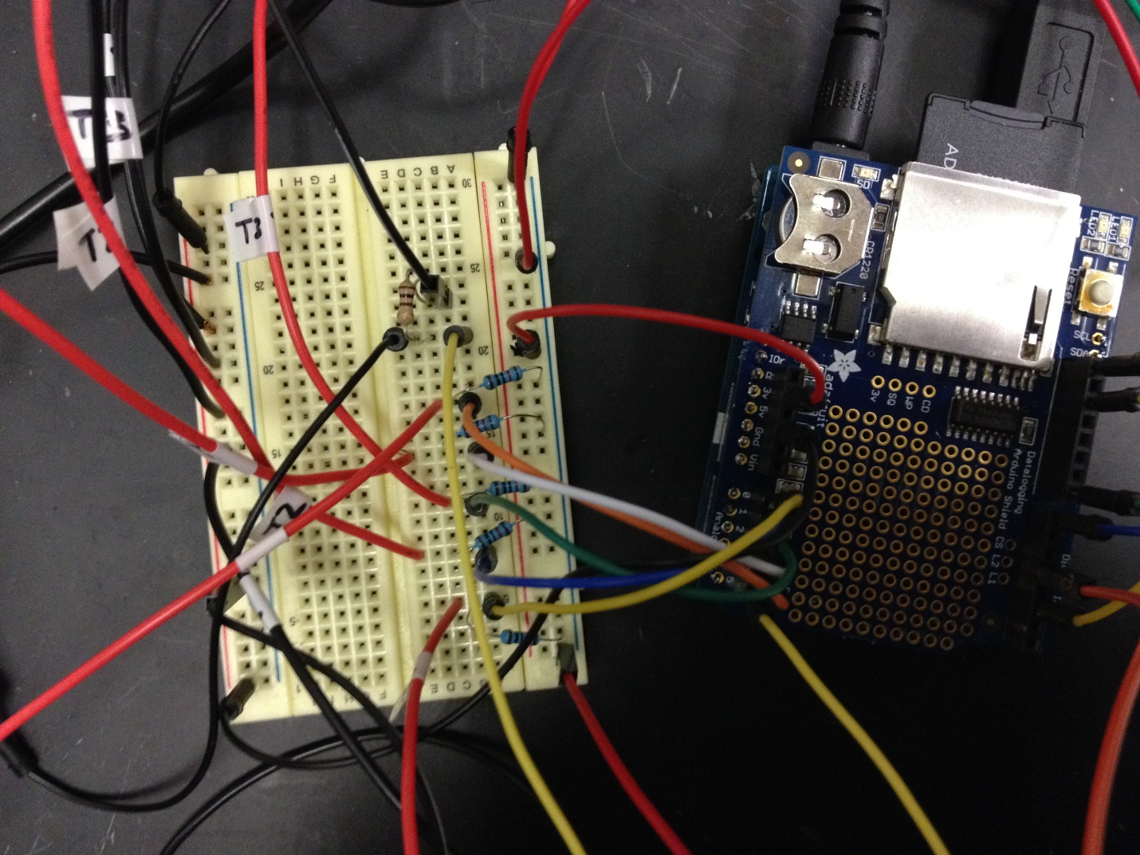

5 thermistors, Red to 10K resistor

5 thermistors, Black to ground

Ground

AREF

Level power

Level sensor

3.3V