1. **Create a Navigation menu bar with dropdown list:**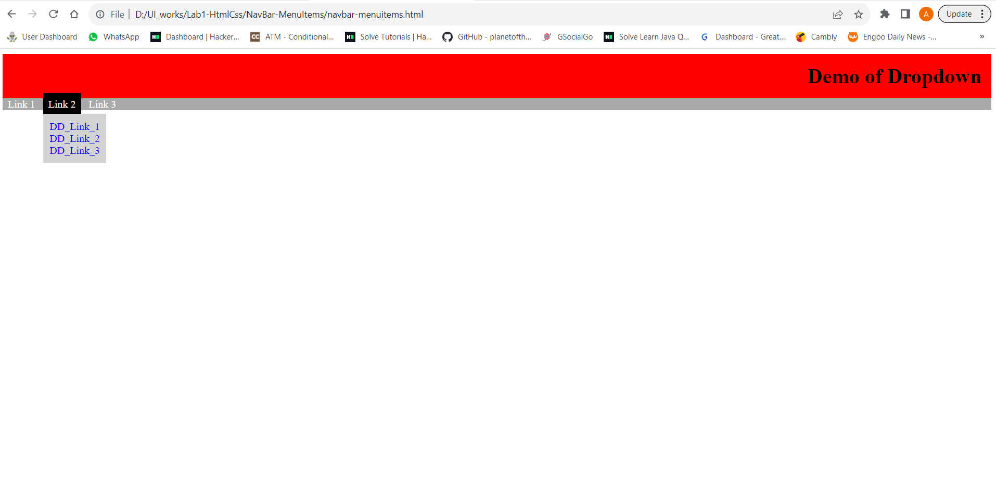
2. **Create a vertical bar graph with the help of animation:**

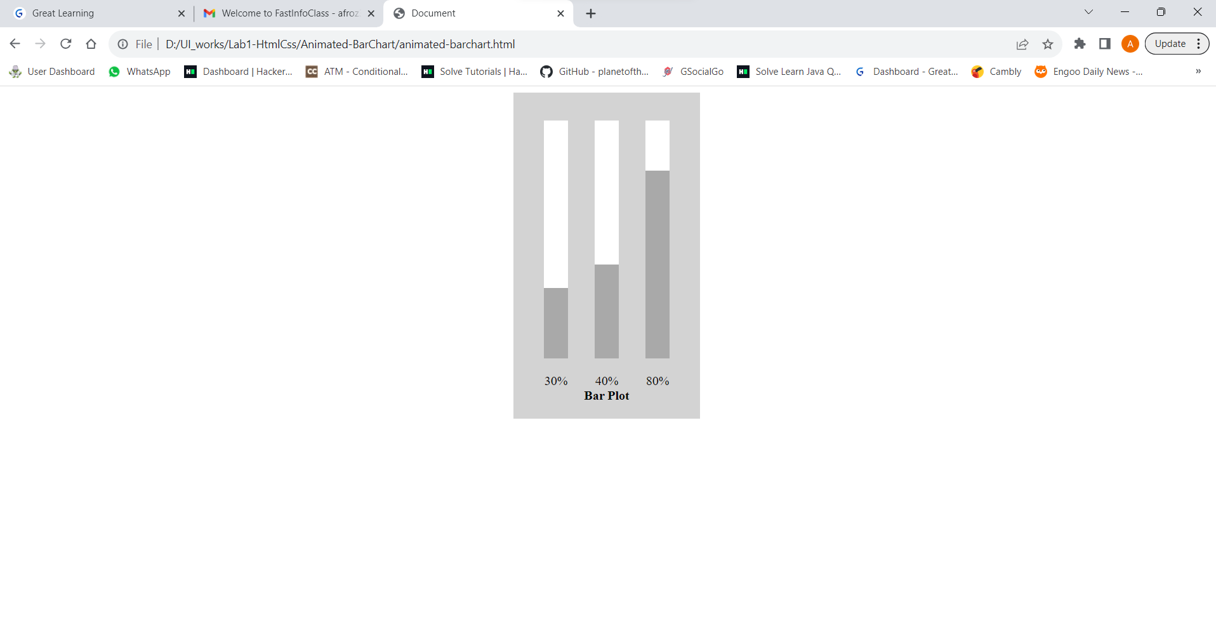

1. **Create a gmail account creation form to take input from users as specified below:**

