Declaration on the use of Artificial Intelligence (AI) systems
in the preparation of the thesis

During the preparation of this thesis, the author(s) used ChatGPT for the purpose of researching the literature and obtaining sources for reference.
The author(s) have verified the content and edited the text of the thesis in accordance with its objectives, present their own intellectual contribution and take full responsibility for the final form of the thesis.*

During the preparation of this thesis, the author(s) did not use any AI tools.

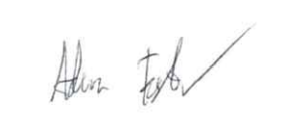

………………………………………..
Signature of the Author / Authors

Delete as appropriate.

