The dataset draws data from a total of 15 schools, 39,170 students. The total student’s average math score 78.98% with % Passing Math 74.98%. The average reading score is 81.87% with % Passing Reading 85.80%. The overall passing rate is 65.17%. Showing that student's score more in reading than math.



The Highest-Performing Schools are Charter with the highest performing school named Cabrera High School.

The Bottom-Performing Schools are all district with the lowest overall passing being Johnson High School.

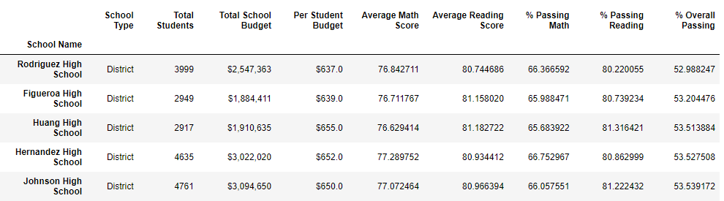

Scores by spending shows that the lowest spending ranges showed the highest overall passing of 90.64% and the highest spending ranges shows the lowest Percentage Overall Passing

The larger the school the lower the percent overall passing

That overall Charter Schools fair better than district schools.