**Functionality**

**how does the website work?**

1. **Header/Nav**

Navigating between the pages is very neccesary when it comes to an online website. That is why the navigation bar has to be intuitive and simple. Also, the header displays the trademark of the client company, GamerZ.



**0.1:** On the first navigation tab button, users can get to the home page. The home page is the first page users will see, so it is not always neccesary to switch there.

**0.2:** On the second tab, customers can reach the products stored in the database.

**0.3:** The third tab is actually a fast filter, which is quiet helpful when customers want to use filters to fint a specific platform.

**0.4:** The fourth tab is responsible for the customer's support. Users can ask questions from the customer service and can also leave a review of the website.

**0.5:** The Add product page is only available for logged in admin users. Here they can register new products to the database, makign their job even easier.

**0.6:** the first icon on the left is responsible for the login adn register. These two possibilites are shown for not logged in users. Otherwise, if a customer has logged in, He can log out or acces their profile page by clicking this Icon.

**0.7:** The last icon is the shopping cart. The chosen products get here. A little index ont he bottom right of the icon shows how many items users currently have in their shopping cart.

**2. Products**

Here the products available in the database are displayed. 12 products are shown at once, but you can change pages to find even more games.

**2.1:** On the left side are the filters. Users can use this to make their searches easier by choosing individual aspects of the product they want. They can search for title, release year, publisher, type, platform, and also in a range of price.

**2.2:** In the middle of the page are the products. Clicking them redirects customers to the seperate page of the clicked product. More info in 2.5

**2.3:** Ont he bottom of the page are the buttons responsible for chaning pages. The next button show the next 12 games, while the previosu button does what it is expected, shows the previous 12 games.

**2.5 Product**

**2.5.1:** the main attraction on this page is that the actual product is shown. You can see its title, price, publisher, platform and description.

**2.5.2:** With the To Cart button, the product gets into the shopping cart. users can only place an item to the shopping cart once.

**2.5.3:** Here users can leave a review of the game, which will be shown in the comment section. First, users have to be logged in in order to perform this action. Secondly, a score has to be given, and lastly, a message has to be left.

**3. Platform filter**

As said earlier, it is a quick filter for does who lack time!

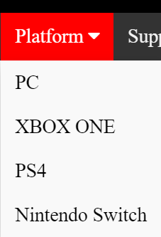

The most common platforms can be fitlered here, precisely PC, Xbox One, PS4, and Nintendo Switch.

**4. Support**

Here users can ask questions from the customer service via email. Altough users have to be logged in in order to identify themself.

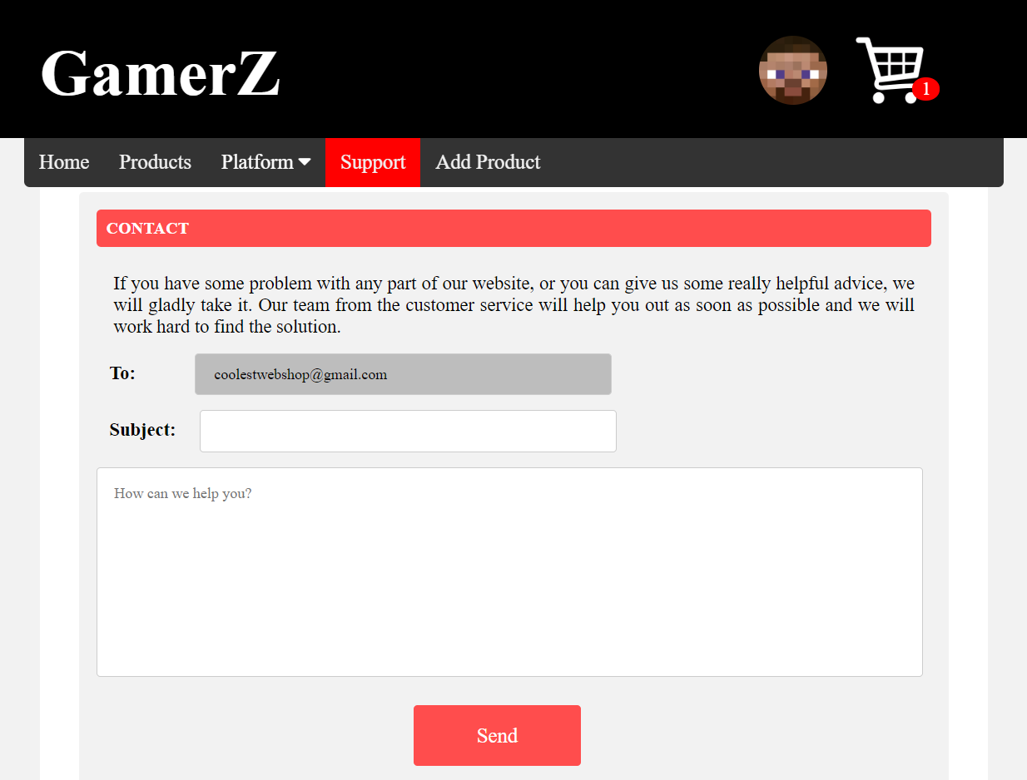On the bottom of the page, there is a possibility to leave a review of the website itself.

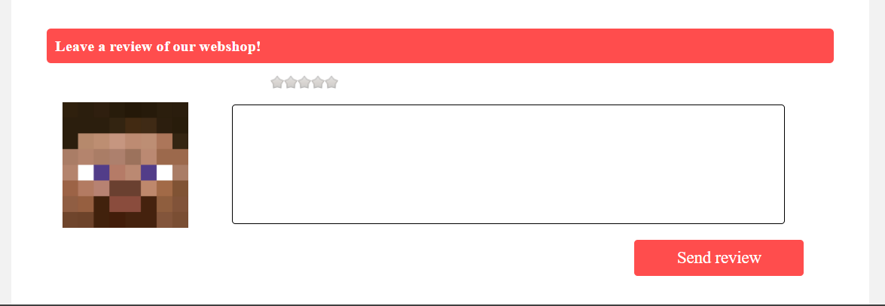

**5. Add Product**

This page is only available for those logged in users, who have admin permission. Here products can be registered to the database, filling the following form.

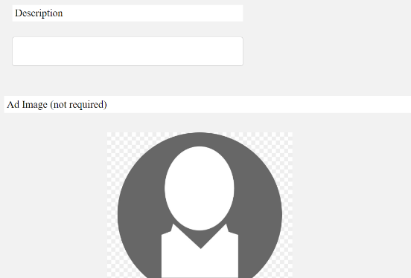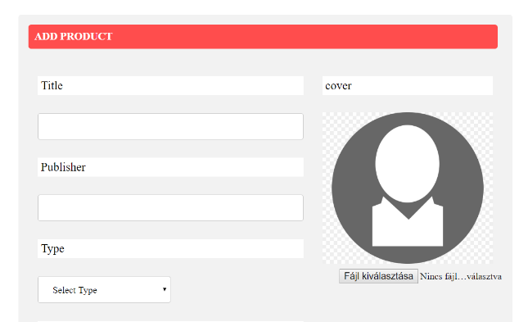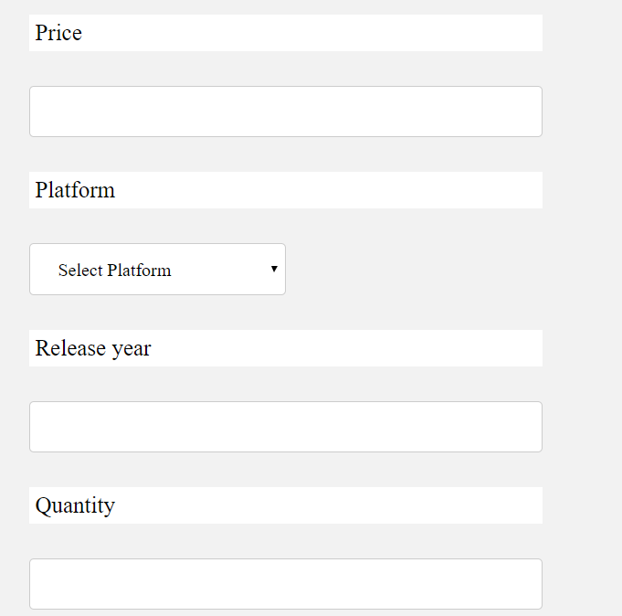

**6. Profile**

Here the personal information of a customer is displayed, such as username, email, full name, which can be changed later, and the birth date, which can not. Also, Shipping informations are shown as well.

**6.1:** Clicking on the edit button redirects the user to the edit profile page. More info in 6.5.

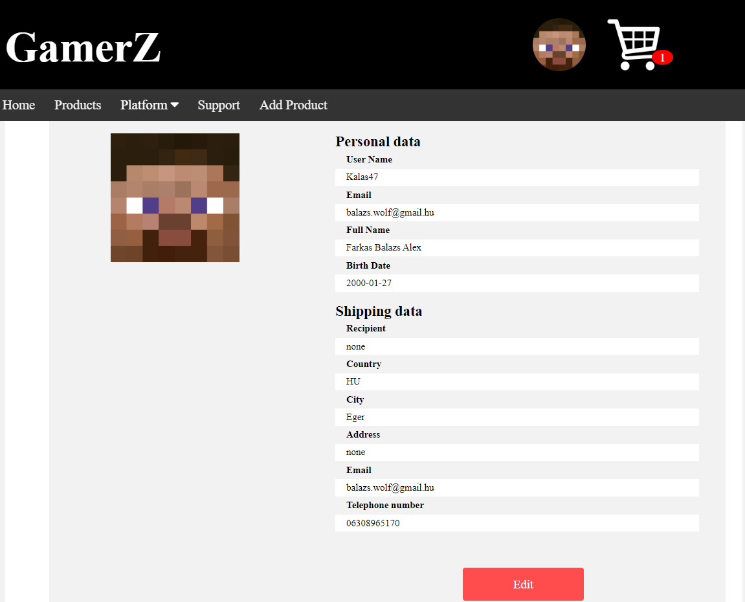

**6.5 Edit Profile**

Here users can change their personal information and shipping data.

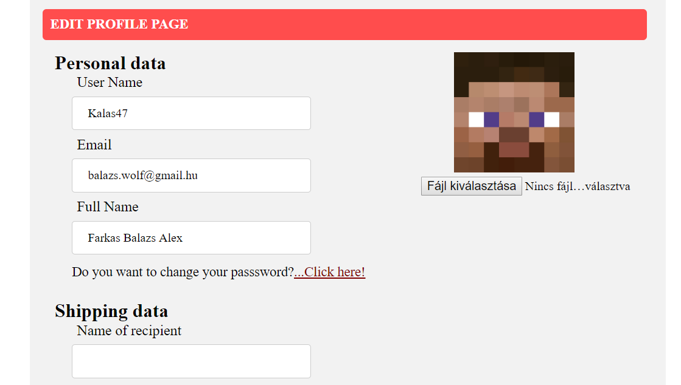

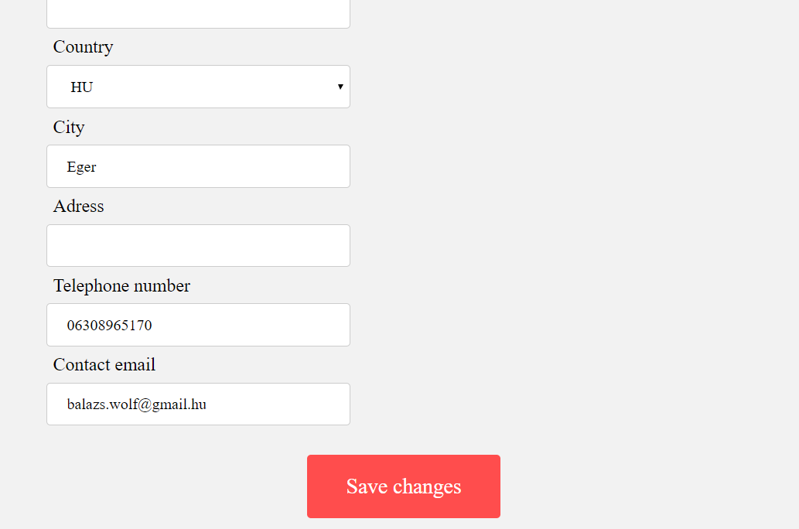

**7. Shopping Cart**

On this page, the Products placed into the shopping cart are available. An item can be put into the shoppign cart only once.

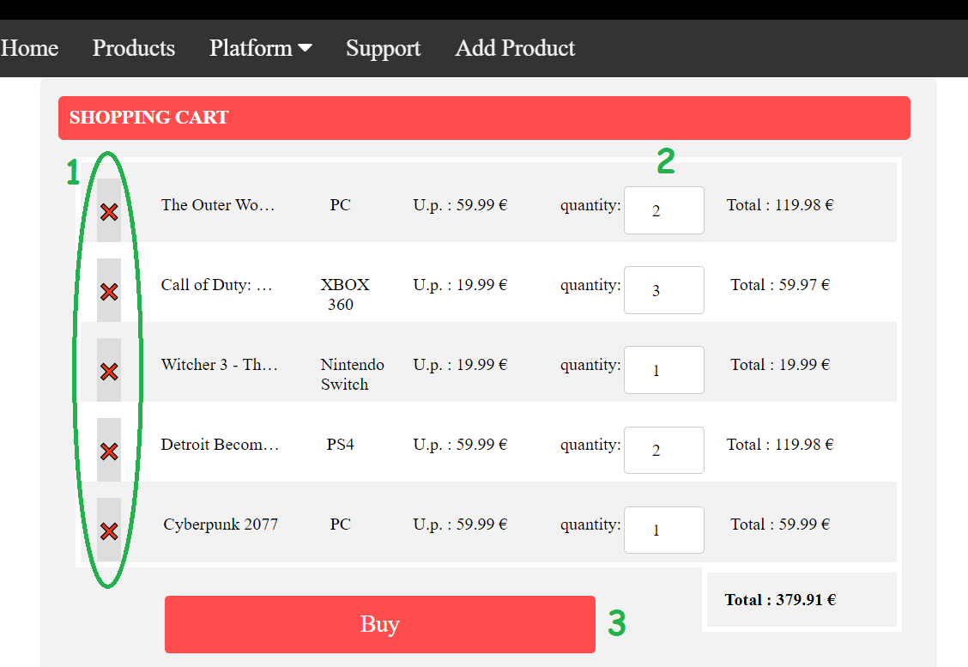

**7.1:** Upon clicking ont he big red cross, the item belonging to it will be deleted from the shopping cart.

**7.2:** Quantity can be changed. Max value is the amount available in the store, min value is 1. 0 item can not be ordered, due to it should bee deleted instead.

**7.3:** By clicking on the buy button, The shopping cart will be finalized and the user will get redirected to the purchase page, the last on in the ordering chain.