Test report

|  |  |
| --- | --- |
| Executed by | Dombi Tibor |
| Project | Gamerz Webshop |
| Date | 2019.12.08 14:09 |
| Commit | #290 ([link](https://github.com/afplabor2019/blank_team/commit/58ebddc38a97617570b543a64d8d330ac5a8ec2a)) |
| Minimum passing percentage | 16/20 (>80%) |
| Module | UI |
| Page | Cart |
| Result | 15/20 (75%) |

# Readability: 3/5

* Paragraph: Easy to read
* Gramar: No spelling mistakes
* Font color: Good contrast, uniformed through the page
* Font style: On default setting, will be different in every browser

# Form: 3/3

* Elements present: OK
* Fields can not be empty: OK
* Password field uses hidden characters: OK

# Structure: 9/12

## 1920x768: 4/4

* Element positions: OK
* Element sizes: OK
* Mouse over animations: OK
* Cliping: None

## 1360×768: 4/4

* Element positions: OK
* Element sizes: OK
* Mouse over animations: OK
* Cliping: OK

## Mobile: 1/4

* Element positions: FAIL
* Element sizes: FAIL
* Mouse over animations: OK
* Cliping: FAIL



* Navigation buttons disappear when screen width is less than 585px

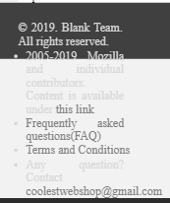

* Footer overflows



* User and cart buttons are at the wrong position

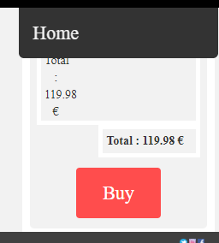

* Form is not responsive