Test report

|  |  |
| --- | --- |
| Executed by | Dombi Tibor |
| Project | Gamerz Webshop |
| Date | 2019.11.25 12:00 |
| Commit | #290 ([link](https://github.com/afplabor2019/blank_team/commit/58ebddc38a97617570b543a64d8d330ac5a8ec2a)) |
| Minimum passing percentage | 15/19 (>80%) |
| Module | UI |
| Page | Home |
| Result | 12/19 (63%) |

# Tab: 1/2

* Favicon: Missing
* Page title: OK

Details:



# Readability: 3/5

* Paragraph: Easy to read
* Gramar: No spelling mistakes
* Font color: Good contrast, uniformed through the page
* Font style: On default setting, will be different in every browser
* Encoding: Database and the website encodings are diferent

Details:

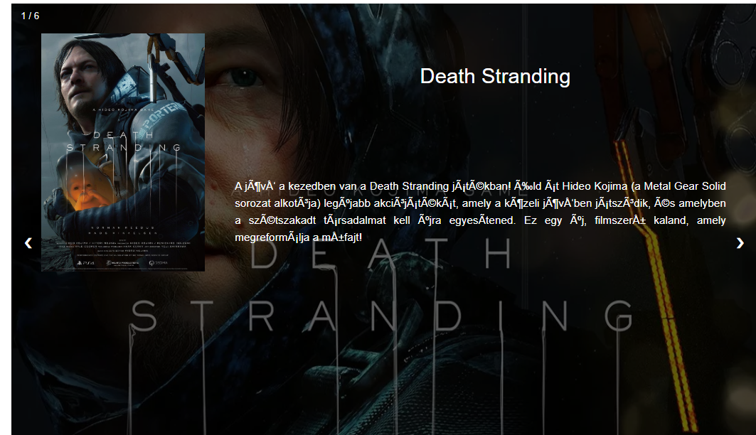

# Structure: 8/12

## 1920x768: 4/4

* Element positions: OK
* Element sizes: OK
* Mouse over animations: OK
* Cliping: None

## 1360×768: 2/4

* Element positions: OK
* Element sizes: FAIL
* Mouse over animations: OK
* Cliping: FAIL

Details:



* Floating navigation clipping in the top of the image

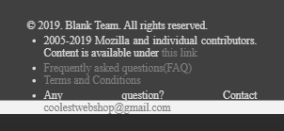

* Footer content overflows through the footer itself

## Mobile: 2/4

* Element positions: OK
* Element sizes: FAIL
* Mouse over animations: OK
* Cliping: FAIL



* Navigation buttons disappear when screen width is less than 585px

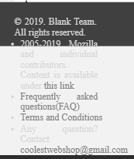

* Footer overflows