Test report

|  |  |
| --- | --- |
| Executed by | Dombi Tibor |
| Project | Gamerz Webshop |
| Date | 2019.11.25 12:00 |
| Commit | #235 ([link](https://github.com/afplabor2019/blank_team/commit/6fc0a297ea3c6f55d24c4c3a07fd55dda23170ad)) |
| Minimum passing percentage | 14/17 (>80%) |
| Module | UI |
| Page | Home |
| Result | 9/17 (53%) |

# Tab: 0/2

* Favicon: missing
* Page title: Placeholder not replaced

# Readability: 1/3 (2 test not apllicable yet)

* Paragraph: Needs space before paragraphs (see the arrows)
* Gramar: Placeholder text present, test not applicable
* Word usage: Placeholder text present, test not applicable
* Font color: Good contrast, uniformed through the page
* Font style: On default setting, will be different in every browser

# Structure: 8/12

## 1920x768: 4/4

* Element positions: OK
* Element sizes: OK
* Mouse over animations: OK
* Cliping: None

## 1360×768: 2/4

* Element positions: OK
* Element sizes: FAIL
* Mouse over animations: OK
* Cliping: FAIL

Details:



* Floating navigation clipping in the top of the image

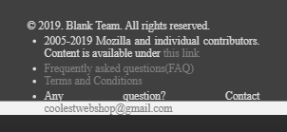

* Footer content overflows through the footer itself

## Mobile: 2/4

* Element positions: OK
* Element sizes: FAIL
* Mouse over animations: OK
* Cliping: FAIL



* Navigation buttons disappear when screen width is less than 585px

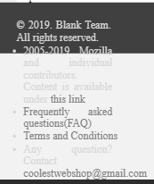

* Footer overflows