UNIVERSITI MALAYSIA SARAWAK
Faculty of Computer Science and Information Technology
TMA3084 Software Engineering Laboratory | Semester 1, 2026/2027
PROJECT PROPOSAL
(Product Requirements Document)
<Event & Attendance Tracking App>
Group Number / Name | Group 21 – ByteChew
Lab Group / Demonstrator | Group 2 – Mr. Raynold anak Kabai
Client / Organisation | Lambert Gan, Chief Executive Officer, Skybylamby
Lecturer | Mdm. Nurfauza Jali
GitHub Repository | https://github.com/afqskb/TMA3084_G02_T21_ByteChew_EventnAttendanceTrackingApp
Version / Date | v1.0 (original) – 17/10/2026

Team Members
No. | Name | Matric No. | TSPi Role | Signature
1 | Muhammad Afiq bin Sakub | 102719 | Team Leader, Planning Manager | 
2 | Adenillo Sheldy anak Stephen | 102372 | Support Manager | 
3 | Ahmad Danish bin Alin | 102384 | Quality Manager | 
4 | Shelsy anak Nicholas Felix | 102958 | Development Manager | 
5 | Syafik bin Sali | 102978 | Client Liaison | 

Declaration
By signing above, we certify that this proposal is our own work, that all external sources, libraries, APIs and AI-assisted content are acknowledged, and that we have not engaged in plagiarism or unauthorised collusion (Peraturan Akademik UNIMAS, Etika Akademik). AI tool usage is recorded in LOGAI.

Table of Contents
Abstract 3
1. Introduction 3
1.1 Client Background 3
1.2 Team Background 3
2. Problem Statement 4
3. Project Objectives & Success Metrics 4
4. Project Perspective 5
4.1 Target Users 5
4.2 System Context and Architecture 6
5. Project Scope 7
5.1 In Scope / Out of Scope 7
5.2 Features and User Stories 8
5.3 AI Feature 10
5.4 Non-Functional Requirements and Constraints 11
5.5 System Environment 11
6. Task Allocation & Team Contribution 12
7. Team Goals 13
8. Expected Results 13
8.1 Working System 13
8.2 Documentation and Artefacts 14
9. Project Planning 15
9.1 Methodology 15
9.2 Submission Schedule 16
9.3 Development Milestones (GitHub) 16
10. References 17
Appendix B: Revision History 18

Abstract
PRD section: Executive Summary / TL;DR Rubric link: Clarity & presentation
Universities host many academic, cultural, and social activities, but events are mostly promoted through scattered social media posts, so students struggle to discover relevant events and forget to attend, while organisers can only guess how many people will come. ByteChew addresses this with a centralised Android app built with Flutter and Firebase. It offers an interactive campus map with event locations, one tap attendance confirmation with a live attendee count for organisers, a push reminder a week before the event, and AI filtering and sorting that ranks events by each students’ interests. The project is complete when a signed release APK (v1.0.0) is delivered, all core feature tests pass, a SUS of 70 or above is achieved with at least 20 testers, and the client signs off in User Acceptance Testing (UAT).

1. Introduction
PRD section: Background & Context Rubric link: Background (Section A)
Universities host academic, recreational, cultural and social events, and information about them is usually shared across many social media and messaging channels. This makes it hard for students to find and keep track of relevant events, and they often miss events that have already been announced. Organisers face the opposite problems, since they cannot reliably tell how many people will attend. A centralised event discovery, location information, attendance registration and notifications in one place. It can also let authorised students create and manage their own events, encouraging participation across the university community.

1.1 Client Background
Skybylamby, founded in 2025, is a dynamic creative media production service provider led by Chief Executive Officer Lambert. The organisation specialises in delivering high-quality media production solutions, catering to a growing audience and client base expected to scale beyond 10,000 users.

1.2 Team Background
ByteChew is a team of five 3rd year students whose motto, “Chewing on problems, one byte at a time,” reflects on how we approach the project by breaking a large problem into smaller manageable steps. Our skills cover Flutter development, Firebase, AI API integration, testing and project management, and each member takes a TSPi role (Humphrey, 2000) so that planning, development, quality, support and client communication are all covered.
2. Problem Statement
PRD section: Problem & Opportunity Rubric link: Objectives / constraints analysed
ID | Current process / problem | Impact on client | Evidence (source)
P1 | Organisers promote events by posting on social media, and students must scroll through many posts to find relevant events | Low awareness and engagement | Client interview, 10/10 (ByteChew, 2026)
P2 | Organisers rely on guesses or informal responses to estimate attendance | Wasted resources or overcrowding | Client interview, 10/10
P3 | Event information is scattered across different posts and platforms | Attendees are confused and miss events | Client interview, 10/10
P4 | Students receive no reminders as the event date approaches | Lower turnout | Client interview, 10/10
Table 1: Summary of client problems
A Flutter mobile app that maps university events with attendance booking and timely reminders, using AI to recommend events to students based on their interest.

3. Project Objectives & Success Metrics
PRD section: Goals & Success Metrics Rubric link: Objectives well defined and prioritised
No. | Objective | Solves | Success metric (how we measure) | Priority
O1 | To gather requirements by interviewing the client about how they find, promote and plan for events | P1, P2, P3, P4 | At least 1 client interview completed | High
O2 | To build the Flutter app with an interactive campus map, event details and the “Confirm Attendance” button | P1, P2, P3 | All event locations on the map show details; a booking updates the organiser’s attendee count in real time with 100% accuracy in test cases | High
O3 | To add notifications 1 week before an event, and an AI powered filtering and sorting of events by student interests | P4 | Reminders delivered for ≥ 95% of booked events; relevant events in the top results for ≥ 80% of AI test queries | Medium
O4 | To conduct user testing with students and organisers and evaluate whether the app solves the problems | P1, P2, P3, P4 | ≥ 20 testers; SUS ≥ 70 (Brooke, 1996); ≥ 80% of students find events easier to find; ≥ 80% of organisers say counts help planning; client sign-off on the final demo | High
Table 2: Project objectives and success metrics
4. Project Perspective
PRD section: Target Users & System Context Rubric link: Information obtained and analysed

4.1 Target Users
User type | Description | Main needs / goals | Device / tech level
Student | University students | Find events by AI sorted list or map, get reminders, and confirm attendance | Android phone, basic
General Public | Visitors, alumni, or parents | Find public events and navigate the campus | Android phone, basic
Event Organiser | Club committee members or staff | Post events and see confirmed attendee counts | Android phone, intermediate
System Admin | University staff managing the app | Approve, reject or remove events, manage organiser accounts | Android phone, intermediate
Table 3: Target users

4.2 System Context and Architecture
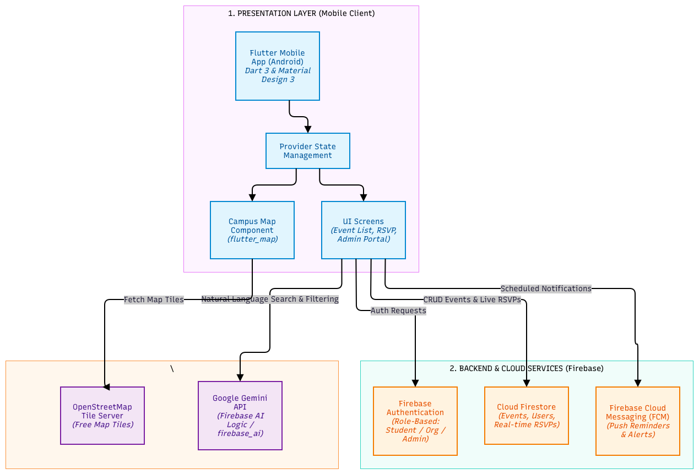
Figure 1: High-level system architecture
As illustrated in Figure 1, the tracking app operates on multi-tier architecture. The client-side Presentation Layer is built with Flutter and Dart 3 using Material Design 3 (Google, n.d-b), and Provider (Rousset, n.d.) state management featuring core UI screens and a flutter_map (fleaflet, n.d.) campus map component which fetches tiles from the OpenStreetMap Tile Server (OpenStreetMap Foundation, n.d.). Backend operations integrate with Firebase, utilising Firebase Authentication for role-based access control (Student, Organiser, Admin), Cloud Firestore for real-time event data and RSVP persistence, and Firebase Cloud Messaging for automated push notifications (Google, n.d.-a). Additionally, intelligent event discovery and natural-language filtering via Google Gemini API (Google, n.d.-c) accessed via Firebase AI Logic (Google, n.d.-d) and the firebase_ai package (Firebase, n.d.-a).

5. Project Scope
PRD section: Scope, Features & Requirements Rubric link: Design recommendations supported

5.1 In Scope / Out of Scope
In scope (will deliver this semester) | Out of scope (will not deliver)
Android mobile app built with Flutter | iOS version and publishing to the Google Play Store
Basic admin interface to approve, reject or remove events | Full admin web portal with analytics and reports
Interactive campus map with event markers | Indoor navigation and turn-by-turn directions
Organiser can create an event and place them on the map | Event analytics dashboards and feedback forms
“Confirm Attendance” button with live attendee count | QR code check-in, waiting lists and seat selection
Push notification reminder 1 week before a booked event | SMS or email reminders and multiple reminder times
AI sorted event list as the home screen, filtered by student interests | Training our own AI model or predicting turnout
Firebase login with roles | University single sign-on integration
Firebase backend for data, authentication and notifications | Custom server and data migration
Testing with at least 20 users, a SUS survey and a client demo | Large-scale load testing and security audits
Table 4: Scope boundary

5.2 Features and User Stories
FR-ID | Module | User story (As a … I want … so that …) | Priority
FR-01 | User Management | As a student, I want to log in with my email so that I can book events and get reminders. | Must
FR-02 | User Management | As a system, I want to assign each account a role so that users only see features they are allowed to use. | Must
FR-03 | User Management | As a user, I want to reset my password so that I can regain access if I forget it. | Could
FR-04 | Campus Map | As a student, I want to see a campus map with event markers so that I know where events are held. | Must
FR-05 | Campus Map | As a student, I want to tap a marker to see the event details so that I can decide quickly if it interests me. | Must
FR-06 | Event Discovery | As a student, I want to see a list of upcoming events so that I can browse without using the map. | Should
FR-07 | Event Discovery | As a student, I want to filter events by date or category so that I can find relevant events faster. | Could
FR-08 | Event Discover | As a general public visitor, I want to log in with a non-student email so that I can browse events open to the public. | Should
FR-09 | Event Management | As an organiser, I want to create an event with its details and map location so that students can discover it in one place. | Must
FR-10 | Event Management | As an organiser, I want to edit or cancel my event so that students always see correct information. | Must
FR-11 | Event Management | As an organiser, I want to upload a poster so that my event looks attractive. | Could
FR-12 | Event Management | As an event organiser, I want to mark my event as public or students only so that the right audience sees it. | Should
FR-13 | Attendance Confirmation | As a student, I want to confirm my attendance with one tap so that organisers know I am coming. | Must
FR-14 | Attendance Confirmation | As a student, I want to cancel my attendance so that the attendee count stays accurate. | Must
FR-15 | Attendance Confirmation | As a student, I want to see my booked events so that I can keep track of my plans. | Should
FR-16 | Attendance Confirmation | As an organiser, I want to set a maximum capacity so that bookings stop when the venue is full. | Could
FR-17 | Notifications | As a student, I want a push notification 1 week before a booked event so that I do not forget to attend. | Must
FR-18 | Notifications | As a student, I want a notification when a booked event changes or is cancelled so that I do not go to the wrong place or time. | Could
FR-19 | Admin Management | As an admin, I want to approve or reject submitted events so that only appropriate events appear. | Must
FR-20 | Admin Management | As an admin, I want to manage organiser accounts so that only authorised users can create events. | Should
FR-AI-01 | AI Feature | As a student, I want to set my interests so that the AI sorts the most relevant events first. | Must
Table 5: Features and user stories
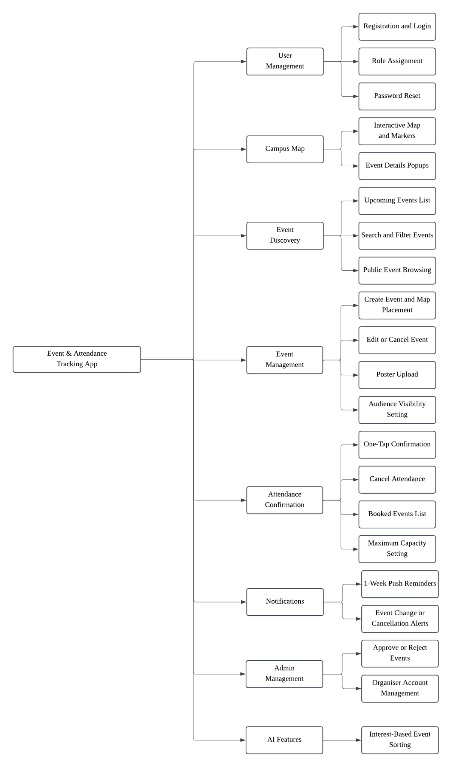
Figure 2: System modules diagram
5.3 AI Feature
This app uses AI to filter and sort upcoming events by a student’s saved interests or a typed phrase, ranking the most relevant first. This solves the problem of students scrolling through many posts to find the few events that matter to them. The AI only sorts events already in the database, so it cannot invent events.
Item | Description
AI capability | Filtering and sorting upcoming events by relevance from interests or natural-language requests
User value | Solves P1 which is students find relevant events faster, and organisers reach the students most likely to attend
Input → Output | Input: the student’s interests or typed request. Output: a list ordered from most to least relevant
AI service / API | Gemini API (Google, n.d.-c) via Firebase AI Logic and firebase_ai (Firebase, n.d.-a)
Constraints | API key stays out of the app. If free tier limits are reached, the app falls back to date and category filter. Only event data is sent to the AI, with no personal student data.
Table 6: AI feature summary

5.4 Non-Functional Requirements and Constraints
NFR-ID | Category | Requirement / constraint | Target
NFR-01 | Performance | The main screens and AI filtering respond quickly. | Map and event list load in < 3 s on a mid-range Android phone over 4G; AI filtering responds in < 5 s for ≥ 90% of test queries.
NFR-02 | Security | API keys are never stored in the app or source code, each role can only use its own features, and only the minimum personal data is sent to the AI service. | 0 secrets repository or app package; 100% of role tests pass; only interests, typed requests and event data sent to the AI, with no names or emails.
NFR-03 | Usability | A first-time student can use the core features without training. | SUS score of ≥ 70 (Brooke, 1996); a new user can open an event and confirm attendance within 30 s and 3 taps with no instructions in ≥80% of attempts.
NFR-04 | Reliability | Attendance data stays correct, reminders are delivered, and the app keeps working if the AI service is down. | Attendee count is 100% accurate in test cases; ≥ 95% of reminders delivered; on AI failure the normal event list and search are shown instead of an error.
Table 7: Non-functional requirements and constraints

5.5 System Environment
Layer | Technology / tool | Justification
Mobile app | Flutter (Dart 3), Material 3 | Course requirement, and one codebase for Android
State management | Provider | Simple and enough for this app size
Backend / database | Firebase Authentication and Cloud Firestore (Firebase, n.d.-a, n.d.-c, n.d.-d) | Email login, roles and real-time attendee counts without our own server
Notifications | Firebase Cloud Messaging and flutter_local_notifications (Firebase, n.d.-e; Flutter Community, n.d.) | Sends 1 week reminder and change or cancel alerts
Map | flutter_map with OpenStreetMap | Free campus map with no billing account
AI service | Gemini API via Firebase AI Logic, firebase_ai package | Keeps the API key out of the app and free tier for testing
Version control & CI | GitHub, GitHub Actions (GitHub, n.d.-a) | Course requirement
Target devices | Android 8.0+ phones | Covers common Android phones since iOS is out of scope
Table 8: System environment

6. Task Allocation & Team Contribution
PRD section: Team & Stakeholders (RACI) Rubric link: Project breakdown; team work
Member | TSPi role | Owned features (FR-IDs) | Other responsibilities / contribution
Muhammad Afiq bin Sakub | Team Leader, Planning Manager | FR-01, FR-02, FR-03, FR-20 | Weekly meetings, WEEK reports, TASK / SCHEDULE, GitHub board
Shelsy anak Nicholas Felix | Development Manager | FR-04, FR-05, FR-06, FR-07 | Architecture, code review
Ahmad Danish bin Alin | Quality Manager | FR-13, FR-14, FR-15, FR-16 | LOGTEST, CI, testing
Adenillo Sheldy anak Stephen | Support Manager | FR-17, FR-18, FR-08, FR-AI-01 | Repo setup, LOGAI, tools
Syafik bin Sali | Client Liaison | FR-09, FR-10, FR-11, FR-12, FR-19 | Client meetings, UAT
Table 9: Task allocation and contribution

7. Team Goals
PRD section: Team Working Agreement Rubric link: Team work
No. | Team goal | Measure
G1 | Deliver a quality product that solves the client’s problems | All Must-have FRs pass their tests; CI green on main; SUS score of 70 or above
G2 | Run a productive, well-managed project | Every milestone delivered on or before its date; GitHub board updated before each weekly meeting
G3 | Make sure every member contributes fairly | Each Member merges at least 1 PR per sprint and completes their owned FRs
G4 | Keep the client engaged | Client meeting at least every 2 weeks; client approves requirements and signs off the final demo
Table 10: Team goals

8. Expected Results
PRD section: Release Criteria / Deliverables Rubric link: Decisions supported by information

8.1 Working System
The final system is an Android app, built with Flutter and backed by Firebase, that gives the students and the general public one place to discover university events. The home screen is a list of upcoming events, filtered and sorted by AI so that a student’s saved interests, or a phrase they type, bring the most relevant events to the top. Tapping an event shows its details and a “Confirm Attendance” button, and students receive a push reminder one week before events they have booked. A second tab shows the interactive campus map, with a marker at each event location. General public visitors can only confirm attendance events marked as open to the public. Organisers can create, edit and cancel events, set them as public or students-only, and see a live count of confirmed attendees. The system admin can approve, reject or remove events and manage organiser accounts. This system is ready for release when a signed release APK (v1.0.0) is produced, all Must-have features pass their tests on the main branch, user testing reaches a SUS score of 70 or above with at least 20 testers, and the client signs off the final demo in UAT.

8.2 Documentation and Artefacts
Deliverable | Submitted with
Project Proposal (original) | Proposal Submission (Week 4)
Revised Proposal and Software Requirements Specification (SRS) | Initial Report (Week 9)
Runnable prototype (4–5 screens), tagged release | Demo 1 (Week 9)
Software Design Specification (SDS), test plan and results (LOGTEST), user manual, maintenance plan, client acceptance form | Final Report (Week 13)
Release APK, demo video (5–10 min), presentation slides | Final Demo 2 (Week 14)
GitHub repository and complete project file | e-Archive (Week 15)
TSPi forms (LOGT, LOGD, LOGAI, SCHEDULE, SUMP, SUMQ, SUMS, SUMTASK, WEEK, PEER) and meeting minutes | Ongoing; compiled in Final Report
Table 11: Deliverables

9. Project Planning
PRD section: Milestones, Timeline & Risks Rubric link: Methodology to be followed

9.1 Methodology
The project follows an Agile development approach structured around 2-week iterative sprints, aligning with the dynamic nature of client requirements and the 15-week academic timeline. Development tasks are managed transparently using GitHub Projects boards (GitHub, n.d.-a) and Issues assigned to team members according to their TSPi roles. Every feature implementation follows a strict spec-driven workflow: requirements are mapped from the Product Requirements Document (PRD), developed within isolated feature branches, subjected to mandatory peer code reviews via Pull Requests (PRs), and verified through automated CI checks on GitHub Actions (GitHub, n.d.) before merging into the main branch.

9.2 Submission Schedule
Phase | Deliverable | Week | Due
Phase 1: Planning & Development | Proposal Submission | 4 | 16 Oct 2026
 | Proposal Presentation | 5 | 19 – 23 Oct 2026
 | Initial Report | 9 | 16 Nov 2026
 | Demo 1 | 9 | 16 – 20 Nov 2026
Phase 2: Finalisation & Closure | Final Report | 13 | 24 Dec 2026
 | Final Demo 2 | 14 | 28 – 31 Dec 2026
 | e-Archive | 15 | Before 10 Jan 2027
Table 12: Submission schedule
9.3 Development Milestones (GitHub)
Milestone | Week | Key output | Status
M1 – Scope & Requirements | 4 – 5 | GitHub repo, issue board, CI file; proposal and initial SRS in /docs | In Progress
M2 – Design & Prototype | 9 | SDS draft, 4–5 screen prototype, green CI, v0.2.0 tag | Pending
M3 – Product & Verification | 13 | ≥50 tests, ≥60% coverage, AI feature working | Pending
M4 – Final Release & Acceptance | 15 | Release APK v1.0.0, client sign-off, e-Archive | Pending
Table 13: Development milestones
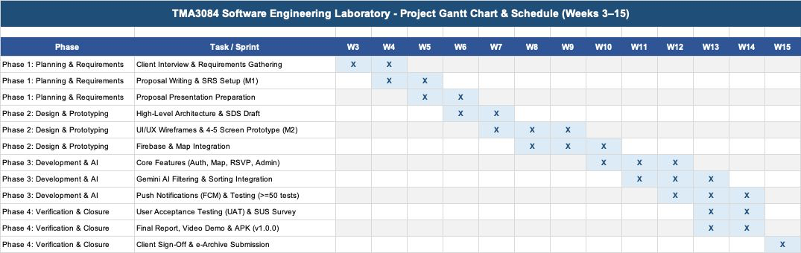
Figure 3: Gantt chart
9.4 Risks and Assumptions
ID | Risk / assumption | Likelihood | Impact | Mitigation
R1 | Client delays feedback or UAT sign-off | Medium | High | Fixed fortnightly meeting with Lambert Gan (Skybylamby) plus an online channel
R2 | Gemini free tier limits reached during testing | Medium | High | Cache queries and fall back to date and category filters
R3 | Skill gaps with Provider, flutter_map or Firebase | Medium | High | Pair programming and peer code reviews
R4 | Scope creep delays delivery | Low | Medium | Follow the scope and build Must-have stories first
Table 14: Risks and assumptions
10. References
Brooke, J. (1996). SUS: A quick and dirty usability scale. In P. W. Jordan, B. Thomas, B. A. Weerdmeester, & I. L. McClelland (Eds.), Usability evaluation in industry (pp. 189-194). Taylor & Francis.
ByteChew. (2026, October 10). Minutes: Team meeting 01 [Meeting minutes]. GitHub. https://github.com/afqskb/TMA3084_G02_T21_ByteChew_EventnAttendanceTrackingApp/blob/main/Meeting%20Minutes/TMA3084_G02_T21_Minutes_Team%20Meeting_01.docx
Fleaflet. (n.d.). flutter_map [Computer software]. pub.dev. Retrieved October 15, 2026, from https://pub.dev/packages/flutter_map
Flutter Community. (n.d.). flutter_local_notifications [Computer software]. pub.dev. Retrieved October 15, 2026, from https://pub.dev/packages/flutter_local_notifications
FlutterFire. (n.d.). FlutterFire documentation. Retrieved October 15, 2026, from https://firebase.flutter.dev
GitHub. (n.d.). GitHub documentation. Retrieved October 15, 2026, from https://docs.github.com
Google. (n.d.-a). Firebase documentation. Firebase. Retrieved October 15, 2026, from https://firebase.google.com/docs
Google. (n.d.-b). Flutter documentation. Flutter. Retrieved October 15, 2026, from https://docs.flutter.dev
Google. (n.d.-c). Gemini API documentation. Google AI for Developers. Retrieved October 15, 2026, from https://ai.google.dev/gemini-api/docs
Humphrey, W. S. (2000). Introduction to the Team Software Process. Addison-Wesley.
OpenStreetMap Foundation. (n.d.). Tile usage policy. Retrieved October 15, 2026, from https://operations.osmfoundation.org/policies/tiles/
Rousset, R. (n.d.). provider [Computer software]. pub.dev. Retrieved October 15, 2026, from https://pub.dev/packages/provider

Appendix A: Client Meeting Evidence
Item | Details
Date | 10 October 2026
Attendees | - Muhammad Afiq bin Sakub  - Ahmad Danish bin Alin  - Adenillo Sheldy anak Stephen  - Shelsy anak Nicholas Felix  - Syafik bin sali  - Lambert (Client)
Key Decisions | - Build a centralised mobile app that bridges the information gap between organisers and attendees and gives organisers a live count of confirmed attendees.  - Target users include attendees (students and general public), organisers, and system admin for approving events and managing accounts.  - Core features in scope include 1 week push notification reminder, interactive campus map with event markers and a confirm attendance button with a live attendee count.  - Multiple reminder times and QR check-in and analytics dashboards are out of scope.  - Client requests blue as the primary colour of the application and black as the secondary colour. Client also note that AI chatbots are highly discouraged, so AI features are limited to interest-based filtering and sorting of events only.
Photo Evidence | 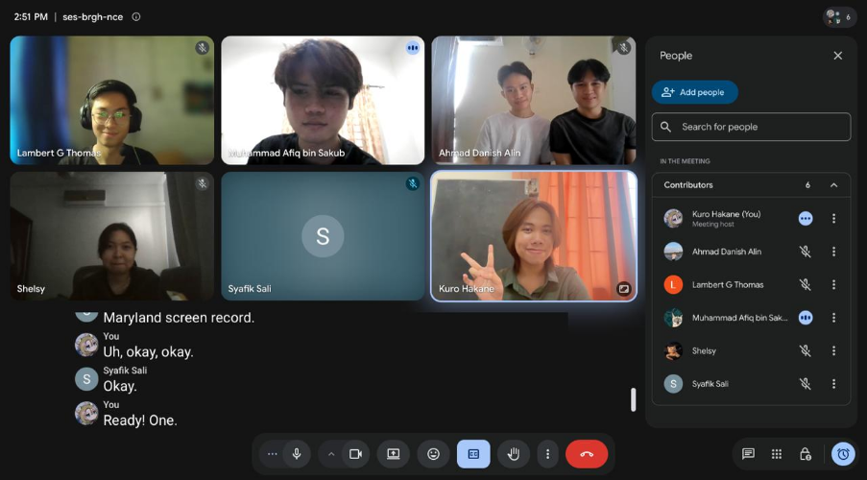

Appendix B: Revision History
Version | Date | Changes (e.g. after proposal presentation feedback) | By
1.0 | 17/10/2026 | Original submission | Danish

Appendix C: Recorded Video Pitch
Video link: https://youtu.be/tNUCElRzwpg

