<https://www.youtube.com/watch?v=bNrhKRGQwBg>

Step 1

sudo apt-get update

Reading package lists… Done

Step 2

安裝 Apache

sudo apt-get install apache2

…

Do you want to continue? [Y/n] y

…

Starting web server apache2

Step 3

安裝 MySQL

sudo apt-get install mysql-server php5-mysql

sudo apt-get install mysql-server mysql-client libmysqlclient-dev

After this operation, 203 MB of additional disk space will be used.

Do you want to continue? [Y/n] y

步骤2-3不分顺序

Step4

安装php

sudo apt-get install php php-common php-curl php-dev php-gd php-pear php-imagick php-mysql libapache2-mod-php

step5

创建www主页

sudo nano /var/www/html/index.php

<?php

phpinfo()

?>

保存之后，访问<http://ec2-18-217-70-140.us-east-2.compute.amazonaws.com/index.php>

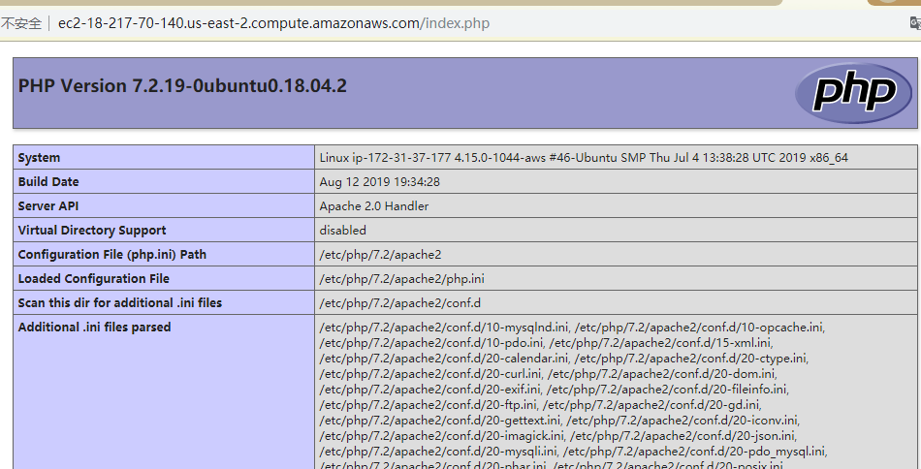

last step

ec2-18-217-70-140.us-east-2.compute.amazonaws.com

ec2-18-217-70-140.us-east-2.compute.amazonaws.com/index.php

打开安全组

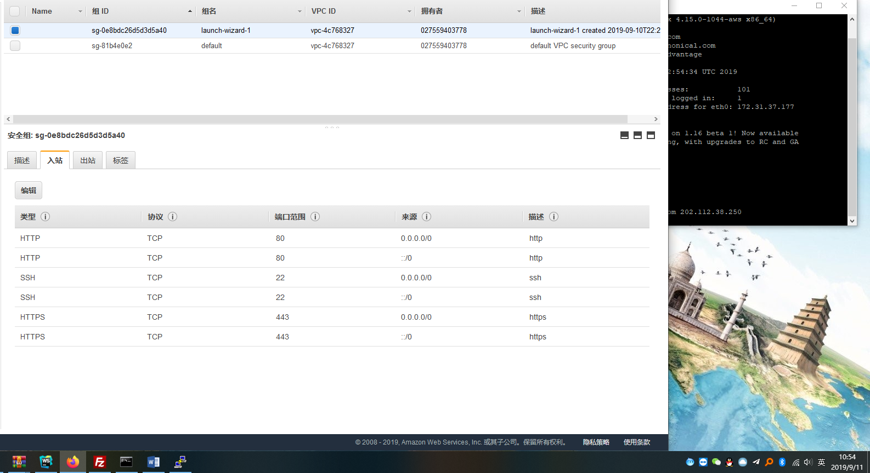

打开public DNS已经可以访问<http://ec2-18-217-70-140.us-east-2.compute.amazonaws.com/>

安装phpmyadmin

sudo apt update

sudo apt install phpmyadmin php-mbstring php-gettext

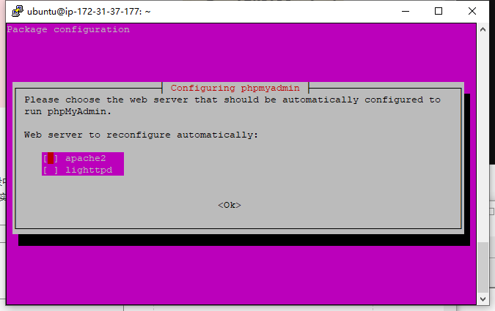

pw：Ms

$ sudo phpenmod mbstring

$ sudo systemctl restart apache2

激活mbstring和phpenmod，并重启apache2

$ mysql -u root -p

用根用户登陆进入mysql服务器，并输入root密码

创建软 链接（参考<https://blog.csdn.net/weixin_39467231/article/details/83958552>）

sudo ln -s /usr/share/phpmyadmin /var/www/html/phpmyadmin

创建可以登陆的MySQL账户

**命令:**

sudo mysql -u root

以下加分号

mysql>

CREATE USER 'username'@'host' IDENTIFIED BY 'password';

CREATE USER 'mysql1'@'%' IDENTIFIED BY '密码';

GRANT ALL PRIVILEGES ON *.* TO 'mysql1'@'%' WITH GRANT OPTION;

（账号1：mysqlid1,Ms.账号2gst,gst123454321）

* username：你将创建的用户名
* host：指定该用户在哪个主机上可以登陆，如果是本地用户可用localhost，如果想让该用户可以**从任意远程主机登陆**，可以使用通配符%
* password：该用户的登陆密码，密码可以为空，如果为空则该用户可以不需要密码登陆服务器

