Submission: Easy Test - plotModel Function

This document contains the implementation of the plotModel function for the Easy Test.

The function takes a gfpop::graph object and visualizes the states and rules in a matrix format.

Below is the R code implementation followed by the generated graph.

library(gfpop) library(ggplot2)

plotModel <- function(graph) { edges_df <- as.data.frame(graph)

states <- unique(c(edges_df$state1, edges_df$state2)) rules <- unique(edges_df$type)

state_positions <- setNames(seq_along(states) * 2, states) rule_positions <- setNames(seq_along(rules) * 3, rules)

edges_df$x_from <- rule_positions[edges_df$type] edges_df$x_to <- edges_df$x_from + 1 edges_df$y_from <- state_positions[edges_df$state1] edges_df$y_to <- state_positions[edges_df$state2]

ggplot() +

geom_point(data = edges_df, aes(x = x_from, y = y_from), color = "blue", size = 4) + geom_point(data = edges_df, aes(x = x_to, y = y_to), color = "red", size = 4) + geom_segment(data = edges_df, aes(x = x_from, y = y_from, xend = x_to, yend = y_to),

arrow = arrow(length = unit(0.2, "cm")), size = 1.2, color = "black") + scale_x_continuous(breaks = seq_along(rules) * 3, labels = rules, name = "Rule Type") + scale_y_continuous(breaks = seq_along(states) * 2, labels = states, name = "State") + theme_minimal() +

ggtitle("Better Graph Representation: States vs Rules")

}

plotModel(LOPART.graph)

**Generated Graph:**

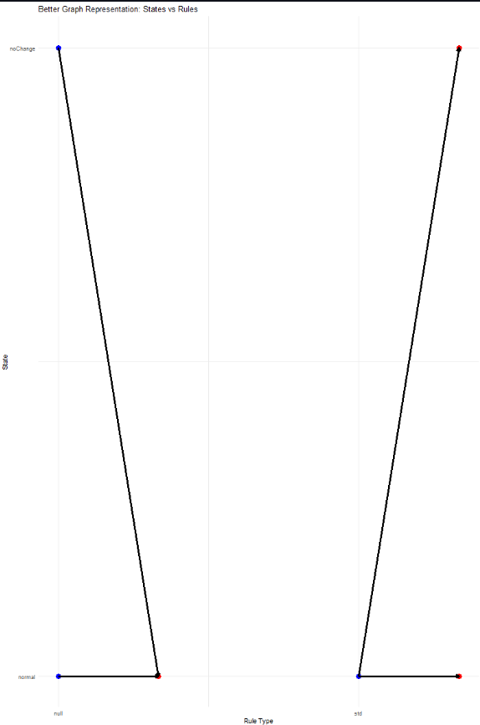

**Observations About the Output**

* The function successfully plots states and rules in a structured manner.
* States are positioned on the y-axis, and rules are positioned on the x-axis.
* Blue and red points indicate different node types, and arrows show connections.
* The graph effectively represents state transitions based on the given gfpop::graph structure.
* The spacing between nodes has been improved for better readability.

**Issues Faced and How They Were Resolved**

**1. Initial Graph Was Too Compressed**

**Issue:** The first version had states and rules too close, making it hard to read. **Solution:** Adjusted spacing by scaling x and y positions to spread out nodes.

**2. Missing Labels or Incorrect Label Positions**

**Issue:** Some labels were misaligned due to default ggplot positioning. **Solution:** Used scale_x_continuous() and scale_y_continuous() to ensure proper alignment.

**3. Graph Display Errors (NULL Data Issue)**

**Issue:** The function failed when LOPART.graph$edges was NULL. **Solution:** Ensured that graph is properly converted into a data frame before plotting.

**Conclusion**

This function provides a structured visualization of a gfpop::graph by mapping states to rules, making it easier to interpret the transitions. The improvements in spacing and label positioning enhance readability, and the error handling ensures robust execution.