**Programming Language: Java**

**Version: JDK 1.8**

**Pseudocode:**

1.Read the number of strings to compare (stringCount) from the user.

2.Validate the stringCount input:

**If the number of strings is less than 2:**

- Display an error message indicating that at least 2 strings are required.

- Prompt the user if they want to enter another value or exit the program.

**If the number of strings is greater than 5:**

- Display an error message indicating that too many strings were entered.

- Prompt the user if they want to enter another value or exit the program.

3. Prompt the user to enter each string and store them in the array after ensuring

they contain only alphabetic characters.

4.Read the comparison type (comparisonType) from the user, ensuring it is either "Vowels" or "Consonants".

5.Compare each string based on the comparisonType:

For each string:

->Count the number of matching characters (either vowels or consonants).

->Print the string, the count, and the positions of the matching characters.

**Test Cases**

**Tested the program in Eclipse and shared the snapshots**

**1.Normal Flow:**

Checking the positive flow of the application one by one.

Getting the string count:

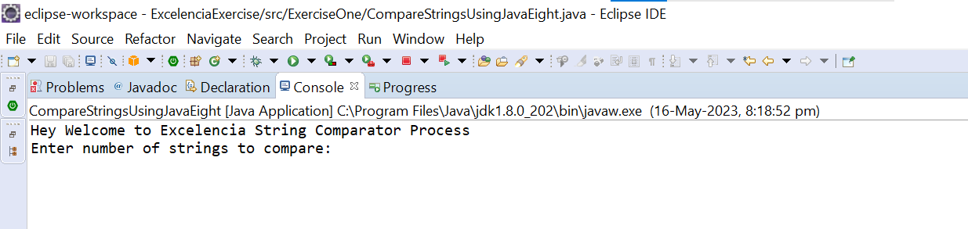

Getting the string values:

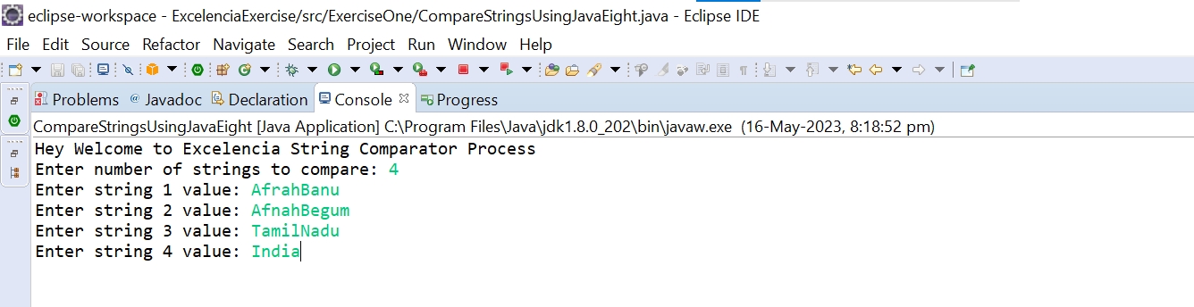

Getting the comparison type:

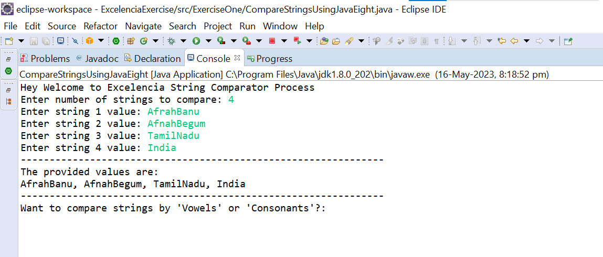

Final Output:

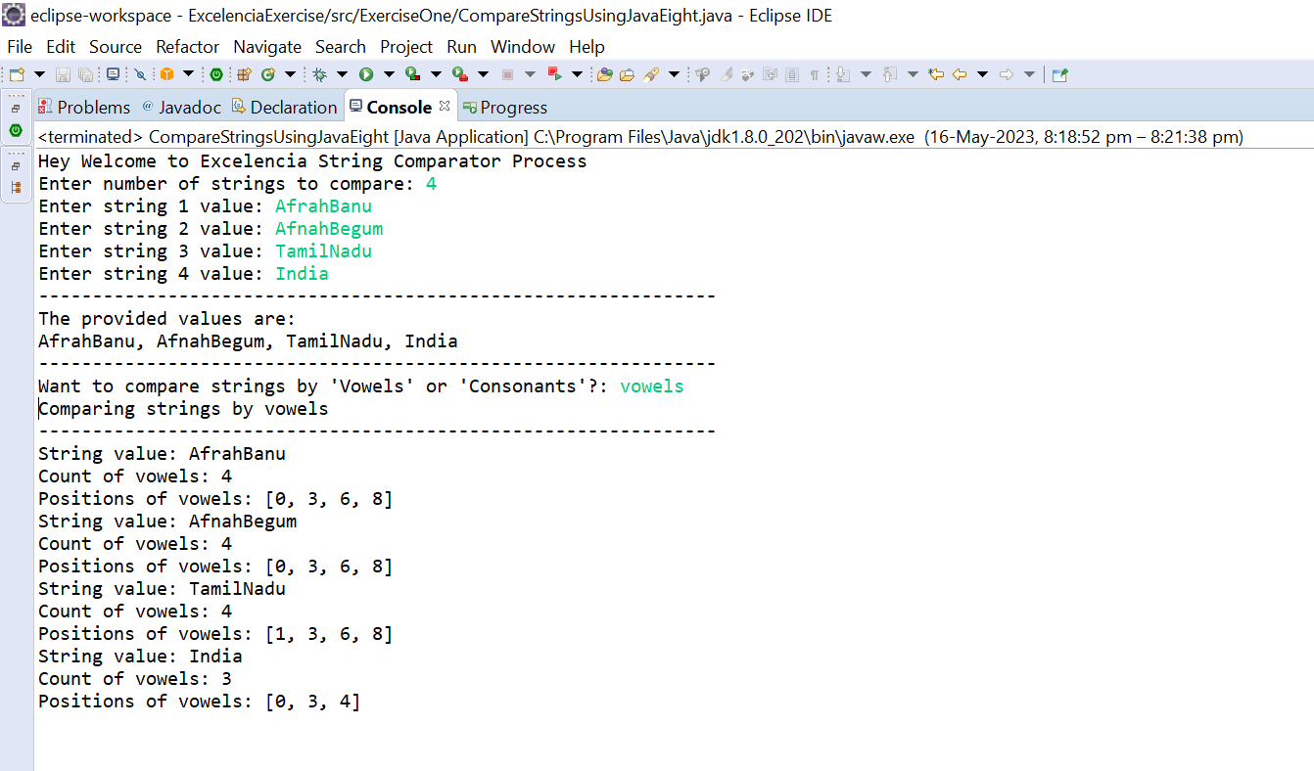

**2.Negative Flow**

Scenario for count > 5

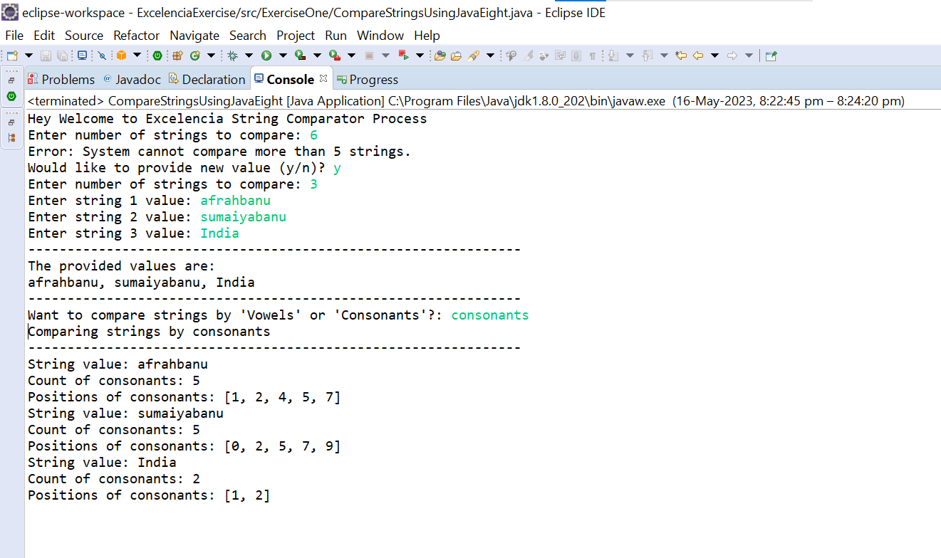

Scenario for count < 2

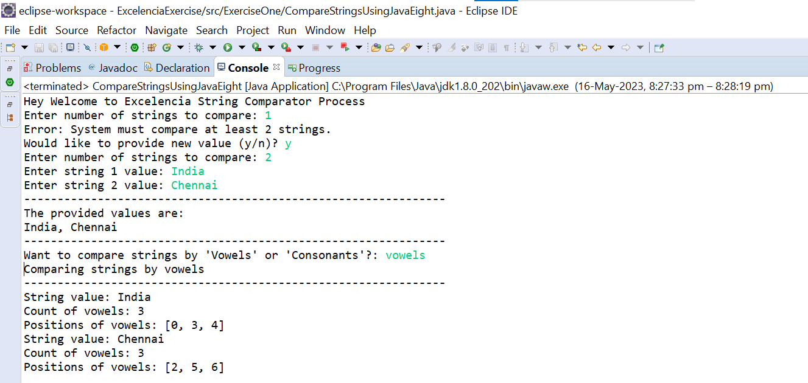

**3.Error Handling:**

If entered wrong count value:

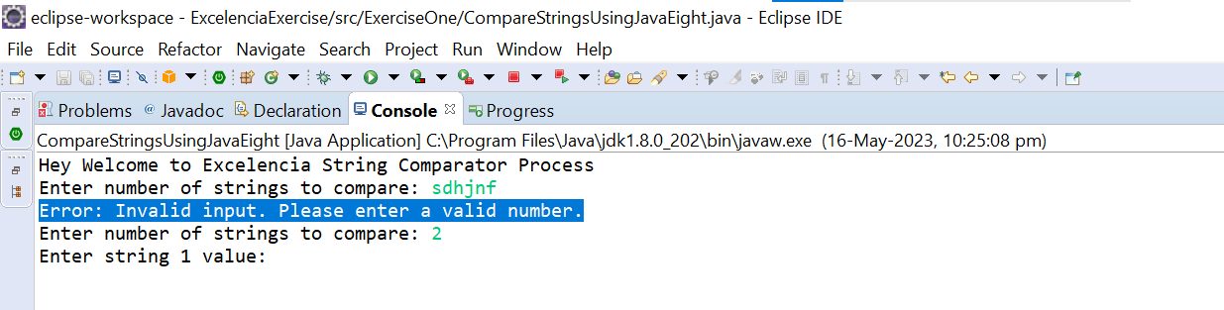

If entered wrong string value:

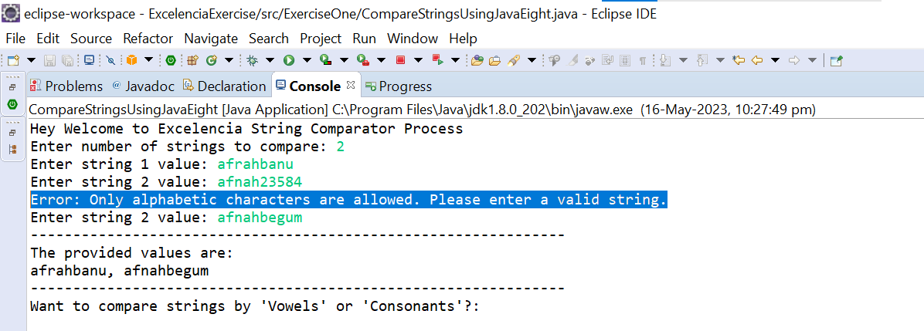

If entered wrong comparison type value:

