Data structures

$\boxed{all_OD_pairs}$

## 

Cell array.

* all_OD_pairs (2nd dimension (columns), or all_OD_pairs(,:))

Identifies the OD_pair (Origin-Destination pair) we are talking about.

* all_OD_pairs (1st dimension (rows))
* all_OD_pairs(1,OD_pair): lists the different original routes connecting the OD_pair
* all_OD_pairs(2,OD_pair): lists, for every of the original routes, the alternative routes it can switch to (i.e., the other routes connecting this OD_pair)
* all_OD_pairs(3,OD_pair): gives the origin airport latlon coordinates.

### Example 1 : OD_pair with two different original routes connecting same O and D



all_OD_pairs{1,1} = [1;25];

all_OD_pairs{2,1} = [25;1];

all_OD_pairs{3,1} = [34.200556 -118.358611];

### Example 2 : OD_pair with five different original routes connecting same O and D

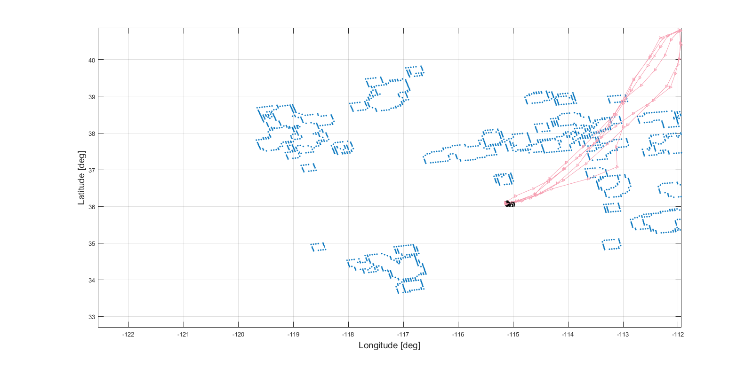

all_OD_pairs{1,2} = [2;3;4;19;26;27]; %O/D pair (depart from same, land on same)

all_OD_pairs{2,2} = [3 4 19 26 27;2 4 19 26 27;2 3 19 26 27;2 3 4 26 27;2 3 4 19 27;2 3 4 19 26]; %alternative for every one

all_OD_pairs{3,2} = [36.08 -115.152222];

Note: data is not available since is protected information by the US federal government. A TRX format example is attached to understand what the inputs the program runs with are. The same with weather data (even though some websites make public this information and can be found online)

$\boxed{CONTROLS}$

## 

Cell array.

* CONTROLS (2nd dimension (columns))

Identifies the OD_pair (Origin-Destination pair) we are talking about.

* CONTROLS (1st dimension (rows))
* CONTROLS(1,OD_pair): ground holding control.
* CONTROLS(2,OD_pair): pre-departure reroute control.
* CONTROLS(3,OD_pair): airborne re-route control.

Each of these elements are cells array at its turn. Let’s look into each of them:

* CONTROLS(1,OD_pair): ground holding control. It contains

1. Origin Airport (one ID)
2. Nominal Path (a vector of nodes ID’s)
3. Alternative Path (a vector of nodes ID’s)

gh = cell(3,1);

gh{1,1} = nom_path(1); %

gh{2,1} = nom_path; %whats the point of that??

gh{3,1} = alt_path;

gh_OD_pair{i,1} = gh;

* CONTROLS(2,OD_pair): pre-departure reroute control. It contains

1. Origin Airport (one ID)
2. Nominal Path (a vector of nodes ID’s)
3. Alternative Path (a vector of nodes ID’s)

pdrr = cell(3,1);

pdrr{1,1} = nom_path(1);

pdrr{2,1} = nom_path;

pdrr{3,1} = alt_path;

pdrr_OD_pair{cont_pdrr,1} = pdrr;

Basically the difference is that the alternative path in the pdrr is actually another route while for gdh the alternative path is exactly the same route with the first node duplicated (or $n-$ repeated).

$\boxed{allLatLonCH}$

## 

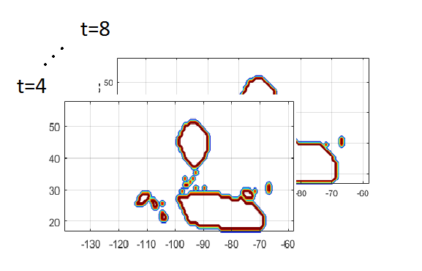(allLatLonConvexHulls), cell array of 1xT 1:timeStep:timeHorizon other cell arrays each of them containing an lx2 list of LatLon pairs representing the convex hulls of the avoidance zones on the 2-D plane for a certain timeStep t

**Example: 2nd timestep, 3rd of the enclosed polygons representing Avoidance Zones**

allLatlonCH{1,2}{3,1}

ans =

32.9190 -97.1281

33.8977 -97.1281

33.8977 -96.1344

32.9190 -96.1344

32.9190 -97.1281

$\boxed{blockedRoutes }$

## 

**Example:**

field1 = 'ID';

field2 = 'timeSteps';

field3 = 'nodesBlocked';

field4 = 'polygonID'; %'polygonsIDForThisTimeStep';

value1 = (1:nTotalRoutes)';

value2 = cell(nTotalRoutes,1);

value3 = cell(nTotalRoutes,1);

value4 = cell(nTotalRoutes,1);

blockedRoutes = struct(field1,value1,field2,value2,field3,value3,field4,value4);

% % %%% for example, it can be that 5 nodes are affected for route 15, which is

% % %%% the first to be afected

% % blockedRoutes(1).ID = 15;

% % blockedRoutes(1).timeSteps = [3 4 5 12 13];

% % blockedRoutes(1).nodesBlocked = [14 15 16 22 23];

% % % as we can see there are 2 problematic zones, blocked by different

% % % avoidance zones

% % blockedRoutes(1).polygonID = [7 7 7 2 2];

* We don’t reroute aircrafts that don’t have any impediment just for optimization. This is a shortcoming since in practice happens. We could maybe restrict the unaccidented reroute for more optimality to alternative known routes (no detour since there is neither an obstacle to skirt)
* We consider reroutes to neighboring routes form same O/D pairs (the alternative toures can be only other routes connecting same O/D). In practice it could be extended to ANY route going to the destination. I think it should be that way.
* The optimization program sets all the flights for a particular time or for a time window?? Because in the first case then the blockedRoutes are easy to identify but in the latter it becomes more difficult, probably need to do them