S80 Oscillators
Num | Cat | Name | Wave | Envelope
244 | Wv | ModSaw | 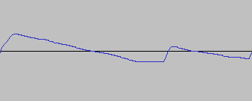
245 | Wv | ObStr | 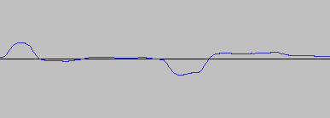  Oberheim String
246 | Wv | JpStr
247 | Wv | SyzStr
248 | Wv | Padd
249 | Wv | ObBrs | Oberheim Brass
250 | Wv | SyncLd | 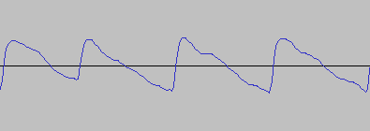
251 | Wv | CS80Br | 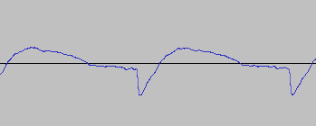  CS80 Brass
252 | Wv | 3o3Saw | 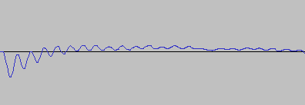  Roland TB-303
253 | Wv | 3o3Sw2 | 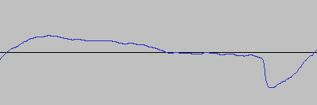
254 | Wv | 3o3Squ | 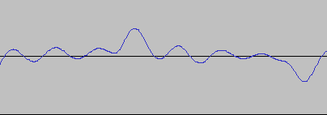
255 | Wv | MogBs1 | 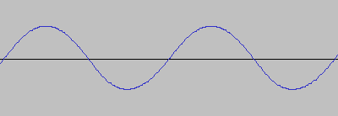
256 | Wv | MogBs2 | 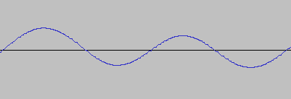
257 | Wv | MogBs3 | 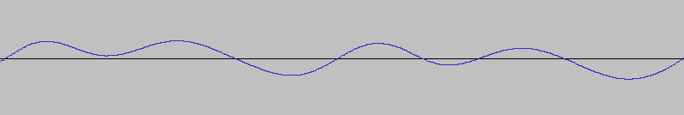
258 | Wv | FMBs1 | 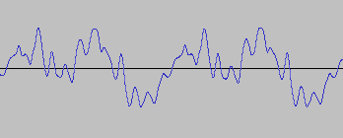
259 | Wv | FMBs2
260 | Wv | FMBs3
261 | Wv | FMBs4
262 | Wv | FMBs5
263 | Wv | FMBs6
264 | Wv | FMFnk
265 | Wv | FMGtr
266 | Wv | Late-S
267 | Wv | Late-L
268 | Wv | P5Saw | 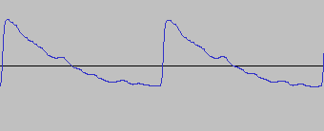  Prophet V Saw
269 | Wv | Saw2 | 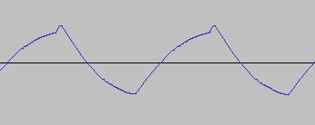
270 | Wv | 1o1Saw | 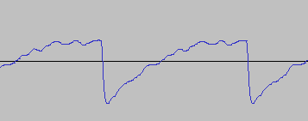
271 | Wv | 1o1Sub | 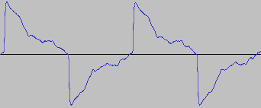
272 | Wv | SawSqu | 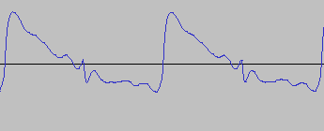
273 | Wv | SquSaw | 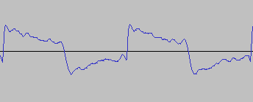
274 | Wv | MgRamp | 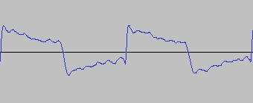
275 | Wv | P10-1 | 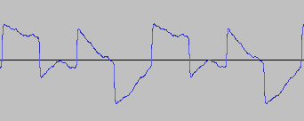
276 | Wv | P10-2 | 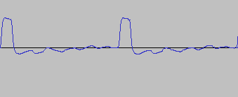
277 | Wv | P10-3 | 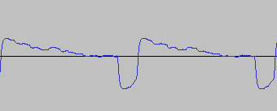
278 | Wv | P25-1 | 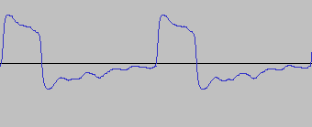
279 | Wv | P25-2 | 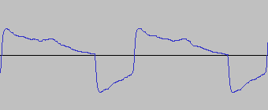
280 | Wv | P50-1 | 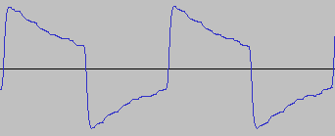
281 | Wv | P50-2 | 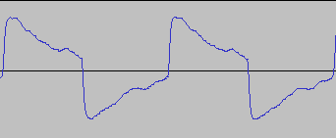
282 | Wv | Tri | 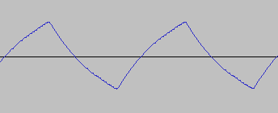
283 | Wv | Digi01
284 | Wv | Digi02
285 | Wv | Digi03
286 | Wv | Digi04
287 | Wv | Digi05
288 | Wv | Digi06
289 | Wv | Digi07
290 | Wv | Digi08
291 | Wv | Digi09
292 | Wv | Digi10
293 | Wv | Digi11
294 | Wv | Digi12
295 | Wv | Bel1Wv
296 | Wv | Bel2Wv
297 | Wv | DgVox1
298 | Wv | DgVox2
299 | Wv | DgVox3
300 | Wv | DgVox4
301 | Wv | DgVox5
302 | Wv | VoxG2 | Nord G2 Vox
303 | Wv | VoxE3 | E-mu Emulator III
304 | Wv | Ep1
305 | Wv | Ep2
306 | Wv | Ep3
307 | Wv | Ep4
308 | Wv | Ep5
309 | Wv | EP6
310 | Wv | Org1Wv
311 | Wv | Org2Wv
312 | Wv | Org3Wv
313 | Wv | Sin
314 | Wv | Noise
315 | Wv | PnoNP
316 | Wv | EPNP
317 | Wv | VibeNP

