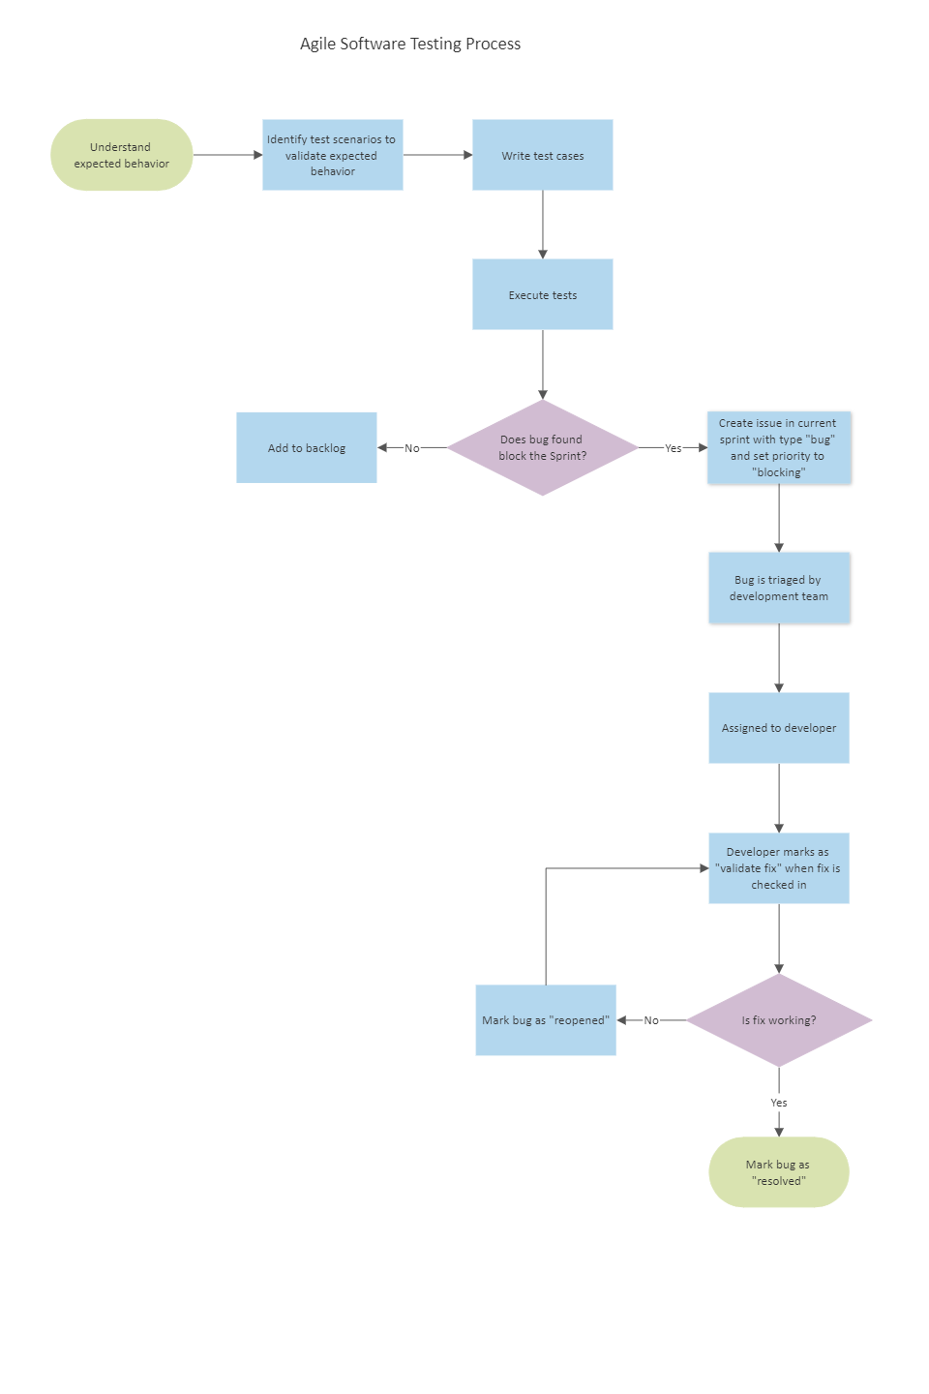

Support System

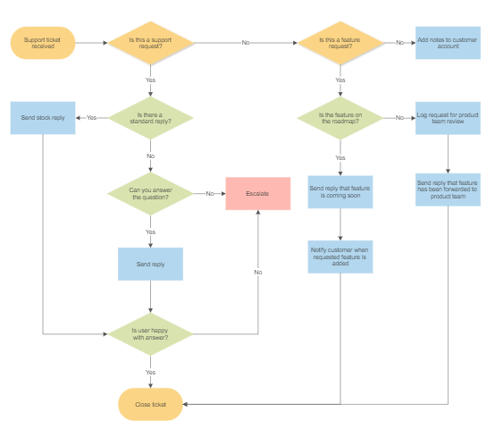

Login System

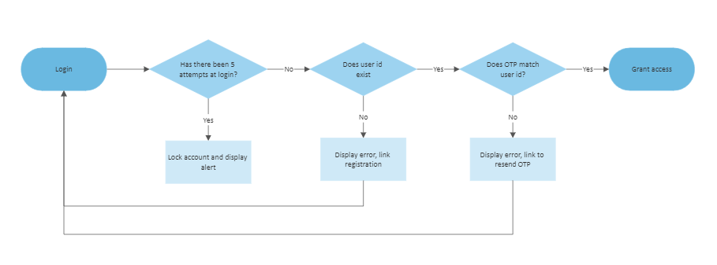

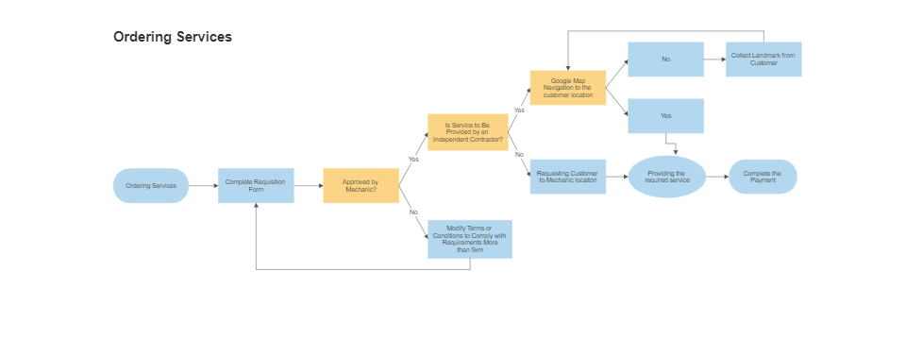

Web server Module

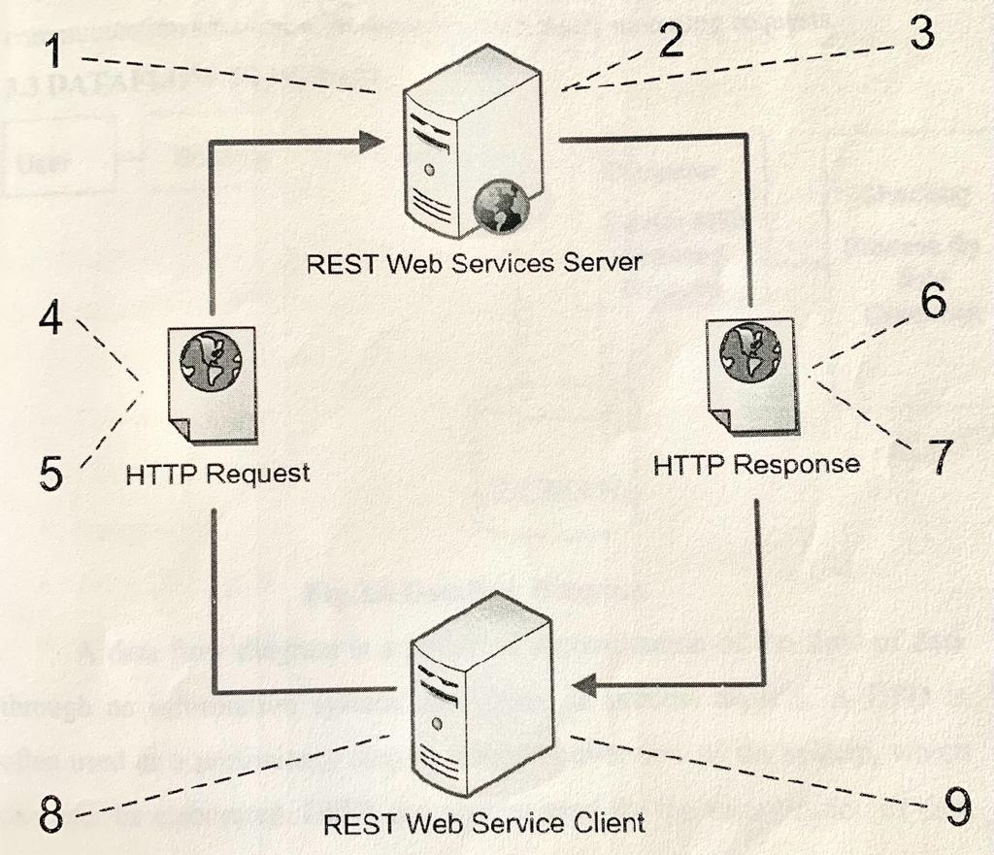

Data Flow Diagram

UML Diagrams

Use case.

Class Diagram

Sequence Diagram

Activity diagram

Collaborative Diagram

