Task 1: Exploring and Visualizing a Simple Dataset

1. Introduction:
The purpose of this task is to explore and visualize the Iris dataset using Python. Data exploration helps in understanding the structure of the dataset, identifying patterns, and gaining insights from the data. In this task, different visualization techniques such as scatter plots, histograms, and box plots are used to analyze the dataset.

2. Objective:
The main objective of this task is to understand how to load a dataset, inspect its structure, and create visualizations to analyze relationships between different variables using Python libraries such as pandas, matplotlib, and seaborn.

3. Dataset Description:
The Iris dataset is one of the most popular datasets used in data science and machine learning. It contains measurements of iris flowers belonging to three different species: Setosa, Versicolor, and Virginica.
The dataset contains the following features:
- Sepal Length
- Sepal Width
- Petal Length
- Petal Width
- Species
The dataset consists of 150 records and is commonly used for data analysis and classification tasks.

4. Tools and Technologies Used:
The following tools and libraries were used in this task:
- Python – Programming language used for data analysis
- Pandas – Used for loading and exploring the dataset
- Matplotlib – Used for creating visualizations
- Seaborn – Used for advanced and attractive data visualizations
- Jupyter Notebook – Used to write and run the analysis code

5. Data Exploration:
Data exploration was performed using pandas functions to understand the dataset structure. Functions such as .shape, .columns, and .head() were used to inspect the number of rows, columns, and sample records of the dataset.
Additionally, .info() and .describe() were used to understand the data types and statistical summary of the dataset.
Code & Output:
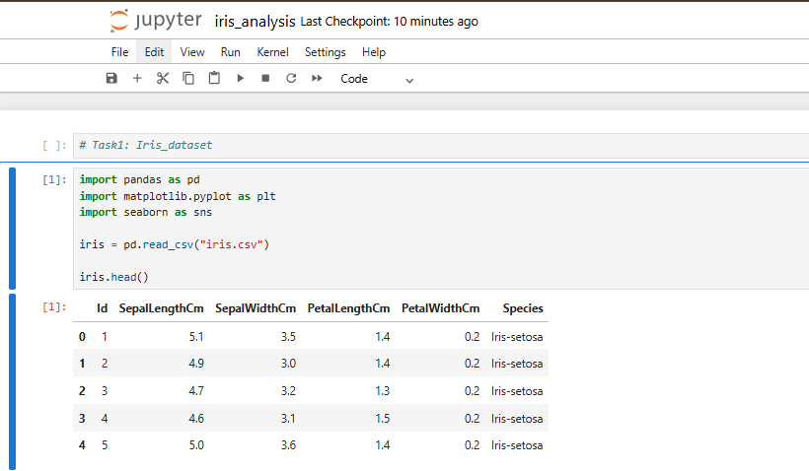
Dataset Structure:
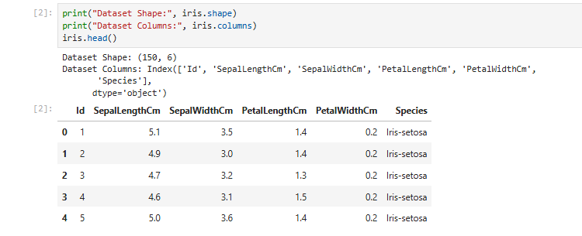
Dataset Information:
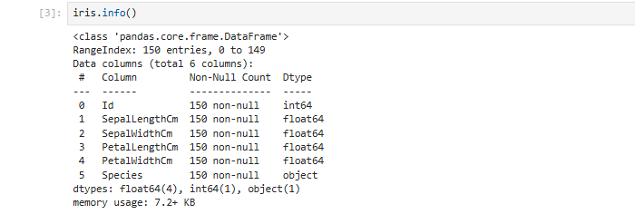
Dataset Summary:
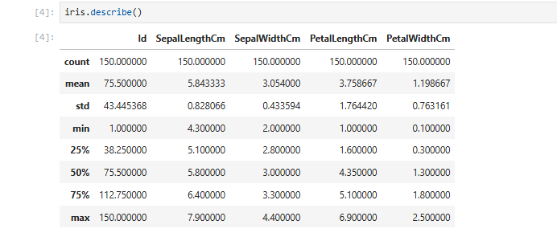

6. Data Visualization:
Different visualization techniques were used to better understand the dataset:
Scatter Plot:
Scatter plots were used to analyze the relationship between sepal length and sepal width. This helps in understanding how the two variables are related and how different species are distributed.

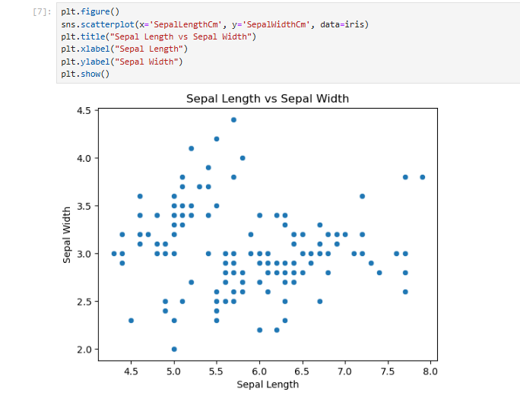

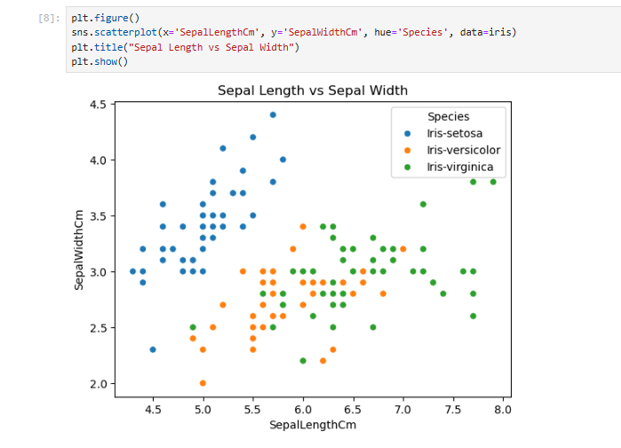

Histogram:
Histograms were used to analyze the distribution of sepal length values in the dataset. This helps in understanding how the data is spread across different value ranges.

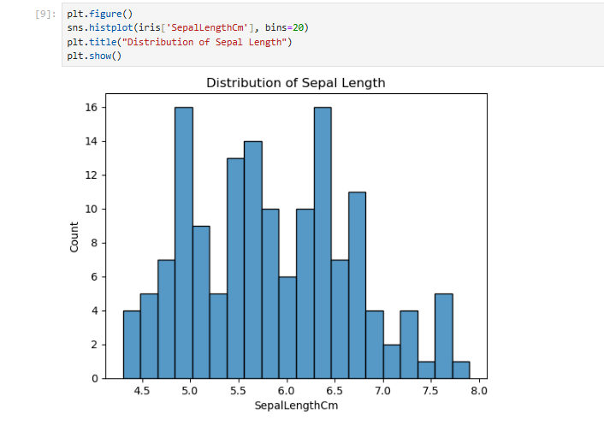

Box Plot:
Box plots were used to identify the spread of data and detect possible outliers. It also helps compare the distribution of sepal length among different species of iris flowers. 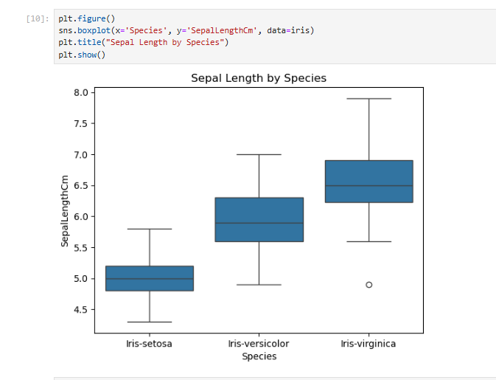

7. Results and Insights:
Through data exploration and visualization, several insights were observed:
- The dataset contains measurements of three different iris species.
- Sepal length and sepal width show variation across different species.
- The distribution of sepal length shows how frequently certain values appear in the dataset.
- Box plots highlight differences in measurements between species.

8. Conclusion:
In this task, the Iris dataset was successfully explored and visualized using Python. Data exploration techniques helped in understanding the structure and characteristics of the dataset. Visualization techniques such as scatter plots, histograms, and box plots provided useful insights into the relationships and distribution of variables in the dataset.

