Task 2: Credit Risk Prediction

1. Introduction:
This project focuses on predicting whether a loan applicant is likely to default on a loan. The goal is to build a classification model that can help banks make better lending decisions using machine learning techniques.

2. Objective:
The objective of this task is to:
- Perform data cleaning and handle missing values.
- Perform exploratory data analysis (EDA).
- Build a classification model.
- Evaluate the model using accuracy and confusion matrix.

3. Dataset Description:
The dataset used for this task is the Loan Prediction Dataset from Kaggle.
It contains information about loan applicants such as:
- Gender
- Marital Status
- Education
- Applicant Income
- Loan Amount
- Credit History
- Loan Status (Target Variable)
The target variable Loan_Status indicates whether the loan was approved or not.

4. Data Cleaning:
The dataset contained missing values in several columns.
Missing values were handled using:
- Mean value (for numerical columns like LoanAmount).
- Mode value (for categorical columns like Gender, Married, Credit_History).
This step ensured that the dataset was clean and ready for model training.

5. Data Visualization:
A visualization was created to analyze important features.
Graphs help in understanding patterns in the data.
For example, income distribution and loan status relationships were analyzed using plots.
Code + Output:

Import libraries and load dataset:

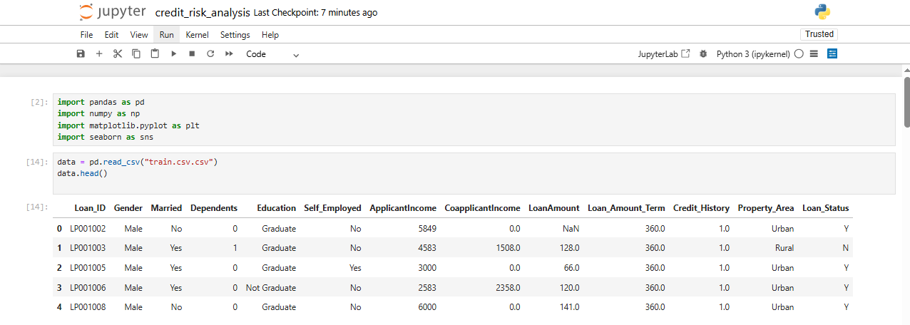
Dataset Exploration:

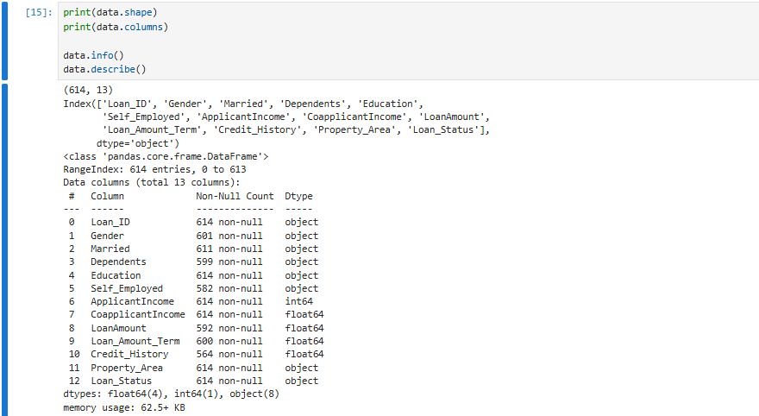

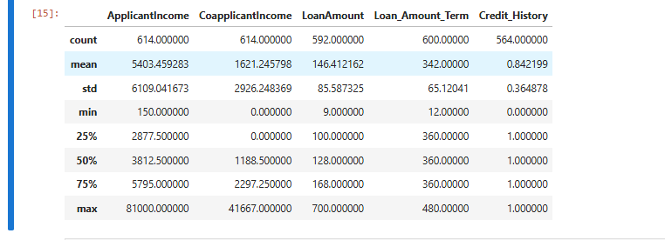

Handle Missing Values:

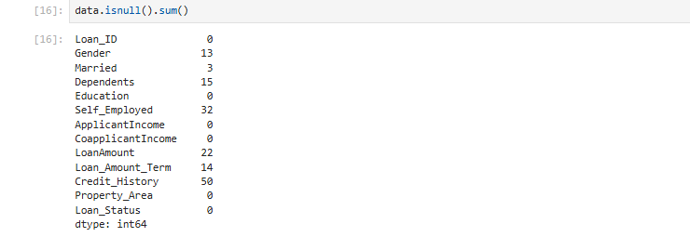

Visualization (EDA):

Loan Amount Distribution:
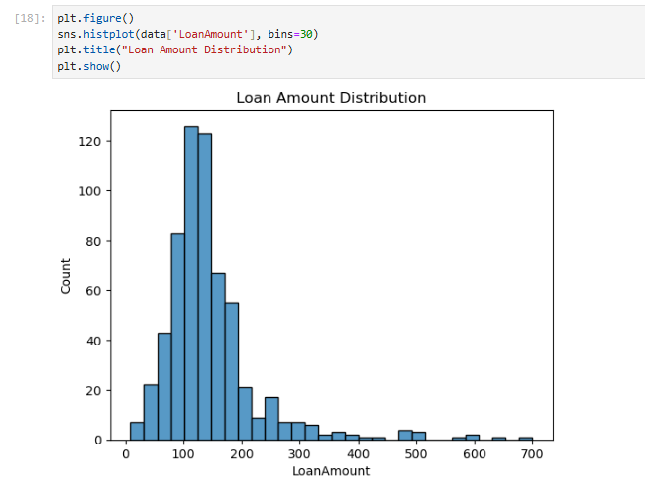
Education vs Loan Status: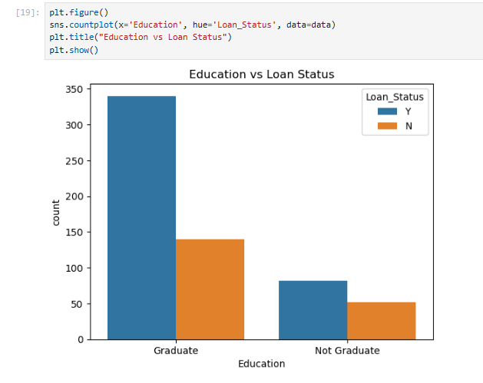
Applicant Income Distribution: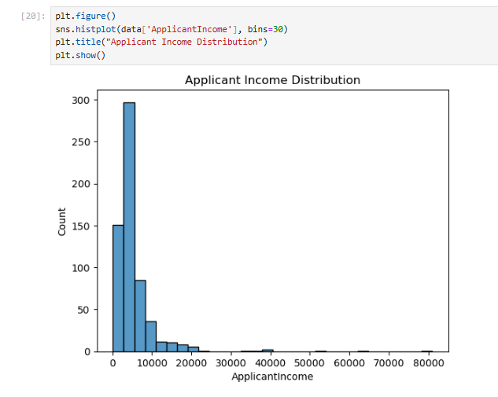
Convert categorical data: 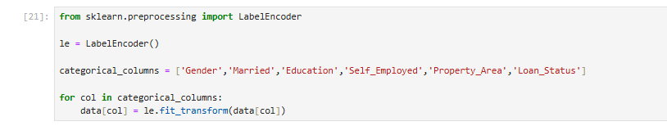Feature selection:Train test split:

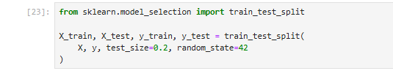

Train Model (Logistic Regression):

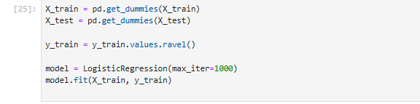
Predictions:

Model Evaluation: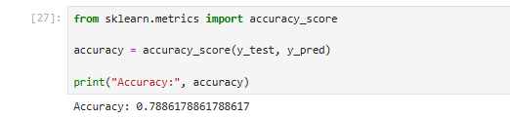
Confusion Matrix:

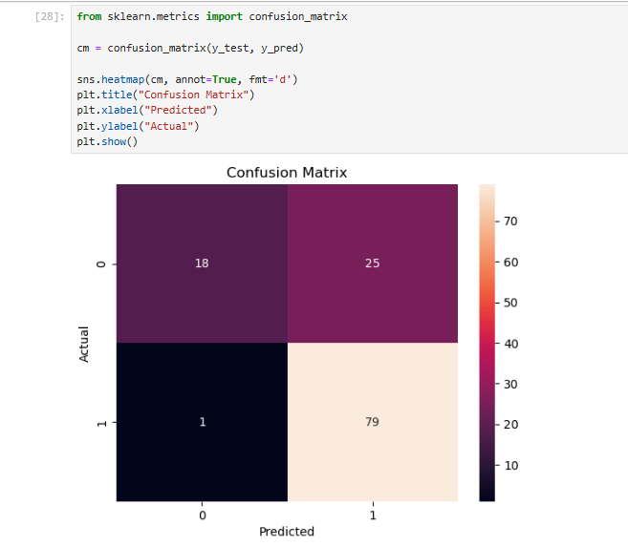

6. Model Building:
A Logistic Regression model was used for prediction.
Logistic Regression is a classification algorithm used for binary outcomes (Yes/No, 0/1).
The dataset was divided into:
- Training data
- Testing data
The model was trained using the training dataset.

7. Model Evaluation:
The model was evaluated using:

Accuracy:
Accuracy measures how many predictions were correct.

Confusion Matrix:
The confusion matrix shows:
- True Positive
- True Negative
- False Positive
- False Negative
It helps in understanding model performance in detail.

8. Conclusion:
The machine learning model was successfully developed to predict loan approval status.
Data preprocessing and visualization improved understanding of the dataset.
The model achieved reasonable accuracy, and the confusion matrix helped evaluate its performance.

