Task 3: Customer Churn Prediction (Bank Customers)

Introduction:
Customer churn prediction is a machine learning task that helps banks identify customers who are likely to leave the bank. By analyzing customer data, the bank can take preventive actions to improve customer retention and reduce losses.

Objective:
The main objective of this task is to build a classification model that predicts whether a customer will leave (churn) or stay with the bank. Additionally, the task aims to identify important features that influence customer churn.

Dataset Description:
The Churn Modelling Dataset contains information about bank customers. It includes demographic details, account information, and banking behaviour.
Key features include:
- Customer ID
- Credit Score
- Geography
- Gender
- Age
- Tenure
- Balance
- Number of Products
- Has Credit Card
- Is Active Member
- Estimated Salary
- Exited (Target Variable)
The target variable Exited indicates whether the customer left the bank (1) or stayed (0).

Data Cleaning and Preparation:
Before building the model, the dataset must be cleaned and prepared. This includes:
- Checking for missing values
- Removing unnecessary columns (such as Customer ID)
- Ensuring data types are correct
- Preparing features for machine learning

Model Training:
After preparing the data, a supervised classification algorithm is used to train the model.
Common algorithms include:
- Logistic Regression
- Decision Tree Classifier
The model is trained using input features to predict whether a customer will churn or not.

Feature Importance Analysis:
Feature importance helps identify which factors have the greatest impact on customer churn.
For example:
- Age
- Balance
- Credit Score
- Activity Status
By analyzing feature importance, the bank can understand which characteristics influence customer decisions.
This helps in making better business strategies to reduce churn.

Model Evaluation:
The model performance is evaluated using:
- Accuracy Score
- Confusion Matrix
These metrics help determine how well the model predicts customer churn.

Code and Output:
Import Libraries, load dataset and drop unnecessary columns:
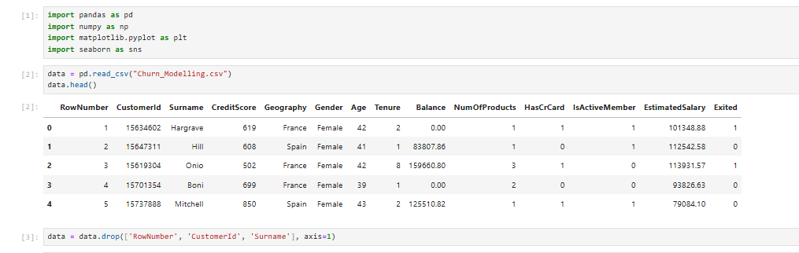Encode Categorical Features: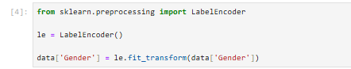
For Geography new hot encoding:
Define Features and target, and train test split: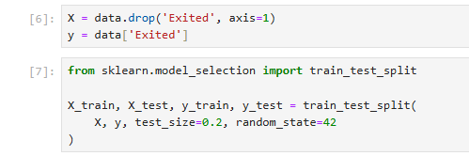

Logistic Regression:

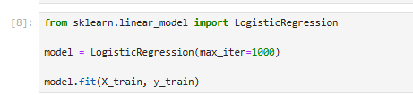

Prediction and accuracy:
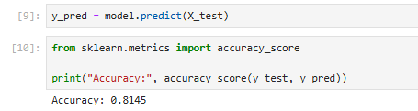
Confusion Matrix:

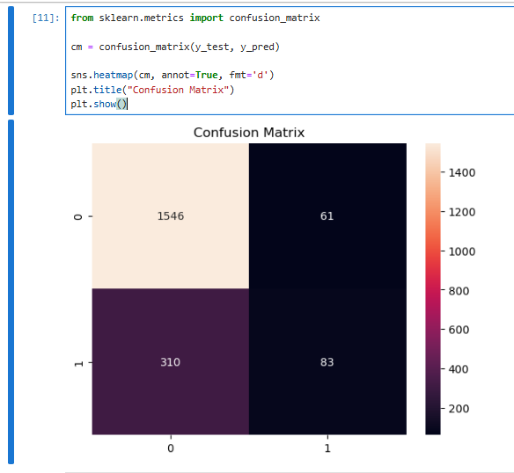

Logistic Regression with coefficients:
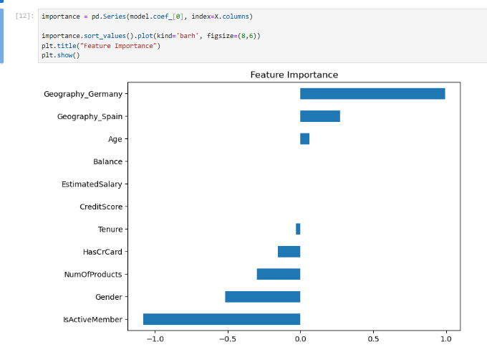

Results and Insights:
The model provides predictions about customer behaviour.
Feature importance analysis helps identify key factors affecting churn.
This information can help banks improve customer satisfaction and retention strategies.

