Task 4: Predicting Insurance Claim Amounts

1. Introduction:
Health insurance companies need to estimate the potential medical costs of customers in order to set appropriate insurance premiums and manage financial risk. By analyzing personal information such as age, BMI, smoking habits, and other demographic factors, data science techniques can help predict the expected insurance charges. In this task, machine learning is used to estimate insurance claim amounts based on customer data.

2. Objective:
The objective of this task is to build a regression model that predicts medical insurance charges using personal attributes of individuals. The analysis also aims to understand how factors such as age, BMI, and smoking status affect insurance costs.

3. Dataset Description:
The dataset used for this task is the Medical Cost Personal Dataset. It contains information about individuals and their medical insurance charges.
The main features in the dataset include:
- Age – Age of the individual
- Sex – Gender of the individual
- BMI – Body Mass Index, which indicates body fat based on height and weight
- Children – Number of children or dependents covered by insurance
- Smoker – Whether the individual is a smoker or not
- Region – Residential area of the individual
- Charges – Medical insurance cost billed to the individual (target variable)
The target variable charges represents the amount of medical insurance claim.

4. Data Visualization:
Data visualization is used to understand relationships between different variables and insurance charges.
In this task:
- Scatter plots were used to analyze the relationship between age and insurance charges.
- Another scatter plot was used to observe how BMI affects medical charges.
- A box plot was used to compare insurance charges between smokers and non-smokers.
Code and output:
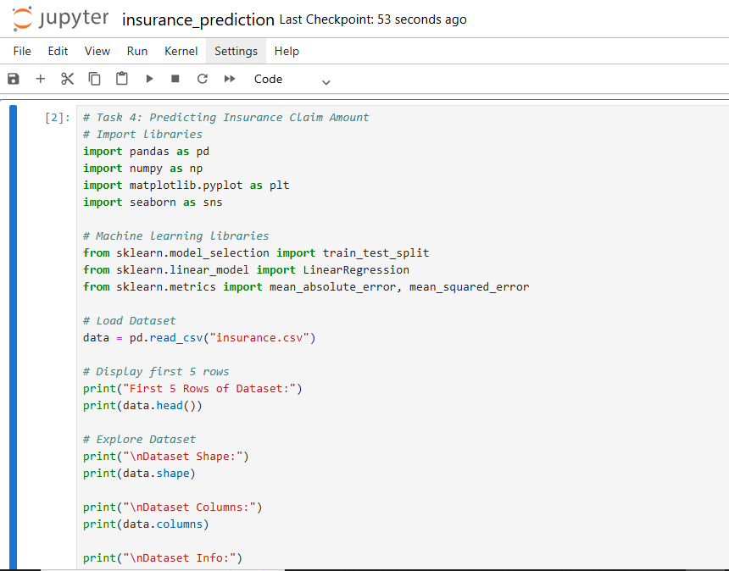

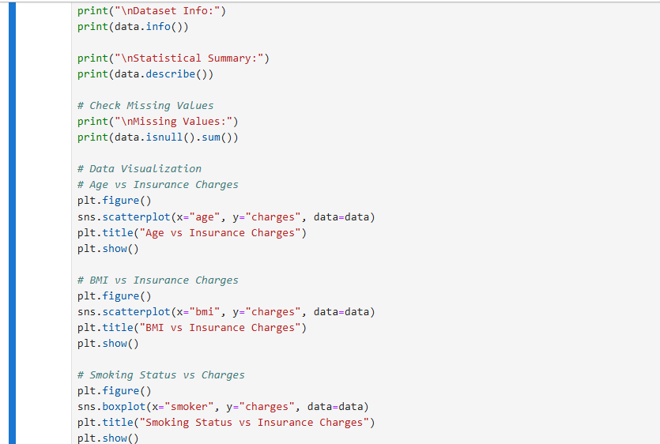

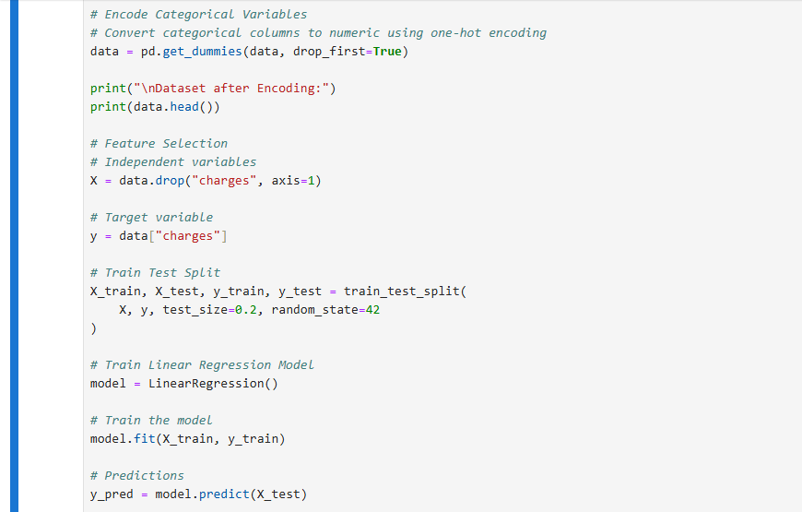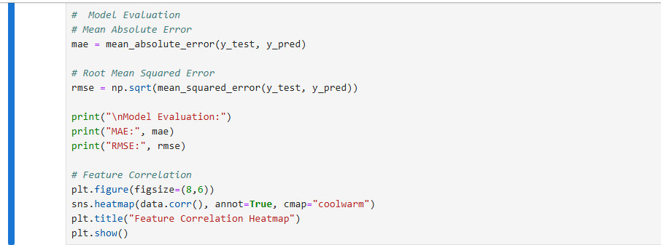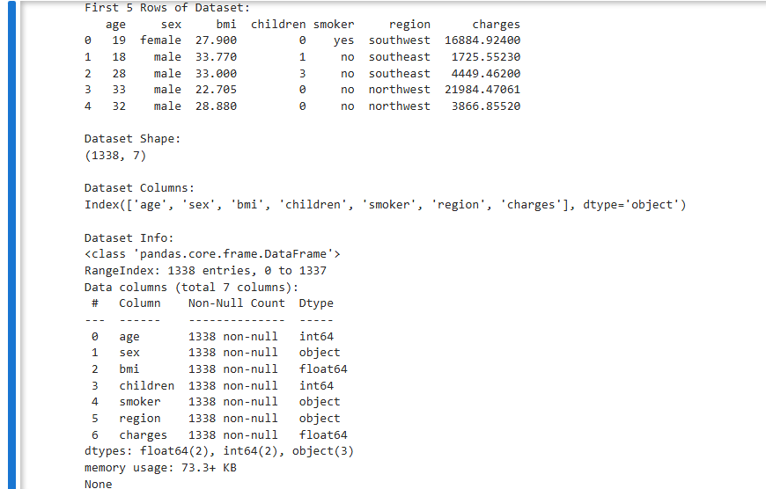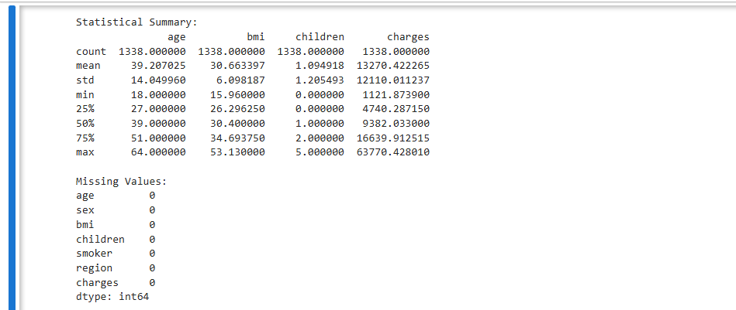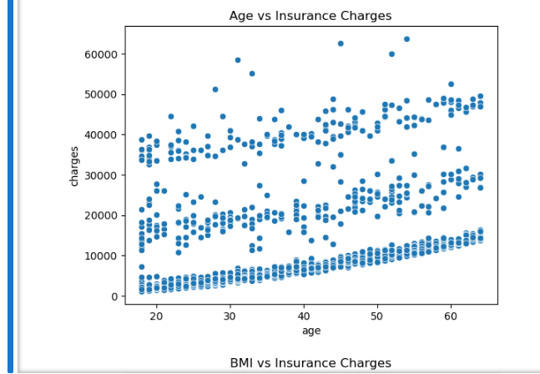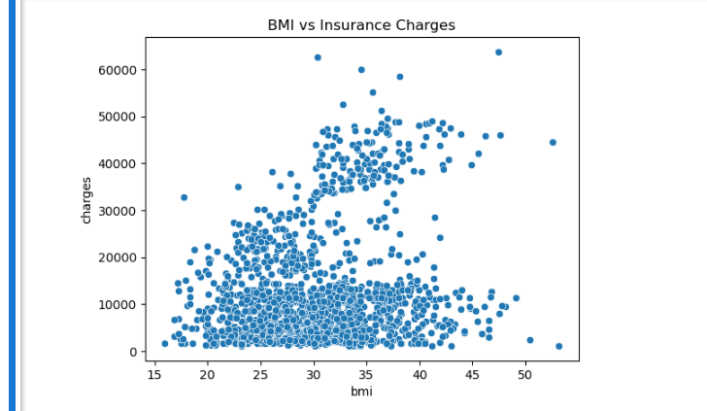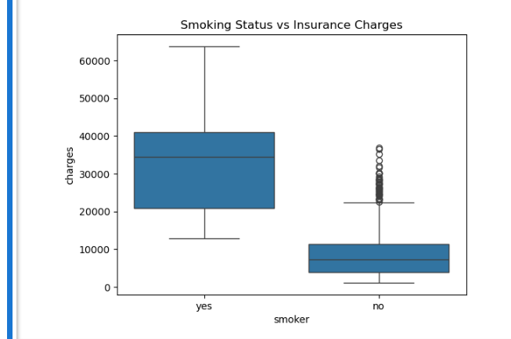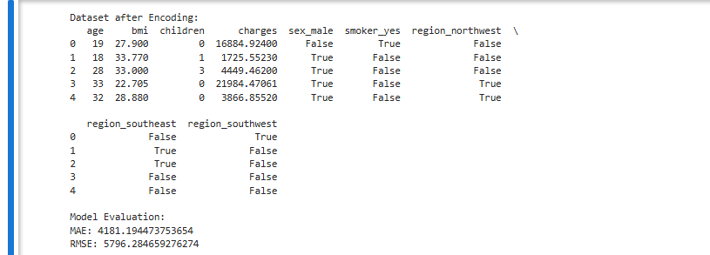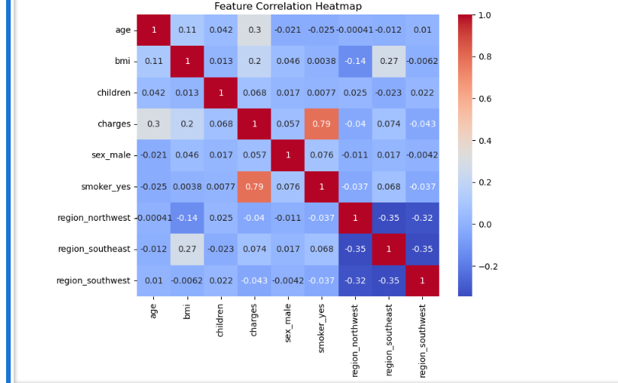

5. Data Preprocessing:
Before building the model, the dataset needs to be prepared for machine learning. This includes:
- Checking for missing values in the dataset
- Converting categorical variables such as gender, smoking status, and region into numerical form using encoding techniques
- Separating the dataset into input features and target variable
Proper preprocessing ensures that the data can be used effectively by the machine learning model.

6. Regression Model (Linear Regression):
A Linear Regression model is used to predict the insurance charges. Linear regression is a supervised machine learning algorithm used for predicting continuous numerical values.
The model learns the relationship between input variables (age, BMI, smoker status, etc.) and the target variable (insurance charges). After training, the model can estimate the expected insurance cost for new individuals.

7. Model Evaluation:
The performance of the regression model is evaluated using error metrics:
Mean Absolute Error (MAE)
MAE measures the average difference between predicted values and actual values.
Root Mean Squared Error (RMSE)
RMSE measures the square root of the average squared differences between predicted and actual values. It penalizes larger errors more strongly.
These metrics help determine how accurately the model predicts insurance charges.

8. Results and Insights:
From the analysis and visualizations, several observations can be made:
- Insurance charges tend to increase with age.
- Higher BMI values may lead to higher medical costs.
- Smokers generally have significantly higher insurance charges compared to non-smokers.
These insights can help insurance companies better understand factors affecting medical costs.

9. Conclusion:
In this task, a regression model was developed to predict medical insurance charges using personal data. The dataset was explored, visualized, and prepared for machine learning. A Linear Regression model was trained and evaluated using MAE and RMSE metrics. The results showed that personal factors such as age, BMI, and smoking status significantly influence insurance costs.

