Task 5: Personal Loan Acceptance Prediction

1. Introduction:
Banks often offer personal loans to customers as part of their financial services. However, not every customer accepts these offers. By analyzing customer data, banks can predict which customers are more likely to accept a personal loan. Machine learning techniques can help analyze customer demographics and behaviour to identify patterns and improve marketing strategies.

2. Objective:
The objective of this task is to build a classification model that predicts whether a customer will accept a personal loan offer. The analysis also aims to explore customer characteristics such as age, job type, and marital status to understand which groups are more likely to accept the loan.

3. Dataset Description:
The dataset used in this task is the Bank Marketing Dataset, which contains information collected from a direct marketing campaign of a banking institution.
Important features in the dataset include:
- Age – Age of the customer
- Job – Type of occupation
- Marital – Marital status of the customer
- Education – Education level
- Balance – Average yearly account balance
- Housing Loan – Whether the customer has a housing loan
- Personal Loan – Whether the customer has an existing personal loan
- Contact – Communication method used during the campaign
- Target Variable (y) – Indicates whether the customer accepted the loan offer (yes or no)
The target variable y represents whether the customer subscribed to the personal loan offer.

4. Data Exploration:
Data exploration is performed to understand the dataset and identify important patterns. This includes:
- Checking dataset structure and size
- Examining column names and data types
- Reviewing summary statistics
- Analyzing distributions of important variables such as age, job, and marital status
Exploring the data helps identify meaningful relationships between customer attributes and loan acceptance.

5. Data Visualization:
Data visualization techniques are used to better understand customer behaviour.
In this task:
- A histogram is used to observe the distribution of customer ages.
- A count plot is used to analyze how different job categories relate to loan acceptance.
- Another count plot is used to compare loan acceptance across different marital statuses.
These visualizations help identify which customer groups are more likely to accept loan offers.

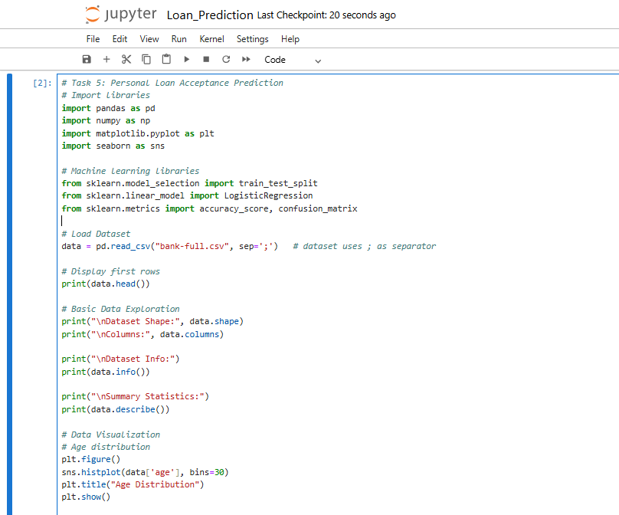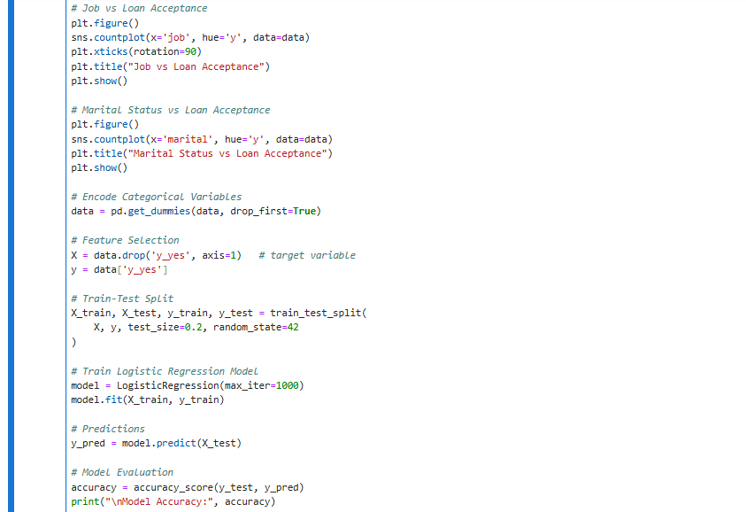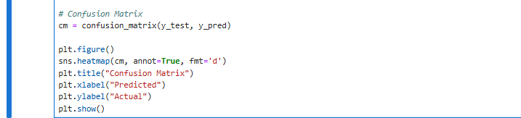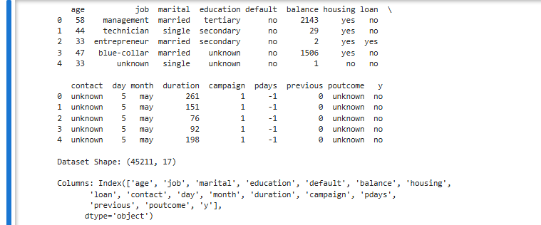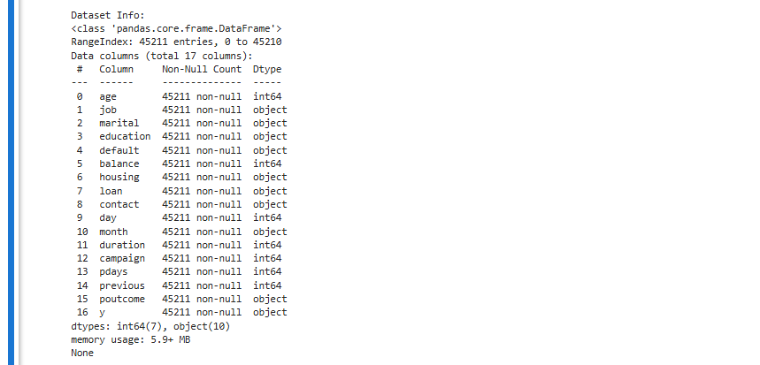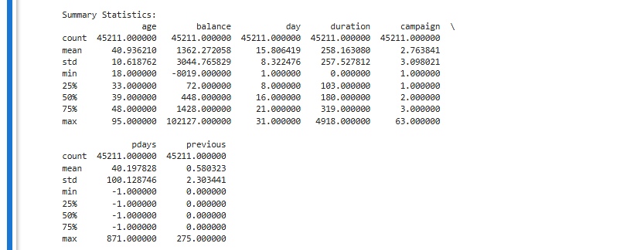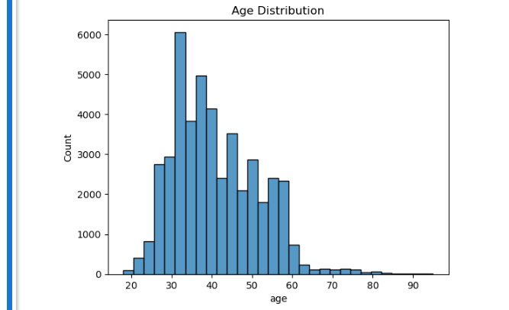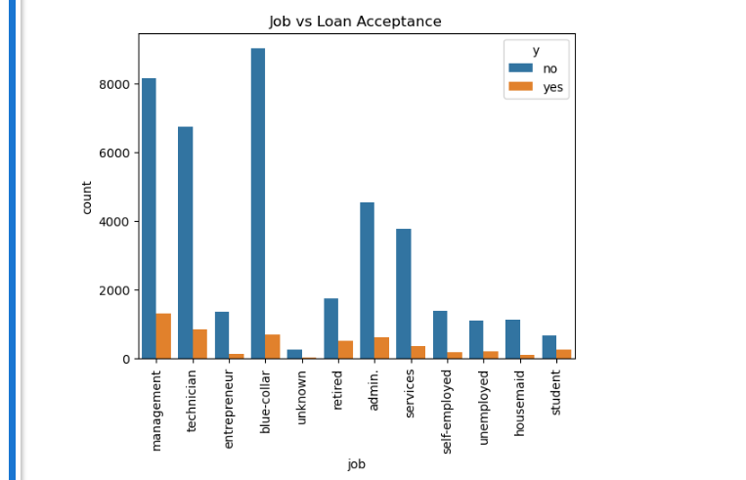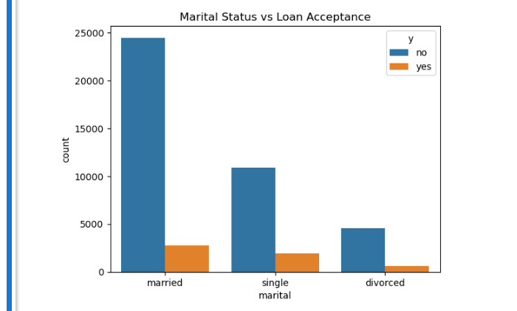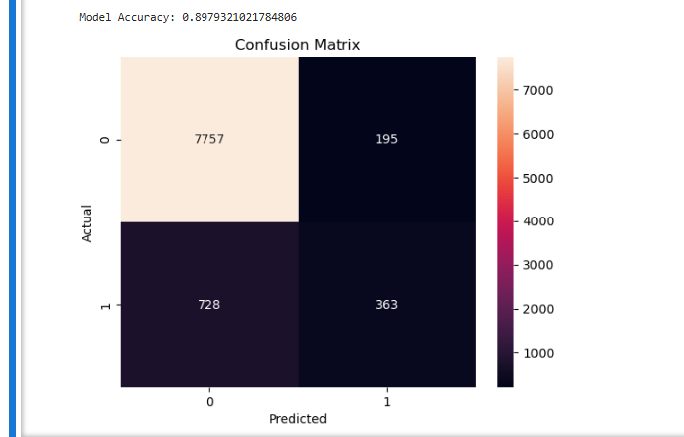

6. Data Preprocessing:
Before training the model, the dataset must be prepared for machine learning.
This includes:
- Converting categorical variables such as job, marital status, and education into numerical format using encoding techniques.
- Separating the dataset into input features and the target variable.
Proper preprocessing ensures that the data can be used effectively by the classification model.

7. Classification Model:
A Logistic Regression model is used for predicting loan acceptance. Logistic regression is a supervised machine learning algorithm used for binary classification problems.
The model learns the relationship between customer attributes and the likelihood of accepting a personal loan offer.

8. Model Evaluation:
The performance of the classification model is evaluated using:
Accuracy Score:
Accuracy measures the proportion of correct predictions made by the model.
Confusion Matrix:
The confusion matrix shows the number of correct and incorrect predictions made by the model. It helps evaluate how well the model distinguishes between customers who accept and those who reject the loan offer.

9. Results and Insights:
From the analysis and visualizations, useful business insights can be obtained:
- Certain job categories may show higher acceptance rates for personal loans.
- Age distribution can reveal which age groups are more responsive to loan offers.
- Marital status may influence the likelihood of accepting a loan.
These insights can help banks target the right customers in future marketing campaigns.

10. Conclusion:
In this task, a classification model was developed to predict whether customers are likely to accept a personal loan offer. The dataset was explored, visualized, and prepared for machine learning. A logistic regression model was trained and evaluated using accuracy and a confusion matrix. The analysis provided insights into customer characteristics that influence loan acceptance, which can help banks improve their marketing strategies.

