**“FUNDAMENTALS OF PROGRAMMING”**

**NAME:-** AFRAZ AHMED(new student enrolled)

**CMS ID:-** 349181

**BE(SE)-11’B**

**LAB 2 TASKS :-**

1. Write a program in the scripted mode that adds three numbers (of your choice) together. Use variables to store the values in your program.

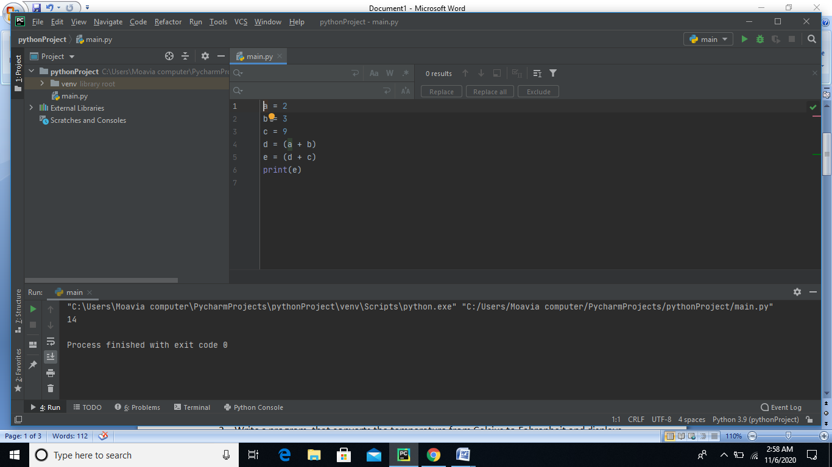

1. Write a program that converts the temperature from Celsius to Fahrenheit and displays the result to the screen.

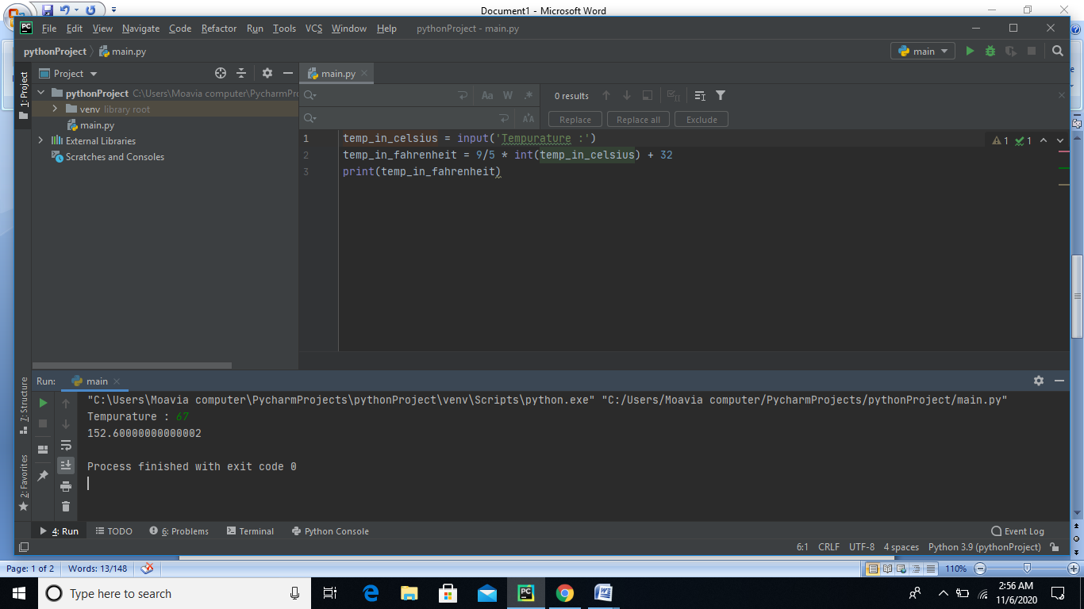

3- Mr. Ali has provided you with the electricity bills for past three months. The bills for the last three months have been **Rs. 8925, Rs. 7645 and Rs. 6280**. Write a program that computes average monthly electricity bill over the three-month period. Using variables write an appropriate expression to calculate the average and use print( ) to display the result

