Name: Afraz Hassan
Roll No: 26i-3182
Section: BSE-A
Prompt 1:
Attached are the html and css files of myn website. The topic of this website is to guide the users about their next travelling destination and provide them packages we offer for the trips.
I have designed the basic structure of the website. Review and understand it carefully. Then, suggest me at least 3 pages to add on this website. The attached is design is approved by my instructor. Make sure every page you add should follow the same theme, color scheme and fonts, so that the whole website looks like it belongs together.
Response 1 Summary:
The AI understood the complete theme and suggested these pages: Explore Destinations, Travel Guide and Tips, contact and booking, about us.
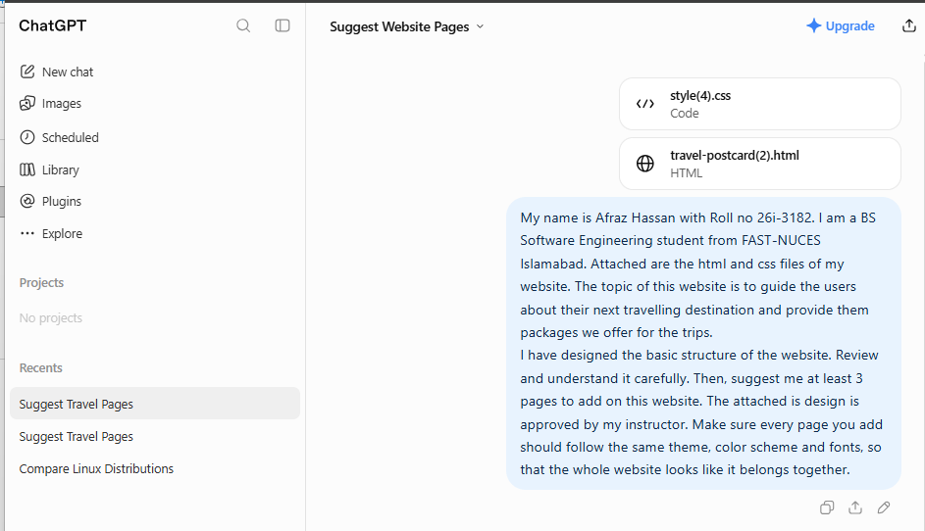
Prompt 2:
I would prefer these pages:
Home
Explore Destinations
Travel Guide and Tips Explore
Packages and booking
First of all, redesign the home page completely in a user friendly, attractive, professional and optimized way.

Response 2 Summary:
The AI created the home page but the actual theme and typography was changed.
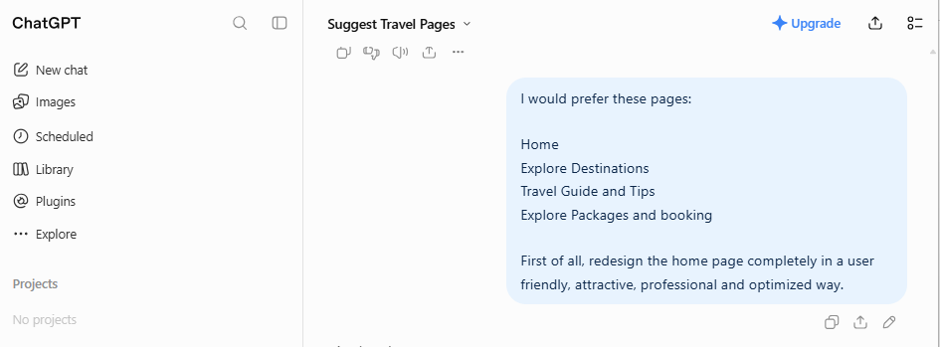

Prompt 3:
Adjust the typography and make sure theme matches the one approved by my instructor. Now, keeping the same theme. Create the below page also for this website. Also add attractive images and provide me the zip file containing all the files of the website:
Explore Destinations
Travel Guide and Tips
Explore Packages and booking
The website must be very professional, user-friendly and optimized.
Response 3 Summary:
The AI created the next pages which was good and according to requirements. But it missed the Javascript message and alert.
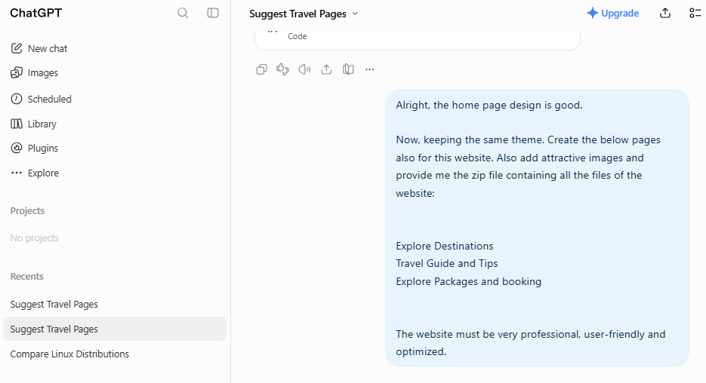
Prompt 4:
Also add the basic javascript capabilities using these functions window.alert() and console.log() When user submit the form, then the alert should show a message "Form submitted successfully".
Response 3 Summary:
The AI now added the javascript capabilities to the website.
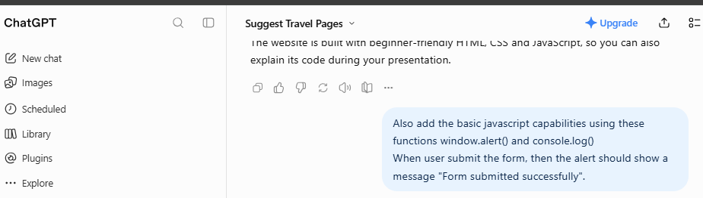
Prompt 4:
The zip file is unable to download, Just give me the javascript file containing the changes. I will add it to the website
Response 3 Summary:
The zip file was not downloading due to some issue, the AI provided separate code for javascript which I copied and added to the website.



