AI-BDM — Phase 2 & Phase 3
Lead Enrichment & Review Intelligence — Project Plan
July 2026

Table of Contents

1. Objective
Enrich every qualified lead produced by the existing Phase 1 pipeline with three additional layers of information: verified business facts, owner/decision-maker contact details, and customer-review-based problem signals — combined into a single per-business breakdown. Every source used is free, low-cost, or licensed, and none require the weeks-long official API review processes (Meta App Review, LinkedIn Partner Program) ruled out earlier.

2. Goals
- Extract as much company data as possible from LinkedIn — free snippet parsing first, a licensed dataset second — without needing official API approval or running scraping risk.
- Detect each business's technology stack and cross-reference it against known security vulnerabilities.
- Discover LinkedIn and Facebook page links without needing official API approval.
- Find owner/decision-maker contact details through a licensed contact-finder vendor.
- Discover and analyze customer reviews across multiple platforms, scored against the original user query using the existing RAG engine.
- Synthesize all gathered evidence into a plain-language summary of the business's actual weaknesses.
- Never block or delay a lead — every lookup fails safely, leaving a field blank rather than guessing or halting the pipeline.

3. Approach
Two rules govern every source in Phase 2 and Phase 3:
- Cache first, own data second, external call last. Before spending money or making a network call, check whether the answer is already cached from a previous run, then whether it's already sitting in data already scraped from the business's own site during Phase 1. Only if both come up empty does the system make a real external call.
- Fail safe, never fail closed. If any single source finds nothing, times out, or errors, that one field is left blank and logged — it never blocks the lead or the rest of the pipeline. Enrichment only ever runs on leads that already passed Phase 1's qualification, so no cost is spent on candidates that didn't qualify.

4. Alternatives Considered
Before settling on the approach above, several other sources and methods were evaluated and rejected. This section explains why.

4.1 Why not Indeed or Glassdoor
Both were considered as additional review/job-listing sources and rejected for the same reason: neither has a usable official API anymore. Indeed discontinued its public Publisher API in 2023. Glassdoor shut its public API down entirely and now only offers data through undisclosed-pricing enterprise partnerships. In both cases the only remaining access route is scraping through a third-party marketplace (see 4.2), which adds ongoing per-record cost and shifts — but does not remove — Terms of Service risk onto AI-BDM. The same signal (employer/employee sentiment) is obtainable through Google Reviews or BBB with cleaner legal standing, so both were dropped rather than pursued via scraping.

4.2 Why not Apify or similar scraping marketplaces
Apify and comparable marketplaces sell pre-built "Actors" that scrape LinkedIn, Glassdoor, Instagram, and Facebook for as little as $1–$10 per 1,000 results — cheap and technically easy. They were rejected anyway because of a live legal precedent: in January 2025, LinkedIn sued Proxycurl, a commercial "LinkedIn data API" business functionally identical to what an Apify Actor does. Proxycurl settled for a $500,000 judgment, a permanent injunction, and forced destruction of its entire dataset, and shut down as a company. Renting a cheap Actor doesn't change whose account is doing the scraping when it runs — it only changes who wrote the code. This risk applies specifically to LinkedIn, Glassdoor, Instagram, Facebook, and Twitter/X; it does not apply to Serper-based Google search (used throughout this plan), since that only reads Google's own public index.

4.3 Why LinkedIn and Facebook official APIs are hard to access
Both platforms do have official, fully legal APIs — they were still ruled out for this plan because of what it actually takes to get access:
- LinkedIn (Marketing Developer Platform / Organization API): requires an approved partnership. Even at the faster quoted review timelines, real enterprise partnerships run $10,000–$50,000+/year plus development cost, and usage is contractually restricted to "the relevant Marketing Services for which the data was made available" — meaning even after approval, repurposing that data into a general lead-gen product may not be permitted.
- Facebook (Graph API, either the lighter "Page Public Metadata Access" or the fuller "Page Public Content Access" tier): both require the identical process — register a developer app, request the permission, complete Meta's App Review (a multi-week manual review that can reject the use case), then complete Business Verification (a separate step verifying AI-BDM itself is a legitimate business). There is no lighter tier that skips this — both cost the same weeks of setup before a single call can be made.
This is precisely why Phase 2.1 finds LinkedIn and Facebook URLs a different way entirely — a plain Google search via Serper, which needs no approval, no review, and no extra cost, and stays inside both platforms' terms since it never touches linkedin.com or facebook.com directly.

4.4 Why automated LinkedIn/Facebook outreach tools were ruled out
A separate category of tools (Dux-Soup, PhantomBuster, Waalaxy, Expandi, HeyReach, and similar) automate browsing and connection requests, marketed as "safe" alternatives to raw scraping. They were rejected because they automate the exact behavior both platforms' Terms of Service prohibit, regardless of how the tool is marketed. The enforcement data backs this up: browser-extension-based tools carry roughly a 23% chance of a 90-day account restriction within a quarter, and even the "safer" cloud-based tools aren't immune — LinkedIn wiped HeyReach's entire company page and banned its founder's personal profile in early 2026.

5. Phase 2.1 — Business + Owner Info
Takes the domains shortlisted by Phase 1's evidence system and gathers company facts and decision-maker contact details for each, using only easy, low-friction lookups.
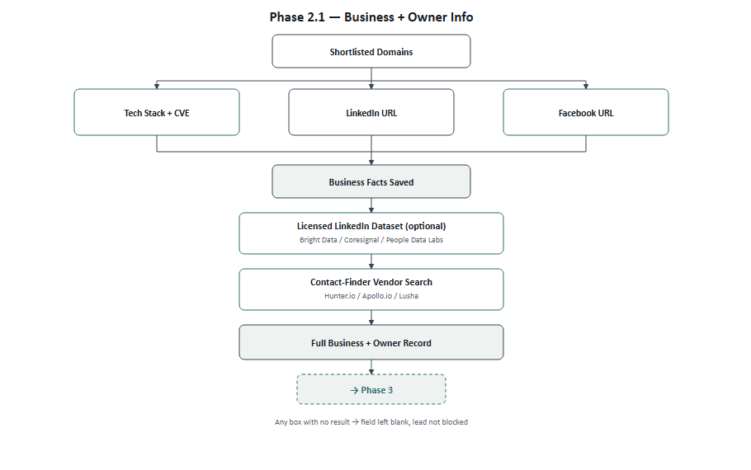

Process Flow
Step | Action | If nothing is found
1 | Input: shortlisted domains from Phase 1's top-15-chunk output | —
2 | Tech Stack + CVE: reuse existing Wappalyzer scan, cross-reference against the CVE database | Field left blank
3 | LinkedIn URL: check the business's own scraped homepage for a linkedin.com link first; if none, Google search "site:linkedin.com" — also parse the full Serper snippet (industry, employee-count range, followers, if shown) rather than just the URL | Field left blank
4 | Facebook URL: same method as step 3 — own site first, then Google search "site:facebook.com" | Field left blank
5 | Save steps 2–4 as the Business Facts record | —
6 | Licensed LinkedIn dataset lookup (optional): Bright Data / Coresignal / People Data Labs, keyed by the LinkedIn URL or domain → firmographic and headcount data beyond what the snippet shows | Field left blank
7 | Contact-Finder Vendor: search the business's website domain via Hunter.io / Apollo.io / Lusha → owner or decision-maker name, title, email | Field left blank
8 | Save the Full Business + Owner Record; pass it to Phase 3 | —

Platforms & Tools
Tool | Used For | Cost
Serper | LinkedIn / Facebook URL search + snippet data | Already in use
Wappalyzer | Tech stack detection | Already in use
NVD (CVE database) | Known vulnerability cross-reference | Free
Licensed LinkedIn dataset (see below) | Extra LinkedIn firmographic data, optional | $0.0025/record – $100+/mo
Contact-finder vendor (see below) | Owner / decision-maker contact | $37 – $175/mo

Getting More Out of LinkedIn, Legally
Beyond the free URL discovery already covered in Section 4.3, two further steps add real data without scraping or an official API partnership:
- Parse the Serper search snippet fully, not just the URL. Google's own indexed snippet for a LinkedIn company page often already shows industry, an employee-count range, and sometimes a follower count — this is data Google itself surfaces from its public index, not anything fetched from LinkedIn directly, and it's already being paid for as part of the existing search call. Currently only the URL is being kept from that response; the rest is free extra detail sitting unused.
- Buy a licensed LinkedIn dataset instead of scraping one. Several vendors sell finished, pre-collected LinkedIn datasets rather than live-scraping on request — the compliance work (and risk) sits with the vendor, not with AI-BDM. This is a materially different legal position than an Apify Actor: Bright Data, one of the larger vendors in this space, was sued by Meta over Instagram/Facebook data collection and won on the argument that collecting public, logged-out data is lawful — a real precedent in this exact area, unlike Proxycurl's outcome against LinkedIn.
Vendor | Cost | Notes
Bright Data | $250 per 100K records (~$0.0025/record); up to 80% off with a refresh subscription | Cheapest at AI-BDM's likely volume; public-data-only, logged-out collection stance; won its own scraping-legality case against Meta
Coresignal | API from $49/mo; full datasets from $1,000 | Better fit if an ongoing API is preferred over a static dataset purchase
People Data Labs | Company data from ~$98–100/mo (Pro tier); $20,000–$100,000+/yr at enterprise volume | Strong firmographic/headcount data; phone and email fields are priced as separate add-ons
- Recommendation: start with free snippet parsing — zero added cost. Add Bright Data's per-record dataset only if the snippet's limited fields prove insufficient; its pay-per-record pricing is the cheapest fit at current query volume and carries the most defensible legal position of the three, though buying from any of these vendors is meaningfully safer than scraping directly, not a zero-risk guarantee.

Contact-Finder Vendor — Individual Cost Breakdown
Only one of these needs to be picked to start; they overlap in what they do. Broken out individually since pricing and strengths differ meaningfully:
Tool | Entry Tier | Higher Tiers | Notes
Hunter.io | $49/mo — 2,000 searches | — | Cheapest entry point, email-focused. Best first choice to start with.
Lusha | Free — 70 credits/mo, or $37/mo paid | — | Phone numbers cost 10 credits vs. 1 for email — email-only usage stretches further.
RocketReach | $33/user/mo — 125 lookups (Essentials) | $75/mo — 300 lookups + phone (Pro); $175/mo — 1,000 lookups + API (Ultimate) | 700M+ profile database; only the top tier includes API access for automation.
Apollo.io | Tiered, mid-range | Scales with seats | Combines the contact database with outreach sequencing — more than this plan needs right now.
ZoomInfo | No low tier | $10,000+/year contracts | Best accuracy in the category, but enterprise-only pricing — likely overkill at current query volume.
- Recommendation: start with Hunter.io — cheapest, simplest, and sufficient at current scale. Move to RocketReach's Ultimate tier or Apollo.io only if phone numbers or outreach sequencing become a real requirement, and consider ZoomInfo only once volume genuinely justifies an enterprise contract.

6. Phase 3 — Reviews + Problem Detection
Finds customer reviews for each business across multiple platforms, scores them against the original user query using the existing RAG engine, and produces a final plain-language summary of the business's weaknesses.
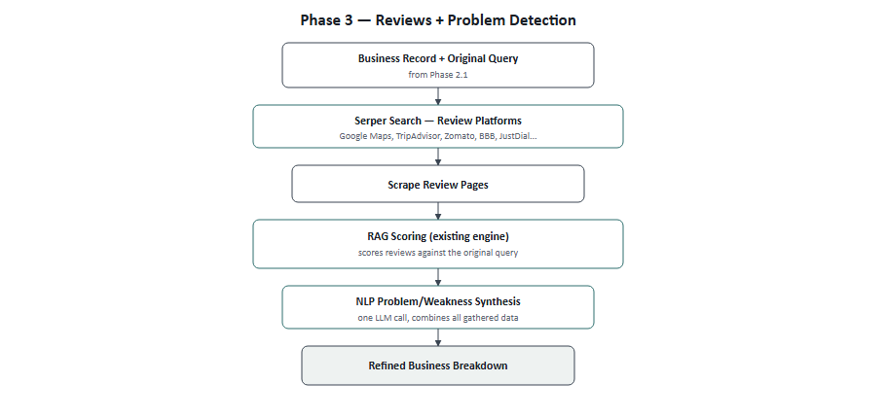

Process Flow
Step | Action | If nothing is found
1 | Input: Business + Owner record from Phase 2.1, plus the original user query | —
2 | Serper search across review platforms (Google Maps, TripAdvisor, Zomato, BBB, JustDial, Yelp, etc.) | That platform is skipped, others continue
3 | Scrape each matched review page using the existing scraper (ZenRows / Scrape.do) | That platform is skipped, others continue
4 | Score review text against the original query using the existing RAG engine (rag/top_matches.py) | Reviews section left empty
5 | Save the best-matching review evidence, tagged by platform | —
6 | Combine business facts + owner info + review evidence | —
7 | One LLM call: synthesize the business's actual weaknesses, grounded only in the gathered evidence | Raw fields still returned, summary omitted
8 | Deliver the final Business Breakdown to the user | —

Platforms & Tools
Tool | Used For | Cost
Serper | Review page discovery | Already in use
ZenRows / Scrape.do | Review page scraping | Already in use
rag/top_matches.py | Scoring reviews against the query | Already built
Existing LLM provider | Final weakness synthesis | Already in use

Review Platforms — Coverage by Business Type
Platform | Best For | Note
Google Reviews / Maps | Any business type | Broadest coverage, always try first
TripAdvisor | Restaurants, hotels, tourism | Free official API also available (5,000 calls/mo)
Zomato | Restaurants, dining | Strong in South Asia & Middle East
Better Business Bureau | Any US/Canada business | Complaint-focused — best fit for weakness detection
JustDial | Local businesses, South Asia | Good regional fit for Pakistan-area queries
Yelp | General, US/Canada-heavy | Lower priority — more actively anti-scraping
G2 / Capterra | B2B software / SaaS | Only relevant if leads are software companies
Facebook page rating | Any business with a Facebook page | Free — reuses the URL already found in Phase 2.1

