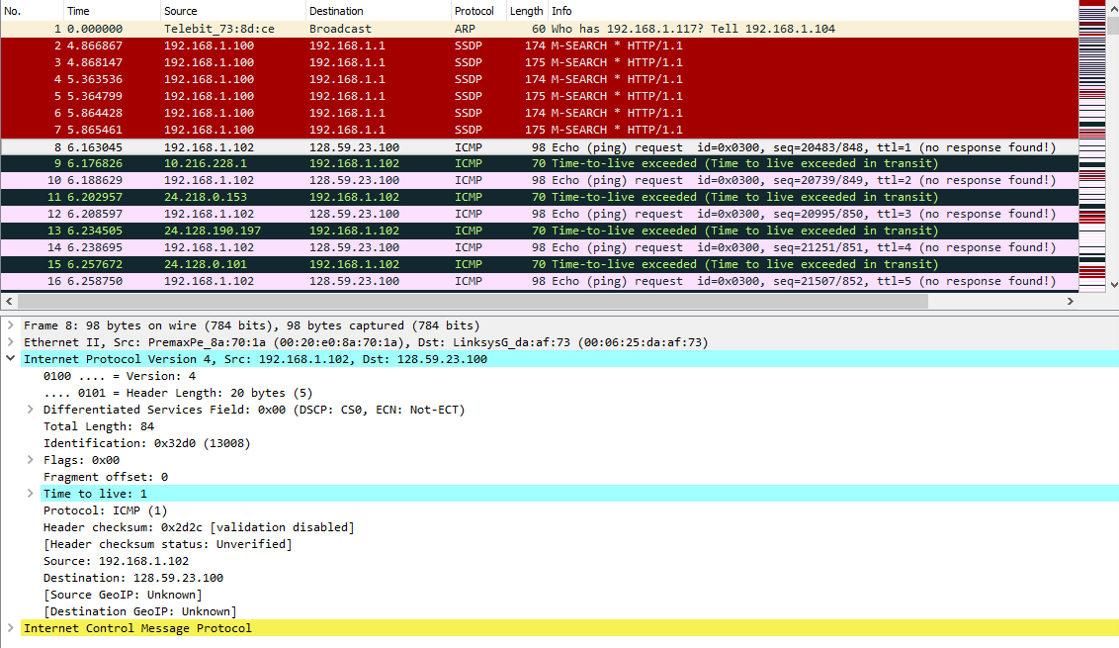

1. **Select the first ICMP Echo Request message sent by your computer, and expand the Internet Protocol part of the packet in the packet details window. What is the IP Address of your computer?**



192.168.1.102

1. **Within the IP packet header, what is the value in the upper layer protocol field?**

  
The value in the upper layer protocol field is ICMP (1)

1. **How many bytes are in the IP Header? How many bytes are in the payload of the IP datagram? Explain how you determined the number of payload bytes.**

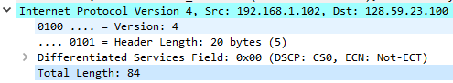

There are 20 bytes in the header, and 64 bytes in the payload of the IP datagram. I determined this because the total length is 84, and 20 of this is the header. 84-20 = 64.

1. **Has this IP datagram been fragmented? Explain how you determined whether or not the datagram has been fragmented.**

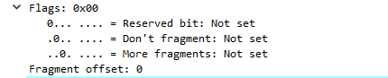

This IP datagram has not been fragmented. We can determine this because The ‘More Fragments’ flag is set to 0.

1. **Which fields in the IP datagram always change from one datagram to the next within this series of ICMP messages sent by your computer?**  
   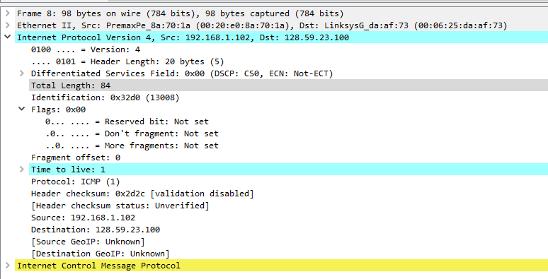

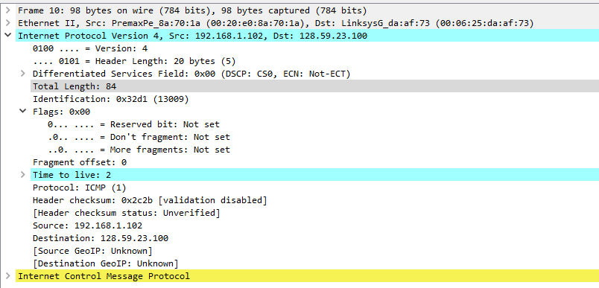

The fields that change from IP datagram to the next include:  
Identification, Time to live, Header checksum.

1. **Which fields stay constant? Which of the fields must stay constant? Which fields must change? Why?**

**The fields that stay constant include:**  
Version – can’t change version number mid packet  
Source IP – the IP address of my PC should not change

Destination IP – the IP address of my destination should not change

Header Length – all header lengths should be the same length

Differentiated Services Field – all of these packets are on ICMP, thus they must not change

Protocol – again, all of these packets are ICMP, thus they should all use ICMP

**The fields that *must* stay constant include:**  
Version – see above  
Source IP– see above

Destination IP– see above

Header Length– see above  
Differentiated Services Field– see above

Protocol– see above

**The fields that must change include:**  
Identification – every packet must have a unique ID  
Time to live – traceroute program will increment each packet in sequence  
Header Checksum – we utilize this checksum to ensure our packets are arriving correctly, must change every packet.

1. **Describe the pattern you see in the values in the Identification field of the IP datagram.**  
   (See above pictures). The Identification field is incrementing by one in between each packet.   
   0x32d0 -> 0x32d1
2. **What is the value in the Identification field and the TTL field?**  
   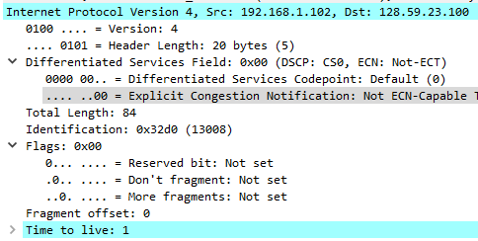  
   ID field: 0x32d0 (130008)

TTL field: 1

1. **Do these values remain unchanged for all of the ICMP TTL-exceeded replies sent to your computer by the nearest (first hop) router? Why?**  
   The ID field will change with every single packet. ID must be unique.

TTL does not change for a first hop.

1. **Find the first ICMP Echo Request message that was sent by your computer after you changed the Packet Size in pingplotter to be 2000. Has that message been fragmented across more than one IP datagram? [Note: if you find your packet has not been fragmented, you should download the zip file http://gaia.cs.umass.edu/wireshark-labs/wireshark-traces.zip and extract the ipethereal-trace-1packet trace. If your computer has an Ethernet interface, a packet size of 2000 should cause fragmentation.]**  
   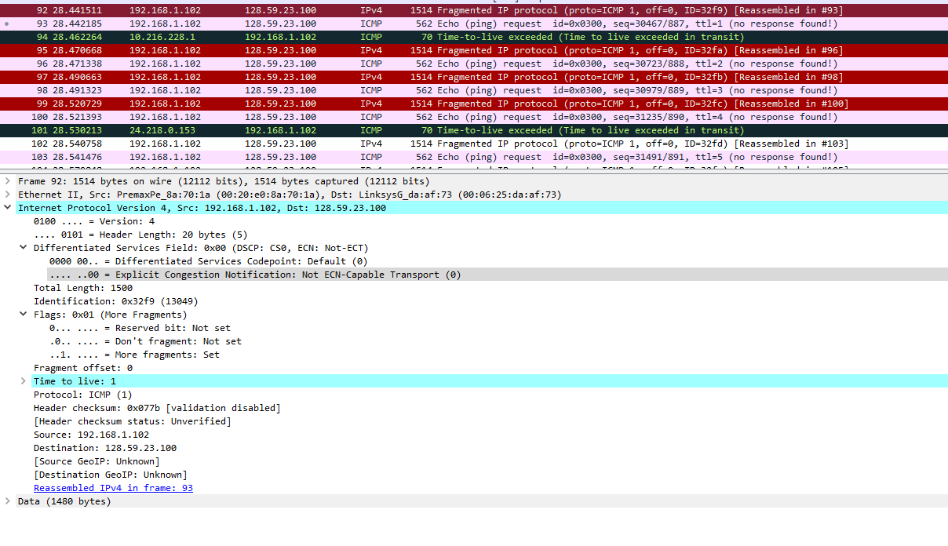  
   Yes, it has been fragmented.
2. **Print out the first fragment of the fragmented IP datagram. What information in the IP header indicates that the datagram been fragmented? What information in the IP header indicates whether this is the first fragment versus a latter fragment? How long is this IP datagram?**  
   (See above picture).  
   The flag for More Fragments has been set to 1. This indicates the datagram has been fragmented. We can conclude that this is the first fragment because the Fragment offset value is 0. The total length of this IP datagram is 1500 bytes.
3. **Print out the second fragment of the fragmented IP datagram. What information in the IP header indicates that this is not the first datagram fragment? Are the more fragments? How can you tell?**  
   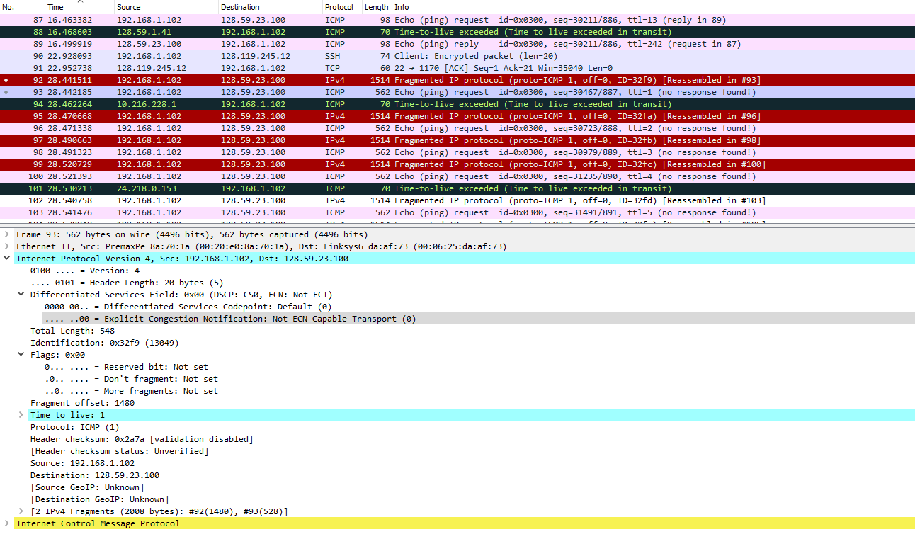  
   The fragment offset value is 1480, indicating that this is not the first fragment (which offset would be 0). We can tell that there are no more fragments because now the More Fragments flag value is 0.
4. **What fields change in the IP header between the first and second fragment?**

  


**The field values that change in between the two fragments include:**  
the Total Length field in the Differentiated Services Field section  
the Flag, specifically the More Fragments flag  
the Fragment offset  
and the Header Checksum.  
  
Identification stays the same since this is the same IP Datagram.

1. **How many fragments were created from the original datagram?**  
   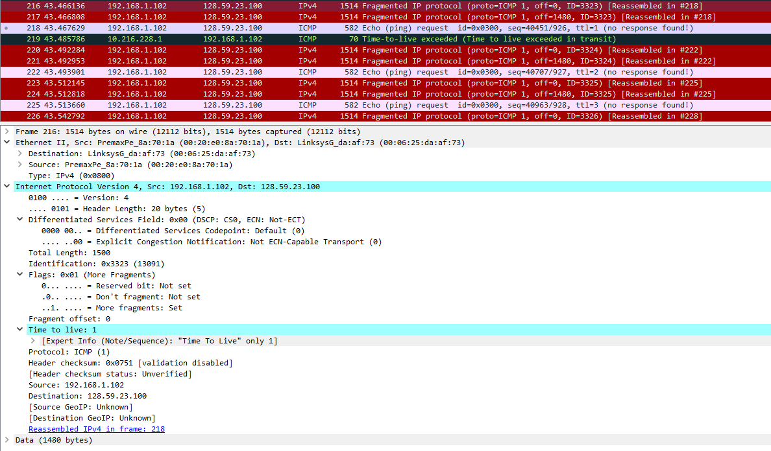  
   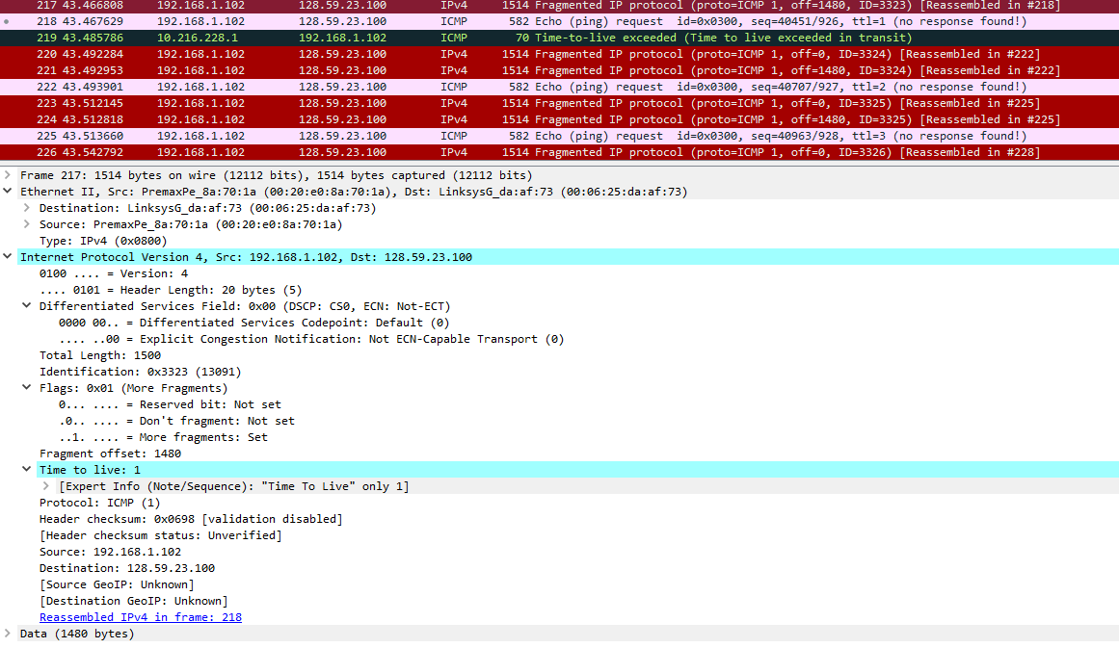

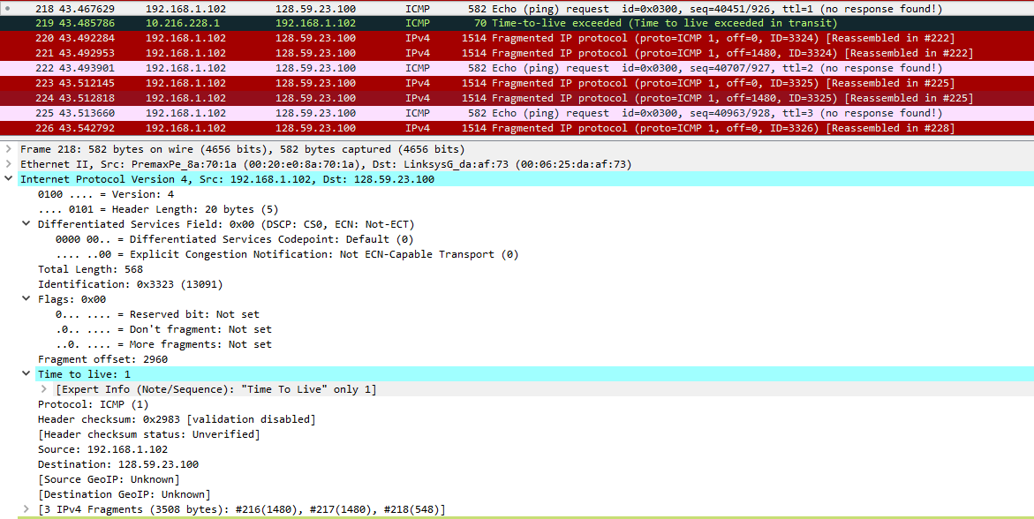

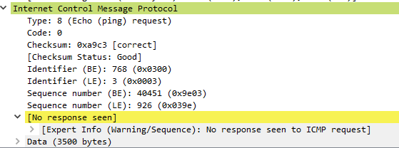  
  
Three fragments were created. On frames 216, 217 and 218.

1. **What fields change in the IP header among the fragments?**  
   (See above pictures)  
   Between the first two fragments, Fragment offset changes from 0 to 1480, and between the second and third fragment from 1480 to 2960.

Between the first two fragments, the More Fragments flag is 1, stating that there are more fragments.  
Between the second and third fragment, the More Fragments flag will change from 1 to 0, indicating that the third fragment is the last one.