Introduction Lab:

1. **List three different protocols that appear in the protocol column in the unfiltered packet-listing window in step 7 above.**  
   C:\Users\That_Nein\AppData\Local\Microsoft\Windows\INetCache\Content.Word\1_1.png TCP, SSL, DNS
2. **How long did it take from when the HTTP Get message was set until the HTTP OK reply was received?**

C:\Users\That_Nein\AppData\Local\Microsoft\Windows\INetCache\Content.Word\1_2.png (8.454674 – 8.414423) = 0.040251 seconds

1. **What is the internet address of the gaia.cs.umass.edu? What is the internet address of your computer?**  
     
   C:\Users\That_Nein\AppData\Local\Microsoft\Windows\INetCache\Content.Word\1_3.png 128.119.245.12
2. **Print the two HTTP messages (GET and OK) referred to in question 2 above.   
    (See other two files attached)**

**HTTP Lab:**

**Basic HTTP GET/response interaction**  
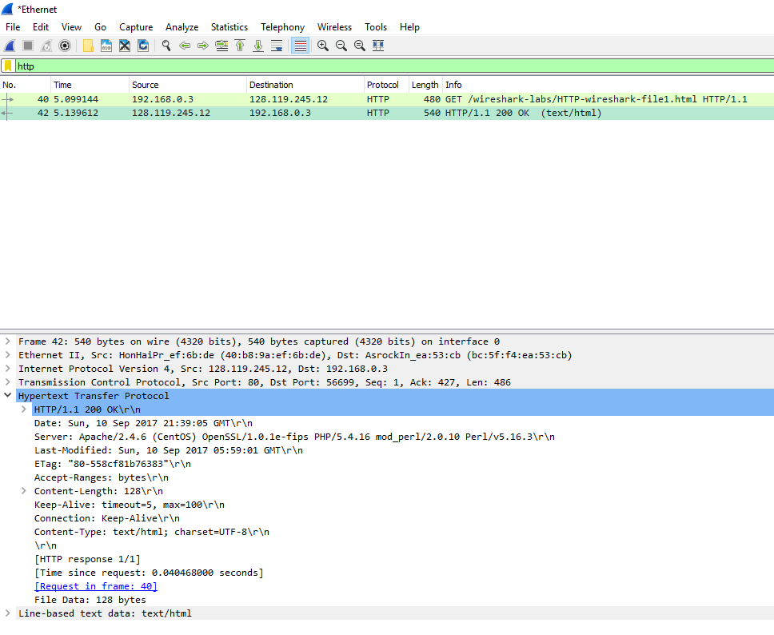

1. **Is your browser running HTTP version 1.0 or 1.1? What version of HTTP is the server running?**  
     
   My browser is running HTML1.1, as well as the server.
2. **What languages, if any, does your browser indicate that it can accept to the server?**  
   C:\Users\That_Nein\AppData\Local\Microsoft\Windows\INetCache\Content.Word\2.png  
   My browser indicates en-US language.
3. **What is the IP address of your computer? Of the server?**  
   C:\Users\That_Nein\AppData\Local\Microsoft\Windows\INetCache\Content.Word\3.png  
    My local IP is: 192.168.0.3, and the server’s IP is 128.119.245.12
4. **What is the status code returned from the server to your browser?**

C:\Users\That_Nein\AppData\Local\Microsoft\Windows\INetCache\Content.Word\4.png  
  
The status code returned from the server is HTTP/1.1 200 OK (text/html)

1. **When was the HTML file that you are retrieving last modified at the server?**  
     
   C:\Users\That_Nein\AppData\Local\Microsoft\Windows\INetCache\Content.Word\5.png  
    The file was last modified on Sunday, September 2017 at 5:59:01 GMT
2. **How many bytes of content are being returned to your browser?**

C:\Users\That_Nein\AppData\Local\Microsoft\Windows\INetCache\Content.Word\6.png 128 bytes.

1. **By inspecting the raw data in the packet content window, do you see any headers within the data that are not displayed in the packet-listing window? If so, name one.**

I do not see any headers that are not listed.

**The HTTP Conditional GET/response interaction**  
  
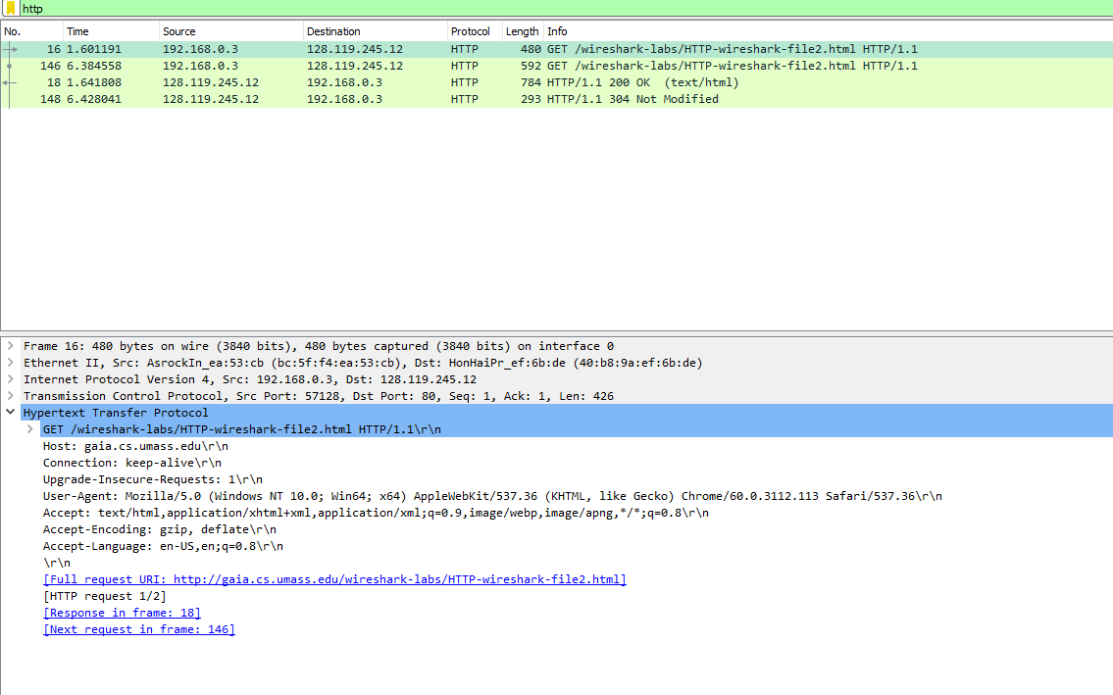

1. **Inspect the contents of the first HTTP GET. Do you see an “IF-MODIFIED-SINCE” line?**  
     
   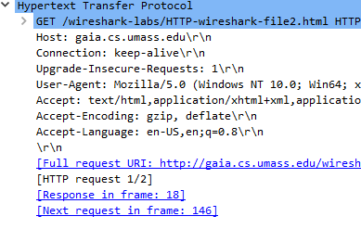  
   There is no ‘IF-MODIFIED-SINCE’ line in the first HTTP GET.
2. **Inspect the contents of the server response. Did the server explicitly return the contents of the file? How can you tell?**  
     
   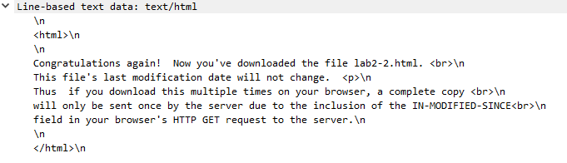

The contents of the file were sent explicitly in this server response.

1. **Inspect the contents of the second HTTP GET. Do you see an “IF-MODIFIED-SINCE” line? If so, what information follows the “IF-MODIFIED-SINCE” header?**

C:\Users\That_Nein\AppData\Local\Microsoft\Windows\INetCache\Content.Word\10.png  
  
This does contain this line, and the information contained within is the time last modified.

1. **What is the HTTP status code and phrase returned from the server in response to this second HTTP GET? Did the server explicitly return the contents of the file? Explain.**



This file was not redownloaded because the file had not been modified since we obtained our previous version.

**Retrieving Long Documents  
  
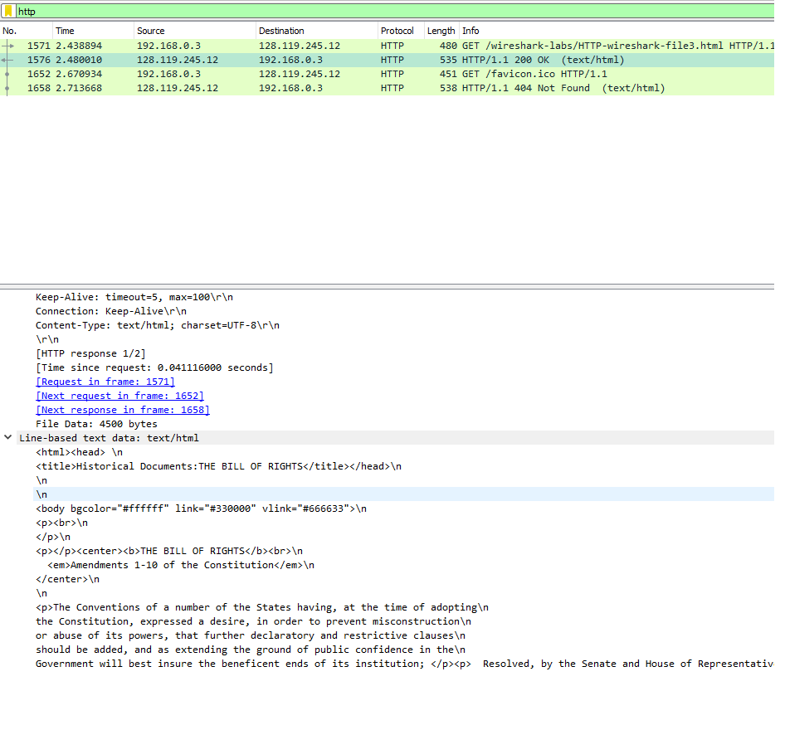**

1. **How many HTTP GET request messages did your browser send? Which packet number in the trace contains the GET message for the Bill of Rights?**  
     
   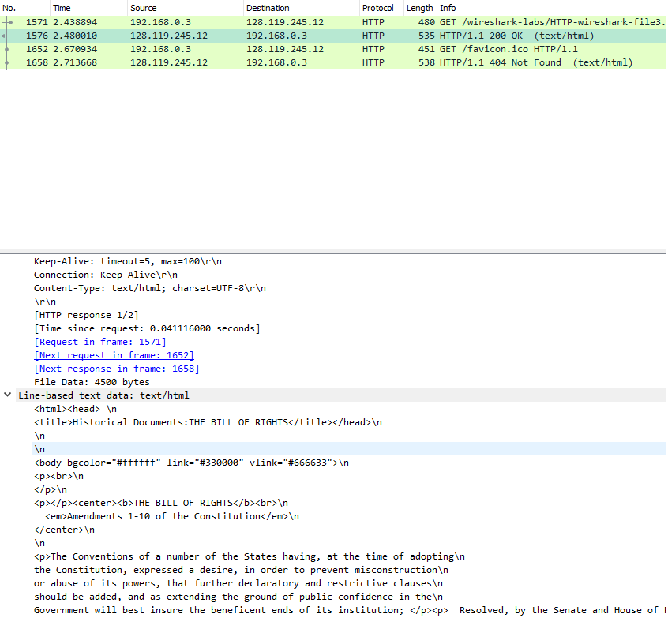

Two GET requests were sent, the first GET request (1576) obtained the bill of rights.

1. **Which packet number in the trace contains the status code and phrase associated with the response to the HTTP GET request?**

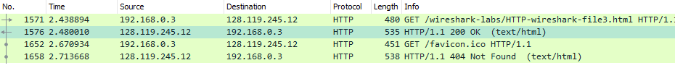  
  
1576 contains the status code and phrase.

1. **What is the status code and phrase in the response?**  
   OK (text/html).
2. **How many data-containing TCP segments were needed to carry the single HTTP response and the text of the Bill of Rights?**

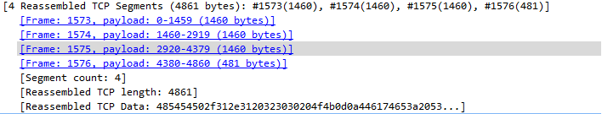

Four segments were needed.

**HTML Documents with Embedded Objects  
  
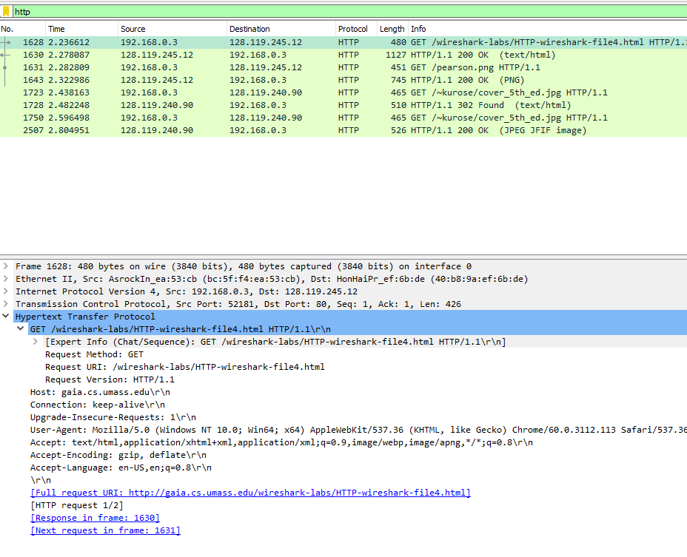**

1. **How many HTTP GET request messages did the browser send? To which internet addresses were these GET requests sent?**  
     
   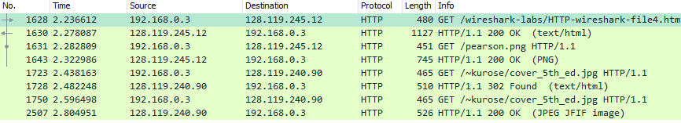

Four GET requests were sent.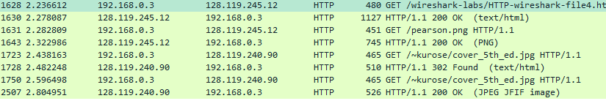

1. **Can you tell if your browser downloaded the two images serially, or if they were downloaded in parallel? Explain.**

The images were downloaded serially, the first image is requested at 2.282809 and downloaded at 2.322986. The second image is not requested until 2.438163.

**HTTP Authentication  
  
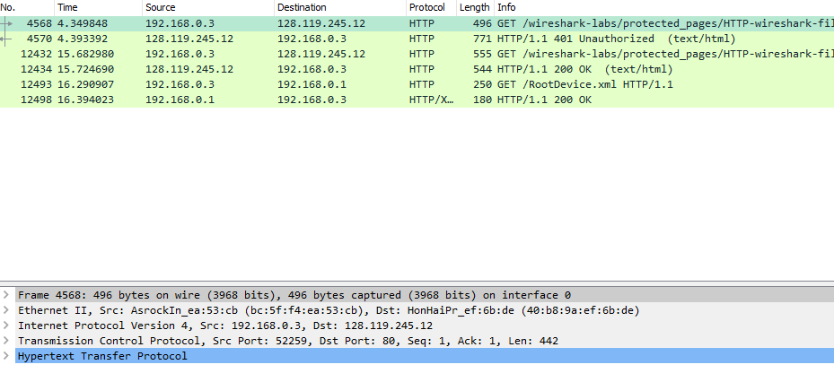**

1. **What is the server’s response (status code and phrase) in response to the initial HTTP GET message from your browser?**  
     
   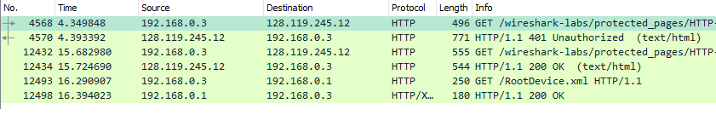

The initial response is Error 401, Unauthorized.

1. **When your browser sends the HTTP GET message for the second time, what new field is included in the HTTP GET message?**

C:\Users\That_Nein\AppData\Local\Microsoft\Windows\INetCache\Content.Word\19.png  
  
The new field is Authorization: Basic <key> and Credentials: wireshark-students:network.