* Exercise 2.4.3: a, f (page 55)

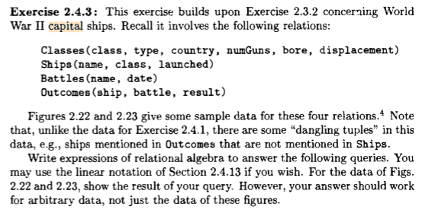



π class, country (σ bore >= 16 (Classes))

This will return from the sample data:

Iowa, USA

North Carolina, USA

Yamato, Japan



π ship, Ships.name (Ships X Outcomes)

This will return from the sample data:

Arizona, Bismarck, California, Duke of York, Fuso, Hood, King George V, Kirishima, Prince of Wales, Rodney, Scarnhorst, South Dakota, Tennessee, Washington, West Virginia, Yamashiro,

California, Haruna, Hiei, Iowa, Kirishima, Kongo, Missouri, Musashi, New Jersey, North Carolina, Ramillies, Renown, Repulse, Resolution, Revenge, Royal Oak, Royal Soverign, Tennessee, Washington, Wisconsin, Yamato

* Exercise 2.4.7: a, b, c, d (page 5

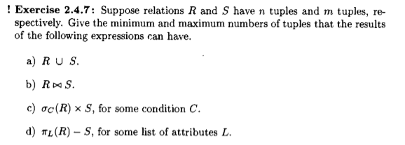

* 1. Minimum: max(n,m)  
     Maximum: n+m
  2. Minimum: 0  
     Maximum: n\*m
  3. Minimum: 0  
     Maximum: n\*m
  4. Minimum: 0  
     Maximum: n
* Exercise 2.5.2: a, c (page 63)

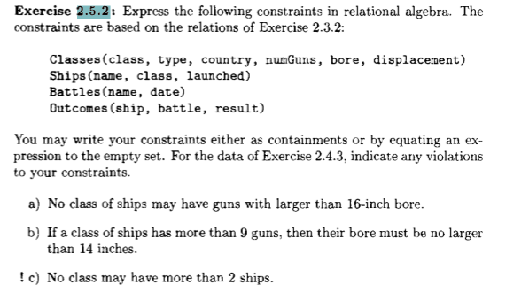

* 1. π class (σ bore <= 16 (Classes))

This will return from the sample data:  
  
Bismarck, Iowa, Kongo, North Carolina, Renown, Revenge, Tennessee

* 1. π class ( count(σ Ships.class = Tennessee) <= 2 AND

count(Ships.class = Kongo) <= 2 AND

count(Ships.class = Iowa) <= 2 AND

count(Ships.class = Yamato) <= 2 AND

count(Ships.class = North Carolina) <= 2 AND

count(Ships.class = Revenge) <= 2 AND

count Ships.class = (Renown) <= 2 (Ships))

This will return from the sample data:  
  
Tennessee, Yamato, North Carolina, Renown